

**Birzeit University**

**Faculty of Engineering & Techonology**

**Department of Electrical & Computer Engineering**

**ENEE**

**“Prelab Exp#4”**

**Student : Mohamad Bornat #1130842**

**Instructor:Dr.Jasser Sa’ed**

**Date: 29\6\2016**

|  |  |  |
| --- | --- | --- |
|  |  |  |
| **Part A** |  |  |

1.using the derived expressions, we find:

Vc(∞) = 1V from the circuit .

Vc(0+)=0 V

Vs+(Vc(0+)-Vs)*exp(-t/RC) =**(1-exp(-1000t))*u(t)**

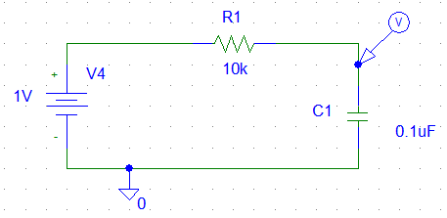



2. T(time constant)=RC = 10k*0.1u=1ms

3.Vp-p=8V , f=50Hz,Rsoure=600ohm , set Td=Tf=Tr=0 , Period=0.02 , PW=0.01,

V1(low ) = -4 and V2(high ) =4 .

4.

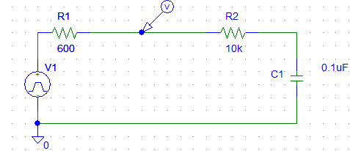



5.

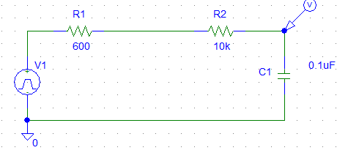



1.VR(t)=0+( 1-0)*exp(-1000t)= exp(-1000t)u(t)

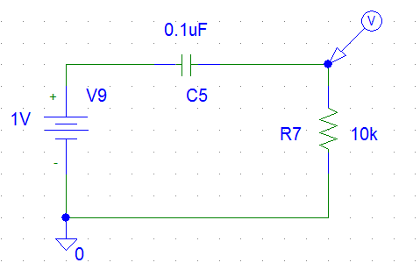



2. T=RC=1ms

3. Vp-p=8, f =50Hz, Rsoure=600ohm ,We set , Td=Tf=Tr=0 , Period=0.02 , PW=0.01,

V1(low ) = -4 and V2(high ) =4 .

4-

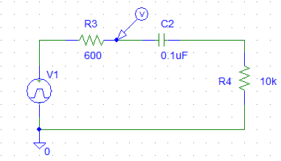

**Input square signal**



**5.**

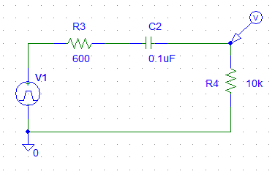



|  |  |  |
| --- | --- | --- |
|  |  |  |
| **Part B** |  |  |

1.Using the derived expressions , we found the response easily to be :-Vf= 0 , V(0+) = 1V

VL(t)=exp(-1000t)u(t)



2.T=L/R=100mH/100 =1ms .

3.Vp-p=8 ,f=50Hz, Rsoure=600ohm ,We set , Td=Tf=Tr=0 , Period=0.02 , PW=0.01,

V1(low ) = -4 and V2(high ) =4

4-

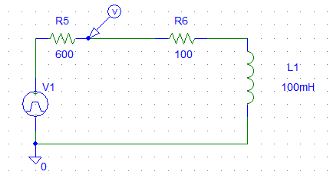



5.

. 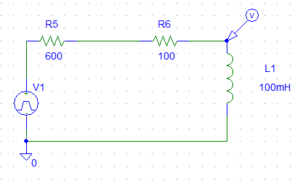



**6.**

1.VR(t)=(1-exp(-1000t) )u(t)



2. T=L/R=1ms.

3. Vp-p=8 ,f=50Hz, Rsoure=600ohm ,We set , Td=Tf=Tr=0 , Period=0.02 , PW=0.01,

V1(low ) = -4 and V2(high ) =4

4. Like above input signal, since no change in the signal or internal resistance .

5.

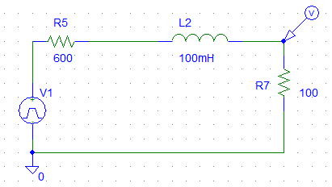



|  |  |  |
| --- | --- | --- |
|  |  |  |
| **Part C** |  |  |

1- K.V.L



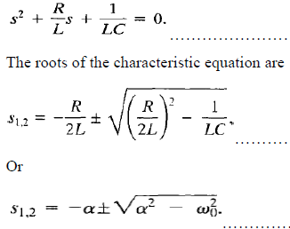

 Substitute values : 10k/2*250m =20kHz

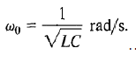wo2 =1/250*0.1n= 40MHz

S1,2 =-20000±

S1,2=-20000±18974

S1-1026

S2-38974

When Vi(t)=u(t) or 1 volt for t>0

Vc at t=∞ , =1 V (steady state )

So **Vc(t) = 1+A1 exp(S1*t) +A2 exp(S2*t)** …..Over damped case since S1 and S2 are unequal and real roots.   
To find the coefficients A1 and A2:

Vc(0+)=Vc(0-)=0 from the circuit .

Since iL(0+)=iL(0-) = 0

dvc(0+)/dt=ic(0+)=0

Solvinf for A1 and A2:

A1+A2= -1

-1026A1-38974A2 =0

**A1= -1.02 , A2 = 0.02**

**Total response of Vc(t) = (1-1.02* exp(-1026*t) +0.02 exp(-38974*t))u(t)**



2. must equal )^2 3.2kΩ

The same idea above but with different new roots for the characteristic equation:

S1=S2=-6400 = solution takes the form:-

**Critical damped** case.

Vc(0+)=Vc(0-)=0 from the circuit .

Since iL(0+)=iL(0-) = 0

dvc(0+)/dt=ic(0+)=0

solving for D1 and D2 after derivation and substitution :

**D2=-1 , D1= - 6400**

**)u(t) as assured below in the plot .**

3. R=160:

The same steps followed above.

**Underdamped** case since

S1,2=-320 complex conjugate . Such that and

…… (Under damped case solution)

Vc(0+)=Vc(0-)=0 from the circuit .

Since iL(0+)=iL(0-) = 0

dvc(0+)/dt=ic(0+)=0

Vc(∞) =1 V from the circuit .

B1=-1

Taking the derivative at t=0+

B2=-



4&5.Vp-p=2V, f=100Hz, period =0.01sec RL=100ohm , Rsource=600ohm ,the square signal is as follow:

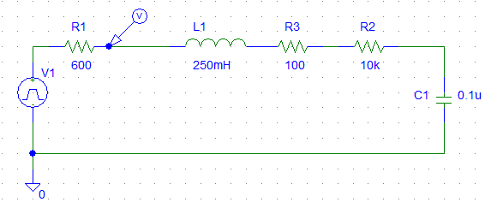



6. A

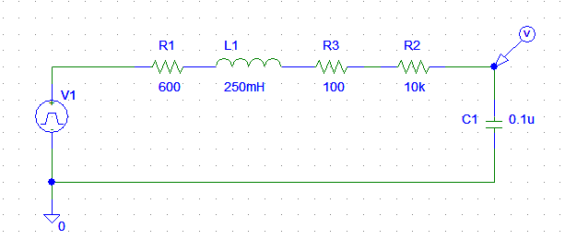



B. Rc=3.2k

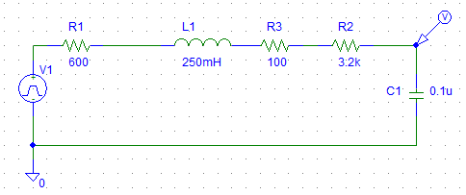



c. R=0

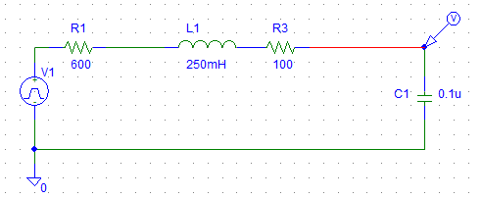



|  |  |  |
| --- | --- | --- |
|  |  |  |
| **Part D** |  |  |

1. source transformation : Is=Vi/R =0.1mA (in parallel with R,L,C)

Differential equation from KCL for the parallel connection:-

.

= 500 >>

Rad/sec

S1,2=- 500

9987 rad/sec

S1,2= -500j 9987

(Underdamped)

Vf=Vc(V . from the circuit .

Vc(0+)=Vc(0-)=0 V .

B1=0

B2=1000/Wd

**u (t) **

2. =500Ω

.= 10000 >>

rad/sec

S1=S2==-10000

(Critically Damped)

Vf=Vc(V . from the circuit .

Vc(0+)=0 V .

D2=o

D1=1000

3.rad/sec

33333

S1,2=-33333

S1,2= -33333 **over damping case**

S1= - 65131

S2= -1535

(Over damped)

Vf=Vc(V . from the circuit .

Vc(0+)=0 V .

A1- 0.0157

A2 0.0157

**)u(t)**



4&5 - Vp-p=2 ,f=100Hz, Rsoure=600ohm ,RL=100ohm ,We set , Td=Tf=Tr=0 , Period=0.01 , PW=0.005, V1(low ) = -1 and V2(high ) =1

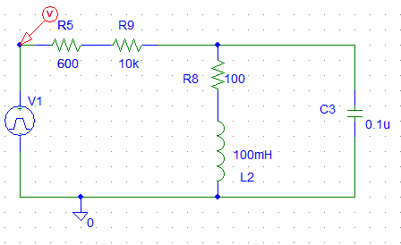



Or at R=600ohm included as resistance of source:



6.A R=10k



B.R=500



C. R=100ohm





      
      
      