

Faculty of Engineering and Technology

Electrical and Computer Engineering Department

Circuits LAB (ENEE2102)

Pre-LAB of Experiment #5

First and Second Order Circuits

**________________________________________________________**

Prepared by:

Name: Sara Totah Number: 1181779

Instructor:

Jaser Sa'Ed

Date:

8/10/2020

Section: #1

**Table of Contents**

Part A: Step Response of First-order RC circuit: 2

Part B: Step response of First-order RL circuit: 4

Part C: Step response of second-order Series RLC circuit: 6

Part D: Step response of second-order parallel RLC circuit: 9

# Part A: Step Response of First-order RC circuit:

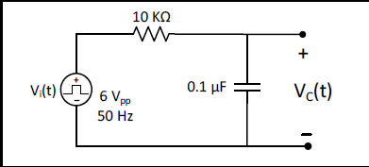

Figure (5.1)

1. Calculate VC (t) using the general solution formula, show calculation of time constant (τ).

|  |  |  |
| --- | --- | --- |
|  | V(0) = 0  VC(∞) = 6volts |  |
|  | * Toe = Rth * C   = 10k * 0.1u = 1ms | (1) |
|  | VC(t) = VC(∞) + [VC(0) - VC(∞)] | (2) |
|  | * VC(t) = 6 + [0-6] $e^{\frac{-t}{1ms}}$  = 6[1- $e^{-1000t}$] |  |

1. Use PSPICE to do transient analysis of the circuit. Show VC(t) and use cursors to measure time constant (𝛕).

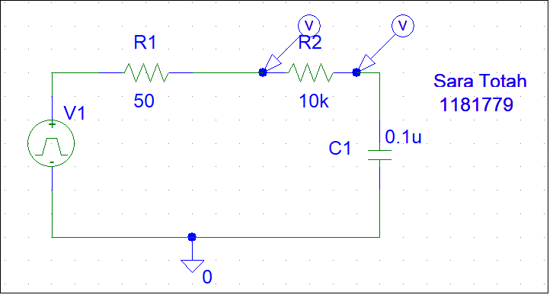

Figure (5.1): PSPICE simulation



VC(t)

|  |  |  |
| --- | --- | --- |
|  | 0.63*Vo = 3.78 |  |
|  | Toe $≈0.998m ≈$ 1ms |  |

1. For the same circuit show VR(t) using a differential voltage marker, and use cursors to measure time constant (𝛕).



VR(t)

|  |  |  |
| --- | --- | --- |
|  | 0.37*Vo = 2.22 |  |
|  | * Toe $≈0.976m ≈$ 1ms |  |

# Part B: Step response of First-order RL circuit:

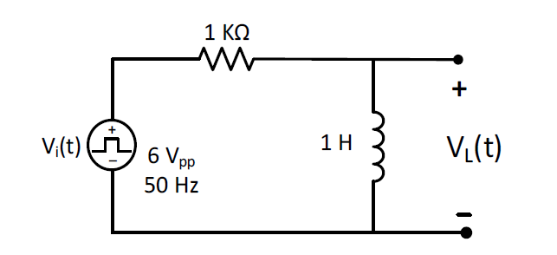

Figure (5.2)

1. Calculate VL (t) using the general solution formula, show calculation of time constant (τ).

|  |  |  |
| --- | --- | --- |
|  | VL(∞) = 0  VL(0) = Vin max = 6v |  |
|  | * Toe = $\frac{L}{R}=1ms$ | (3) |
|  | VL(t) = VL(∞) + [VL(0) – VL(∞)] |  |
|  | * VL(t) = 6 $e^{1000t}$* |  |

1. Use PSPICE to do transient analysis of the circuit. Show VL(t) and use cursors to measure time constant (𝛕)

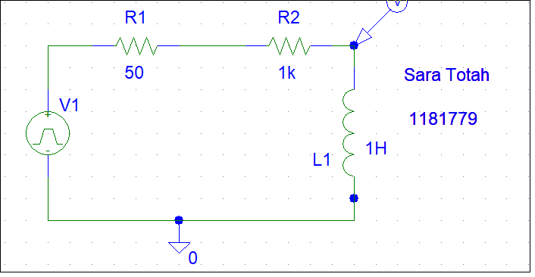

Figure (5.2): PSPICE simulation



VL(t)

0.37*Vo = 2.22

* Toe $≈0.941m ≈$ 1ms

1. For the same circuit show VR(t) using a differential voltage marker, and use cursors to measure time constant (𝛕).



VR(t)

0.63*Vo = 3.78

* Toe $≈1.0394m ≈$ 1ms

# Part C: Step response of second-order Series RLC circuit:

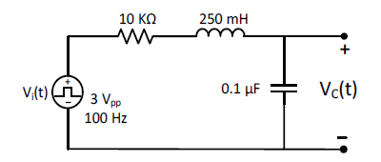

Figure (5.3)

1. For R = 10 kΩ, calculate the roots of the characteristic equation and write an expression for VC(t). Use PSPICE to do transient analysis of the circuit, and show VC(t).

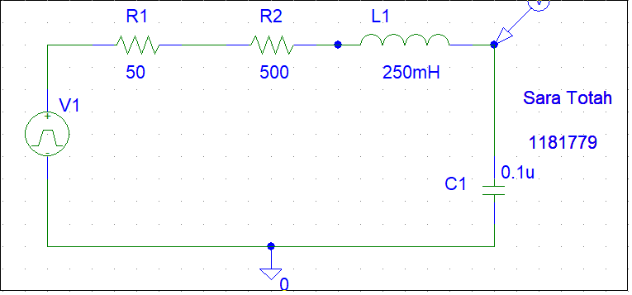

Figure (5.3): PSPICE simulation

|  |  |  |
| --- | --- | --- |
|  | α = | (4) |
|  | ω0 = | (5) |

The system is over damped:

|  |  |  |  |  |
| --- | --- | --- | --- | --- |
|  | | S1,2 = - α $±$ $\sqrt{α^{2}- {ω0}^{2} }= -$ 20000 | (6) | |
|  | | * S1 = -1026.3 * S2 = -38973.68 |  | |
|  | | Vc(∞) = 3 |  | |
|  | | VC(t) = A1 t * + A2 t * + VF | (7) | |
|  | * VC(t) = A1 * + A2 * + 3 | | |  |



VC(t)

1. Calculate the critical resistance RC that will result in equal roots (S1 = S2 = - α) and write an expression for VC(t). Use PSPICE to do transient analysis of the circuit and show VC(t).

S1 = S2 = - α means that the response will be critically damped, so:

|  |  |  |
| --- | --- | --- |
|  | = |  |
|  |  | (8) |
|  | R2 =  R = 3.162k ohm |  |
|  | * S1 = S2 = - |  |
|  | VC(t) = D1 t * + D2 t * + VF | (9) |
|  | * VC(t) = A1 t * + A2 t * + 3 |  |



VC(t)

1. For R = 500 Ω, calculate the roots of the characteristic equation, showing the value of 𝛂 𝐚𝐧𝐝 𝛚𝐝 and write an expression for VC(t). Use PSPICE to do transient analysis of the circuit, show VC(t), and measure 𝛂 𝐚𝐧𝐝 𝛚𝐝 using cursors.

α =

ω0 =

ω0 > α so the response is under-damped:

|  |  |  |  |  |
| --- | --- | --- | --- | --- |
|  | | $ωd=(\sqrt{{ω0}^{2}- α^{2}})$ $=\left(\sqrt{{6324.5}^{2}- {1000}^{2}}\right)=6244.94$ | (10) | |
|  | | Vc(t) = VF + e-α (A cos ω0t + B sin ω0t) | (11) | |
|  | * Vc(t) =3 + $e^{-1000t}$ (A cos 6244.94t + B sin 6244.94t) | | |  |



VC(t)

|  |  |  |
| --- | --- | --- |
|  | $τ= \frac{tb-ta}{ln⁡(\frac{Va-Vo\left(∞\right)}{Vb- Vo\left(∞\right)})}$ = $\frac{1.5m-0.5m}{ln⁡(\frac{4.7227-3 }{3.5627-3)})}$ =  0.894ms | (12) |
|  | * α = $\frac{1}{τ}$ = 1118.56 ohm | (13) |
|  | $ωd= \frac{2π}{tb-ta}= \frac{2π}{1.5m-0.5m}= 6283.2$ | (14) |

# Part D: Step response of second-order parallel RLC circuit:

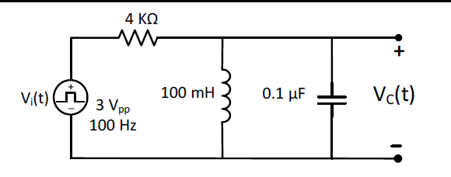

Figure (5.4)

1. For R = 4 kΩ, calculate the roots of the characteristic equation showing the value of 𝛂 𝐚𝐧𝐝 𝛚𝐝. Write an expression of VC(t). Use PSPICE to do transient analysis of the circuit, show VC(t), and measure 𝛂 𝐚𝐧𝐝 𝛚𝐝 using cursors.

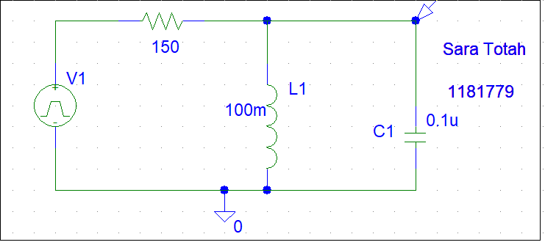

α =

ω0 =

ω0 > α so the response is under-damped:



$ωd=(\sqrt{{ω0}^{2}- α^{2}})$ $=\left(\sqrt{{10000}^{2}- {1250}^{2}}\right)=9921.56$

Vc(t) = VF + e-α (A cos ω0t + B sin ω0t)

* VC (t) = (A cos 9921.56t + B sin 9921.56t)



VC(t)

$τ= \frac{tb-ta}{ln⁡(\frac{Va-Vo\left(∞\right)}{Vb- Vo\left(∞\right)})}$ = $\frac{0.79m-0.146m}{ln⁡(\frac{0.62m-0 }{0.28m-0)})}$ = 0.810ms

* α = $\frac{1}{τ}$ = 1234.56 ohm

$ωd= \frac{2π}{tb-ta}= \frac{2π}{0.79m-0.146m}= 9756.49$

1. Calculate the critical resistance RC that will result in equal roots (S1 = S2 = - α) and write an expression for VC(t). Use PSPICE to do transient analysis of the circuit and show VC(t).

S1 = S2 = - α means that the response will be critically damped, so:

$α^{2}$ = ${ω0 }^{2}$

$${\left(\frac{1}{2RC}\right)}^{2}= {\left(\frac{1}{\sqrt{LC}}\right)}^{2}$$

RC= ohm

* S1 = S2 = -

VC(t) = D1 t * + D2 t * + VF

* VC(t) = A1 t * + A2 t *



VC(t)

1. For R = 150 Ω, calculate the roots of the characteristic equation and write an expression for VC(t). Use PSPICE to do transient analysis of the circuit, and show VC(t).

α =

ω0 =

ω0 < α so the system is over damped:

S1,2 = - α $±$ $\sqrt{α^{2}- {ω0}^{2} }=$- 33333.3

* S1 = -1535.36
* S2 = -65131.24

VC(t) = A1 t * + A2 t * + VF

* VC(t) = A1 * + A2  *



VC(t)