

**Faculty of Engineering and Technology Electrical and Computer Engineering Department Circuits Lab (ENEE2102)**

**Prelab Exp (5)**

**Name: Ameer Butmah**

**1180443**

**Prof. Muhammad Abu-Khaizaran**

A)1)

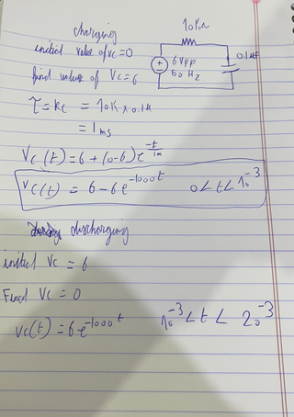

2)





To find the time constant $τ$, the curser was set to $V=0.63 V_{final}=3.78$ in the charging cycle. Or $V=0.37V_{initial}=2.22$ in the discharging cycle.

3) 

when

B)1)



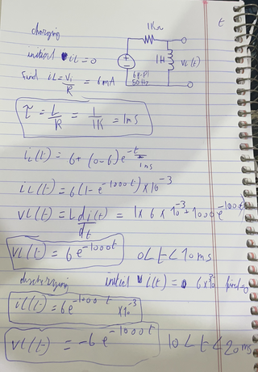

2)



To find the time constant $τ$, the curser was set to $V=0.37V_{initial}=2.22$ in the discharging cycle.

$$τ=100 ms$$

3)



$$V=0.63*6=3.78 V$$

$τ=100ms$

C)

1)



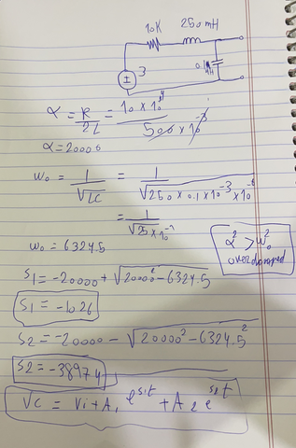



2)

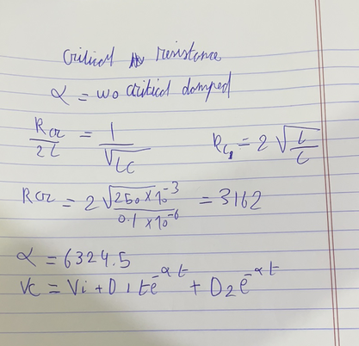



3)

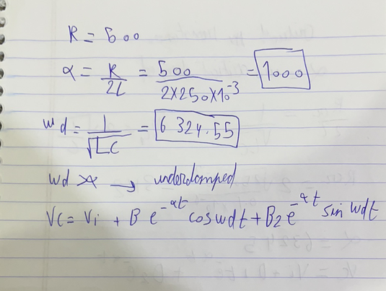



D)





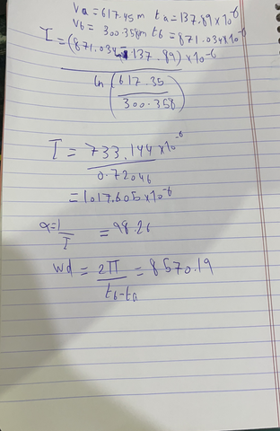

2)

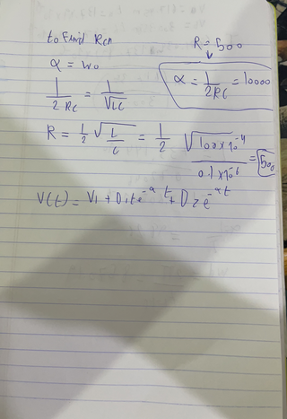



3)

