

**Birzeit University**

**Faculty of Engineering & Techonology**

**Department of Electrical & Computer Engineering**

**ENEE211**

**“**Impedance and Sinusoidal Steady State**”**

**Student :Mohamad Bornat #1130842**

**Instructor:Dr.Jasser Sa’ed**

**Date: 13\7\2016**

|  |  |  |
| --- | --- | --- |
|  |  |  |
|  |  |  |

1.To Calculate Vc(t) using PSpice , we need to find phase and magnitude of Vc(t) , to do that ; insert VPRINT2 between VA and the ground .to print the magnitude and phase of Vc(t) ,set VPRINT2 part names : AC ,Mag, and Phase to yes . To perform simulation at single-frequency, set Start Freq = 50Hz, and Final Freq = 50Hz in the AC sweep analysis part.

2. Vi (t) =4*cos (100*pi*t-90)(Phasor domain form), set ACMAG=4V, ACPHASE=-90

The circuit is as below with everything above taken into consideration

**.** 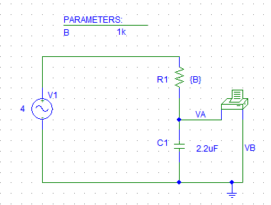

The output file of PSpice contains the following for every resistance from 1k to 10k ohms.

When Param B =1k

FREQ VM (VA,0) VP(VA,0)

5.000E+01 3.291E+00 -1.247E+02

**Vc(t) = 3.291*cos(100*pi*t -124.7)= 3.291*sin(100*pi*t-34.7)**

**Phase difference = 34.7**

When the PARAM B =2k ,the magnitude and phase for Vc(t) as appear in output File of PSpice are:

FREQ VM(VA,0) VP(VA,0)

5.000E+01 2.345E+00 -1.441E+02

**Vc(t) = 2.345*cos(100*pi*t -144.1)= 2.345*sin(100*pi*t-54.1)**

**Phase difference = 54.1**

When the PARAM B =3k, the magnitude and phase for Vc(t) as appear in output File of PSpice are:

FREQ VM(VA,0) VP(VA,0)

5.000E+01 1.738E+00 -1.543E+02

**Vc(t) = 1.738*cos(100*pi*t -154.3)= 1.738*sin(100*pi*t-64.3)**

**Phase difference = 64.3**

When the PARAM B =4k, the magnitude and phase for Vc(t) as appear in output File of PSpice are:

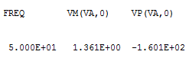

**Vc(t) = 1.361*cos(100*pi*t -160.1)= 1.361*sin(100*pi*t-70.1)**

**Phase difference = 70.1**

When the PARAM B =5k, the magnitude and phase for Vc(t) as appear in output File of PSpice are:

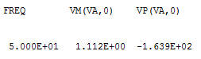

**Vc(t) = 1.112*cos(100*pi*t -163.9)= 1.112*sin(100*pi*t-73.9) / Phase difference = 73.9**

When the PARAM B =6k, the magnitude and phase for Vc(t) as appear in output File of PSpice are:

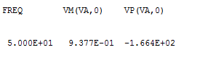

**Vc(t) = 0.9377*cos(100*pi*t -166.4)= 1.361*sin(100*pi*t-76.4)**

**Phase difference = 76.4**

When the PARAM B =7k, the magnitude and phase for Vc(t) as appear in output File of PSpice are:

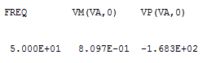

**Vc(t) = 0.8097*cos(100*pi*t -168.3)= 0.8097*sin(100*pi*t-78.3)**

**Phase difference = 78.3**

When the PARAM B =8k, the magnitude and phase for Vc(t) as appear in output File of PSpice are:

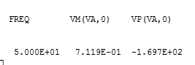

**Vc(t) = 0.7119*cos(100*pi*t -169.7)= 0.7119*sin(100*pi*t-79.7)**

**Phase difference = 79.7**

When the PARAM B =9k, the magnitude and phase for Vc(t) as appear in output File of PSpice are:

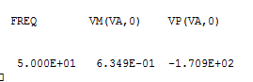

**Vc(t) = 0.6349*cos(100*pi*t -170.9)= 0.6349*sin(100*pi*t-80.9)**

**Phase difference = 80.9**

And finally when the PARAM B =10k, the magnitude and phase for Vc(t) as appear in output File of PSpice are:

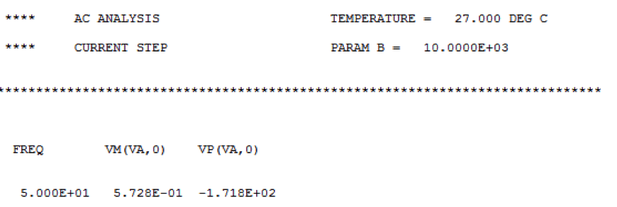

**Vc(t) = 0.5728*cos(100*pi*t -171.8)= 0.5728*sin(100*pi*t-81.8)**

**Phase difference = 81.8**

**The waveforms are as shown below:-**

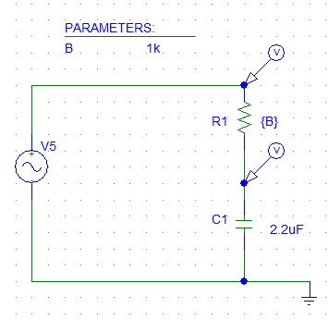



4. Like the previous setting exactly, but only change the magnitude of the input sinusoidal to 5V. And change c to L=100uH.Vi (t) =5*sin (2000*pi*t)

= 5*cos (2000*pi*t-90)

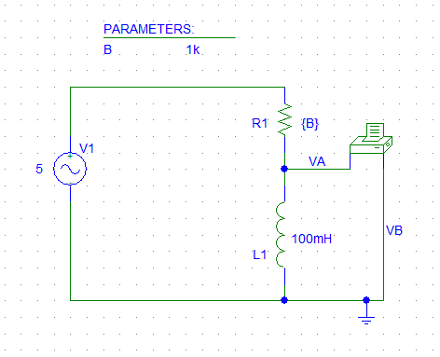

**Using the output File, the Phase and Magnitude are as found below:-**

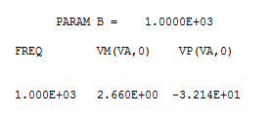

VL(t)= 2.66*cos(2000*pi*t-32.1) =2.66*sin(2000*pi+57.9)

$$∅=57.9$$

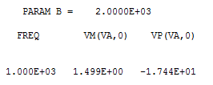

VL(t)= 1.499*cos(2000*pi*t-17.44) =1.499*sin(2000*pi+72.56)

$∅=$**72.56**

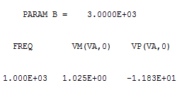

VL(t)= 1.02*cos(2000*pi*t-11.8) =1.02*sin(2000*pi+78.2)

$∅=$**78.2**

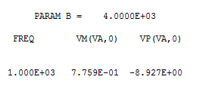

VL (t) =0.77 *cos(2000*pi*t-8.9) =0.77*sin(2000*pi+81.1)

$∅=$**81.1**

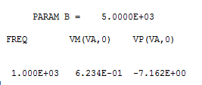

VL (t) = 0.62*cos(2000*pi*t-7.1) =0.62*sin(2000*pi+82.9)

$∅=$**82.9**

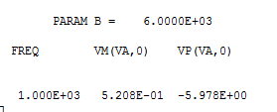

VL(t)= 0.52*cos(2000*pi*t-5.9) =0.52*sin(2000*pi+84.1)

$∅=$**84.1**

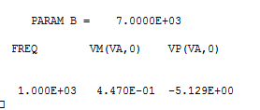

VL(t)= 0.44*cos(2000*pi*t-5.1) =0.44*sin(2000*pi+84.9)

$∅=$**84.9**

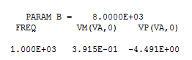

VL(t)= 0.39*cos(2000*pi*t-4.4) =0.39*sin(2000*pi+85.6)

$∅=$**85.6**

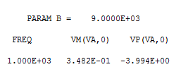

VL(t)= 0.34*cos(2000*pi*t-3.9) =0.34*sin(2000*pi+86.1)

$∅=$**86.1**

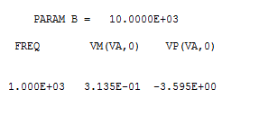

VL(t)= 0.31*cos(2000*pi*t-3.5) =0.31*sin(2000*pi+86.5)

$∅=$**86.5**

**7)**

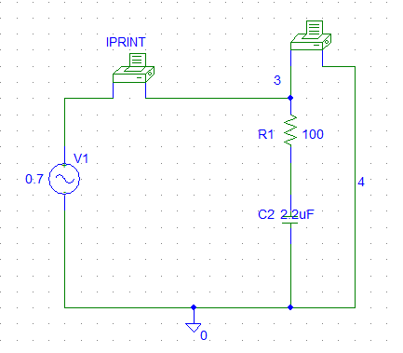

**F=800Hz ,the output file has the magnitude of I and V.**

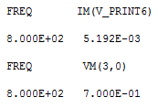

**|Z|=|V|/|I|=0.7/5.192m=134.8ohm**

**F=1600Hz**

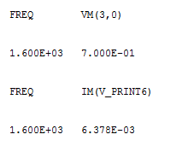

**|Z|=|V|/|I|=0.7/6.378m=109.7ohm**

**F=3200Hz**

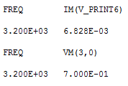

**|Z|=|V|/|I|=0.7/6.828m=102.5ohm**

**F=6400Hz**

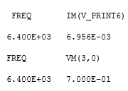

**|Z|=|V|/|I|=0.7/6.956m=100.6ohm**

**Z Vs Freq**

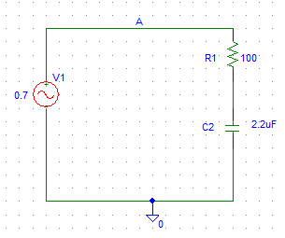



**10.)** 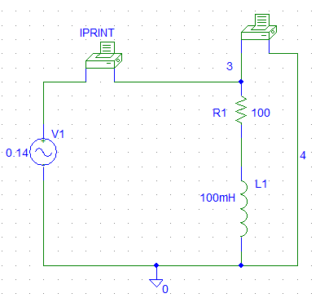

**For f=50Hz, the Magnitude of current and voltage were obtained from the output file as below:-**

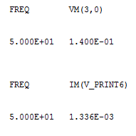

**|Z|=|V|/|I| = 0.14/1.336m = 104.8 ohm**

**F=100Hz**

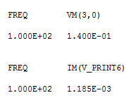

**|Z|=|V|/|I|=0.14/1.185=118.1ohm**

**F=200Hz**

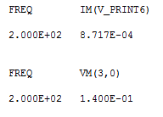

**|Z|=|V|/|I|=0.14/0.8717m= 160.6ohm**

**F=400Hz**

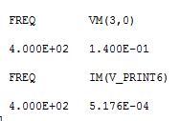

**|Z|=|V|/|I|=0.14/0.5176m = 270 ohm**

**F=800Hz**

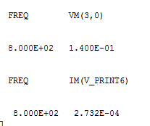

**|Z|=|V|/|I|=0.14/0.2732m=512.4ohm**

**F=1600Hz**

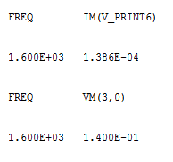

**|Z|=|V|/|I|=0.14/0.0.1386m=1010ohm**

**Z Vs Freq**



