

Faculty of Engineering and Technology

Electrical and Computer Engineering Department

Circuits LAB (ENEE2102)

Pre-LAB of Experiment #9

Passive Filters Analysis

**________________________________________________________**

Prepared by:

Name: Sara Totah Number: 1181779

Instructor: Jaser Sa'Ed TA: Eng. Ahmad Zahran

Date:

31/10/2020

Section: #1

Table of Contents

Pre-Lab: 3

First-order RC High Pass Filter: 3

First-order RC Loaded Low Pass Filter: 4

Parallel RLC Band Pass Filter: 5

Series RLC Band Reject Filter 7

# Pre-Lab:

## First-order RC High Pass Filter:

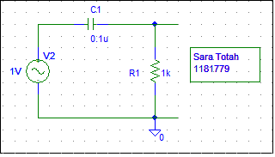

Fig (9.1): First-order RC High Pass Filter

|  |  |  |
| --- | --- | --- |
| The cut-off frequency = | wc =  fc = = 1591.54 Hz | (1)  (2) |



Fig(9.2): Vo(db)



Fig(9.3): p(Vo)

## First-order RC Loaded Low Pass Filter:

## 

Fig (9.4): First-order RC loaded Low pass filter

|  |  |  |
| --- | --- | --- |
| The cut-off frequency = | wc =  fc = = | (3)  (4) |



Fig (9.5): Vo(db)



Fig (9.6): p(Vo)

## Parallel RLC Band Pass Filter:

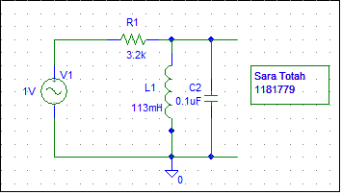

Fig (9.7): Parallel RLC Band Pass Filter

* R = 3.2KΩ

|  |  |  |
| --- | --- | --- |
| The Center Frequency = | Wo = = 9407.2 rad/s  Fo = = 1497.2 Hz | (5)  (6) |
| The cut-off Frequency = | W2,1 =  W2 = 11098.588 rad/s  W1 = 7973.588 rad/s  Fc.2 = = 1766.39 Hz  Fc1 = = 1269.036 Hz | (7)  (8)  (9) |
| Bandwidth = | β = w2 – w1 = 3125 rad/s  β = $\frac{1}{RC}=3125$ rad/s  β = 497.36 Hz | (10)  (11) |

* R = 1.6KΩ

|  |  |  |
| --- | --- | --- |
| The Center Frequency = | Wo = = 9407.2 rad/s  Fo = = 1497.2 Hz | (12)  (13) |
| The cut-off Frequency = | W2,1 =  W2 = 13042.92 rad/s  W1 = 6792.92 rad/s  Fc.2 = = 4959.065 Hz  Fc1 = = 789.259 Hz | (14)  (15)  (16) |
| Bandwidth = | β = w2 – w1 = 6250 rad/s  β = $\frac{1}{RC}=6250$ rad/s  β = 994.72 Hz | (17)  (18) |

Note: The simulation results were taken while the resistor = 3.2kΩ

## 

Fig (9.8): Vo(db)



Fig (9.9): p(Vo)

## Series RLC Band Reject Filter

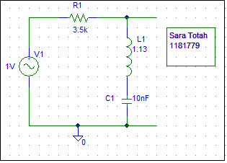

Fig (9.10): Series RLC Band Reject Filter

* R = 3.5KΩ

|  |  |  |
| --- | --- | --- |
| The Center Frequency = | Wo = = 9407.208 rad/s  Fo = = 1497.203 Hz | (19)  (20) |
| The cut-off Frequency = | W2,1 =  W2 = 11082.5 rad/s  W1 = 7985.16 rad/s  Fc.2 = = 1763.83 Hz  Fc1 = = 1270.88 Hz | (21)  (22)  (23) |
| Bandwidth = | β = w1 – w2 = 3097.34 rad/s  β = $\frac{R}{L}=$ 3097.34 rad/s  β = 492.95 Hz | (24)  (25) |

* R = 7.1KΩ

|  |  |  |
| --- | --- | --- |
| The Center Frequency = | Wo = = 9407.208 rad/s  Fo = = 1497.203 Hz | (26)  (27) |
| The cut-off Frequency = | W2,1 =  W2 = 13059.51 rad/s  W1 = 6776.33 rad/s  Fc.2 = =2078.48 Hz  Fc1 = =1078.49 Hz | (28)  (29)  (30) |
| Bandwidth = | β = w1 – w2 = 6283.18 rad/s  β = $\frac{R}{L}=$ 6283.18 rad/s  β = 999.9 Hz | (31)  (32) |

Note: The simulation results were taken while the resistor = 3.5kΩ



Fig (9.11): Vo(db)



Fig (9.9): p(Vo)