

Faculty of Engineering and Technology

Electrical and Computer Engineering Department

Circuits LAB (ENEE2102)

Report on Experiment #3

Simple Resistive Circuits

**________________________________________________________**

Prepared by:

Name: Sara Totah Number: 1181779

Instructor: Jaser Sa'Ed TA: Eng. Ahmad Zahran

Date:

21/12/2020

Section: #1

Table of Contents

**Abstract:** 2

**Theory:** 2

Kirchhoff’s Laws: 2

1. Kirchhoff’s Voltage Law: 2

2. Kirchhoff’s Current Law: 2

The Voltage-Divider and Current Divider: 3

1. The Voltage-Divider: 3

2. The Current-Divider: 3

**Procedure:** 4

Part A: Kirchhoff’s Laws: 4

Part B: Voltage Divider: 4

Part C: Current Divider: 5

Part D: Short and Open Circuited Resistor in Series-Parallel Circuits: 6

**Data and analysis of results:** 7

Part A: Kirchhoff’s Laws: 7

Part B: Voltage Divider: 7

Part C: Current Divider 8

Part D: Short and Open Circuited Resistor in Series-Parallel Circuits: 9

**Conclusion:** 10

**References:** 10

# **Abstract:**

The aim of this experiment is to test KVL, KCL, voltage divider and current divider rules in practical, also to examine the effect of short and open circuits in circuits.

Equipment used in this experiment:

1. Digital multimeter.
2. DC power supply
3. Wires and resistors.
4. Variable resistor box.

# **Theory:**

## Kirchhoff’s Laws:

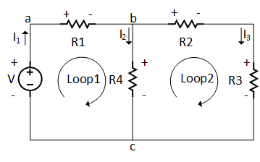

Figure 1: Kirchhoff’s lows applied to a circuit

### Kirchhoff’s Voltage Law:

The algebraic sum of all the voltages around any closed path in a circuit equals zero.

|  |  |  |
| --- | --- | --- |
| From loop 1 | -V +R1I1 + R4I2 = 0 | (1) |
| From loop 2 | -R4I2 + R2I3 + R3I3 = 0 | (2) |

### Kirchhoff’s Current Law:

The algebraic sum of all the currents at any node in the circuit equals zero

|  |  |  |
| --- | --- | --- |
| At node a: | -IV +I1 = 0 | (3) |
| At node b: | I1 – I2 – I3 = 0 | (4) |
| At node c: | -I2 – I3 + I1 = 0 | (5) |

## The Voltage-Divider and Current Divider:

### The Voltage-Divider:

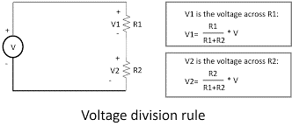

Figure 2: Voltage divider rule

|  |  |  |
| --- | --- | --- |
| The voltage across R1: |  | (6) |
| The voltage across R2: | $$V1=\frac{R2}{R1+R2}V$$ | (7) |

### The Current-Divider:

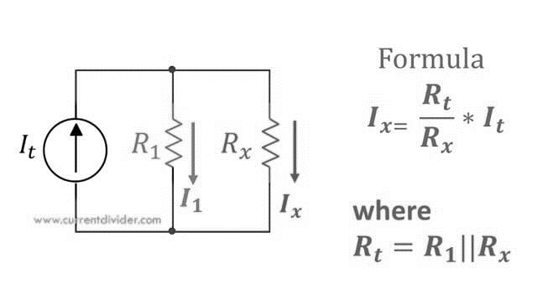

Figure 3: Current divider rule

|  |  |  |
| --- | --- | --- |
|  | IX = | (8) |
|  | I1 = | (9) |

# **Procedure:**

## Part A: Kirchhoff’s Laws:

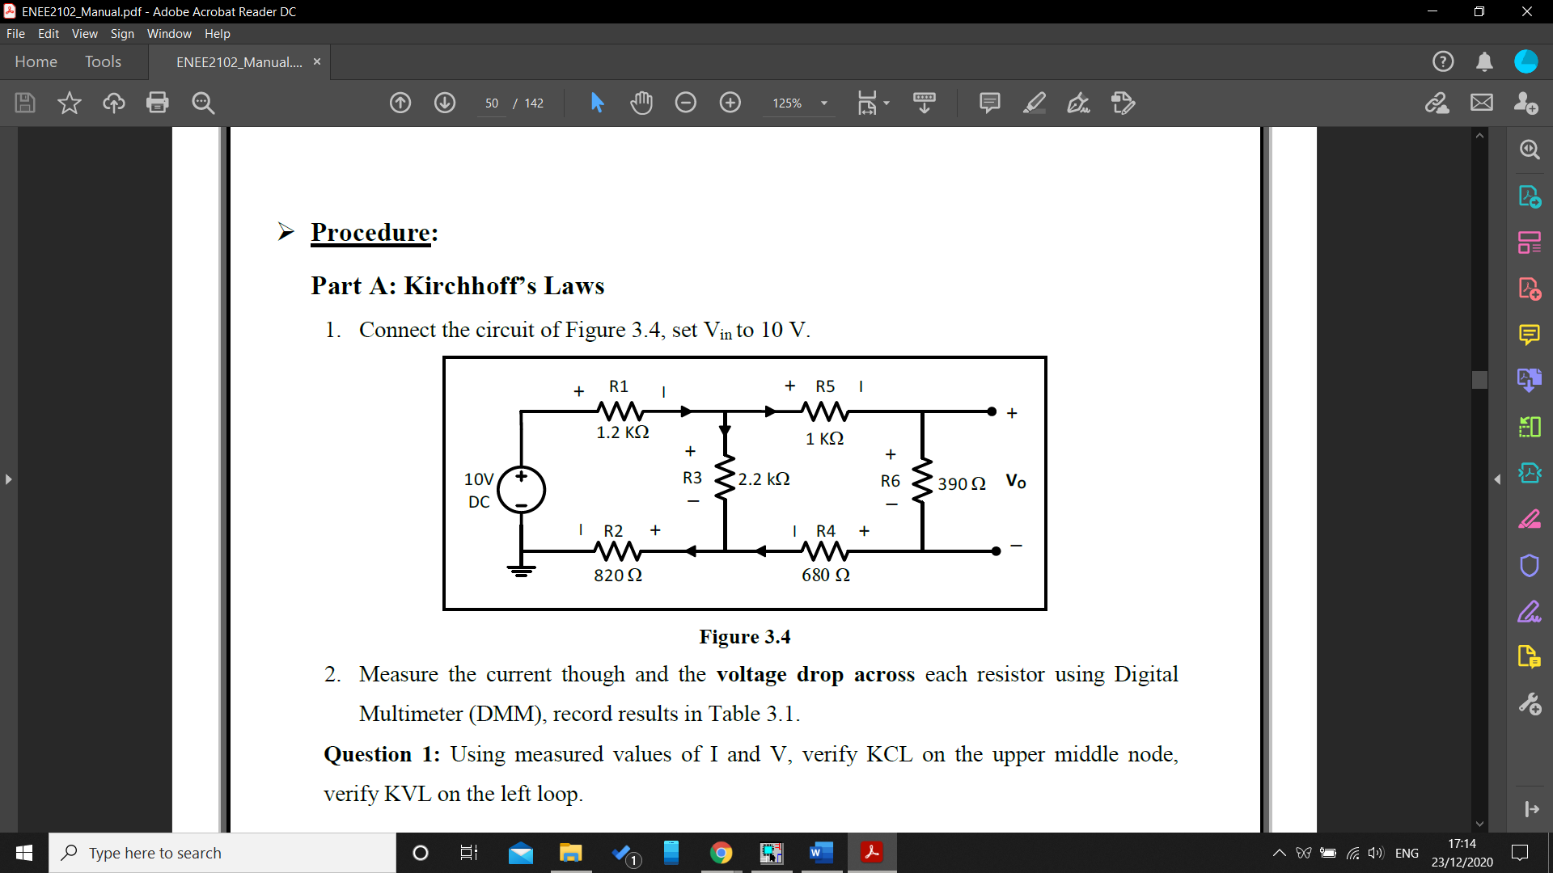

Figure 4: Kirchhoff’s laws

The circuit above was connected and the input voltage was set to 10v, the current passing through each resistor and the voltage across each resistor were measured using the Digital Multimeter, and the results were recorded in table 1 in the Data section.

## Part B: Voltage Divider:

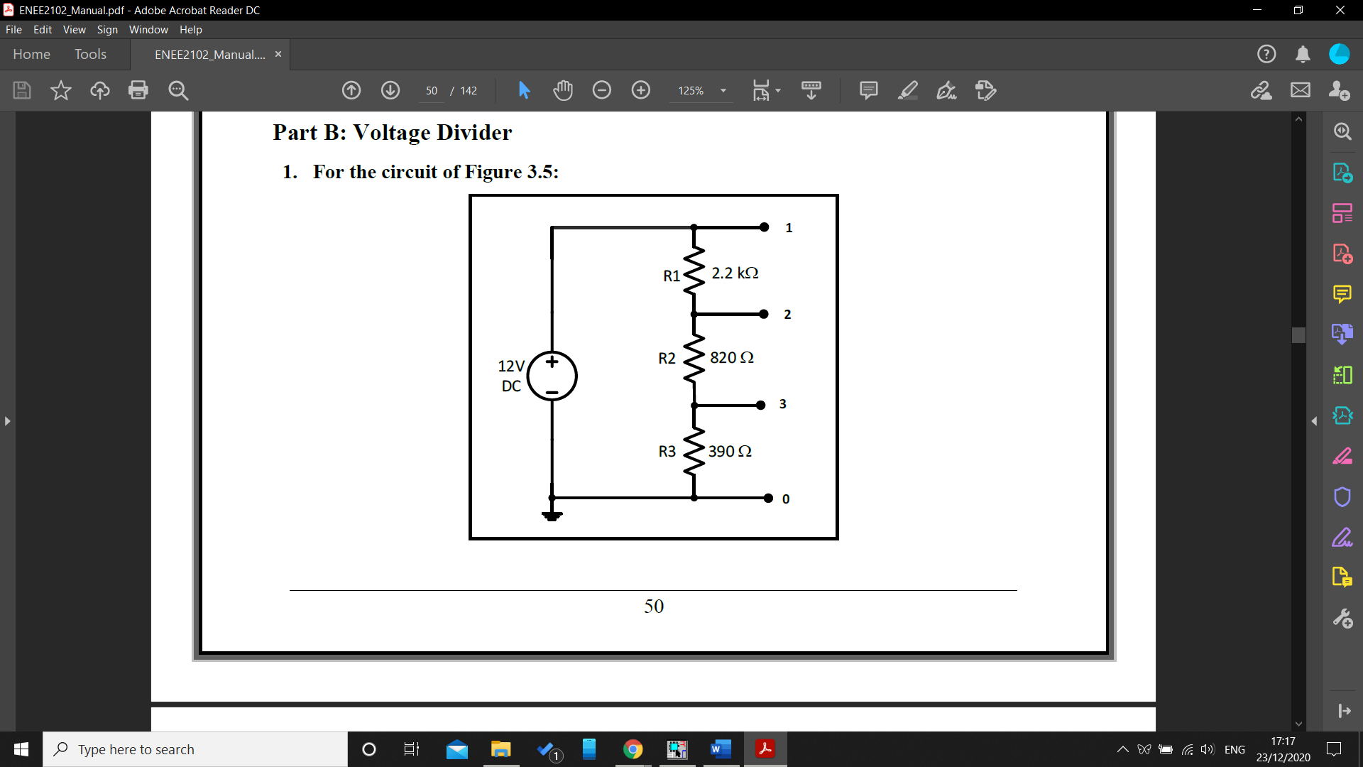

Figure 5: First Voltage Divider circuit

The circuit above was connected and the input voltage was set to 12v, the voltage across each resistor was measured and recorded in table 2 in the Data section.

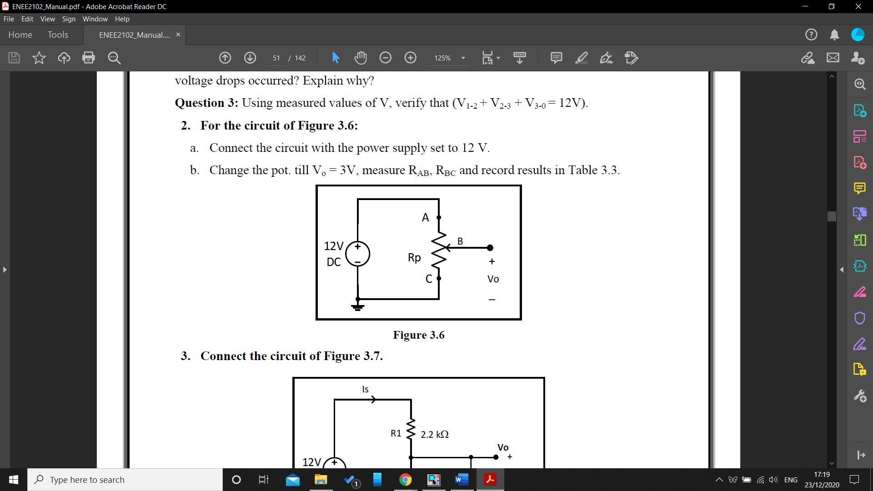

Figure 6: Second Voltage Divider circuit

The circuit above was connected and the output of the power supply was set to 12v, then the potentiometer was changed till the output VO equaled 3v, the resistors RAB and RBC was recorded in table3 in the data section.

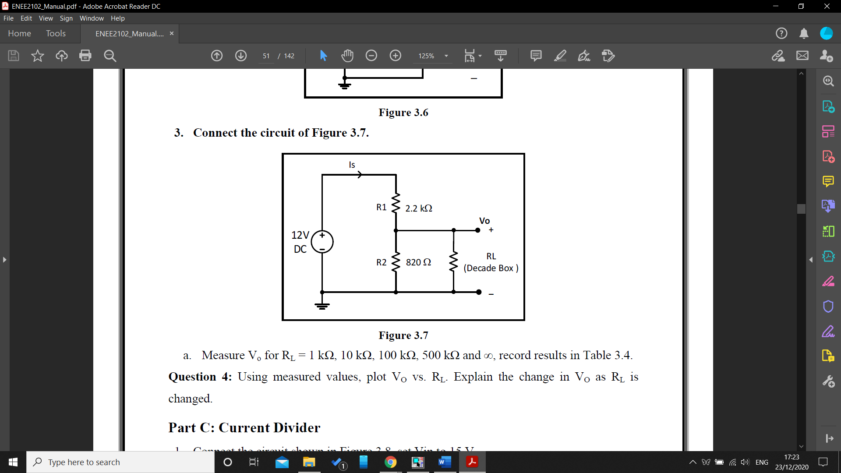

Figure 7: Voltage Divider connected to a load RL

The circuit above was connected and the output voltage VO was measured for different values of the load RL, the results were recorded in table 4 in the data section.

## Part C: Current Divider:

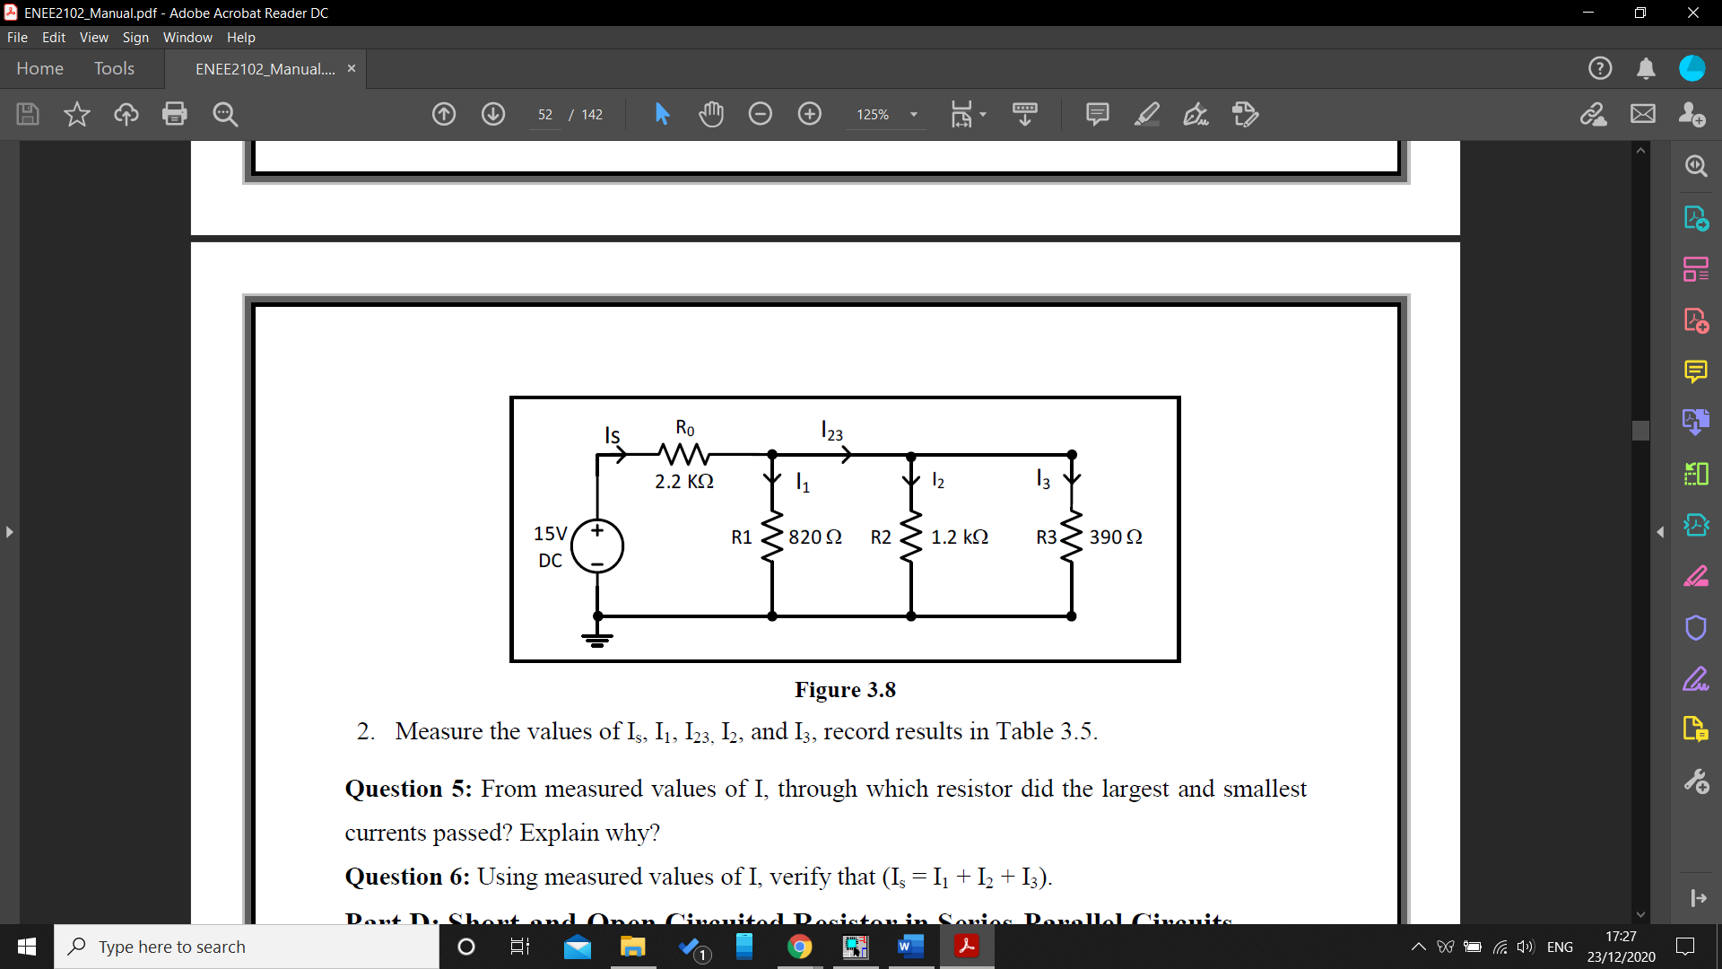

Figure 8: Current Divider

The circuit in figure 8 was connected, and the values IS, I1, I2 and I3, and the results were recorded in table 5 in the data section.

## Part D: Short and Open Circuited Resistor in Series-Parallel Circuits:

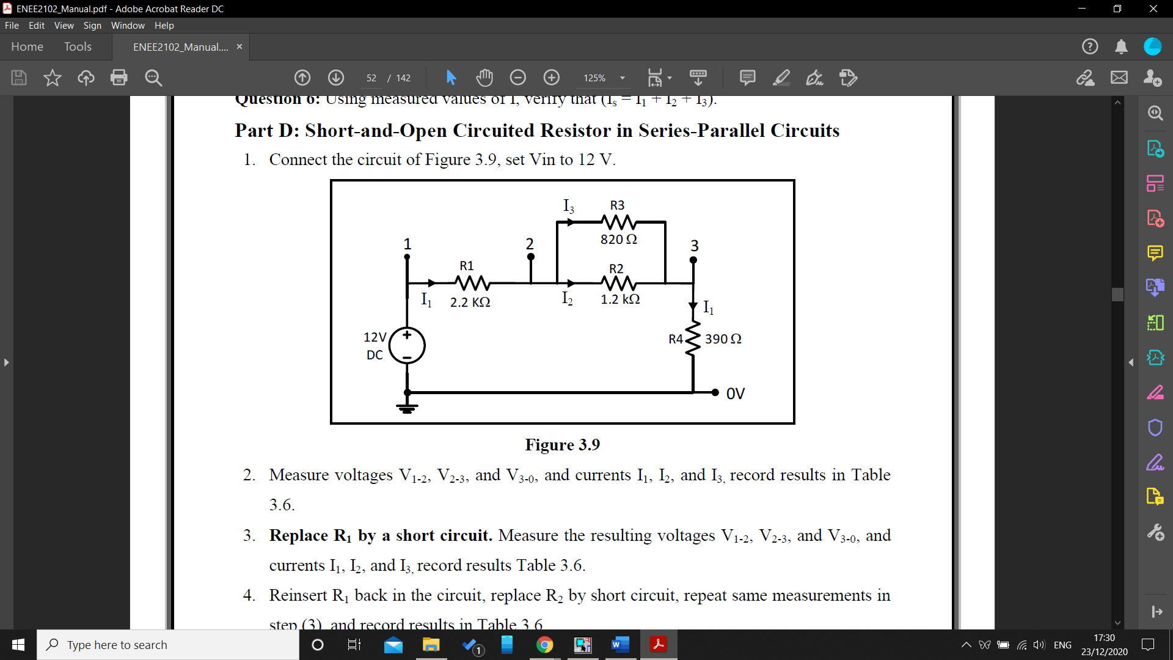

Figure 9: Series-Parallel Circuit

The circuit in figure 9 was connected and the input voltage was set to 12v, the voltage V1-2, V2-3 and V0-3 and currents I1, I2, and I3, the results were recorded in table 6 in the data section.

Then R1 was replaced by a wire in order to make a short circuit, and the voltage V1-2, V2-3 and V0-3 and currents I1, I2, and I3, the results were recorded in table 6 in the data section.

Then, the circuit was returned to its original state and R2 was replaced by a short circuit, and the same measurements in the previous steps were taken again and recorded in table 6.

After putting R2 back to the circuit, R1 was removed and the same measurements were taken and recorded.

Finally, R1 was reinserted in the circuit, and the same measurement were taken and recorded in table 6.

# **Data and analysis of results:**

## Part A: Kirchhoff’s Laws:

|  |  |  |  |  |  |  |
| --- | --- | --- | --- | --- | --- | --- |
|  | **1.2kΩ** | **820Ω** | **2.2kΩ** | **1kΩ** | **680Ω** | **390Ω** |
| **Voltage V** | 3.89 | 2.67 | 3.469 | 1.7 | 1.117 | 0.66 |
| **Current mA** | 3.33 | 3.34 | 1.71 | 1.69 | 1.73 | 1.73 |

Table 1: Voltages and current for circuit in figure 3.4

**Question 1:** Using measured values of I and V, verify KCL on the upper middle node, verify KVL on the left loop.

KCL on the upper middle node:

-3.33 x 10-3+ 1.71 x 10-3 + 1.69 x 10-3 = 0.07 x 10-3 , the error can be neglected.

KVL on the left loop:

10 = 3.89 + 3.469 + 2.6 – 9.959 $≅10$, the error can be neglected.

## Part B: Voltage Divider:

|  |  |  |  |
| --- | --- | --- | --- |
| **Voltage V** | **V1-2** | **V2-3** | **V3-0** |
|  | 7.75 | 2.892 | 1.204 |

Table 2

**Question 2:** From measured values, around which resistor did the largest and smallest voltage drops occurred? Explain why?

The 2.2kΩ is the resistor which has the largest voltage drop, while the 390Ω has the smallest voltage drop, and that makes sense according to ohm’s law.

|  |  |  |
| --- | --- | --- |
|  | R = $\frac{V}{I}$ | (10) |

It can be concluded that the voltage increases proportionally with the increasing resistor.

**Question 3:** Using measured values of V, verify that (V1-2 + V2-3 + V3-0 = 12V).

7.75 + 2.892 + 1.204 = 11.846 $≅$ 12

|  |  |
| --- | --- |
| **RAB [KΩ]** | **RBC[KΩ]** |
| 8.2 | 2.9 |

Table 3: Potentiometer values

|  |  |  |  |  |  |
| --- | --- | --- | --- | --- | --- |
| **RL** | **Open circuit** | **500kΩ** | **100kΩ** | **10kΩ** | **1kΩ** |
| **VO V** | 3.269 | 3.266 | 3.25 | 3.08 | 2.16 |

Table 4: Voltages measurements as the resistance change from 1k to ∞

**Question 4:** Using measured values, plot VO vs. RL. Explain the change in VO as RL is changed.

Figure 10: Voltage vs Resistor

## Part C: Current Divider

|  |  |  |  |  |
| --- | --- | --- | --- | --- |
| **IS [mA]** | **I1 [mA]** | **I2 [mA]** | **I3 [mA]** | **I23 [mA]** |
| **7.325** | 1.99 | 2.315 | 3.466 | 4.618 |

Table 5

**Question 5:** From measured values of I, through which resistor did the largest and smallest currents passed? Explain why?

The largest current passed through 390Ω, while the smallest one passed through 1.2k which can be accepted according to ohm’s law

|  |  |  |
| --- | --- | --- |
|  | R = $\frac{V}{I}$ |  |

The current is to be inverse proportional to the value of the resistor.

**Question 6:** Using measured values of I, verify that (Is = I1 + I2 + I3).

7.325 = 1.99 + 2.3 + 3.4 = 7.771, there is a small error due to some mistakes in the measurements in the laboratory.

## Part D: Short and Open Circuited Resistor in Series-Parallel Circuits:

|  |  |  |  |
| --- | --- | --- | --- |
|  | Normal | R1 S C | R2 S C |
| I1 [mA] | 3.222 | 13.754 | 4.702 |
| I2 [mA] | 1.773 | 5.63 | 4.7 |
| I3 [mA] | 2.35 | 8.172 | 0 |
| V1-2 [V] | 6.968 | 8.172 | 0 |
| V2-3 [V] | 3.78 | 6.627 | 0 |
| V3-0 [V] | 10.744 | 5.359 | 1.810 |

Table 6: Short Circuit with R1, R2 and R3

|  |  |  |
| --- | --- | --- |
|  | R1 O C | R2 O C |
| V1-2 [V] | 11.981 | 7.724 |
| V2-3 [V] | 0 | 2.883 |
| V3-0 [V] | 0 | 1.38 |
| I1 [mA] | 0 | 3.574 |

**Question 7:** What is the value of the short circuit voltage? Is there any current in the circuit when a resistor is open circuit?

It’s clear that the voltage of the short circuit equals zero, while there is no current passes through the open circuit.

# **Conclusion:**

This experiment was very important to examine some basic theories learnt in the network analysis such as Kirchhoff’s laws KCL and KVL, Voltage and current dividers, open and short circuit.

As a result of implementing this experiment, the following points were examined to make sure that the practical implementation of the previous mentioned theories matches the theoretical

1. KVL loop should equal zero.
2. KCL of any node in the circuit should equal zero.
3. The short circuit has a current pass through it, while the voltage across it will be zero
4. The open circuit is the opposite of the short circuit, there is voltage across it while there won’t be any current.

The values of the experiment were accepted and satisfies the theories, the experiment went well without any major complications.

# **References:**

1. Circuits Lab ENEE2102 manual.
2. Electric Circuits tenth edition James W. Nilsson and Susan A. Riedel.

