

Faculty of Engineering and Technology

Electrical and Computer Engineering Department

Circuits LAB (ENEE2102)

Report on Experiment #5

First and Second-Order Circuits

**________________________________________________________**

Prepared by:

Name: Abdallateef Wahdan

Number: 1183005

Partners:

Name: Ameer Butmah

Number: 1180443

Name:Jeries Shehadeh  
Number:1180519

Instructor: Dr. Muhammad Abu-Khaizaran

TA: Mahdi Alsalem

Date:

15/7/2021

Section: 2

Table of Contents

**Abstract:** 2

**Theory:** 2

**Procedure:** 8

Part A: Step response of First-order RC circuit: 8

Part B: Step response of first-order RL circuit: 9

Part C: Step response of second-order Series RLC circuit: 10

Part D: Step response of second-order parallel RLC circuit: 11

**Data, calculations, and analysis of results:** 12

Part A: Step response of First-order RC circuit: 12

Part B: Step response of first-order RL circuit: 13

Part C: Step response of second-order Series RLC circuit: 14

Part D: Step response of the second-order parallel RLC circuit: 16

**Conclusion:** 19

**References:** 19

# **Abstract:**

In this experiment the behavior of the first and second-order circuit was discovered in practical, some equipment was used to implement this experiment, such as;

1. Function Generator.
2. Digital Multimeter.
3. Oscilloscope.
4. Wires, Capacitors, Inductor box, resistance and a board.

# **Theory:**

First-order circuits with DC sources (Step Response):

Unit Step function was defined as:

|  |  |  |
| --- | --- | --- |
| u(t) = | -  + |  |
| u(t-t0) = | | -  + |  |

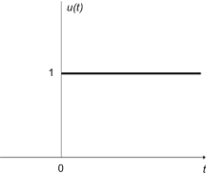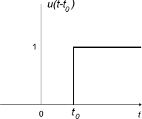

Figure 1: Unit-Step function

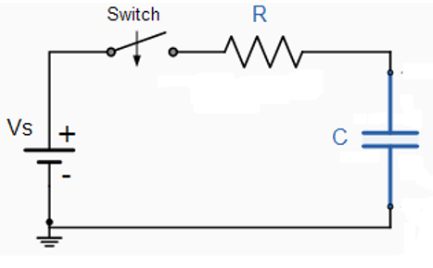

Figure 2: RC circuit

**Step Response of an RC circuit:**

After considering that the switch in the circuit above closed at t = 0, and the capacitor was an initial value of V0, for t>0

|  |  |  |
| --- | --- | --- |
|  |  |  |
|  | R*IC + VC = V | (1) |
| Knowing that | IC = C $\frac{dvc}{dt}$* | (2) |
|  | VC(0+) = VC(0-) = V0 | (3) |

The natural solution to RC circuit is:

|  |  |  |
| --- | --- | --- |
|  | VC,n = K $e^{-\frac{t}{τ}}$* | (4) |

To find the forced response, VC, F=Ashould had found by the differential equation

|  |  |  |
| --- | --- | --- |
|  | RC $\frac{dA}{dt}+A=V$ | (5) |
|  | VC = VC,n + VC,f  = K $e^{-\frac{t}{τ}}$* + V | (6) |

Constant K has found using the initial value of the capacitor voltage

|  |  |  |
| --- | --- | --- |
|  | VC (t) = K $e^{-\frac{t}{τ}}$* + V for t>=0 | (7) |
|  | VC(0+) = K + V  K = VC(0+) - V | (8) |
|  | VC(t) = VC(∞) + [VC(0+) - VC(∞)] | (9) |
| Where, | VC(∞) = Final voltage  VC(0+) = Initial voltage | (10) |

After enough time , theoretically t **>** ∞, the circuit reaches a constant -state condition, which means that the capacitor becomes zero and its voltage equal V



Figure 3: Step Response of an RC circuit

Assumption that the switch closes at t0 instead of 0,

|  |  |  |
| --- | --- | --- |
|  | VC(t) = VC(∞) + [VC(0+) - VC(∞)] | (11) |

To get the response of the voltage or current at any time:

|  |  |
| --- | --- |
| VC at time t = [Initial value of VC - Final value of VC] * + Final Value of VC | (12) |

**Step Response of an RL circuit:**

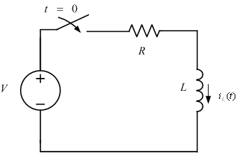

Figure 4: RL circuit

Assuming that the switch closes at t = t0; and there is an initial value of the current in the inductor IL (0+),

|  |  |  |  |  |
| --- | --- | --- | --- | --- |
|  |  | | |  |
|  | IL(t) = IL (∞) + [IL (0+) - IL (∞)] | | | (13) |
| The voltage drop across the inductor = | | $$L\frac{di}{dt}$$ | | (14) |
| The voltage drop across the resistor = | | | I*R | (15) |

After enough time passed (theoretically t -> ∞) the steady-state area, the current reaches to maximum steady-state value, and inductor starts working such a short circuit, as shown in the figure below.

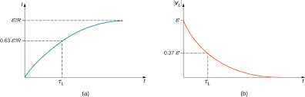

Figure 5: Step Response of an RL circuit

***The Natural and Step Response of an RLC Circuit:***

There are two kinds of the RLC circuit, series and parallel RLC circuit, and there are a small difference between both of them.

**Series RLC circuit:**

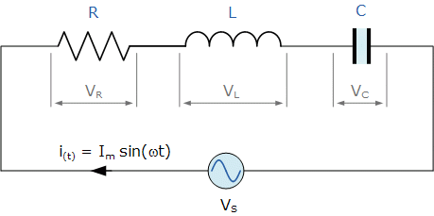

Figure 6: Series RLC circuit

**The Natural response of the series RLC circuit:**

|  |  |  |  |  |
| --- | --- | --- | --- | --- |
| KVL: | | Ri + L $\frac{di}{dt}+ \frac{1}{C} \int_{0}^{t}{id}τ+Vin=0$ | | (16) |
|  | | $$\frac{d^{2}i}{{dt}^{2}}+ \frac{R}{L}\frac{di}{dt}+\frac{i}{CL}=0$$ | | (17) |
| Let s = $\frac{di}{dt}$ | | $$s^{2}+ \frac{R}{L}s+ \frac{1}{LC}=0$$ | | (18) |
| Finding s, | | S1,2 = | | (19) |
| The neper frequency(Series circuit)=  The resonant radian frequency = | | | α= rad/s  ω0 = rad/s | (20)  (21) |
|  | S1,2 = - α $±\sqrt{α^{2}- {ω0}^{2}}$ | | | (22) |

There are three cases of the current response them count on the value of the neper and the resonant frequencies for both parallel and series circuit

|  |  |  |
| --- | --- | --- |
| Over damped () | I (t) = A1eS1t + A2eS2t | (23) |
| Critically damped ( | I(t) = D1te-αt + D2e-αt | (24) |
| Under damped | I(t) = B1e-αt cos(ωdt) + B2e-αt sin(ωdt) | (25) |

**The step response of the series RLC circuit:**

|  |  |  |
| --- | --- | --- |
| From equation 13  where | Vin = Ri + L $\frac{di}{dt}+Vc$ VC = | (26)  (27)  (28) |
|  | $$\frac{d^{2}Vc}{{dt}^{2}} + \frac{R}{L}\frac{dVc}{dt}+\frac{Vc}{LC}=\frac{V}{LC}$$ | (29) |
| Over damped ($α^{2}>{ω0}^{2}$) | VC(t) = VF + A1eS1t + A2eS2t | (30) |
| Critically damped ( $α^{2}={ω0}^{2})$ | VC(t) =VF + D1te-αt + D2e-αt | (31) |
| Under damped | VC(t) = VF + B1e-αt cos(ωdt) + B2e-αt sin(ωdt) | (32) |

**Parallel RLC circuit:**

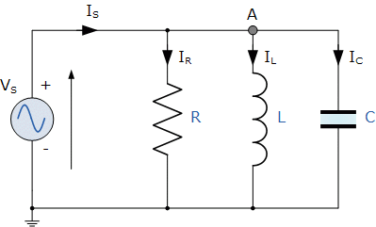;

Figure 7: Parallel RLC circuit

**The Natural response of the parallel RLC circuit:**

|  |  |  |
| --- | --- | --- |
| Using KCL | $\frac{V(t)}{R}$ $+ \frac{1}{L} \int_{0}^{t}{V(τ)d}τ+C\frac{dv(t)}{dt}=0$ | (33) |
|  | $$\frac{d^{2}v(t)}{{dt}^{2}}+\frac{1}{RC}\frac{dv(t)}{dt}+ \frac{1}{LC}v\left(t\right) =0$$ | (34) |
| Let s = $\frac{dv(t)}{dt}$ | $$s^{2}+ \frac{1}{RC}s+ \frac{1}{LC}=0$$ | (35) |
| Finding s, | S1,2 = | (36) |
| The neper frequency (Parallel circuit) =  The resonant radian frequency = | α= rad/s  ω0 = rad/s | (37)  (38) |
| Over damped () | V(t) = A1eS1t + A2eS2t | (39) |
| Critically damped ( | V(t) = D1te-αt + D2e-αt | (40) |
| Under damped | V(t) = B1e-αt cos(ωdt) + B2e-αt sin(ωdt) | (41) |

**The step response of the parallel RLC circuit:**

|  |  |  |
| --- | --- | --- |
|  | IL(t) = I∞ + Natural Response |  |
| Over damped ($α^{2}>{ω0}^{2}$) | IL(t) = IL(∞) + A1eS1t + A2eS2t | (42) |
| Critically damped ( $α^{2}={ω0}^{2})$ | IL(t) = IL(∞) + D1te-αt + D2e-αt | (43) |
| Under damped( | IL(t) = IL(∞) + B1e-αt cos(ωdt) + B2e-αt sin(ωdt) | (44) |

# **Procedure:**

## Part A: Step response of First-order RC circuit:

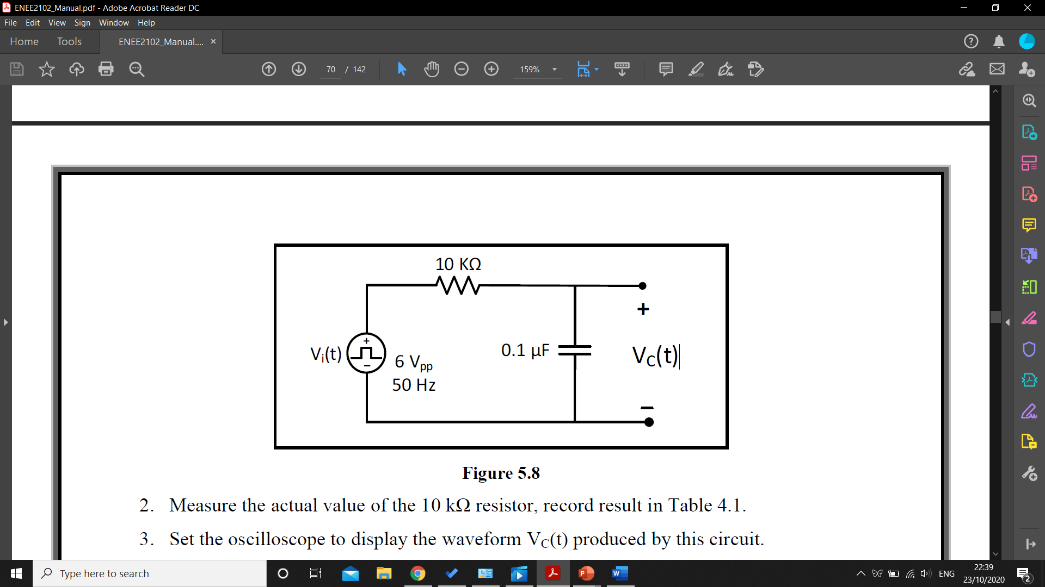

Figure 8

After connecting the circuit in figure 8, and measure the value of the resistor by DMM, and the oscilloscope was used to view VC(t) waveform, and using the cursors in the oscilloscope were used to valuation the value of c and a picture of the waveform was taken and will be attached down bellow in the data section.

I Repeated the previous steps after switching the resistor and the capacitor places, such in figure 9

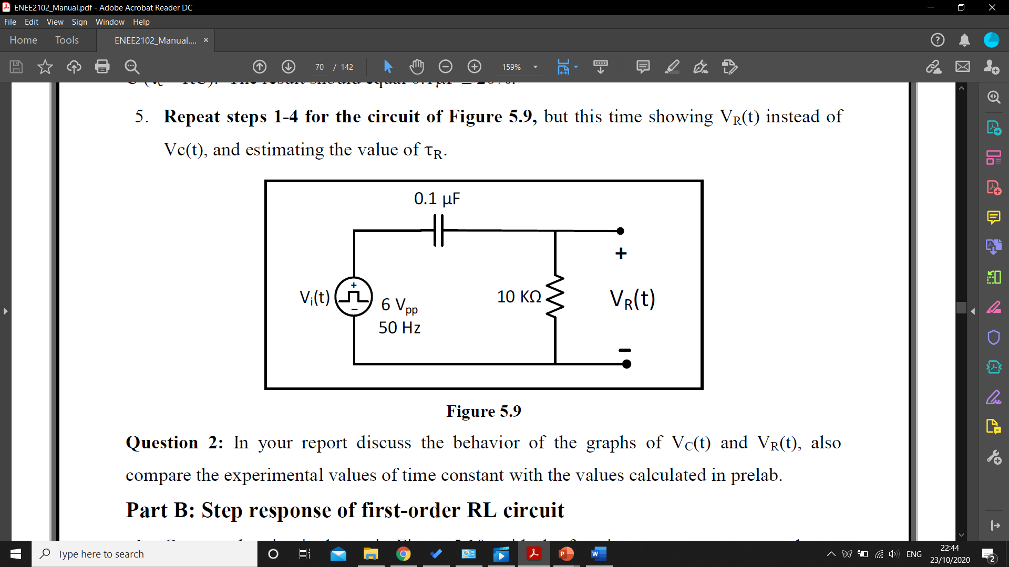

Figure 9

## Part B: Step response of first-order RL circuit:

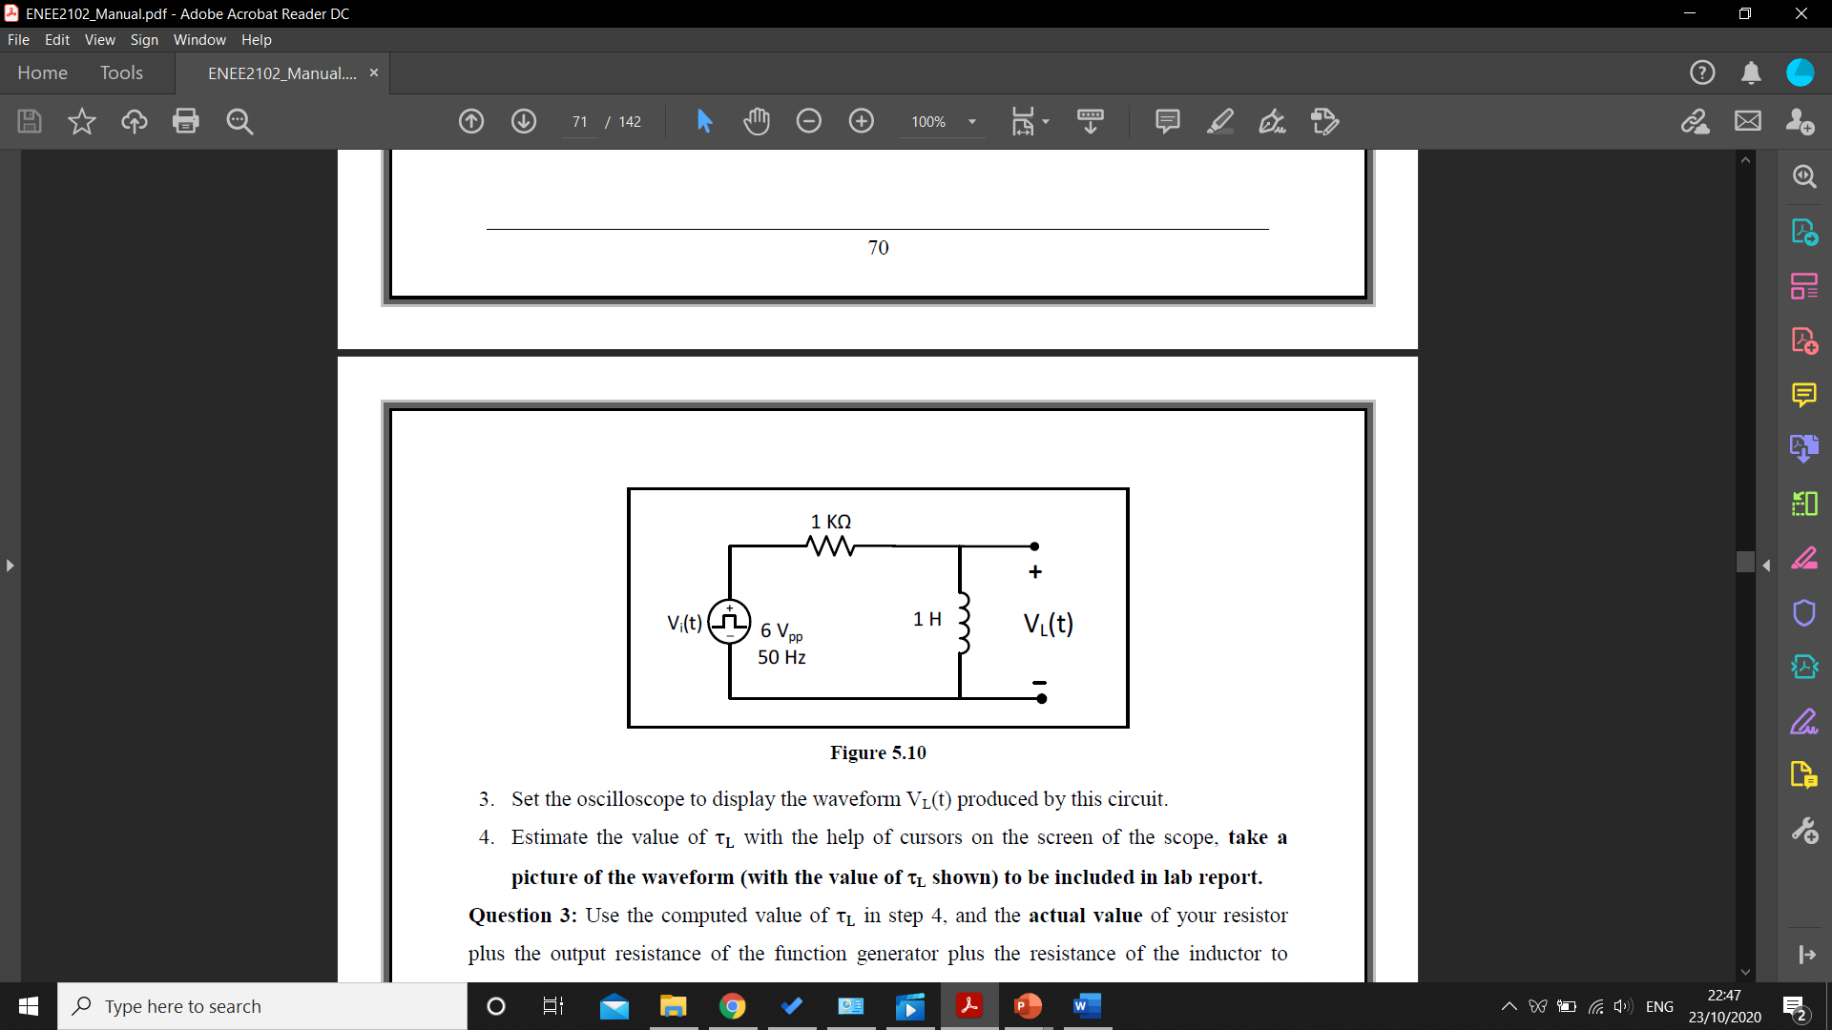

Figure 10

After connecting the circuit in figure 10 the DC resistance of the inductor, and measure the value of the resistor using the DMM, then the oscilloscope was used to view VL(t) waveform and to valuation the value of L and all the results were recorded in the data section.

All the previous steps were repeated at the circuit in figure 11.

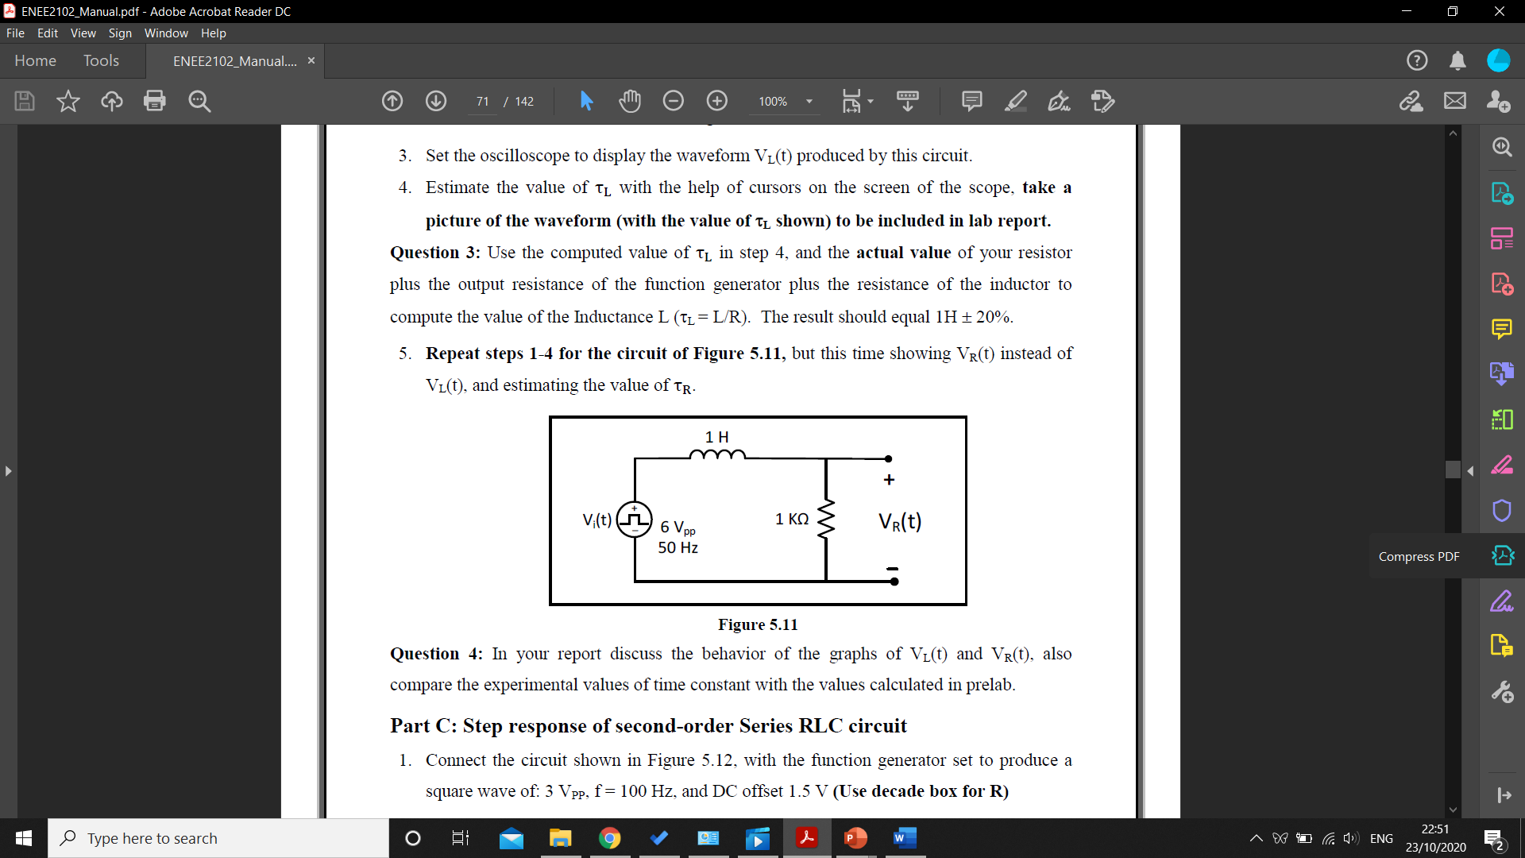

Figure 11

## Part C: Step response of the second-order Series RLC circuit:

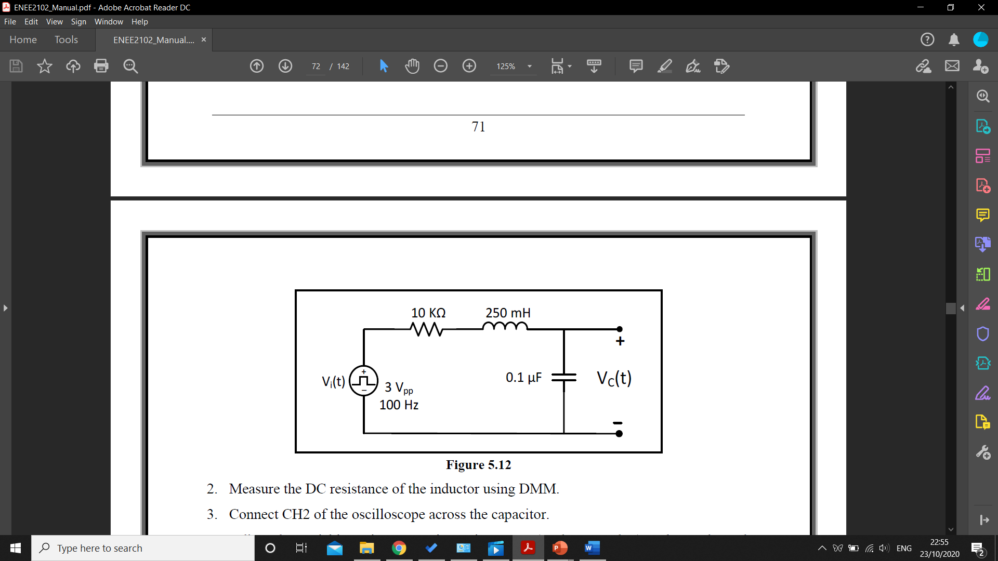

Figure 12

The DC resistance of the inductor in the circuit in figure 12 was measured using DMM, the variable resistor was adjusted in a range of (1kΩ - 10 kΩ) to view the varying of the VC(t) using the oscilloscope

Then to study the response cases, over-damped response, critically damped response and under damped response:

**Case A: Over damped response:**

The variable resistor was set to 10 kΩ, and a picture of the VC(t) waveform show on the oscilloscope was taken and attached to the data section.

**Case B: Critically damped response:**

The variable resistor was set to RCritical found before, and a picture of the VC(t) waveform show on the oscilloscope was taken and attached to the data section.

**Case C: Under damped response:**

The variable resistor was set to 500 Ω, and the cursors were used to find values of Va, ta, Vb, tb and V (∞) and a picture of the VC(t) waveform show on the oscilloscope was taken and attached to the data section.

## Part D: Step response of the second-order parallel RLC circuit:

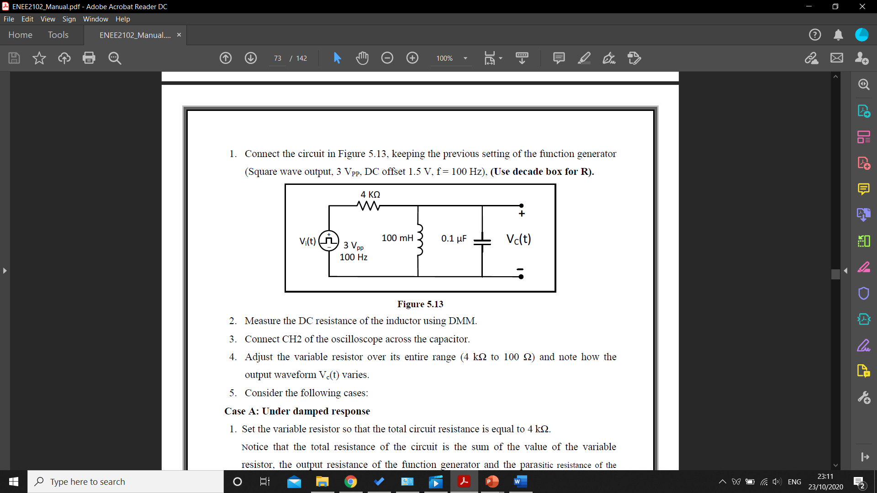

Figure 13

The DC resistance of the inductor was measured using the DMM and the value was recorded, then the variable resistor was changed in the range of (4kΩ - 100Ω), to notice how VC(t) varies.

**Case A: Under damped response:**

The variable resistor was set to 4 kΩ, and the cursors were used to find values of Va, ta, Vb, tb and V (∞) and a picture of the VC(t) waveform show on the oscilloscope was taken and attached to the data section.

**Case B: Critically damped response:**

The variable resistor was set to RCritical found before, and a picture of the VC(t) waveform show on the oscilloscope was taken and attached to the data section.

**Case C: Over damped response:**

The variable resistor was set to 150Ω, and a picture of the VC(t) waveform show on the oscilloscope was taken and attached to the data section.

# **Data, calculations, and analysis of results:**

## Part A: Step response of First-order RC circuit:

Table 1: Resistor value

|  |  |
| --- | --- |
| RActual | 9.8kΩ |

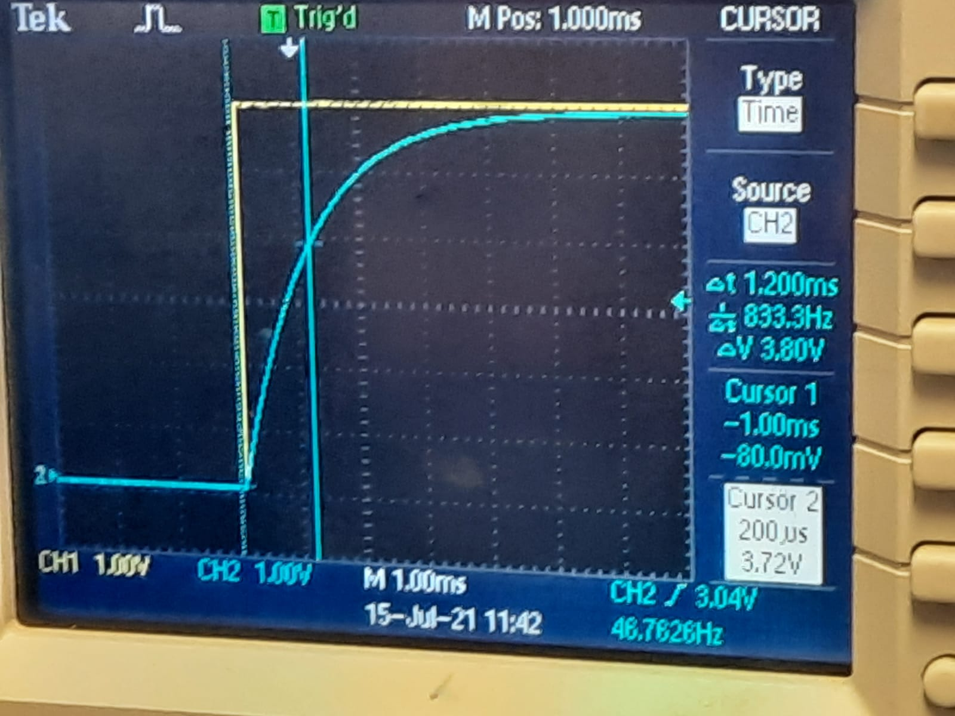Figure 14: Vin vs Vc(t)

|  |  |  |
| --- | --- | --- |
|  | $$τc=1.2ms$$ RFunction Generator = 50Ω |  |
| Actual value of the resistor = | RActual + RFunction Generator  = 9.87k + 50 = 9920Ω | (46) |
| Capacity value = | $$τc=RC$$ C = $\frac{τc}{R}=0.121µF$ | (47) |

The value of the capacitor value is acceptable, it is expected the capacitor will equal 0.1 $µF ±20\%$

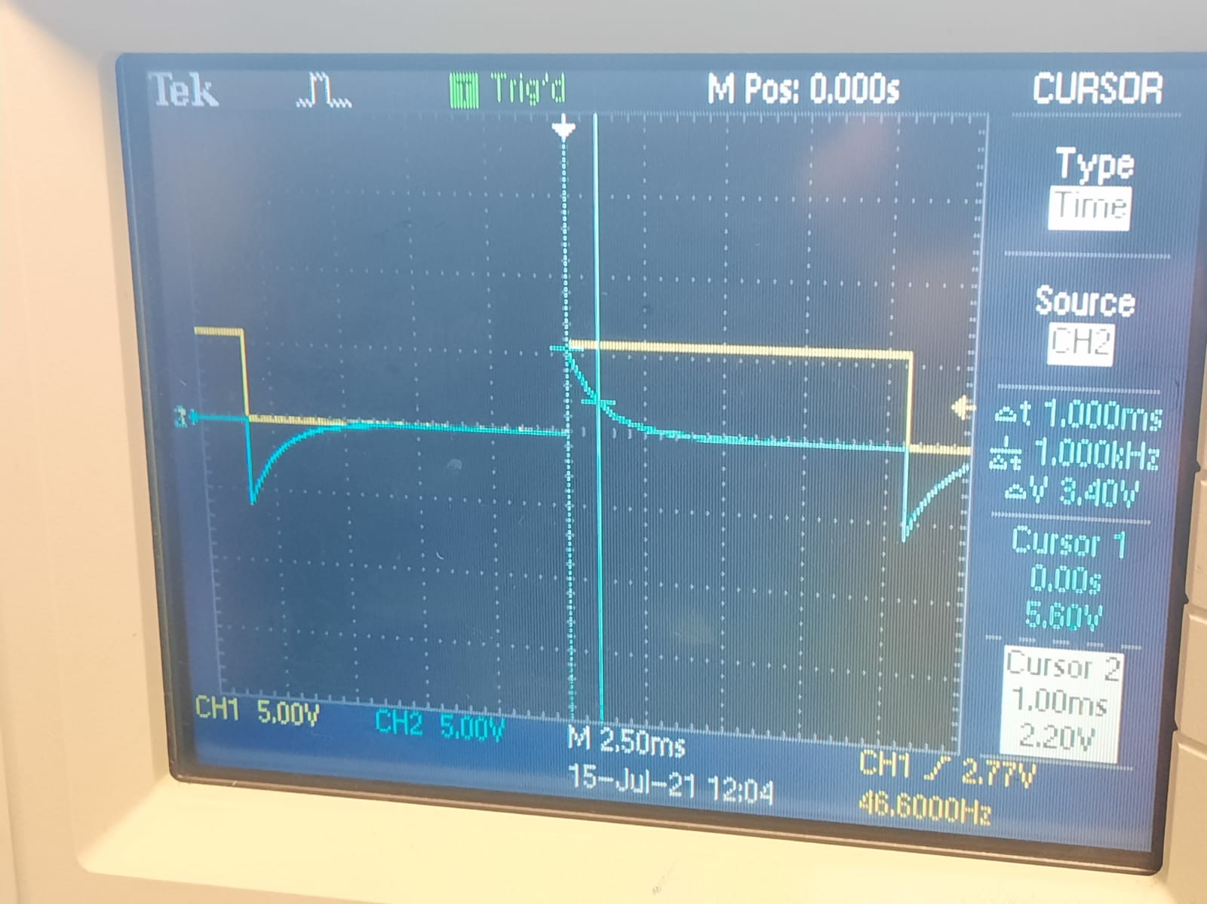

Figure 15: Vin vs VR

|  |  |  |
| --- | --- | --- |
|  | R = 1ms |  |

The capacitor charges up at a charging rate, and it’s faster the beginning of changing and the capacitor remains charging up until it is full then changes to open circuit and begins to dischange the capacitor , and as seen in the lab.

When the capacitor charges the difference between the input voltage and the capacitor voltage decreases, which makes the current decrease too, according to the ohm’s law the voltage on the resistance will decrease too, in figure 15.

## Part B: Step response of first-order RL circuit:

Table 2: Resistors values

|  |  |
| --- | --- |
| RActual | RInductor |
| 0.98kΩ | 1.43Ω |

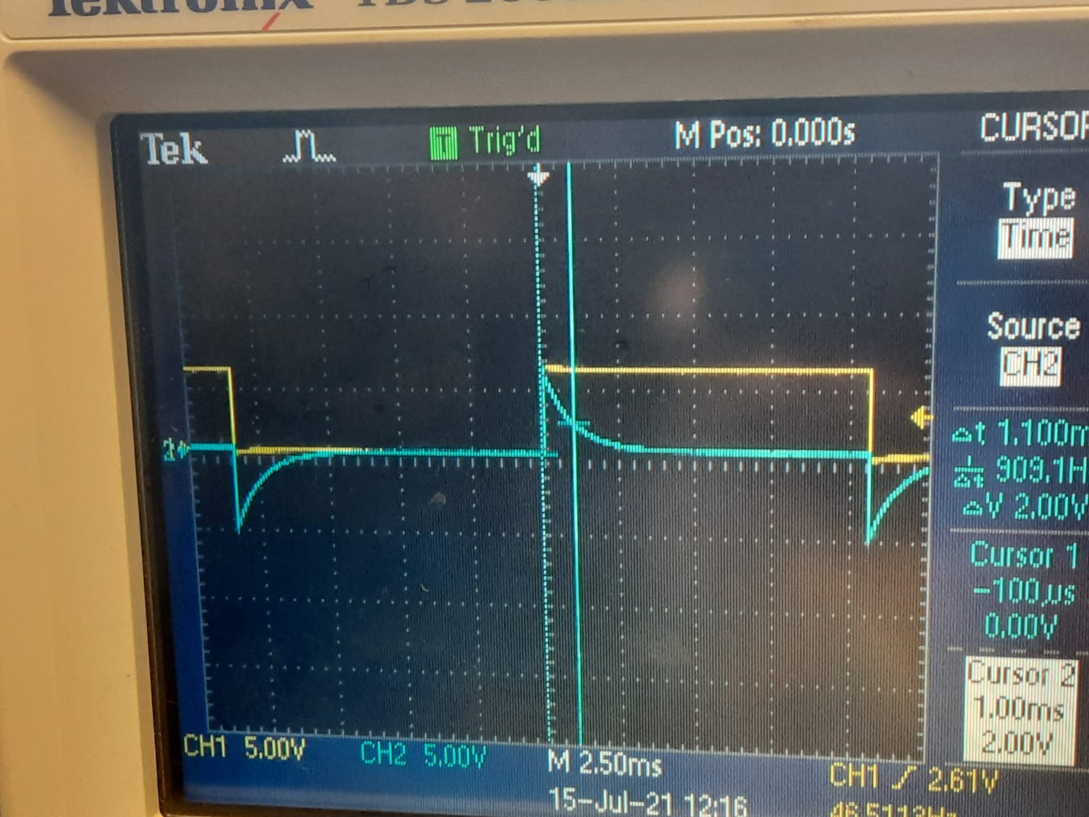

Figure 16: Vin vs VL

|  |  |  |  |
| --- | --- | --- | --- |
|  | RFunction Generator = 50Ω |  | |
| Actual value of the resistor = | RActual + RFunction Generator + Rinductor  = 0.987k + 50 + 1.43 = 1038.43 Ω | | (48) |
| Capacity value = | $$τL=\frac{L}{R}$$ L = $τL*R=1.14H$ | (49) | |

The value of the Inductor is acceptable, it was expected to equal 1H $± 20\%$.

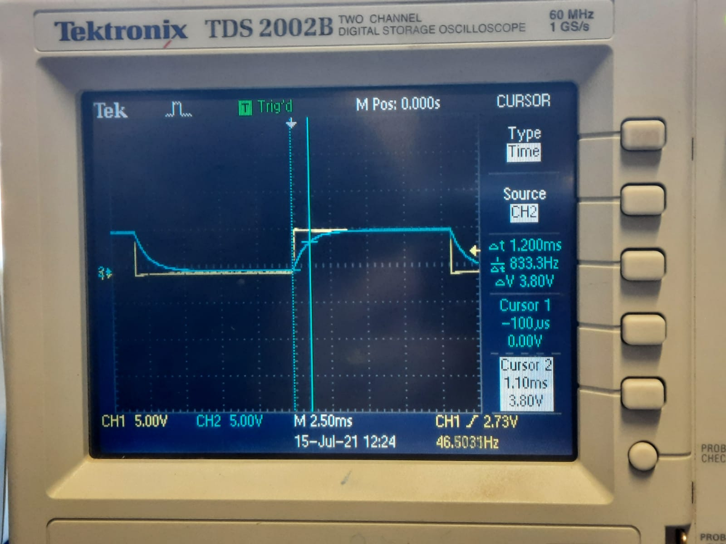

Figure 17: Vin vs VR

|  |  |  |
| --- | --- | --- |
|  | = 1.20ms |  |

The values of both $τL and τR$ were acceptable and were similar to the values calculated in the prelab before, according to the ohm’s law, while the voltage across the inductor depend on the rate of change of the current , so when the current reaches it’s maximum (steady-state) value, the voltage on the resistor will reach the maximum, while the change estimate of the current decreased to almost zero, so the voltage across the inductor will equal almost zero (short circuit), in figure 17.

## Part C: Step response of the second-order Series RLC circuit:

Case A: Over damped response:

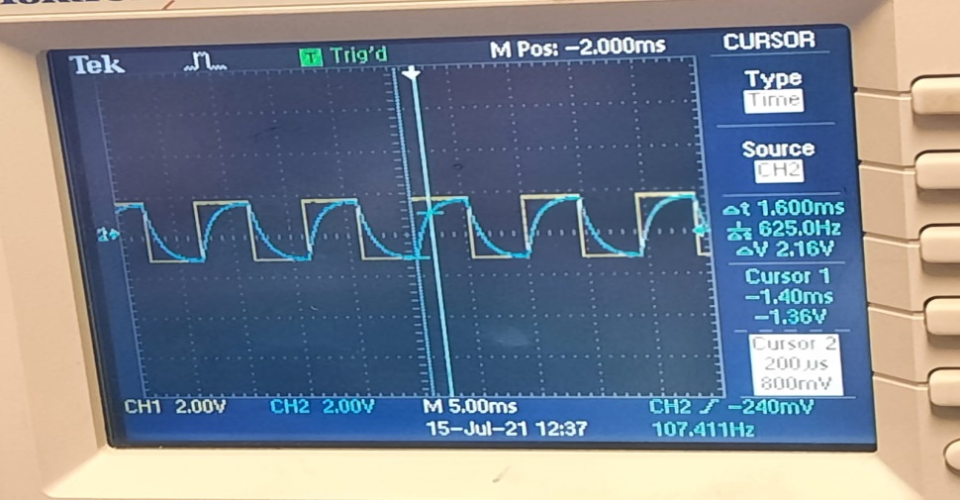

Figure 18: Over damped response

Case B: Critically damped response:

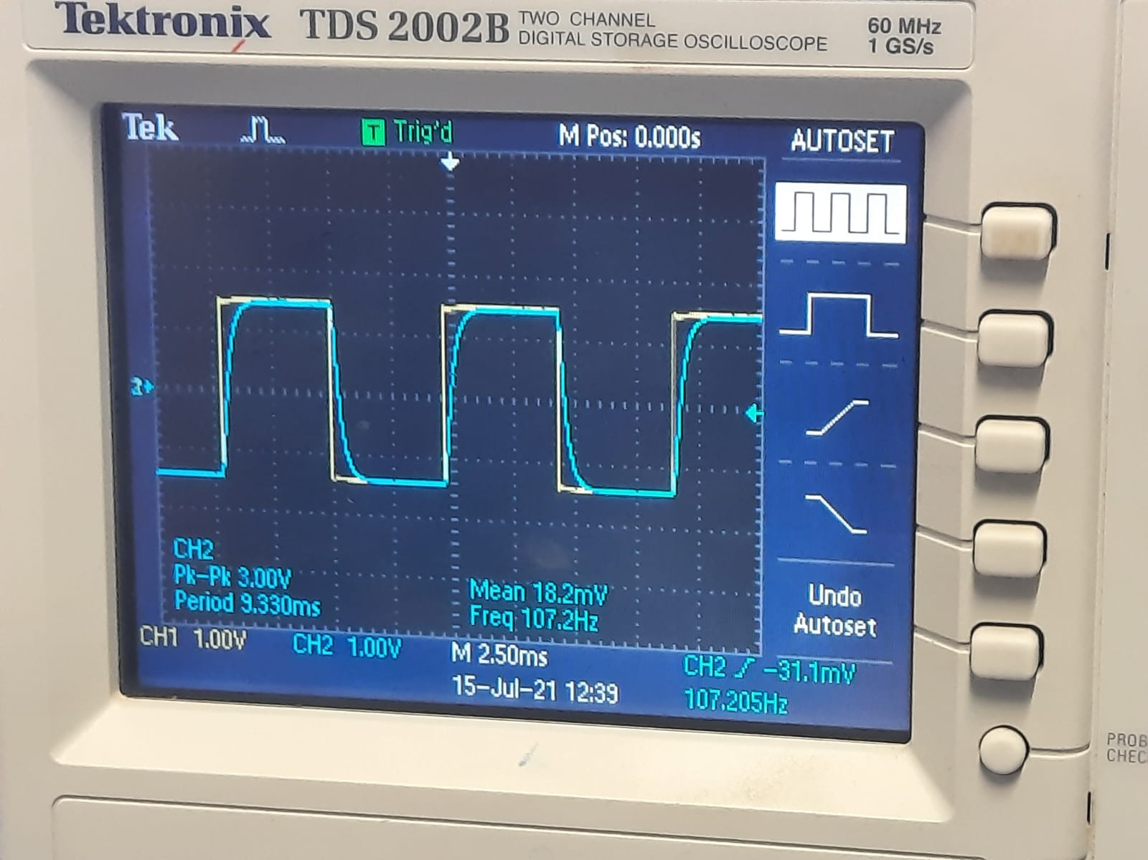

Figure 19: Critically damped response:

Rcritical = 3.162kΩ

The figures 18,19 over damped response are slower than the critically damped response, while in the over damped the circuit system moves slowly across the Required equilibrium while the critical damping the system returns to equilibrium as fast as possible, so the system is being made the critical damping is often desired.

Case C: Under damped response:

Table 3: Measured values

|  |  |  |  |  |
| --- | --- | --- | --- | --- |
| Va | ta | Vb | tb | V(∞) |
| 4.48V | 480µs | 3.36V | 1.52ms | 1.44 |

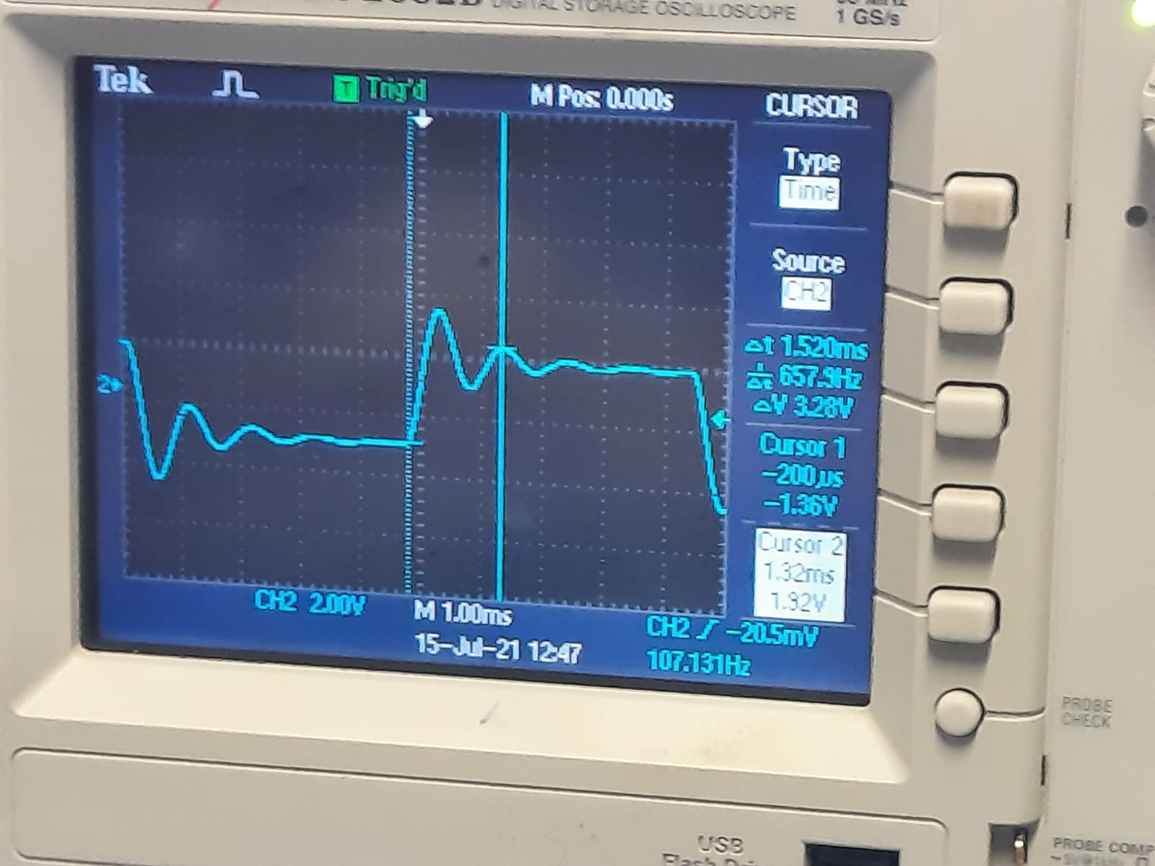

Figure 20: Under damped response

|  |  |  |
| --- | --- | --- |
| Decay-envelope time = | $τ= \frac{tb-ta}{ln⁡(\frac{Va-V\left(∞\right)}{Vb-V\left(∞\right)})}$ = 2.263ms | (50) |
| The damping coefficient = | α = $\frac{1}{τ}$ = 0.4418kΩ | (51) |
| The damped frequency = | ωd = = 6038.46 | (52) |

The values calculated before in the prelab, which were:

Table 4: Measured values in the prelab

|  |  |  |  |  |
| --- | --- | --- | --- | --- |
| Va | ta | Vb | tb | V(∞) |
| 4.727V | 0.5ms | 3.52V | 1.5ms | 3 |

## 

|  |  |  |
| --- | --- | --- |
| Decay-envelope time = | $τ$ = 0.81ms | (53) |
| The damping coefficient = | α = $\frac{1}{τ}$ = 1.0kΩ | (54) |
| The damped frequency = | ωd = = 6324.55 | (55) |

## Part D: Step response of the second-order parallel RLC circuit:

Case A: Underdamped response:

Table 5: Measured values

|  |  |  |  |  |
| --- | --- | --- | --- | --- |
| Va | ta | Vb | tb | V(∞) |
| 1.28V | 900ms | 0.98V | 1.9µs | 860mV |

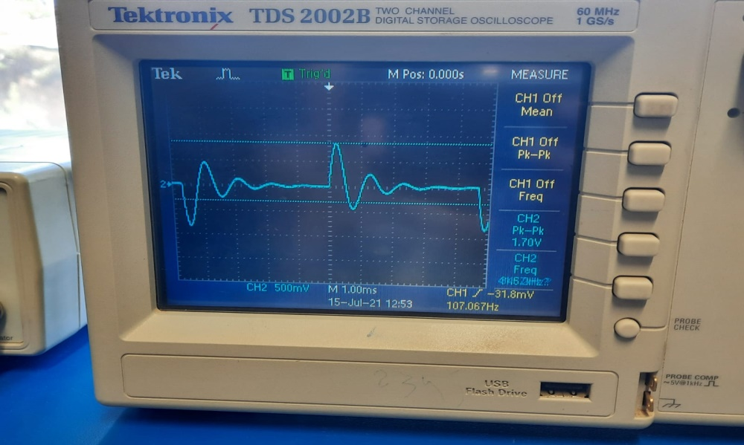

Figure 21: Under damped response

|  |  |  |
| --- | --- | --- |
| Decay-envelope time = | $τ= \frac{tb-ta}{ln⁡(\frac{Va-V\left(∞\right)}{Vb-V\left(∞\right)})}$ = 0.87ms | (56) |
| The damping coefficient = | α = $\frac{1}{τ}$ = 1.137kΩ | (57) |
| The damped frequency = | ωd = = 9817.47 | (58) |

The values calculated before in the prelab, which were:

Table 4: Measured values in the prelab

|  |  |  |  |  |
| --- | --- | --- | --- | --- |
| Va | ta | Vb | tb | V(∞) |
| 617.45m | 0.137ms | 300.35mV | 0.871 ms | 0 |

|  |  |  |
| --- | --- | --- |
| Decay-envelope time = | $τ$ = 1017.605 us | (59) |
| The damping coefficient = | α = $\frac{1}{τ}$ = 982.69Ω | (60) |
| The damped frequency = | ωd = = 8570.19 | (61) |

Case B: Critically damped response:



Figure 22: Critically damped response

RCritical = 500Ω

Case C: Over damped response:



Figure 23: Over damped response

The figures 22,23 over damped response are slower than the critically damped response, while in the over damped the circuit system, moves slowly across the Required equilibrium while in the critical damping the system returns to equilibrium as fast as possible, so the system is being made the critical damping is often desired.

# **Conclusion:**

In conclusion, there are small differences in the values due to the oscillation in the circuit and behaviour of first and second-order was tested, the ran experiment smoothly with sensible and logical results.

# **References:**

1. Circuits Lab ENEE2102 Manual
2. <https://www.electronics-tutorials.ws/inductor/lr-circuits.html>
3. <https://www.electronics-tutorials.ws/accircuits/series-circuit.html>
4. <https://www.electronics-tutorials.ws/accircuits/parallel-circuit.html>

