

**Birzeit University**

**Faculty of Engineering & Techonology**

**Department of Electrical & Computer Engineering**

**ENEE211**

**“Exp#6 Report”**

**Student : Mohamad Bornat #1130842**

**Instructor:Dr.Jasser Sa’ed**

**Date: 20\7\2016**

|  |  |  |
| --- | --- | --- |
|  |  |  |
| **Abstract** |  |  |

After studying the response for constant voltage source, this experiment was done to examine the behavior of the impedances and sinusoidal steady state of circuits as the input voltages were sinusoidal functions (varying with time at specific frequency). It was verified experimentally that resistors are independent of frequency, and there is no phase shift between the voltage across and the current through them. However, Inductors and capacitors were found to be frequency dependent components. For inductor, current lags voltage by 90 degree. For capacitor, current leads voltage by 90 degree. Since there is no phase shift between the current and voltage through a resistor, its voltage is used to represent the current in the circuit because the oscilloscope doesn’t support measuring currents. The sinusoidal steady state was found for RL and RC circuits by measuring the rms value of the voltage and /or current and the phase shift between input signal and output signal. And finally, the self inductance and the capacitance were calculated using experimental measurements in some cases.

|  |  |  |
| --- | --- | --- |
|  |  |  |
| **Theory** |  |  |

Any sinusoidal source has a general equation that can be represented by sine and cosine function and these equations are:

$V=V_{m}\cos\left(ωt+φ\right)(Voltage source)$**…….(1)**

$I=I_{m}\cos\left(ωt+φ\right)(Current source)$**……(2)**

Where we notice that Vm and Im are the maximum amplitudes , w is the frequency, and Phi is the phase shift angle.

(w) which is the angular frequency is the same for the sinusoidal response as for the sinusoidal input source. However, the amplitude and the phase angle is different from the source, usually.

Now, to make the analysis of the steady-state voltages and currents in a sinusoidal driven circuit easier, we use the frequency domain. This can be done by transforming it from the time domain to the frequency domain using Phasors, which are the mathematical tools for this transform.

The Phasor transform (time-frequency):

Using the properties of complex numbers, a sinusoidal equation resembles a vector in the real and imaginary plane, thus it can be written in the following format:

$V=V_{m}e^{jφ}=P\{V_{m}\cos\left(ωt+φ\right)\}$…… **(3)**

The inverse phasor transform (from the frequency domain to the time domain):

$P^{-1}\left\{V_{m}e^{jφ}\right\}=R\left\{V_{m}e^{jφ}e^{jωt}\right\}$**……(4)**

**The V-I Relationship for a Resistor:**

From Ohm’s Law, and as we know that current varies with time, so the voltage on the terminals of the resistor as in figure 8.1 will be:

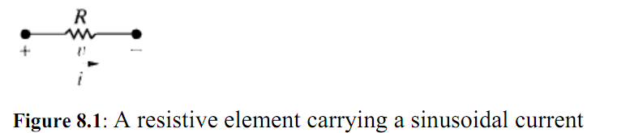

$V=R[V_{m}\cos\left(ωt+θ_{i}\right)]$….. **(5)**

$V=R[V_{m}\cos\left(cot+θ_{i}\right)]$**….(6)**

Where Im is the maximum amplitude in amperes, and $θ_{i}$ is the phase angle of the current. And thus the phasor transform of this voltage will be :

$V={RI}_{m}e^{jθ_{i}}={RI}_{m}∠θ_{i}$**…..(7)**

Anyhow, the part $I_{m}∠θ_{i}$ represents the phasor of the current, and therefore we can write the Voltage as $V=RI$. Which says that the phasor voltage at the terminals, is the result of the multiplication of the resistance with the current phasor.No phase shift takes place between the voltage and current , this can be seen in the figure 8.2. Both signals are on 60o phase angle, however they are in phase as they reach corresponding values at the same time, nonetheless, notice the drop in amplitude of the current due to power dissipation.

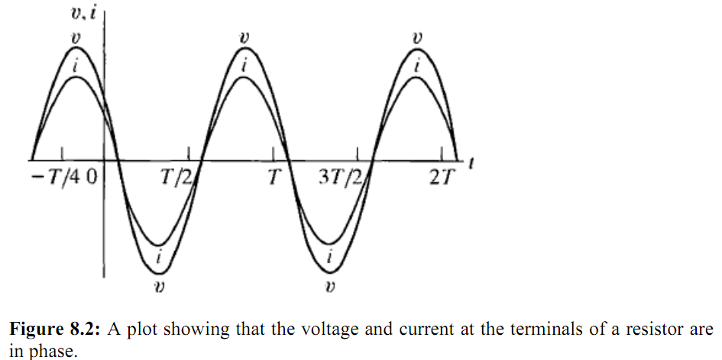

**The V-I Relationship for an inductor:**

To derive the relationship between both phasor current and voltage for an inductor we can assume a sinusoidal current and then as we know, V= Ldi/dt to get the voltage. And so , as I= $I_{m}\cos\left(ωt+θ_{i}\right)]$, the voltage will be $V=\frac{Ldi}{dt}=-ωLI_{m}\sin\left(ωt+θ_{i}\right)$, we can notice that the phasor representation of the voltage is V=jwLI, this means that the voltage around the inductor equals Jwl multiplied by the phasor current. We can see the frequency domain equivalent circuit in figure 8.3.

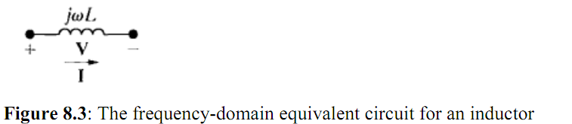

$V=\left(ωL∠90\right)I_{m}∠θ_{i}$**….(8)**

$V=\left(ωL\right)I_{m}∠(90+θ_{i})$**…..(9)**

Which shows that the voltage and the current are out of phase by 90 degrees. Where the voltage leads the current, or we can say that the current lags. We can also see this in figure 8.4

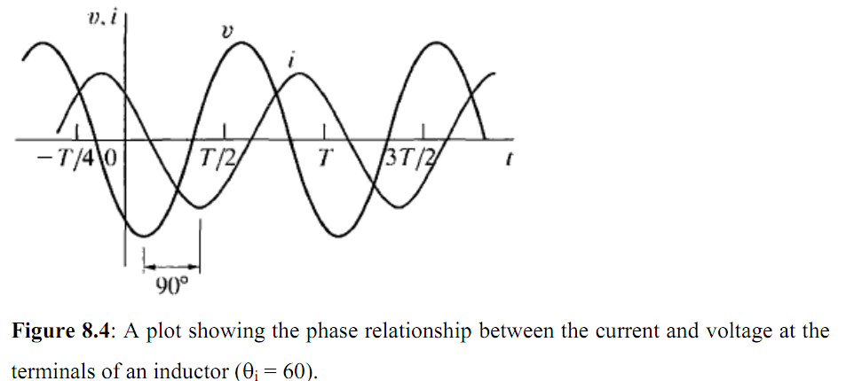

**The V-I Relationship for a capacitor:-**

The voltage and the current on the capacitor are related by the formula Ic=CdVc/dt, now if we assume to have a voltage of the value $V=V_{m}\cos\left(ωt+θ_{V}\right)]$ then we will get I=jwCv. Where the voltage is a function of the current, V=1/jwcI. The equivalent circuit in the phasor domain can be shown in figure 8.5.

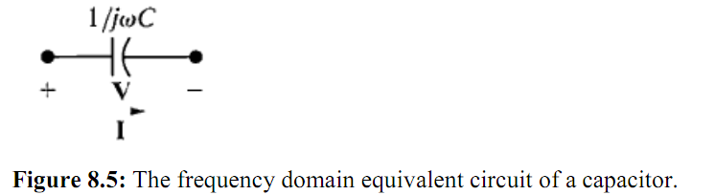

The voltage on the capacitor lags the current by 90 degrees.

$V=\left(\frac{1}{ωC}∠-90\right)I_{m}∠θ_{i}$…. (**10)**

$V=\left(1/ωC\right)I_{m}∠(-90+θ_{i})$…… **(11)**

The current leads the voltage by 90 degrees. This phase relationship can be seen in figure 8.6.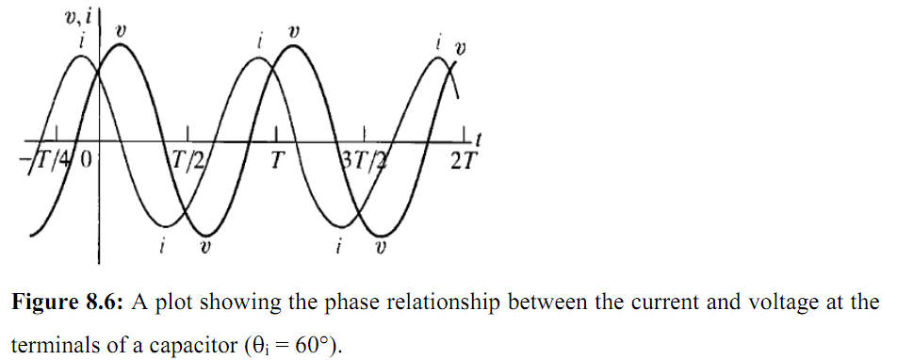

**Impedance and Reactance:**

Impedance is the ratio of the voltage phasor over the current phasor. And so the impedance of the resistor is R, the impedance of an inductor is jwl, the impedance of a mutual inductance is jwM and finally the impedance of the capacitor is 1/wC. Overall, impedance is measured in Ohms.However even if it can be a complex number, yet it is not a phasor. Phasor are complex numbers which show the exponential part , and so, all phasors are complex numbers, but not all complex numbers are phasors. The imaginary part of the impedance is called the reactance, values of impedances and reactance is summarized in table 8.1. Finally, if the reference direction of the current is in the direction of the voltage rise across the element, a minus sign should be inserted in the equation that relates voltage to current.



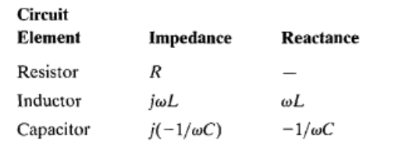

|  |  |  |
| --- | --- | --- |
|  |  |  |
| **Procedure & Data** |  |  |

1. Circuit in figure 1 was connectedwith Vp-p=5V.

The rms voltages were measured for the following frequencies:-

|  |  |  |  |  |  |
| --- | --- | --- | --- | --- | --- |
| F(Hz) | 200 | 400 | 800 | 1600 | 3200 |
| |V|(V)rms | 1.16 | 1.16 | 1.16 | 1.16 | 1.17 |
| |i|(mA) | 11.5 | 11.5 | 11.5 | 11.5 | 11.7 |



**Figure (1): Resistive Load with sinusoidal input**

**Above results agree with simulation, take one example, f=200Hz, Zr=VM(x,0)/IM=100ohm**

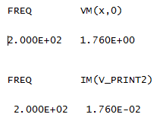

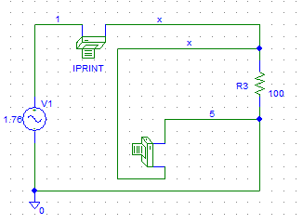

**2.** Resistor was replaced with 2uF capacitor.

The rms voltages were measured for different frequencies :-

Zc= j(-1/(w*C)) ,w=2*pi*f

|  |  |  |  |  |  |
| --- | --- | --- | --- | --- | --- |
| F(Hz) | 200 | 400 | 800 | 1600 | 3200 |
| |V|(V) | 1.72 | 1.69 | 1.56 | 1.26 | 0.798 |
| |Zc|(ohm) | 398 | 199 | 99.5 | 49.7 | 24.8 |
| |i|(mA) | 4.3 | 8.5 | 15.6 | 25.3 | 32 |



**Figure (2): Capacitive Load with sinusoidal input**

Above results agree with simulation, take one example, f=200Hz, |Zc|=VM/IM=1.76/4.423m=398hm

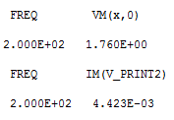

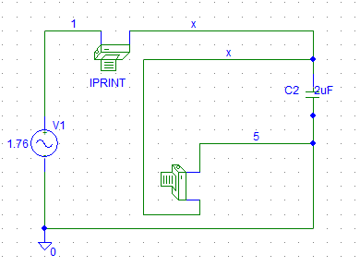

3. The capacitor was replaced with 100mH inductor as appearing in figure (3).



**Figure (3): Inductive Load with sinusoidal input**

**Using ZL=jwl**

|  |  |  |  |  |  |
| --- | --- | --- | --- | --- | --- |
| F(Hz) | 200 | 400 | 800 | 1600 | 3200 |
| |V|(V) | 1.59 | 1.70 | 1.72 | 1.73 | 1.74 |
| |ZL|(ohm) | 125.6 | 246.2 | **502.4** | 1004.8 | 2001 |
| |i|(mA) | 12.6 | 6.9 | 3.4 | 1.7 | 0.87 |

Above results agree with simulation, take one example, f=800Hz,|ZL|=1.76/3.501m=502.7ohm

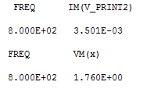

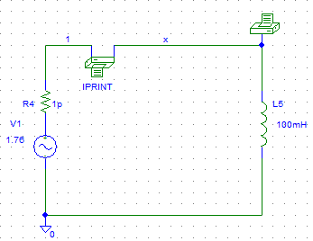

**4**. The circuit in figure (4) was connected with V=0.5Vrms



**Figure (4): RC circuit with sinusoidal signal**

|  |  |  |  |
| --- | --- | --- | --- |
| **Freq(Hz)** | 800 | 1600 | 6400 |
| **|V|(V)** | 0.37 | 0.32 | 0.31 |
| **|I|mA** | 2.65 | 3.0 | 3.16 |
| **|Z_RC|ohm** | **140** | 106.7 | 98.2 |

Simulation of the circuit for f=800Hz

|Z_RC|=0.5/3.545m**=141ohm (like above)**

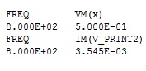

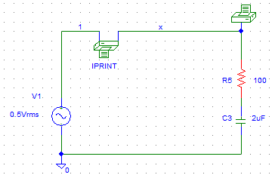

**5.** The circuit in figure (5) was connected with VI=4*sin (100*pi*t).



**Figure (5): RC circuit with sinusoidal input signal**

|  |  |  |
| --- | --- | --- |
| **R(Kohm)** | **Vcp-p** | **Phase angle** |
| **1** | **3.34** | **34.2** |
| **3** | **1.92** | **64.8** |
| **8** | **0.80** | **79.2** |
| **10** | **0.64** | **80.1** |

**Simulation for R=8k ,results in phase and voltage that are very near to the experimental measurements :-**

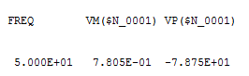

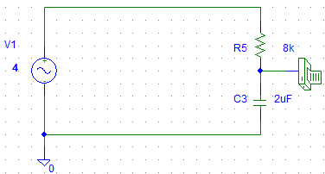

**6. The circuit in figure (6) was connected with VI=5*sin (2000*pi*t).**



**Figure (6): RL circuit with sinusoidal input**

|  |  |  |
| --- | --- | --- |
| **R(K ohm)** | **VLrms** | **Phase angle** |
| **1** | **2.60** | **57.6** |
| **5** | **0.60** | **82.1** |
| **7** | **0.42** | **84.3** |
| **10** | **0.30** | **85.9** |

**Simulation results :-**

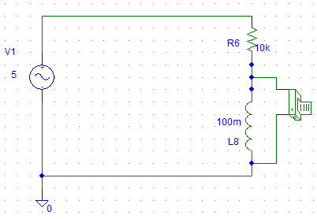

**R=1k**

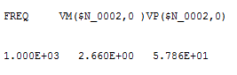

**R=5k**

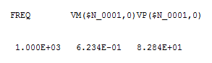

**R=7k**

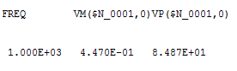

**R=10k**

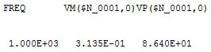

**7**.The circuit in figure 7 was connected .



**Figure (7): RL circuit with Dc input**

Current and voltage across inductor were measured:-

IL=17.3mA, VL=0.13V

**8**. The circuit in figure 8 was connected .



**Figure (8):-RL circuit with sinusoidal input**

The following were measured for the corresponding frequencies :-

|  |  |  |  |
| --- | --- | --- | --- |
| **Freq(HZ)** | **|I|(mA)** | **|VR|(V)** | **|Vcoil|(V)** |
| **200** | **4.6** | **0.114** | **0.014** |
| **1000** | **1.5** | **1.07** | **0.97** |
| **5000** | **0.29** | **0.02** | **0.98** |

**Simulation for f=5000Hz,results in :-**

|I|=0.31mA, |Vcoil|=0.99V

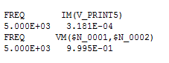

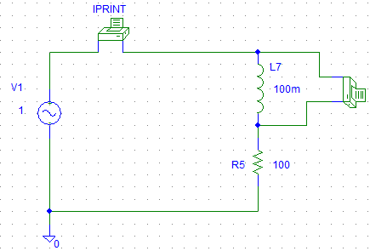

**Self inductance**

**A**-VL (t) =LdiL(t)/dt

L= 0.6/(2*pi*200*4.82m ) =99mH

**B**-|ZL|=|Vcoil|/|IL| = 0.6/4.82m=124.5 ohm

|ZL|= (2*pi*f)*L, so L= |ZL|/ (2*pi*f) =99mH

**9. Circuit in figure 9 was connected.**



**Figure (9): RC circuit with sinusoidal input**

**The following measurements were taken and simulation is shown below :-**

|I|=1mA, |Vc|= 1.73V, |VR|=1.13V, phase shift=58.2 degree

C=I/(dvc/dt) = 1mA/(2*pi*1000*1.73) == 0.1uF

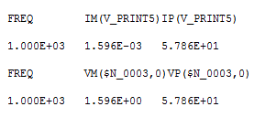

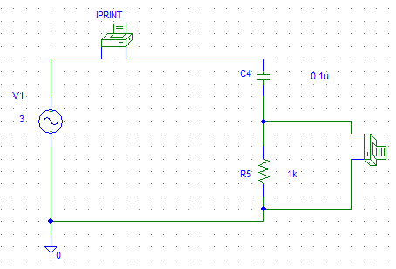

|  |  |  |
| --- | --- | --- |
|  |  |  |
| **Practical Applications** |  |  |

**Oscillators:-**

In this section, the concepts learned will be applied to develop a practical ac circuit: sine wave oscillator. An oscillator is a circuit that produces an ac waveform as output when powered by a dc input.

In order for sine wave oscillators to sustain oscillations, they must meet the following criteria:

1. The overall gain of the oscillator must be unity or greater.

Therefore, losses must be compensated for by an amplifying device.

2. The overall phase shift (from input to output and back to the input) must be zero.

**To achieve these points, the following circuit design is used:-**

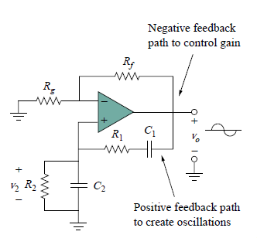

The circuit (oscillator) consists of a non-inverting amplifier with two feedback paths: the positive feedback path to the non- inverting input creates oscillations, while the negative feedback path to the inverting input controls the gain.

**The parameters needed to design the above circuit are derived below:**

If the impedances of the RC series and parallel combinations are defined as Zs and Zp, then

Z*s* = *R*1 + 1/ *jωC*1 = *R*1 – *j*/*ωC*1 .. ….…**….(1)**

Z*p* = *R*2//(1/*jωC*2) = *R*2/(1 + *jωR*2*C*2**)..…..(2)**

The feedback ratio is:-

V2/V*o*= Z*p* /Z*s* + Z*p***……(3)**

Substituting (1) and(2) in (3) ,gives

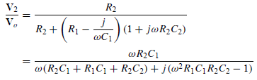 **……..(4)**

To satisfy the second criterion, V2 must be in phase with Vo , so Set the imaginary part equal to zero gives the oscillation frequency ωo as

ω0^2*R1*C1*R2*C2 − 1 = 0

In most practical applications, R1 = R2 = R and C1 = C2 = C, so that

***ωo* = 1/ *RC* = 2*πfo ……(5)***

SubstituteR1 = R2 = R and C1 = C2 = C ,and (5) in (4) :-

**V2/V*o*= 1*/* 3**

in order to satisfy the first criterion, the op amp must provide a gain of 3 or greater so that the overall gain is at least 1 or unity.

**Vo/V2= 1 + Rf/Rg = 3 …gain of a non-inverting OP-AMP**

**So Rf = 2Rg……..(6)**

|  |  |  |
| --- | --- | --- |
|  |  |  |
| **Conclusion** |  |  |

After analyzing the results obtained from the experiment, it was shown that in the resistive load circuit, the voltages measured are the same for the different frequencies, so resistance doesn’t depend on frequency of the source signal and the current and voltage waveforms are in phase. By contrast, in the inductive and capacitive circuits, voltages measured changed with the frequencies selected, so they depend on frequency of the source. Moreover, the sinusoidal steady state response was measured for RC, RL circuits by finding the magnitude and the phase shift on the components since the frequency is the same as that of the source. Results obtained in experiment were very near to simulation as shown with some errors resulted from the noise in wires and resistance of them, and some inaccuracy in measurement tools and components used.