

Faculty of Engineering and Technology

Electrical and Computer Engineering Department

Circuit lab (ENEE2102)

Report of Experiment 7  
**“Impedance and Sinusoidal Steady State**”

Prepared by:

Name: Abdallateef Wahdan

Number: 1183005

Partners:

Name: Ameer Butmah

Number: 1180443

Name:Jeries Shehadeh  
Number:1180519

Instructor: Dr. Muhammad Abu-Khaizaran

TA: Mahdi Alsalem

Date:

29/7/2021

Section: 2

***Contents***

**Abstract** 1

**Theory** 1

**Procedure & Results** 5

**Part A: Impedance Measurement……………………………………………………………………….......** 5

**Part B: Phase Shift Measurement** …………………………………………………………………………….9

**Part C: Inductance and Capacitance Measurement** ……………………………………………………11

**Conclusion** 13

**Appendix** 14

***List of Tables***

Table 1: Data for pure resistive load - 5 -

Table 2: Data for pure capacitive load - 6 -

Table 3: Data for pure inductive load - 7 -

Table 4:Data for RC load - 8 -

Table 5: Data for phase shift in the capacitor - 9 -

Table 6: Data for the phase shift in the inductor - 10 -

Table 7:Data for inductance - 11 -

Table 8: Data for the capacitance - 12 -

***List of Figures***

Figure 1:A resistive element carrying a sinusoidal current - 2 -

Figure 2:Voltage and current at the terminals of a resistor are in phase - 2 -

Figure 3:The frequency-domain equivalent circuit for an inductor - 3 -

Figure 4:A plot showing the phase relationship between the current and voltage at the terminals of an inductor - 3 -

Figure 5: The frequency domain equivalent circuit of a capacitor - 4 -

Figure 6: Circuit for calculating the impedance of pure resistive load - 5 -

Figure 7: Circuit for calculating the impedance of pure capacitive load - 6 -

Figure 8: Circuit for calculating the impedance of puerly inductive load - 7 -

Figure 9: Circuit for calculating the impedance for RC load - 8 -

Figure 10:Circuit for calculating phase shift in the capacitor - 9 -

Figure 11: Circuit for calculating phase shift in the inductor - 10 -

Figure 12:Circuit for calculating the inductance - 11 -

Figure 13: Circuit for calculating the capacitance - 12 -

***Abstract***

The aim of this experiment is to determine the impact of the change in frequency’s values on some passive circuit’s elements, such as resistor, capacitor and inductor. By using a Function wave generator specific signals as a function of time and an Oscilloscope in order to display a voltage signal in visual form.

***Theory***

This experiment focuses on circuits energized by time changing voltage source, which the value of the voltage different sinusoidally. However, sinusoidal sources can be represented by two general equations:

$v=Vm\cos\left(ωt+θ\right)$ $i=Imcos\left(ωt+θ\right)$

Where Vm  or Im is the maximum amplitude, w is the frequency and $θ$ is the phase angle .

* **Sinusoidal steady state**:

it exists as long as the switch remains closed and the source continues to supply the sinusoidal voltage. The best way to find the steady case voltages and currents is to perform the circuit analysis in the frequency domain. The phasor transform which is a component number that carries the amplitude and phase angle information of a sinusoidal function [1],awards us an effective way to move from time domain to the frequency domain :

$$v=Vme^{jθ}v=p〈Vmcos(ωt+θ)〉$$ The inverse phasor transform:

$$p^{-1}〈Vme^{jθ}=R〈Vme^{jθ}e^{jωt}〉〉$$

* **The V-I Relationship for a Resistor :**

From Ohm’s law we can derive that the V-I relationship as:

$$V=IR$$

Which cases that the phasor voltage at the terminals of a resistor is the resistance times the phasor current (see Figure 1).



Figure 1:A resistive element carrying a sinusoidal current

That there is no phase shift between current and voltage, which indicated by the phasor transform equation of the voltage (see Figure2): $$V=RIme^{jθi}$$

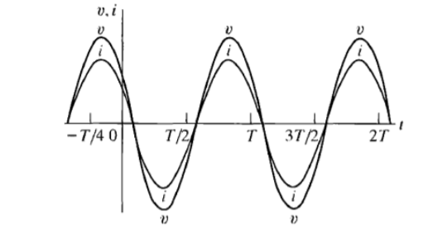

Figure 2:Voltage and current at the terminals of a resistor are in phase

* **The V-I Relationship for an Inductor :**the phasor voltage at the terminals of an inductor equals j $ω$ L times the phasor current ,the mathematical expression is given by this phasor representation (see Figure 3): $$v=jωLI$$



Figure 3:The frequency-domain equivalent circuit for an inductor

The current and voltage are out of phase (there’s a phase shift) by exactly 90 $°$,which means that the voltage leads the current by 90 $°$ as Figure 4 shows.

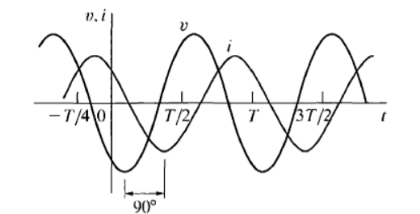

Figure 4:A plot showing the phase relationship between the current and voltage at the terminals of an inductor

The following equation shows this out of phase: $$v=ωLIm[(90+θ)$$

* **The V-I Relationship for a Capacitor :**the voltage across the capacitor can be written in expressions of the current as : $V=\frac{1}{jωc}I$ 
     
  Figure 5 illustrates this relationship

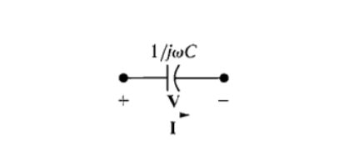

Figure 5: The frequency domain equivalent circuit of a capacitor

The current leads the voltage by 90 $°$ as Figure 6 shows

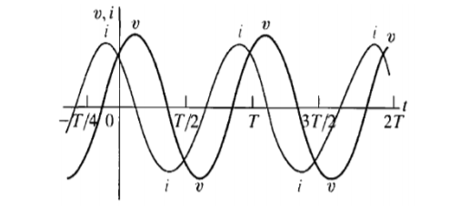.

The equation that describes this behavior is : $V=\frac{Im}{ωc}[(θ-90)$ 
 .

***Procedure, Results & Discussion***

**Part A: Impedance Measurement**

**1.** The circuit in Figure 6 was connected ,Vin was set to 8VPP , f to 250HZ ,then the current and voltage of the resistor were measured by DMM ,and the first step was repeated for f=500,1000 and 2000Hz respectively .results were recorded in Table 1 .

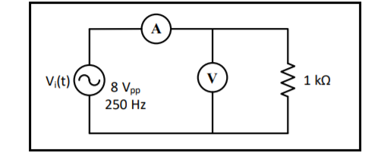

Figure 6: Circuit for calculating the impedance of pure resistive load

|  |  |  |  |  |
| --- | --- | --- | --- | --- |
| **f [Hz]** | 250 | 500 | 1000 | 2000 |
| |**V|** | 2.63 | 2.62 | 2.62 | 2.64 |
| |**I|** | 2.678m | 2.667m | 2.666m | 2.67m |
| **|ZR|** | 0.98K Ω | 0.98K Ω | 0.98K Ω | 0.98K Ω |

Table 1: Data for pure resistive load

The measured values are accepted, that’s the theoretical and actual behavior of purely resistive load, the change in frequency’s values has no effect on the impedance ZR .So, the currents and voltages in each case were constants with a few bit difference resulted from inaccurate calibration of signal generator

.

**2.** The circuit in Figure 7 was connected, and the same steps in the first section were repeated, and then the results were recorded in Table 2.

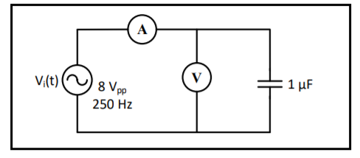

Figure 7: Circuit for calculating the impedance of pure capacitive load

|  |  |  |  |  |
| --- | --- | --- | --- | --- |
| **f [Hz]** | 250 | 500 | 1000 | 2000 |
| |**V|** | 2.77 | 2.73 | 2.57 | 2.28 |
| |**I|** | 4.699mA | 9.233mA | 17.822mA | 31.07mA |
| **|Zc|** | 636.9Ω | 318.47 Ω | 159.23Ω | 79.61 Ω |

Table 2: Data for pure capacitive load

The measured values are accepted, it’s expected that the capacitor impedance will decrease when the frequency increase since the relationship between f and ZR is inverse .so, the current increased and the voltage remained nearly constant with a few bit difference especially.

**3.** The circuit in Figure 8 was connected, with same past steps; data were recorded in Table 3.

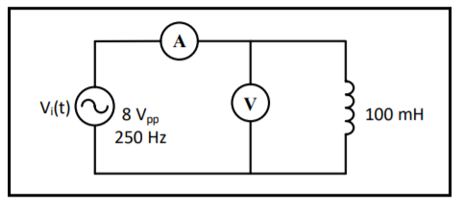

Figure 8: Circuit for calculating the impedance of puerly inductive load

|  |  |  |  |  |
| --- | --- | --- | --- | --- |
| **f [Hz]** | 250 | 500 | 1000 | 2000 |
| |**V|** | 2.58 | 2.72 | 2.76 | 2.77 |
| |**I|** | 15.744mA | 8.39mA | 4.178mA | 2.1mA |
| **|ZL|** | 157Ω | 314 Ω | 628Ω | 1256 Ω |

Table 3: Data for pure inductive load

The results make sense, the frequency increased the impedance increased too, the current decreased, and the voltage remained nearly constant. so the measured values are accepted.

**3.** The circuit in Figure 9 was connected, all pasts steps were repeated, and data were recorded in Table 4.

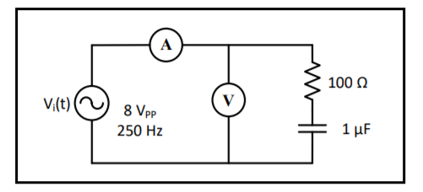

Figure 9: Circuit for calculating the impedance for RC load

|  |  |  |  |  |
| --- | --- | --- | --- | --- |
| **f [Hz]** | 250 | 500 | 1000 | 2000 |
| |**V|** | 2.72 | 2.59 | 2.27 | 1.96 |
| |**I|** | 4.535mA | 8.324mA | 13.053mA | 16.063mA |
| **|ZRC|** | 644.7Ω | 333.8 Ω | 188.027Ω | 127.819 Ω |

Table 4:Data for RC load

The impedance here has two components, the impedance of the resistor which is constant, and the component is for the capacitor . so, the total impedance it decrease as the frequency increase and the current will increase .so they are accepted.

**Part B: Phase shift measurement**

**1.** The circuit in Figure 10 was connected ,Vin was calibrated to sinusoidal voltage at 8 VPP and f =100HZ , then CH1 of the oscilloscope was connected across Vin and CH2 across VR, the time difference (∆t) between Vin and VR was measured , results were recorded in Table 5 . the oscilloscope doesn’t read current signals. so the voltage signal across the resistor was read instead of current signal due to both current and voltage across the resistor have the same wave form (in phase).

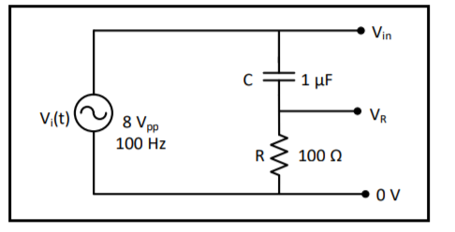

Figure 10:Circuit for calculating phase shift in the capacitor

|  |  |
| --- | --- |
| **∆t** | **∆ $θ$** |
| 2.4ms | 86.4 $°$ |

Table 5: Data for phase shift in the capacitor

the result is accepted, it’s logic to be the effect of the capacitor high, so the phase shift must be near to 90 $°$ (current leads voltage by 90 $°)$.

**2.** The circuit in Figure 11 was connected, the steps in the previous section were repeated, and then results were recorded in Table 6.

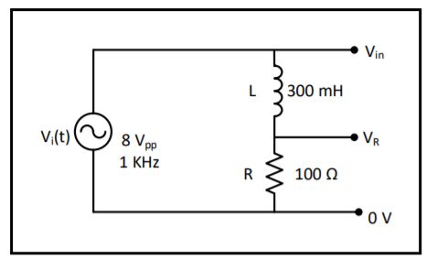

Figure 11: Circuit for calculating phase shift in the inductor

|  |  |
| --- | --- |
| **∆t** | **∆ $θ$** |
| 240.04us | 86.4 $°$ |

Table 6: Data for the phase shift in the inductor

the result is accepted, so the phase shift must be near to 90o the voltage leads the current in the inductor by 90 $°$ (voltage leads currnet by 90 $°)$.

**Part C: Inductance and Capacitance**

**measurement:   
1.** The circuit in Figure 12 was connected ,Vin was calibrated to sinusoidal voltage at 6Vpp , f =1kHz , then the current in the circuit , the voltage across resistor and the voltage across the inductor were measured using DMM ,finally results were recorded in Table 7.

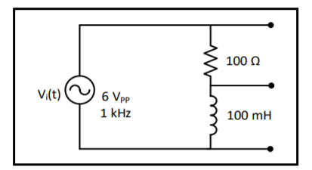

Figure 12:Circuit for calculating the inductance

|  |  |  |  |  |
| --- | --- | --- | --- | --- |
| **f[HZ]** | **|VR|** | **|VL|** | **|I|** | **L** |
| **1kHZ** | 0.307V | 1.99V | 3.133mA | 100mH |

Table 7:Data for inductance

the result is accepted, since it is near to the theoretical value.

**2.** The circuit in Figure 13 was connected, all steps in the previous section were repeated, and then results were recorded in Table 8.

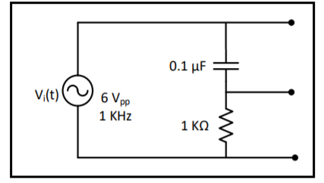

Figure 13: Circuit for calculating the capacitance

|  |  |  |  |  |
| --- | --- | --- | --- | --- |
| **f[HZ]** | **|VR|** | **|VL|** | **|I|** | **C** |
| **1kHZ** | 0.14V | 1.73V | 0.13mA | 0.1 $μF$ |

Table 8: Data for the capacitance

Our result is accepted, since it’s near to the theoretical value.

***Conclusion***

This experiment, the frequency dependent behavior of impedance were verified, self-inductance and capacitance were calculated, and the sinusoidal steady cases response of RL and RC circuits were determined by finding the maximum amplitude and phase angle, the experiment ran smoothly and gave reasonable results.

***References***

[1] J.W.Nilsson and S.A.Riedal, Electrical Circuits. Reading, MA: Addison-Wesley, 10th ed., pp.310.

[2] ENEE 2102, Circuit lab manual, experiment 7, impedance and sinusoidal steady state, pp.81-90.

***Appendix***



