

Faculty of Engineering and Technology

Electrical and Computer Engineering Department

Circuits LAB (ENEE2102)

Report on Experiment #8

AC & DC power analysis and design

**________________________________________________________**

Prepared by:

Name: Sara Totah Number: 1181779

Partners:

Name: Chris Lama Number: 1180132

Instructor: Jaser Sa'Ed TA: Eng. Ahmad Zahran

Date:

18/10/2020

Section: #1

Table of Contents

**ABSTRACT:** 1

**THEORY:** 2

Average and Reactive Power: 2

The Power Factor: 2

Power Factor correction: 3

Maximum Power Transfer: 3

The efficiency of Maximum Power Transfer: 4

**PROCEDURE:** 4

Part A: DC power measurement: 4

Part B: Maximum DC power transfer: 5

Part C: Power factor measurement: 5

Part D: Power factor correction: 6

Part E: Maximum average power transfer: 6

Part F: Measuring power using Wattmeter: 6

**Data, calculations, and analysis of results:** 7

Part A: DC power measurement: 7

Part B: Maximum DC power transfer: 7

Part C: Power factor measurement: 8

Part D: Power factor correction: 9

Part E: Maximum average power transfer: 10

Part F: Measuring power using Wattmeter: 10

**Calculations:** 10

**References:** 11

# **ABSTRACT:**

This experiment aims to examine the DC and the AC power and how the analysis and modelling are done in practice, to that some equipment was used to implement this experiment, such as:

1. Digital Multimeter.
2. Function Generator.
3. Oscilloscope.
4. Some Resistors and the resistor box.
5. Inductor box.

# **THEORY:**

## Average and Reactive Power:

Average power (P) is sometimes referred to us real power or working power because it describes the power in the circuit that is transformed from electric to non-electric energy, and it’s the power that powers the equipment, while Q is called the reactive power is the power needed to produce the magnetizing flux such as transformer and its value should be very small.

|  |  |  |
| --- | --- | --- |
| Average Power (KW) | P = $\frac{VmIm}{2}\cos{(θv- θi)}$ | (1) |
| Reactive Power (KVAR) | Q = $\frac{VmIm}{2}\sin{(θv- θi)}$ | (2) |

Apparent power is the combination of average power P and reactive power Q, it’s also known as the magnitude of the complex power due to Q being very small, the apparent power and the average power are almost equal, and it’s symbolized with the letter |S|, and measured with the (KVA) unit.

|  |  |  |
| --- | --- | --- |
| Complex Power (KVA) | S = P + jQ | (3) |
| Apparent Power (KVA) | |S| = | (4) |

## The Power Factor:

It represents the ratio between the average power and the reactive power, of course, the required value for the power factor to approach is 1 and the reactive factor to approach zero.

|  |  |  |
| --- | --- | --- |
| Power Factor (PF) | PF = $\frac{KW}{\sqrt{{KW}^{2}+{ KVAR}^{2}}}= \frac{P_{av}}{Q}$ | (5) |
|  | PF = cos ($θv- θi$) | (6) |
| Reactive Factor (RF) | RF = sin ($θv- θi$) | (7) |

As a result of $cos⁡(θv- θi)= cos⁡(θi- θv)$, power factor does not tell the power factor angle, we use the following two phrases to describe the power factor angle:

1. Lagging Power Factor: This phrase implies that current lags voltage, such as in Inductive loads.
2. Leading Power Factor: The current here leads the voltage, such as in Capacitive loads.

## Power Factor correction:

The Power Factor correction is used to improve the power factor by maintaining the level of reactive power consumption, here are some benefits of improving the power factor:

1. Lower Electricity bill, by reducing the amount of energy you are paying for but couldn’t use.
2. Reduce system losses and increase the system capacity.

There are some ways to improve the power factor, such as:

1. Installing capacitors (KVAR) which generate reactive power to reduce the amount of the reactive power the motor needs, which leads to higher power factor.
2. Avoid operating the devices above its rated voltage.

## Maximum Power Transfer:

The maximum power transfer theorem implies that the maximum power will be delivered to the complex load ZL only when the ZL equal the conjugate of the Thevenin impedance

|  |  |  |
| --- | --- | --- |
|  | ZL = Z*TH | (8) |

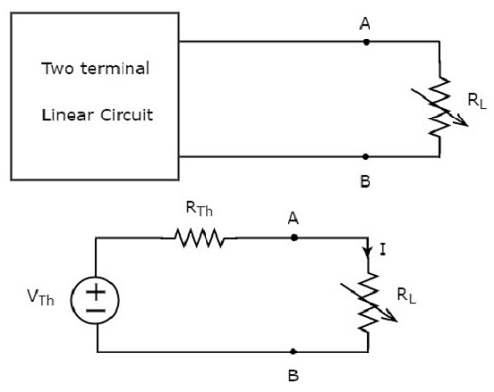

Figure (1)

|  |  |  |
| --- | --- | --- |
|  | PL = I2RL | (9) |
|  | I = | (10) |
|  | PL = ()2RL | (11) |

For the maximum, the first derivative will be zero

|  |  |  |
| --- | --- | --- |
|  | $\frac{dP_{L}}{dR_{L}}=V_{TH}^{2}\{\frac{({R_{TH}+R_{L})}^{2}-2R_{L}(R_{TH}+R_{L}) }{({R_{TH}+R_{L})}^{4}}$ = 0 | (12) |
|  | (RTH + RL)2– 2RL(RTH + RL) = 0 | (13) |
|  | (RTH – RL) = 0  RTH = RL | (14)  (15) |

So, as a result, the maximum average power is

|  |  |  |
| --- | --- | --- |
|  | PL, max =  PL, max =  PL, max = | (16)  (17) |

If the Thevenin voltage was expressed in terms of its maximum amplitude

|  |  |  |
| --- | --- | --- |
|  | PL, max = | (18) |

## The efficiency of Maximum Power Transfer:

The efficiency depends on the ratio between the total power generated by the source and the power delivered to the load.

|  |  |  |
| --- | --- | --- |
| Efficiency (%) | η = $\frac{P_{out}}{P_{in}} ×100$ | (19) |

# **PROCEDURE:**

## Part A: DC power measurement:

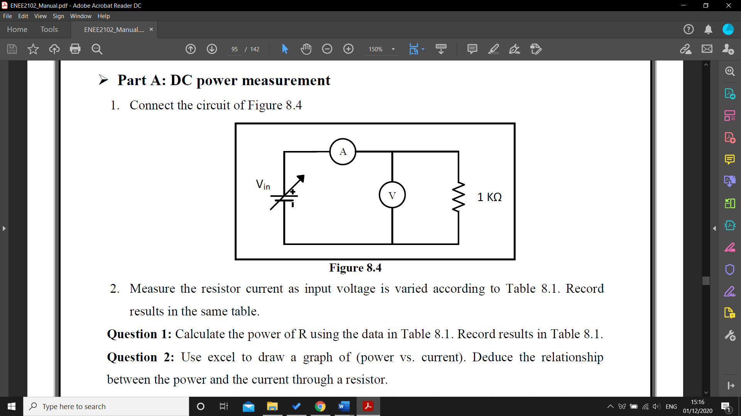

Figure (2)

The circuit in figure 2 was connected, and the ammeter was connected in series with the 1kΩ resistor, while the voltmeter was connected in parallel with the resistor, then the current through the resistor for every value of the input voltage in table 1 in the data section.

## Part B: Maximum DC power transfer:

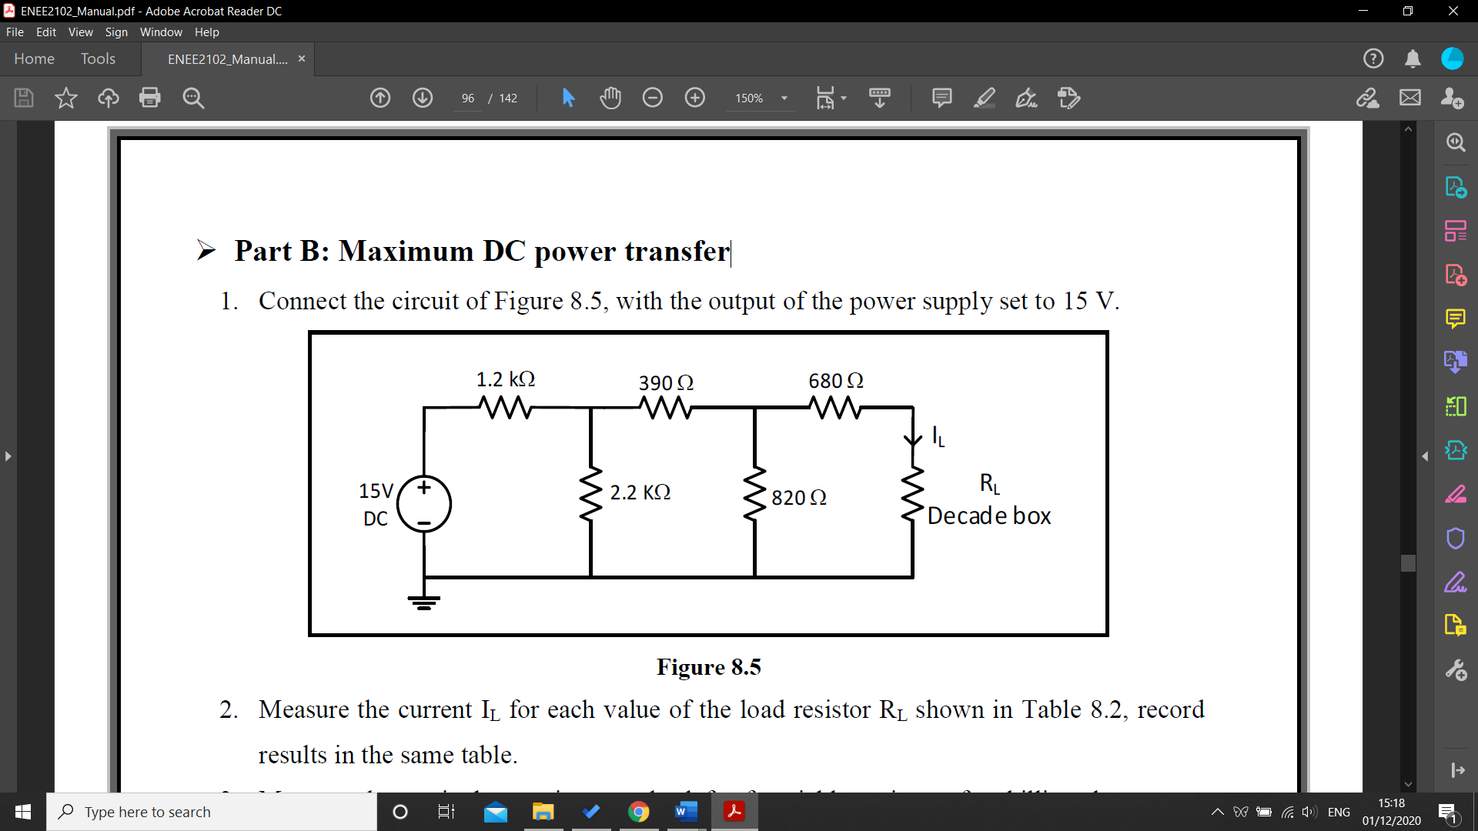

Figure (3)

The circuit in figure 3 was connected, then the value of the current IL was measured for each value of the load resistor RL, and was recorded in table 2 in the data section, then the input voltage source was killed and the equivalent resistor was measured.

## Part C: Power factor measurement:

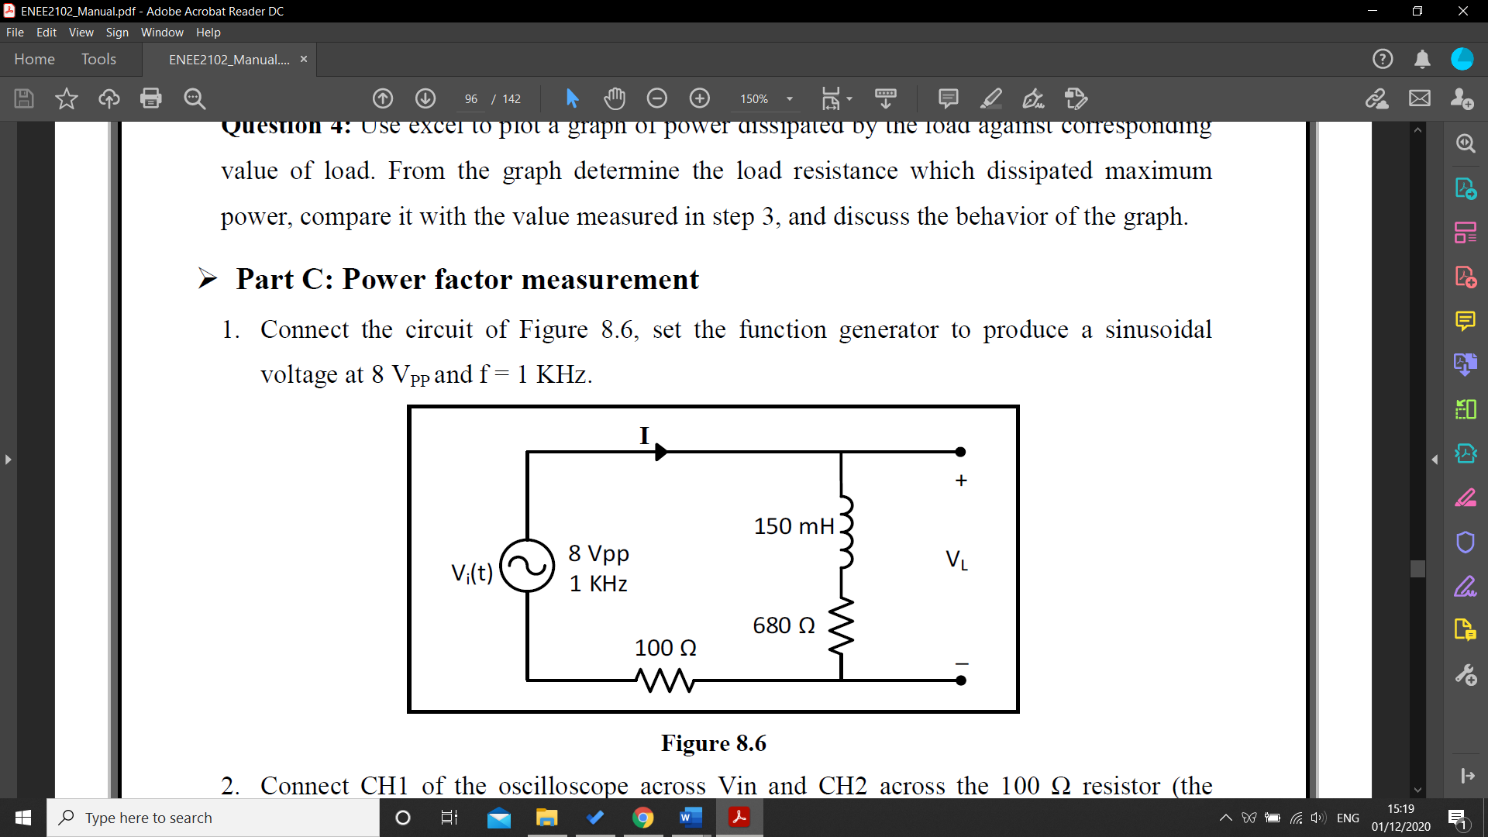

Figure (4)

The circuit in figure 4 was connected, and the function generator was set to produce a sinusoidal voltage at 8 VPP and frequency equals 1kHz, then the first channel of the oscilloscope was connected across the input voltage Vi(t), while channel 2 was connected across the 100Ω, then the difference between the Vi and V100, and all the results were recorded in table 3, with a picture of the oscilloscope screen.

Finally, the RMS values of VL and I were measured and recorded in the same table.

## Part D: Power factor correction:

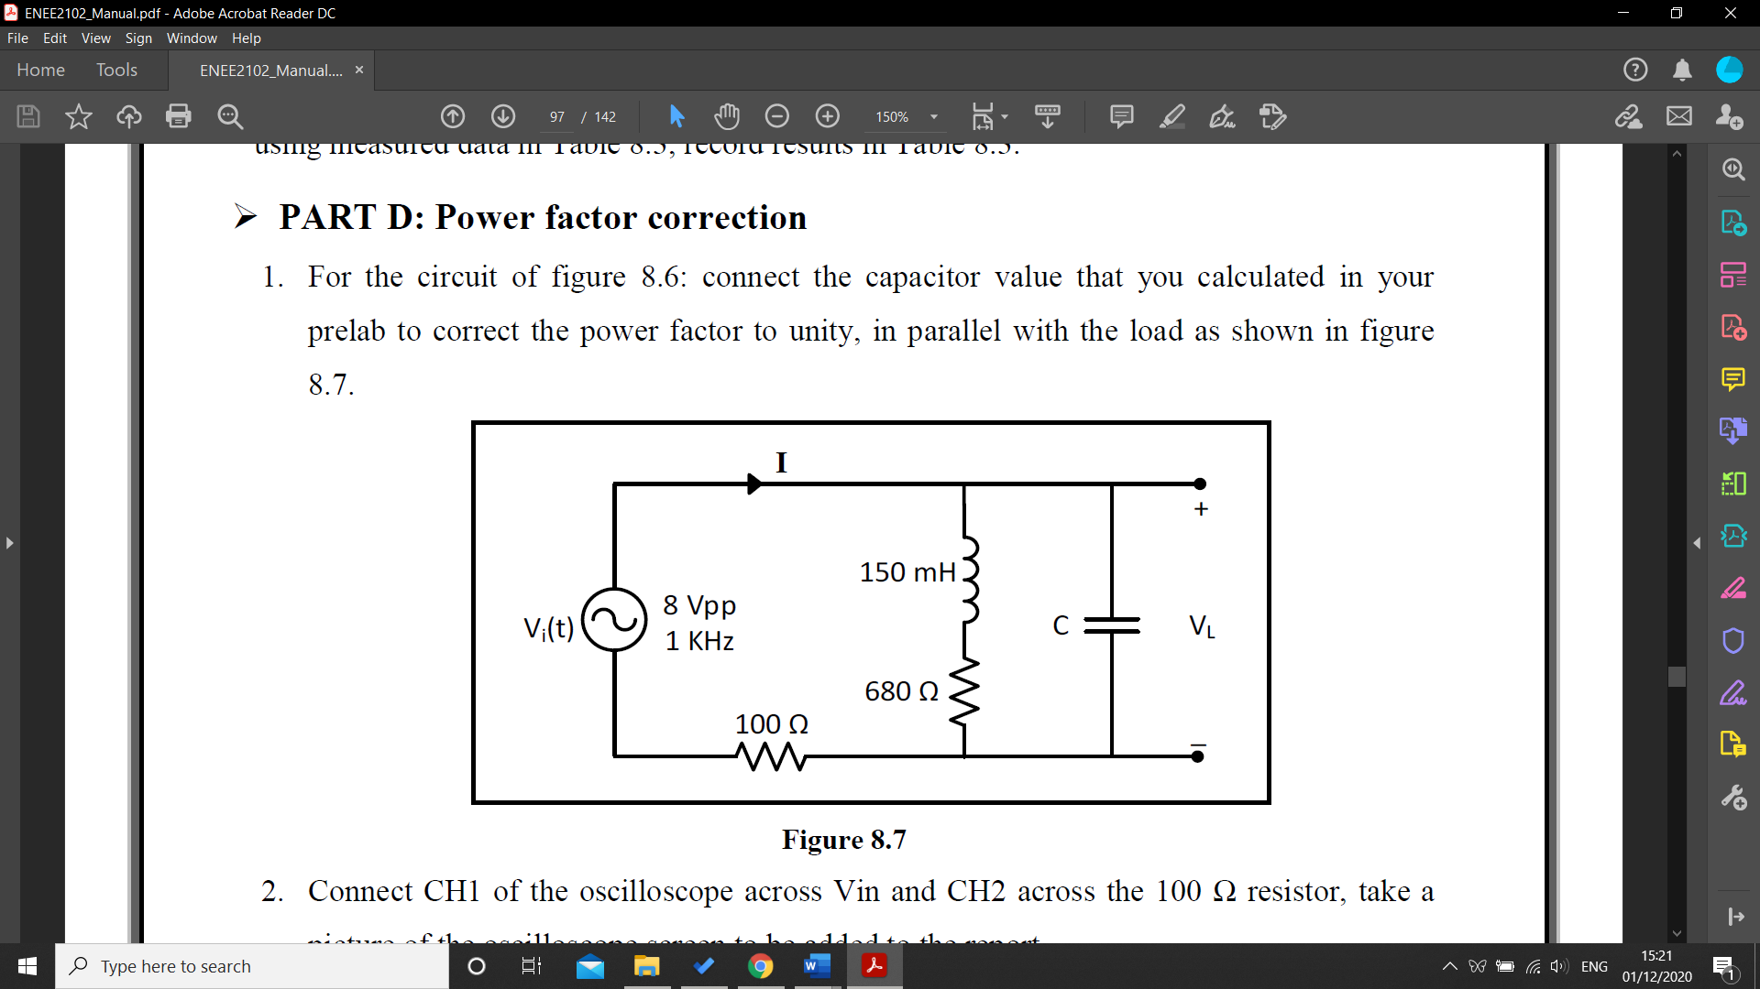

Figure (5)

The circuit in figure 5 was connected, and the value of the capacitor needed for the power factor correction was calculated manually, then this value was connected in parallel with the load to improve the power factor, the first channel of the oscilloscope was connected across the input voltage Vi(t), while channel 2 was connected across the 100Ω, then the difference between the Vi and V100, and all the results were recorded in table 4, with a picture of the oscilloscope screen.

Finally, the RMS values of VL and I were measured and recorded in the same table.

## Part E: Maximum average power transfer:

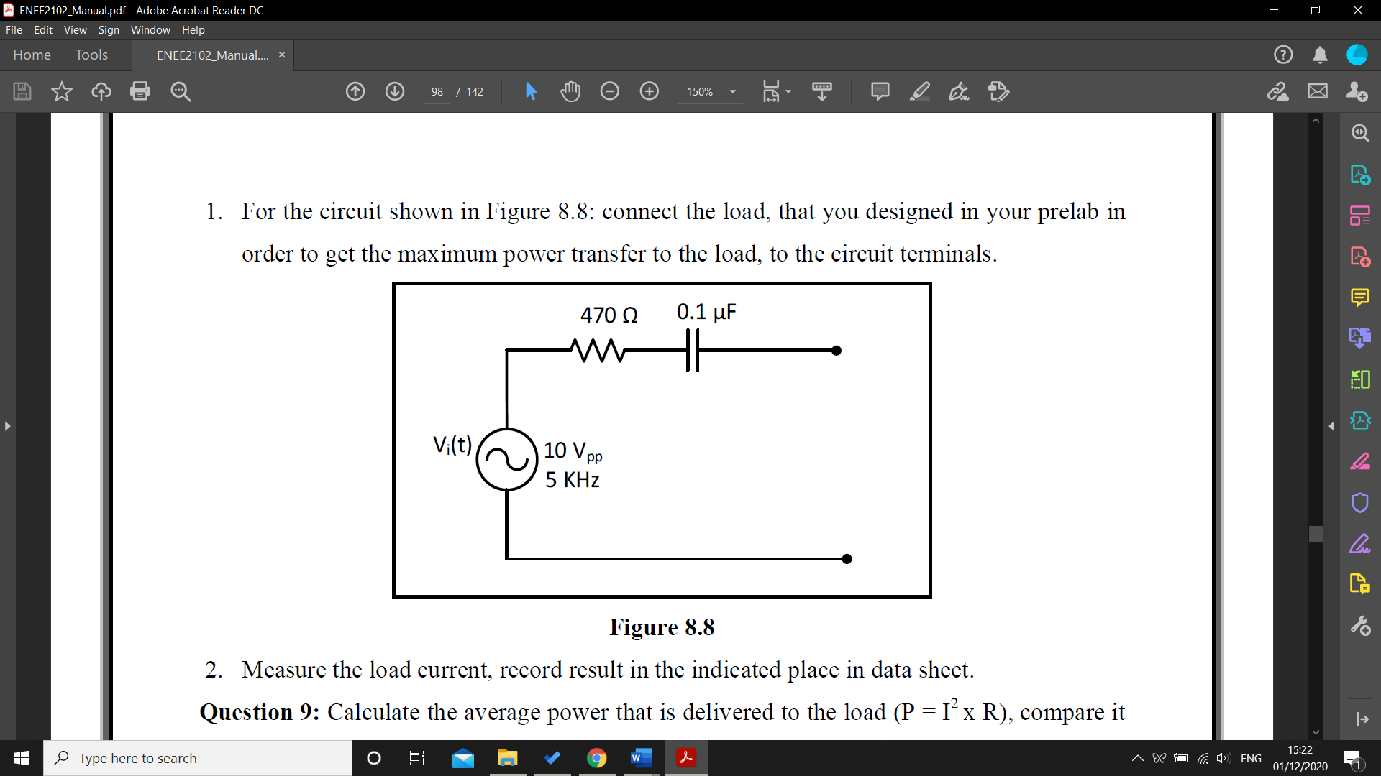

Figure (6)

The circuit in figure 6 was connected, and the load was calculated manually to get the maximum power transfer, and then was added to the circuit, the load current was measured and added to the data section below.

## Part F: Measuring power using Wattmeter:

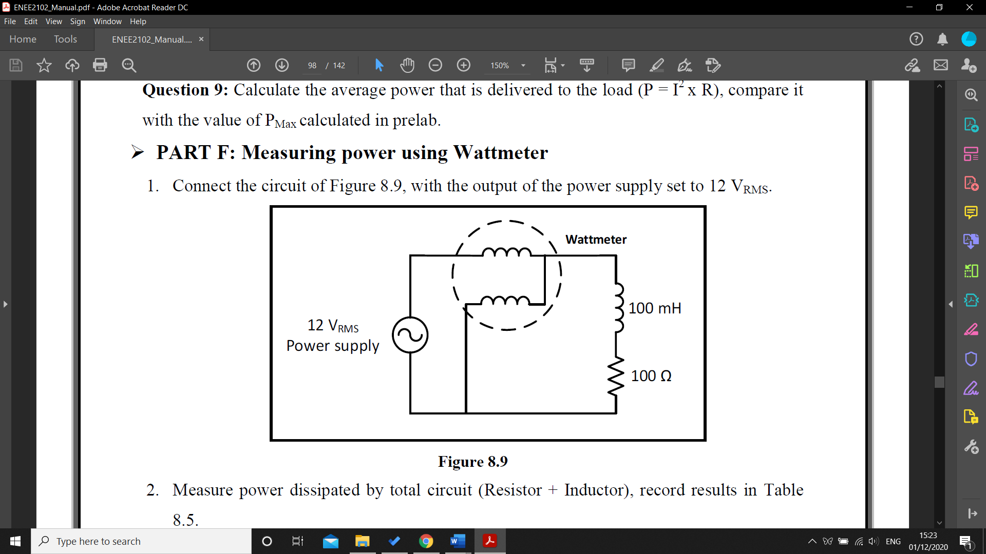

Figure (7)

The circuit above was connected, and the wattmeter was connected to the circuit to measure the current (in series) and the voltage ( in parallel) and the power supply was set to give a 12 VRMS, then the power dissipated by the circuit, 100Ω and 100mH were measured and recorded in table 5.

# **Data, calculations, and analysis of results:**

## Part A: DC power measurement:

|  |  |  |  |  |  |  |
| --- | --- | --- | --- | --- | --- | --- |
| Vin [V] | 0 | 2 | 4 | 6 | 8 | 10 |
| I [mA] | 0.02 | 2.03 | 3.97 | 5.96 | 7.92 | 9.87 |
| P [mW] | 0 | 4.06 | 15.88 | 35.76 | 63.36 | 98.7 |

Table (1)

Figure (8)

There’s a direct correlation between increasing power and increasing current and voltage

|  |  |  |
| --- | --- | --- |
|  | P = V $∝$ I  P = V x I  P = I x R x I  P = R x I2 | (20)  (21) |

## Part B: Maximum DC power transfer:

|  |  |  |  |  |  |  |  |  |  |  |  |
| --- | --- | --- | --- | --- | --- | --- | --- | --- | --- | --- | --- |
| RL | 0 | 100 | 400 | 700 | 1K | 1.1K | 1.2K | 1.3K | 1.4K | 1.5K | 1.7K |
| I [mA] | 3.36 | 3.15 | 2.57 | 2.01 | 1.69 | 1.64 | 1.587 | 1.525 | 1.469 | 1.415 | 1.320 |
| P [mW] | 0 | 992.3 | 2642 | 2828.07 | 2856.1 | 2958.6 | 3022.3 | 3023.3 | 3021.2 | 3003.3 | 2962.08 |

Table (2)

Req $≈$ 1.16kΩ

Figure (9)

The graph shows that the power increases rapidly with increasing resistor until it gets to its maximum value when the resister almost equals the equivalent resistor of the circuit, and thus it starts to decrease slowly.

## Part C: Power factor measurement:

|  |  |  |  |  |  |  |
| --- | --- | --- | --- | --- | --- | --- |
|  | Measure |  |  | Calculate |  |  |
| VL [V] | I [mA] | ∆t | $$θ_{L}$$ | PF | P [mW] | Q[mVAR] |
| 2.73 | 1.297 | 140µs | 50.4 | 0.64 | 2.266 | 2.726 |

Table (3)

|  |  |  |  |  |  |  |
| --- | --- | --- | --- | --- | --- | --- |
|  | | | $θ_{L}$ = 360 x f x ∆t  = 350 x 1k x 140µ  = 50.4 | (22) | | |
|  | | PF = cos ( $θ_{i}- θ_{v})$ = cos (50.4 – 0) = 0.64 | | | (23) | |
|  | P = Vrms x Irms x cos ( $θ_{i}- θ_{v})$ = 2.73 x 1.297 x 0.64 = 2.266mW | | | | | (24) |
|  | Q = Vrms x Irms x sin ( $θ_{i}- θ_{v})$ = 2.73 x 1.297 x 0.77= 2.726mW | | | | | (25) |

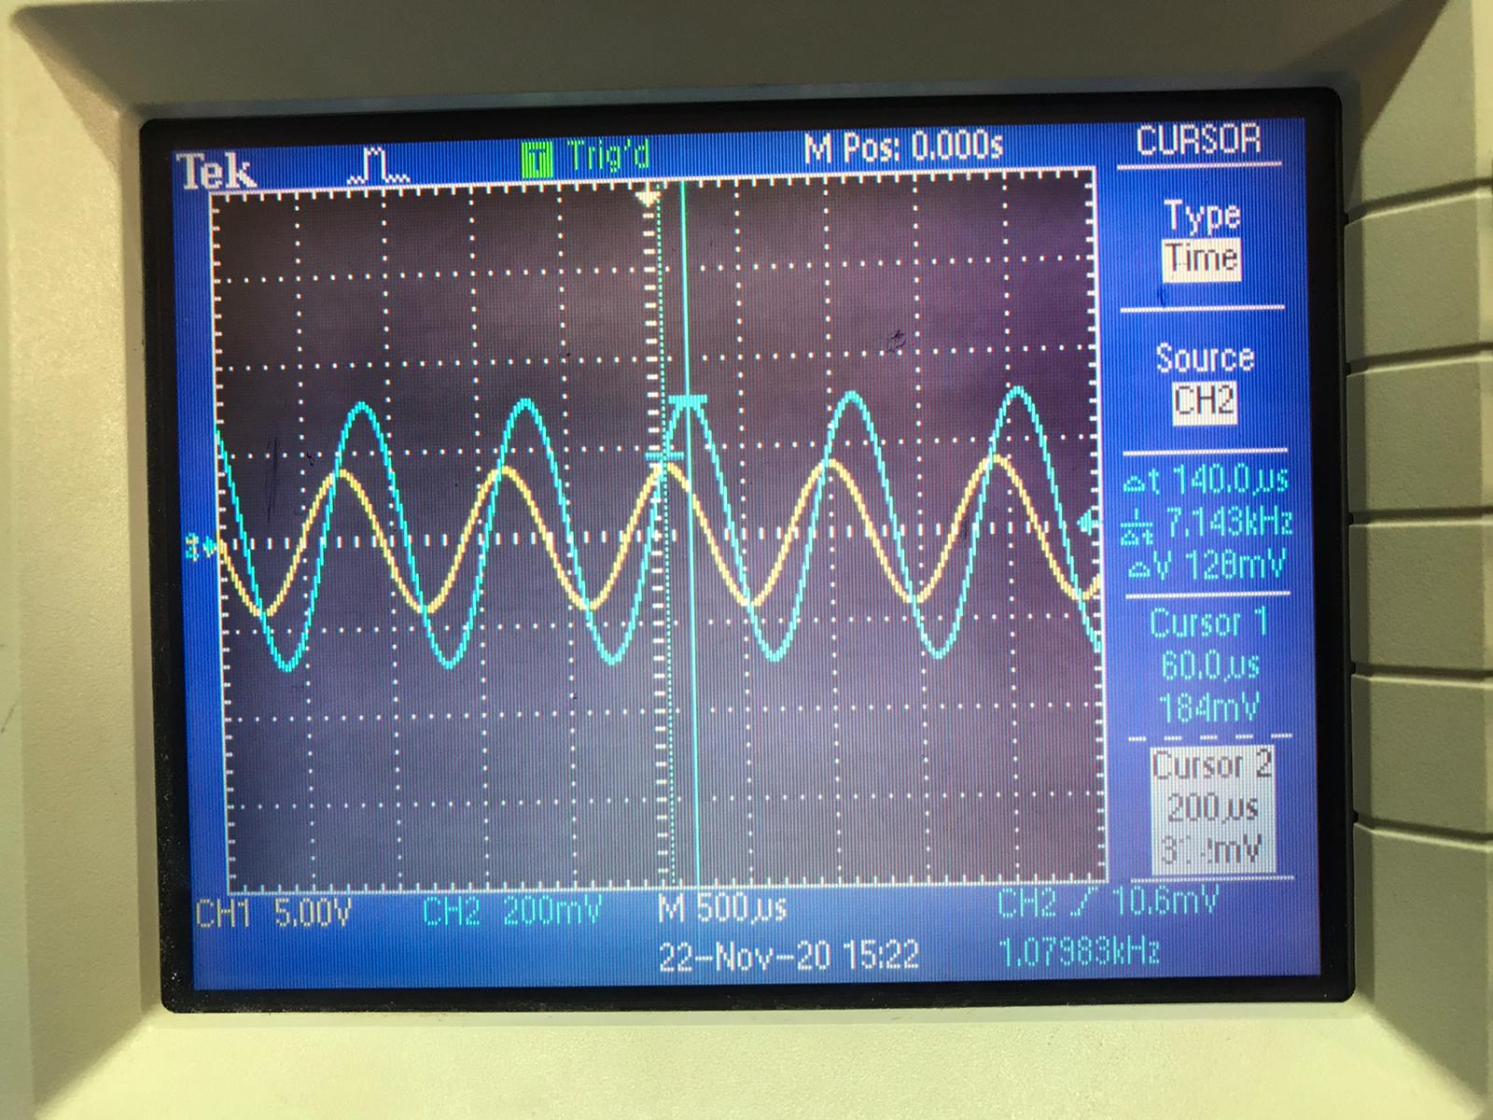

Figure (10)

According to the calculations in the table above, it can be concluded that the power factor is lagging power factor “inductive load” because the current lags the voltage.

## Part D: Power factor correction:

|  |  |  |  |  |  |  |
| --- | --- | --- | --- | --- | --- | --- |
|  | Measure |  |  | Calculate |  |  |
| VL | I | ∆t | $$θ_{L}$$ | Pf | P [mW] | Q[mVAR] |
| 2.84 | 1.256 | 0 $≈$ s | 0 | 1 | 3.54 | 0 |

Table (4)

|  |  |  |  |  |  |
| --- | --- | --- | --- | --- | --- |
|  | | Qc = -Vrms x Irms = -3.567mVAR  Qc = = -3.567mVAR  C = $\frac{-Qc}{w x I_{rms}^{2}}$ = 0.075µF  C $≈ 0.1$ µF | | (26)  (27)  (28) | |
|  | | $θ_{L}$ = 360 x f x ∆t  = 350 x 1k x 0= 0 | | (29) | |
|  | PF = cos ( $θ_{i}- θ_{v})$ = cos (0 – 0) = 1 | | (30) | | |
|  | P = Vrms x Irms x cos ( $θ_{i}- θ_{v})$ = 2.73 x 1.297 x 1 = 3.54mW | | | | (31) |
|  | Q = Vrms x Irms x sin ( $θ_{i}- θ_{v})$ = 2.73 x 1.297 x 0 = 0 | | | | (32) |

Adding the capacitor caused the power factor to increase, which means increasing the system’s capacity compared to the capacity before adding the capacitor.

## Part E: Maximum average power transfer:

IL = 3.542mA

|  |  |  |
| --- | --- | --- |
|  | ZTH = 470 – j318.309  ZL = Z*TH = R + jwL  R = 470Ω  L = 10.1mH | (33) |
|  | Pav = I2 x R  = (3.542m)2 x 470Ω  = 5.89mW | (34) |

To calculate the PMax, theoretically, the peak-to-peak voltage should be converted to RMS value

|  |  |  |
| --- | --- | --- |
|  | VRMS = = 3.53v  PL,MAX = mW | (35)  (36) |

As shown, there is a slight difference between the power calculated in practical and theoretical, due to some uncalculated errors in measuring and rounding the digits.

## Part F: Measuring power using Wattmeter:

|  |  |  |
| --- | --- | --- |
| Total Power (PT) | Resistor Power (PR) | Inductor Power (PL) |
| 1.305W | 1.233W | 112.6mW |

Table (5)

# **Calculations:**

After studying and applying what is learnt in Network analysis I in this lab it’s clear that most of the electric energy is supplied as sinusoidal voltages and currents, in this experiment types of power were tested such as average power, reactive power and apparent power next to some concepts and theories such as power factor correction and maximum power transfer theory, the experiment ran smoothly barely without any problems or complications.

# **References:**

1. Circuits Lab ENEE2102 manual.
2. Electric Circuits tenth edition James W. Nilsson and Susan A. Riedel.