

**Birzeit University**

**Faculty of Engineering & Techonology**

**Department of Electrical & Computer Engineering**

**ENEE**

**“Passive Filters Report ”**

**Student : Mohamad Bornat #1130842**

**Instructor:Dr.Jasser Sa’ed**

**Date: 27\7\2016**

|  |  |  |
| --- | --- | --- |
|  |  |  |
| **Abstract** |  |  |

The experiment covered the design and analysis of the first and second order passive filters. Since the oscilloscope shows signals varying with time and doesn’t give the frequency response , the method throughout the experiment was by ‘taking different frequencies from function generator to see how the different filter circuits behave and affect the output voltage ‘, the expected results were verified which are ;for low pass filter circuits , as the frequency increased from low level , the output voltage was not changing(decreasing) significantly but after the frequency has jumped the cut off frequency , attenuation was clearly noticed on the value of output voltage till reaching a value near zero at far frequencies as will be shown in procedure and analysis. The opposite thing happened in the case of the high pass filter circuits. The band pass filter behaved like a combination of high pass-low pass filters which allowed the frequencies taken near the resonant frequency to pass, other signals with lower or higher frequency components than cut off ones were noticeably attenuated.

|  |  |  |
| --- | --- | --- |
|  |  |  |
| **Theory** |  |  |

**Low-Pass first order Filter:**

The series RC circuit shown in Figure 1 behaves as a low-pass filter. Note that the circuit's output is defined as the output across the Resistive load. We use three frequency regions to develop the behavior of the series RC circuit in



**Figure 1: RC low pass filter**

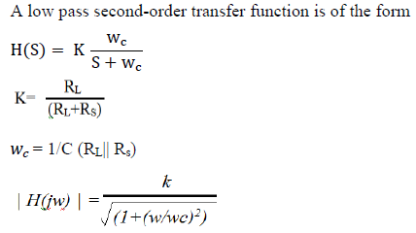

**Low pass filter Parameters**

**High-Pass first order Filters:**

A series RC circuit is shown in Figure 2. In contrast to its low-pass the output voltage here is defined across the resistive load, not the capacitor. Because of this, the effect of the changing capacitive impedance is different than it was in the low-pass configuration

At w = 0, the capacitor behaves like an open circuit, so there is no current flowing in the resistor and Vo = 0.



**Figure 2: RC high pass filter**

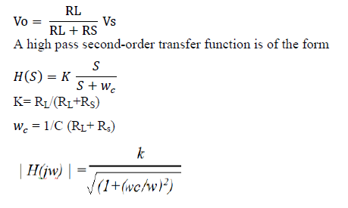

**Second order filters:**

Second order filters can be designed as low pass, high pass, band pass, or notch filters. A low pass second-order transfer function is of the form



**Figure 3: Low pass second-order filters**

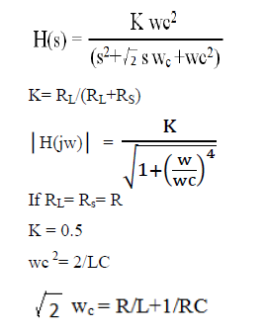

**RLC Bandpass Filter:**

Figure 4 depicts a series RLC circuit. We want to consider the effect of changing the source frequency on the magnitude of the output voltage. As before, changes to the source frequency result in changes to the impedance of the capacitor and the inductor. The qualitative analysis is somewhat more complicated, because the circuit has both an inductor and a capacitor.



**Figure 4: Band pass Filter**

Transfer function is

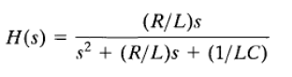

Cut off frequencies

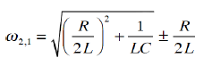

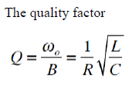

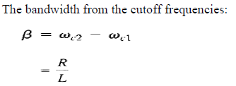



**Figure 5: Frequency Response of band pass filter**

|  |  |  |
| --- | --- | --- |
|  |  |  |
| **Procedure & Data** |  |  |

**Note: in some parts we used a different value of C so there may be a little difference in the frequency range between the simulation and the experimental results.**

**Part A :- First order Passive low-pass filter**

**the circuit in figure 6 was connected and the following data were measured:-**



**Figure 6: Low pass filter**

**FC=320 HZ**

|  |  |  |  |
| --- | --- | --- | --- |
| **F** | **Vin** | **Vout** | **Gain** |
| 10 | 1.88 | 1 | 0.531914894 |
| 20 | 1.998 | 0.994 | 0.497497497 |
| 50 | 1.98 | 0.984 | 0.496969697 |
| 100 | 1.99 | 0.943 | 0.473869347 |
| 150 | 1.998 | 0.885 | 0.442942943 |
| 200 | 1.995 | 0.82 | 0.411027569 |
| 300 | 1.989 | 0.69 | 0.346907994 |
| 318 | 1.988 | 0.67 | 0.337022133 |
| 350 | 1.997 | 0.634 | 0.317476214 |
| 400 | 1.996 | 0.589 | 0.29509018 |
| 450 | 1.995 | 0.54 | 0.270676692 |
| 500 | 1.993 | 0.498 | 0.249874561 |
| 600 | 1.992 | 0.434 | 0.217871486 |
| 700 | 1.99 | 0.383 | 0.192462312 |
| 1000 | 1.985 | 0.274 | 0.138035264 |
| 2000 | 1.983 | 0.143 | 0.07211296 |
| 3000 | 1.993 | 0.095 | 0.047666834 |
| 5000 | 1.994 | 0.057 | 0.028585757 |
| 10000 | 1.992 | 0.028 | 0.014056225 |

**The experimental frequency response Plot using excel:**

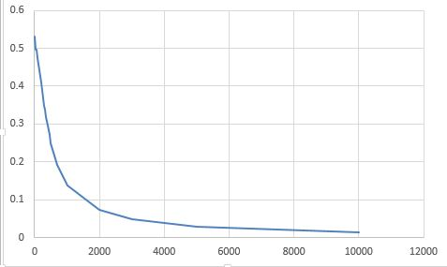

**The circuit simulated using Pspice and the following frequency response was obtained:-**

**This output verifies the measurements next.**



**Part B:- First order high passive filter**

**The circuit in figure 7 was connected and the following data were taken:-**

**  
 Figure 7: first order High pass filter**

**Fc=79.5Hz**

|  |  |  |  |
| --- | --- | --- | --- |
| **F** | **Vin** | **Vout** | **Gain** |
| 10 | 1.931 | 0.138 | 0.071465562 |
| 20 | 1.993 | 0.265 | 0.132965379 |
| 30 | 1.998 | 0.375 | 0.187687688 |
| 50 | 1.995 | 0.565 | 0.28320802 |
| 60 | 1.997 | 0.625 | 0.312969454 |
| 70 | 1.993 | 0.688 | 0.345208229 |
| 79 | 1.992 | 0.727 | 0.364959839 |
| 90 | 1.991 | 0.77 | 0.386740331 |
| 100 | 1.99 | 0.806 | 0.405025126 |
| 150 | 1.988 | 0.88 | 0.442655936 |
| 250 | 1.983 | 0.947 | 0.477559254 |
| 500 | 1.99 | 0.98 | 0.492462312 |
| 1000 | 1.987 | 0.987 | 0.496728737 |
| 5000 | 1.993 | 0.991 | 0.497240341 |
| 10000 | 1.993 | 0.992 | 0.497742097 |

**The experimental frequency response Plot using excel:**

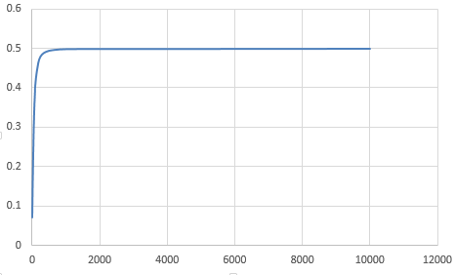

**The simulation is below but the capacitor was 1 uF in Prelab not 0.1uF as in experiment.**

**It’s close enough to data above and verifies the measurements taken .**



**Part C :- Second order Passive low-pass filter**

**The circuit in figure 8 was connected and the following data were measured:-**



**Figure 8:-second order low pass filter**

**Fc= 355Hz**

|  |  |  |  |
| --- | --- | --- | --- |
| **F** | **Vin** | **Vout** | **Gain** |
| 10 | 1.987 | 0.992 | 0.499245093 |
| 50 | 1.989 | 0.976 | 0.490698844 |
| 100 | 1.98 | 0.939 | 0.474242424 |
| 200 | 1.98 | 0.831 | 0.41969697 |
| 300 | 1.975 | 0.707 | 0.357974684 |
| 356 | 1.985 | 0.649 | 0.326952141 |
| 400 | 1.983 | 0.603 | 0.30408472 |
| 500 | 1.981 | 0.511 | 0.25795053 |
| 700 | 1.981 | 0.377 | 0.190307925 |
| 1000 | 1.981 | 0.251 | 0.126703685 |
| 2000 | 1.989 | 0.085 | 0.042735043 |
| 5000 | 1.993 | 0.08 | 0.040140492 |
| 10000 | 1.994 | 0.004 | 0.002006018 |

**The experimental frequency response Plot using excel:**

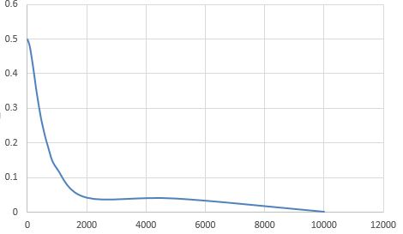

**The simulation below verifies the measurements in the table: not that some frequencies above and the output voltage were shown on the curve below:-**



**Part D:- Second order high passive filter**

**The circuit in figure below was connected and the following data were measured:-**



|  |  |  |  |
| --- | --- | --- | --- |
| **F** | **Vin** | **Vout** | **Gain** |
| 10 | 1.968 | 0.00001 | 5.0813E-06 |
| 50 | 1.989 | 0.019 | 0.009552539 |
| 100 | 1.985 | 0.07 | 0.035264484 |
| 200 | 1.977 | 0.202 | 0.102175013 |
| 300 | 1.971 | 0.332 | 0.168442415 |
| 400 | 1.982 | 0.438 | 0.2209889 |
| 500 | 1.98 | 0.532 | 0.268686869 |
| 600 | 1.98 | 0.604 | 0.305050505 |
| 650 | 1.98 | 0.644 | 0.325252525 |
| 700 | 1.98 | 0.666 | 0.336363636 |
| 712 | 1.98 | 0.678 | 0.342424242 |
| 750 | 1.98 | 0.695 | 0.351010101 |
| 800 | 1.979 | 0.717 | 0.362304194 |
| 1000 | 1.978 | 0.794 | 0.401415571 |
| 2000 | 1.986 | 0.933 | 0.46978852 |
| 5000 | 1.987 | 0.987 | 0.496728737 |
| 10,000 | 1.987 | 0.978 | 0.492199295 |

**The experimental frequency response Plot using excel:**

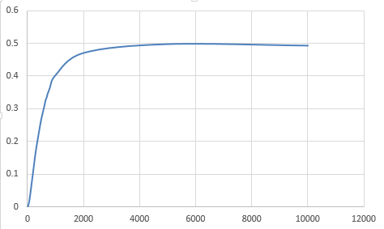

**The simulation below verifies the measurements**



**Part E:- passive Bandpass filter**

**The circuit in figure below was connected and the following measurements were taken:-**

**f0= w0/2*pi = = 5kHz.**

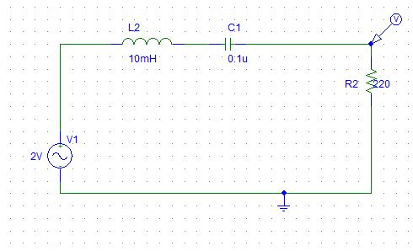

|  |  |  |  |
| --- | --- | --- | --- |
| **F** | **Vin** | **Vout** | **Gain** |
| 10 | 1.974 | 0 | 0 |
| 50 | 1.989 | 0.014 | 0.007038713 |
| 100 | 1.986 | 0.03 | 0.01510574 |
| 500 | 1.878 | 0.791 | 0.421192758 |
| 1000 | 1.985 | 0.078 | 0.03929471 |
| 2000 | 1.983 | 0.033 | 0.016641452 |
| 3000 | 1.979 | 0.018 | 0.009095503 |
| 4000 | 1.99 | 0.011 | 0.005527638 |
| 5000 | 1.991 | 0.005 | 0.002511301 |
| 6000 | 1.991 | 0.001 | 0.00050226 |
| 8000 | 1.991 | 0.002 | 0.00100452 |
| 10000 | 1.991 | 0.007 | 0.003515821 |

**The experimental frequency response Plot using excel:**

**The simulation below verifies the measurements but in different frequencies because we used different elements as I note at the first page of the report.**



**Part F:- passive Bandreject filter**

**The circuit in figure below was connected and the following measurements were taken:-**

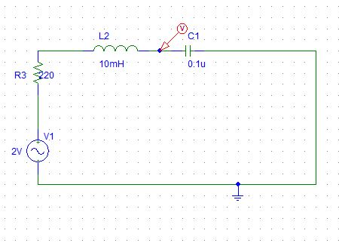

|  |  |  |  |  |
| --- | --- | --- | --- | --- |
|  | **f** | **vin** | **vout** | **gain** |
|  | 10 | 1.978 | 1.976 | 0.998988878 |
|  | 50 | 1.988 | 1.986 | 0.998993964 |
|  | 100 | 1.986 | 1.984 | 0.998992951 |
|  | 500 | 1.985 | 1.977 | 0.995969773 |
|  | 1000 | 1.974 | 1.945 | 0.985309017 |
|  | 2000 | 1.927 | 1.801 | 0.934613389 |
|  | 3000 | 1.825 | 1.446 | 0.792328767 |
|  | 4000 | 1.692 | 0.735 | 0.434397163 |
|  | 5000 | 1.642 | 0.255 | 0.155298417 |
|  | 6000 | 1.734 | 0.988 | 0.569780854 |
|  | 8000 | 1.866 | 1.564 | 0.838156484 |
|  | 10000 | 1.92 | 1.759 | 0.916145833 |

**The experimental frequency response Plot using excel:**

**The simulation below verifies the measurements but in different frequencies because we used different elements as I note at the first page of the report.**



|  |  |  |
| --- | --- | --- |
|  |  |  |
| **Practical Applications** |  |  |

**Filters are used widely especially in communication systems,** **since Filtering of signals in communications systems is necessary in order to select the desired signal from others in the same range,** **and to minimize the effects of noise and interference on the desired signal.**

**Radio Receiver:-**

**The block diagram shown next page of an AM radio receiver. The Incoming is an amplitude-modulated radio wave (thousands of them at different frequencies from different broadcasting stations) are received by the antenna. After that the band pass filter is needed to select just one of the incoming waves. Since the selected signal is very weak it is amplified in stages in order to generate an audible audio-frequency wave.**

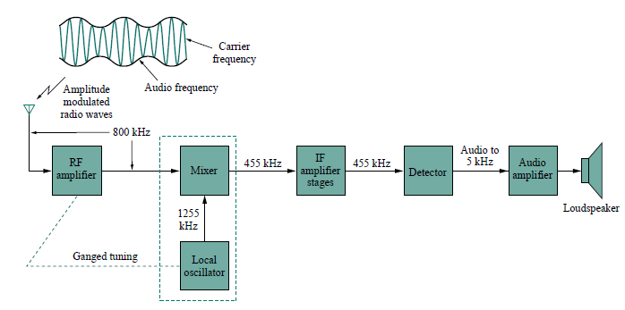

**What we are concerned about is the circuit of the band pass filter below (parallel RLC resonant circuit):-**

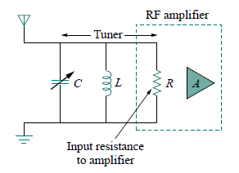

**To design the above filter, the values of C, L must be found using the techniques discussed in theory and the derived formulas:-**

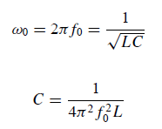

**The frequency range for AM broadcasting is 540 to 1600 kHz, so f0 =540Hz (lowest) to 1600kHz (highest ) to find the range of the capacitor necessary to cover the whole band .**

|  |  |  |
| --- | --- | --- |
|  |  |  |
| **Conclusion** |  |  |

**In this experiment, different circuits that select some frequencies and attenuate others were tested. Such circuits are widely used in applications since they can be used to eliminate harmonics or undesired frequencies and pass other useful ones.**

**First of these is ; low pass filter, values of voltages obtained for frequencies less than the half power frequency were passed normally and changes in voltages in this region were small. By contrast; for frequencies exceeding fc signals’ magnitudes were largely attenuated. Second type is high pass filters, and they behaved opposite the low pass filters. Third, Band pass filters were tested by measuring voltages for frequencies around resonance frequency which represents a special frequency since maximum value for current occurs and there was almost no phase shift at fo this phenomena happens at minimum impedance and zero phase shift for series circuits, and at maximum impedance or the voltage and current are in phase for parallel circuits. Finally, some deviations occurred between experimental and simulation results as appeared analysis section, this may have been caused by the resistance of wires, components uncertainty and tolerances, and inaccuracy in measurement devices.**