

**Electrical Engineering Department**

**ENEE211**

**Basic Electrical Engineering Lab**

**Experiment #5**

**Name:** Jeries Abedrabbo **No:** 1120414

**Name:** Fahed AbuGhazaleh **No:**

**Name:** Ward Jaradat **No:**

**Dr. Mohammad Wasfi Kafri**

**Abstract:**

This experiment was done to examine the behavior of first-order circuit in response to a step input. RC and RL series circuits were connected with a pulse voltage source. The real values for the resistor, the capacitor and the inductor were measured in the RC and RL circuits. Then, for the RC circuit, the oscilloscope was connected across the resistor terminals and then across the capacitor terminals to find the time constant from the graph. The same thing was done for the RL circuit. It was seen that in the RC circuit, the time constant depends on the value of the resistor and the capacitor. Also in the RL circuit, the time constant depends on the value of the inductor and the resistor. Moreover, the behavior of the voltage and the current in the RC and RL circuits is exponential.

**Theory:**

**First-Order circuits with DC sources (Step Response):**

In mathematics there are certain kinds of functions defined. One of these, is the unit step function.

Unit step function is defined as:

$$\left\{\begin{matrix}u\left(t\right)=0 & for t≤0^{-} \\ u\left(t\right)=1 & for t≤0^{+}\end{matrix}\right\}$$

Defining $t^{'}=t-t_{0}$ then the function would be $u\left(t^{'}\right)=u\left(t-t_{0}\right)$

And thus: $$\left\{\begin{matrix}u\left(t-t_{0}\right)=0 & for t≤{t_{0}}^{-} \\ u\left(t-t_{0}\right)=1 & for t≤{t_{0}}^{+}\end{matrix}\right\}$$

The graph of this function is described in the following figures:

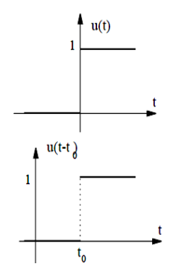

However, these step functions are useful and are one way top describe switches in electrical circuits as the following.

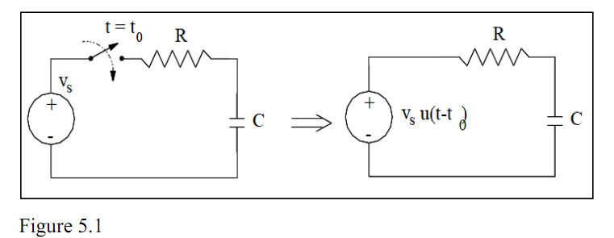

**Step Response of an RC circuit:**

Take a look at the previous circuit, as you notice the switch will close at time t=0, and the capacitor will begin to charge. Anyhow, the capacitor will have an initial voltage of V0. Now if we took KVL on this circuit, it will result in $R_{ic}+V_{c}=V_{s}$ where this can be also written as:

$RC\frac{dV_{c}}{dt}+V_{c}=V_{s}$ and for t>0, Vc(0+)=Vc(0-)=V0 and through these values we can say that we found the natural solution to the RC circuit.

$$V_{c,n}=Ke^{-\frac{t}{τ}} and τ=RC$$

And now to find the forced response, take Vc,f=A and when we substitute in the differential equation we will get.

🡺 and thus after all the solution will have both parts (Natural and forced) $V_{C}=V_{C,n}+V_{C,f}=Ke^{-\frac{t}{τ}}+v_{s}$ also the constant K can be found from the initial conditions Vc(0+)=Vc(0-)=V0

Thus and so $K=V_{C}\left(0^{+}\right)-v_{s}$. Adding to this, $V_{C}(∞)=V_{s}$, where this leads us finally to, 🡺

Where $V_{C}\left(0^{+}\right)=initial voltage$

$V_{C}\left(∞\right)=final voltage$

Finally at T🡺∞ or at t=5τ the circuit will reach it’s steady state. Where the current in the capacitor will be zero and the voltage will reach Vs. as seen in the expression of Vc seen in the figure.

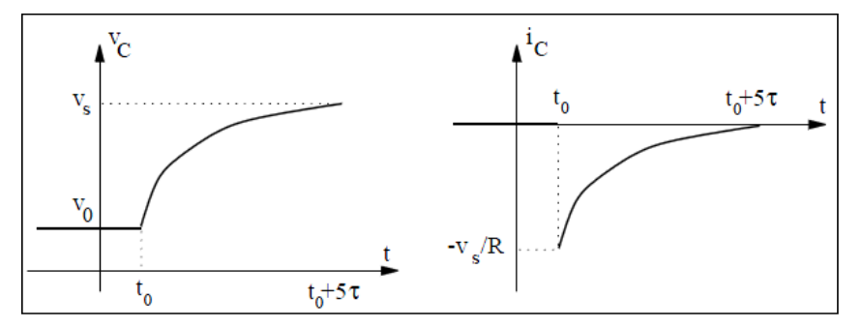

However, if the switch was closed at time t=t0 then the voltage on the capacitor would be as the following.

$$V_{C}\left(t\right)=V_{C}(∞)+[V_{C}\left(0^{+}\right)-V_{C}(∞)]e^{-\frac{(t-t0)}{τ}}$$

**Step response of an RL circuit:**

If we take the RL circuit in the following figure:

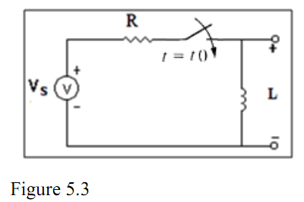

When we close the switch at time t=t0 the inductor will have an initial current of $I_{L}(t_{0}^{-})$. Now, what left is finding the waveform of the inductor current, which will have the same procedure as the one in the capacitor circuit. Anyhow we can use the above equation as a general response equation and substitute to find the response of interest which is IL , but the difference is that the time constant is $τ=\frac{L}{R}$. Finally, when we leave the circuit for a long time or mathematically until t🡺∞ the circuit will have reached a steady state condition. The inductor will be replaced with a short and IL(∞) = is=Vs/R.

Where this will also lead to,

$$I_{L}\left(t\right)=I_{L}\left(∞\right)+\left[I_{L}\left(0^{+}\right)-I_{L}\left(∞\right)\right]e^{-\frac{\left(t-t0\right)}{τ}} t≥t0$$

**Procedure:**

**Part A: Step response of First-order RC circuit:**

* The circuit of figure (6) was connected and the function generator was set to produce a square wave with a frequency 50Hz and a peak-to-peak voltage of 8V.
* The oscilloscope was set to display the Figure (6): series RC circuit. wave form Vc(t) produced by the circuit in figure (6).
* The voltage Vc(t) was drawn using the oscilloscope, and the drawing was used to find the time constant of the circuit τ.
* The time constant and the actual value of the resistor plus output of the function generator were used to find the value of capacitance C.

**Part B: Step response of First-order RC circuit:**

* The circuit of figure (7) was connected and the function generator was set to produce a square wave with a frequency 50 Hz and a peak-to-peak voltage of 8 V.
* The oscilloscope was set to display the Figure (7): series RC circuit. wave form VR (t) produced by the circuit in figure (7).
* The voltage VR (t) was drawn using the oscilloscope, and the drawing was used to find the time constant of the circuit τ.
* The time constant and the actual value of the resistor plus the output resistance of the function generator were used to find the value of the capacitance C.

**Part C: Step response of First-order RL circuit:**

* The circuit of figure (8) was connected and the function generator was set to produce a square wave with a frequency 50 Hz and a peak-to-peak voltage of 8 V.
* The oscilloscope was set to display the Figure (8): series RL circuit. wave form VL (t) produced by the circuit in figure (8).
* The voltage VL (t) was drawn using the oscilloscope, and the drawing was used to find the time constant of the circuit τ.
* The time constant and the actual value of the resistor plus the output resistance of the function generator were used to find the value of the inductor L.

**Part D: Step response of First-order RL circuit:**

* The circuit of figure (9) was connected and the function generator was set to produce a square wave with a frequency 50 Hz and a peak-to-peak voltage of 8 V.
* The oscilloscope was set to display the wave Figure (9): series RL circuit. form VR (t) produced by the circuit in figure (9).
* The voltage VR (t) was drawn using the oscilloscope, and the drawing was used to find the time constant of the circuit τ.
* The time constant and the actual value of the resistor plus the output resistance of the function generator were used to find the value of the inductor L.

**Data:**

**Part A:**

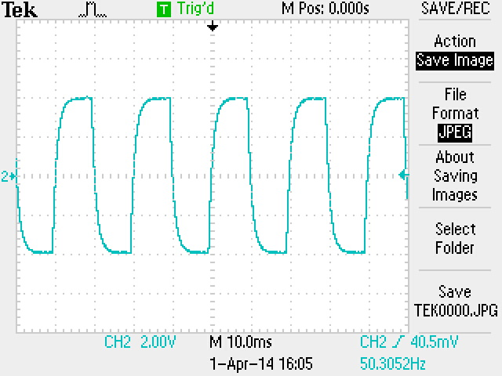

Using the following drawing we were able to measure the time constant using cursors. And it was found to be $τ_{c}=1.04 ms$

Function Generator Resistance= 48.3 Ω measured.

Actual Value of the resistor=9.5kΩ So R=9.5k+48.3=9.55kΩ. Now using these values we can compute $τ_{c}=RC=>C=\frac{τ_{c}}{R}=\frac{1.04 ms}{9.55k}=0.109μF$

**Part B:**

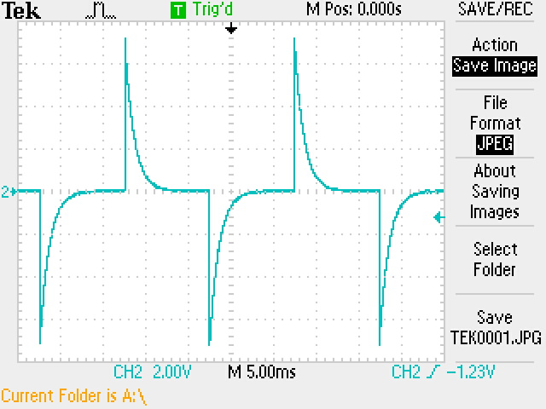

Using the following drawing we were able to measure the time constant using cursors. And it was found to be $τ_{c}=1.02 ms$

Function Generator Resistance= 48.3 Ω measured.

Actual Value of the resistor=9.5kΩ So R=9.5k+48.3=9.55kΩ. Now using these values we can compute $τ_{c}=RC=>C=\frac{τ_{c}}{R}=\frac{1.02 ms}{9.55k}=0.107μF$

**Part C:**

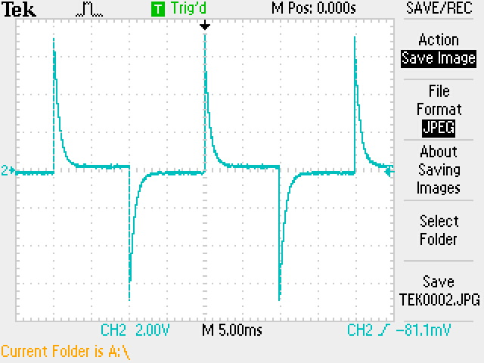

Using the following drawing we were able to measure the time constant using cursors. And it was found to be $τ_{L}=760 μs$

Function Generator Resistance= 48.3 Ω measured.

Actual Value of the resistor=98.1 Ω So R=98.1 +48.3=146.4 Ω. Now using these values we can compute $τ_{L}=\frac{L}{R}=>L=τ_{L}R=\left(760μ\right)\left(146.4\right)=111.3 mH$

**Part D:**

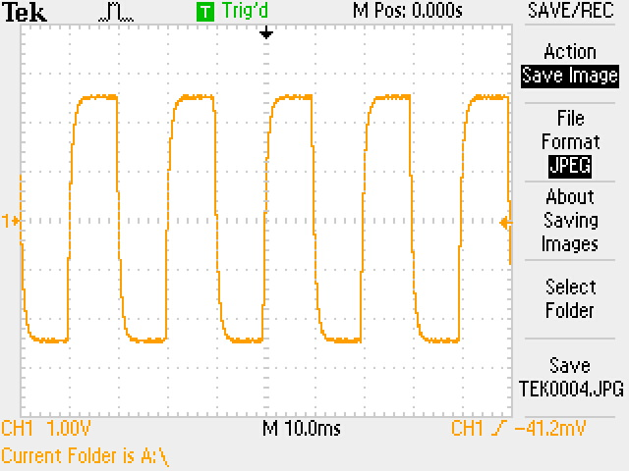

Using the following drawing we were able to measure the time constant using cursors. And it was found to be $τ_{L}=1.2 ms$

Function Generator Resistance= 48.3 Ω measured.

Actual Value of the resistor=98.1 Ω So R=98.1 +48.3=146.4 Ω. Now using these values we can compute.