

**CIRCUITS AND ELECTRONICS LABORATORY**

**ENEE2103**

**ISLAM JIHAD**

**1191375**

**Exp #2**

**Sec 1**

**Instructor: Alhareth Zyoud**

**Date: 19/9/2021**

A. KVL,KCL

Rx=1k

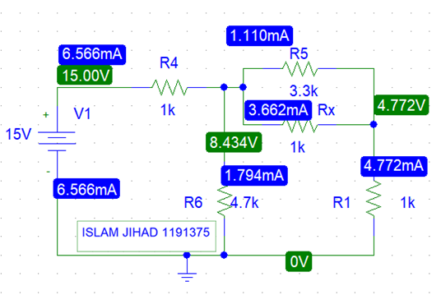

Rx=0.5k

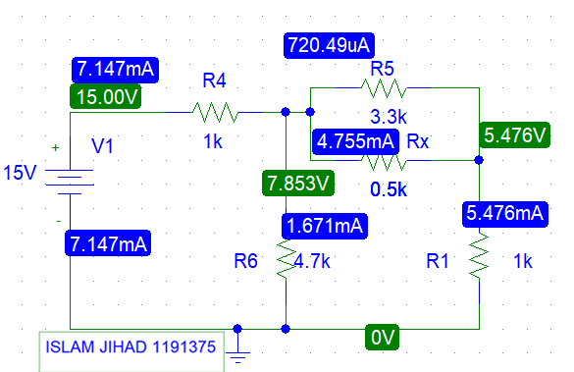

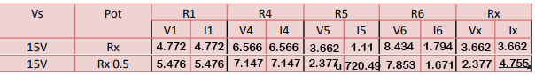

B. Voltage & Current Division:

I. Voltage division

Rx=1k

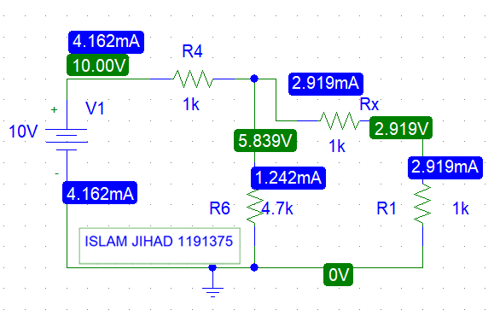

Rx=0.5k

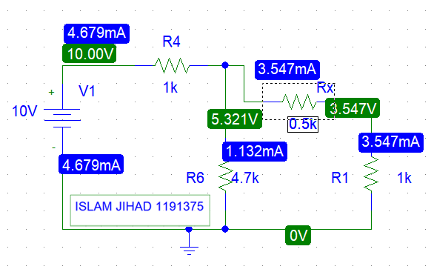

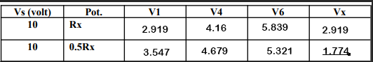

II. Current division

Rx=1k

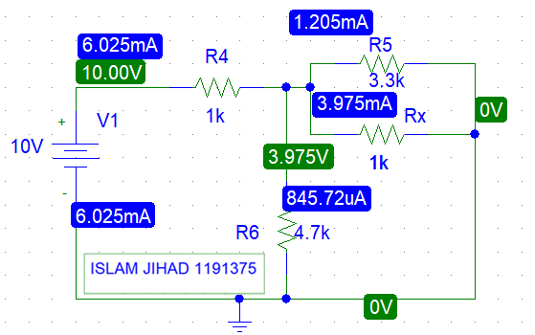

Rx=0.5k

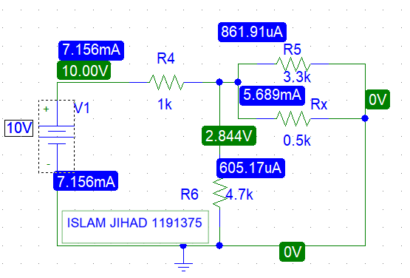

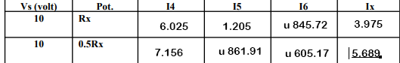

C. Superposition

Vs1 to 5 volts and Vs2 to 10 volts:

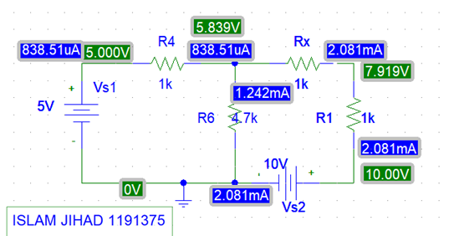

Vs1 = 0v, Vs2 = 10v:

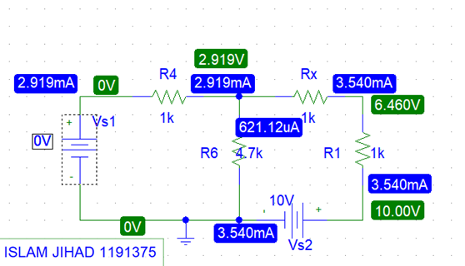

Vs1 = 5v, Vs2 = 0v:

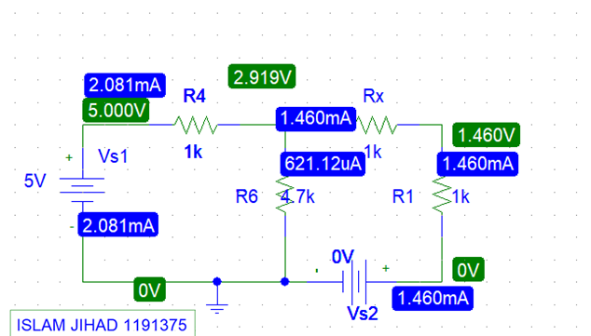

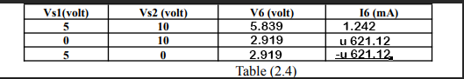

D. Thevenin and Norton equivalent circuits

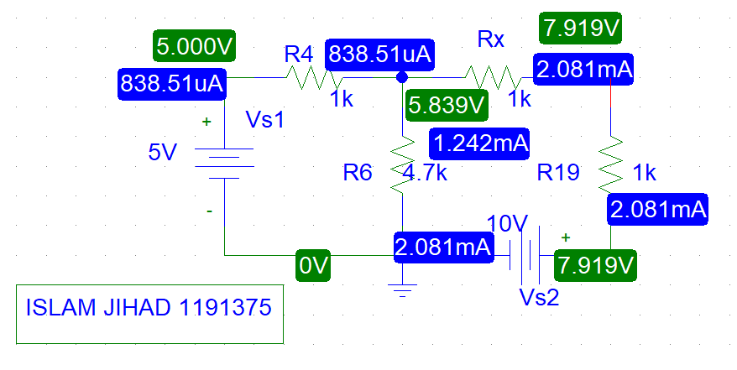

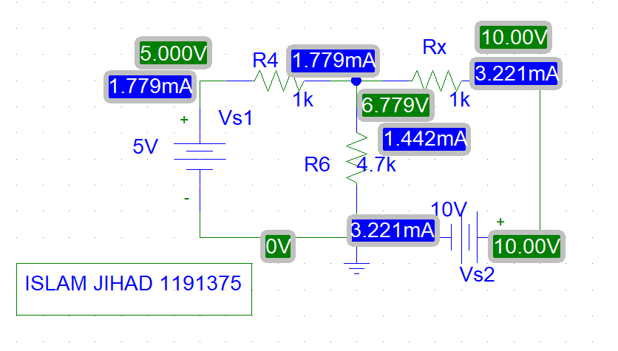

2. Vr1= -2.11v

3. Voc= -5.99v

4. Ioc= -3.23mA

6. Rth= 1.81KΩ

8. Inn= -5.98v

10. Isc= -3.28mA

-2.1v