
Department Of electrical and computer Engineering
ENEE2103 CIRCUITS AND ELECTRONICS LABORATORY
Experiment No.6 Prelab
Insructer: Dr. Alhareth Zyoud
Made By: Islam Jihad
ID: 1191375
TA: MR. Ismail Abualia
Date: 26/09/2021

I. DIODE CHARACTERISTICS
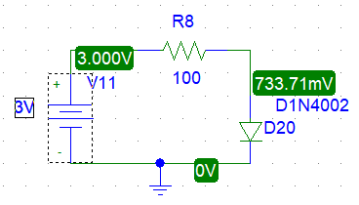

V_{S} | VR | V_{D} | I_{D}
0 | almost zero | almost zero | 0A
0.2 | 0.007mV | 199.93mV | 684.15nA
0.4 | 3.23mV | 396.77mV | 32.71uA
0.6 | 56.46mV | 543.54mV | 564.59uA
0.8 | 193.28mV | 606.72mV | 1.933mA
1 | 361.16mV | 638.84mV | 3.612mA
1.5 | 819mV | 681mV | 8.19mA
2 | 1295.32mV | 704.68mV | 17.79mA
2.5 | 1778.88mV | 721.12mV | 17.79mA
3 | 2266.29mV | 733.71mV | 22.66mA
After reversing the diode, on paper: the diode will act as open circuit sense it is reversed because the voltage on the anode is more than the voltage on the cathode. Practically on PSpice a small amount of current (almost zero) will go through the current which is called reverse saturation current.
II. RECTIFICATION
- HALF - WAVE RECTIFICATION.
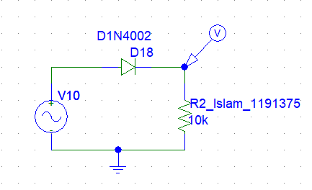
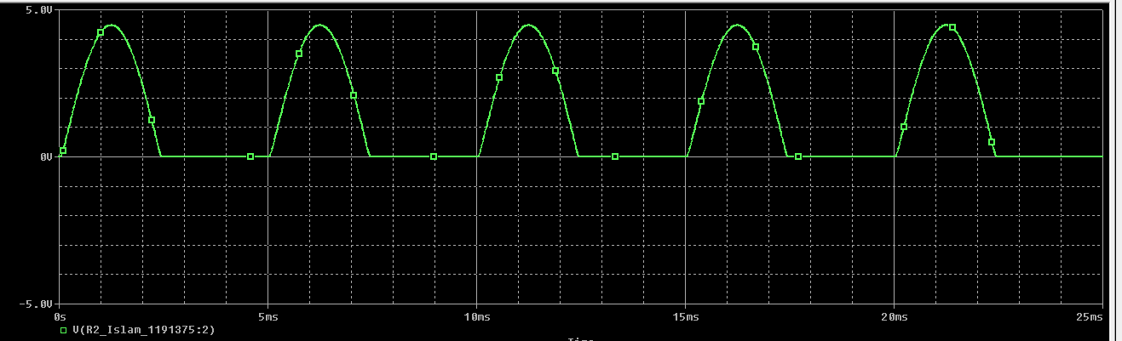

Last cycle:
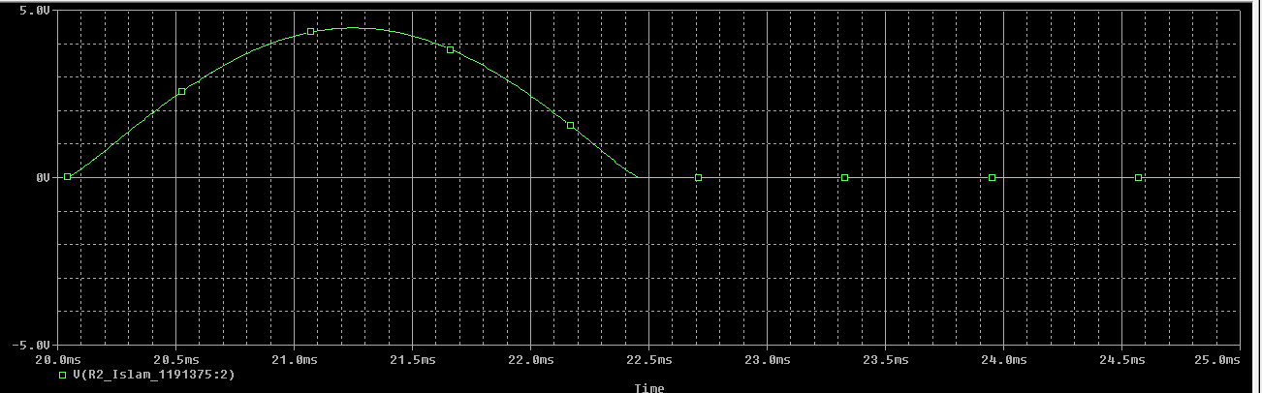
Using cursor VP=4.4685V and T=5ms equal to the source.
VDC=0.318Vm=0.318x4.4685=1.42V
After reversing the diode, the rectifier will pass the negative waves as shown below

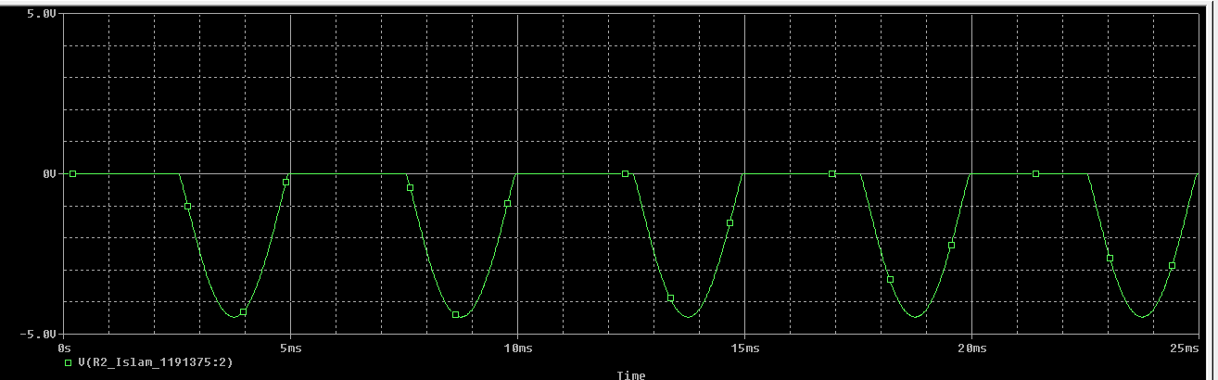
After putting the capacitor
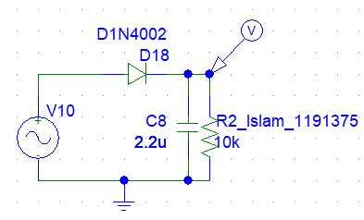
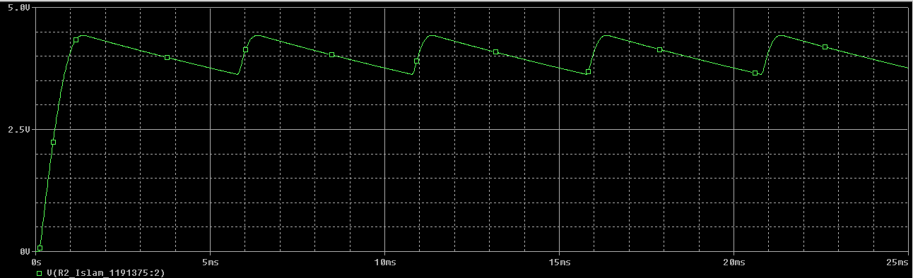
Last cycle:
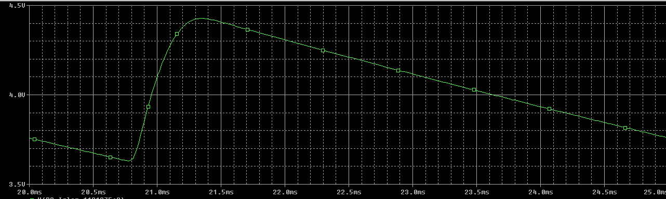
V_{lrp}-p=4.4273-3.6310 =0.7963 (From Slides) (Max and Min Value)
VDC=4.4272-0.5x0.7963 =4.028V
The Value of the capacitor was set to 47uF.

- FULL-WAVE RECTIFICATION:
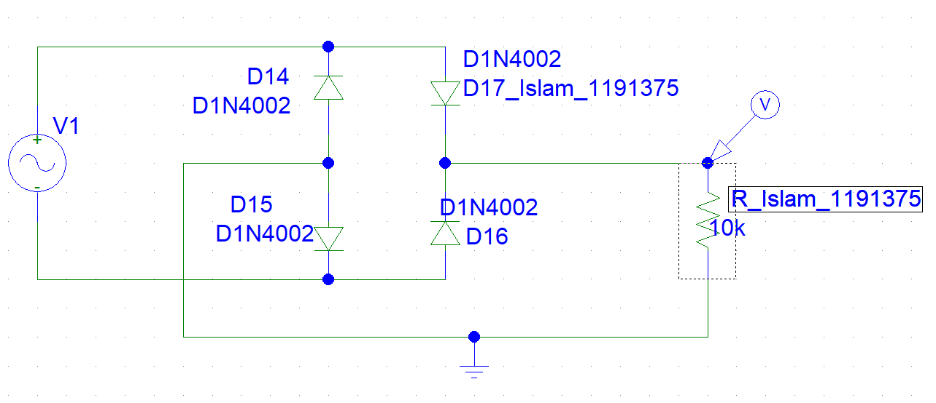
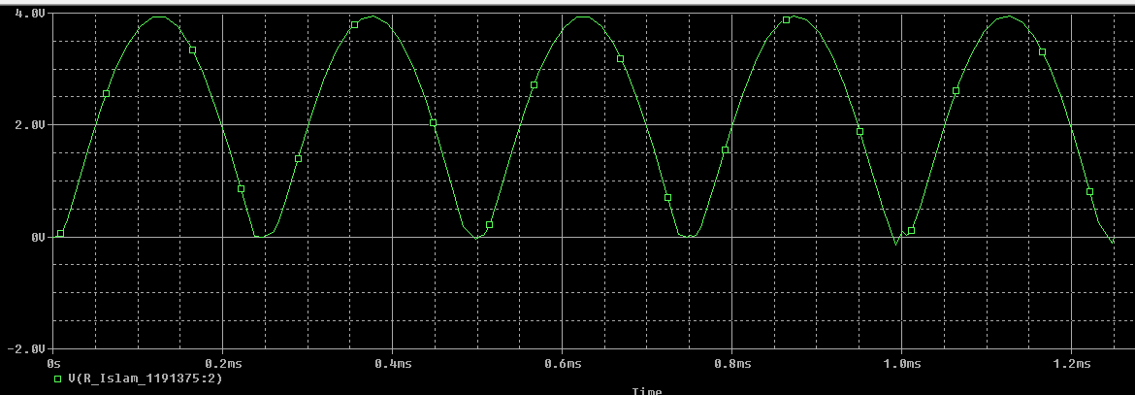
Last cycle:
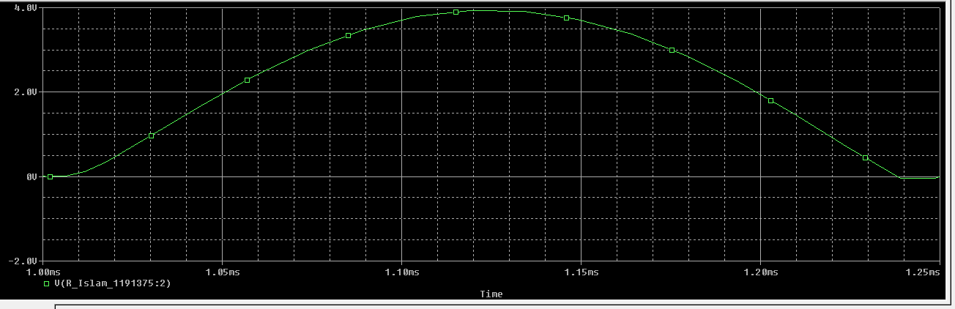
T=t0/2 =1/2000x2=0.25ms
Vp=3.978V
VDC=0.636Vp=2.52V
The 2.2uF capacitor connected:
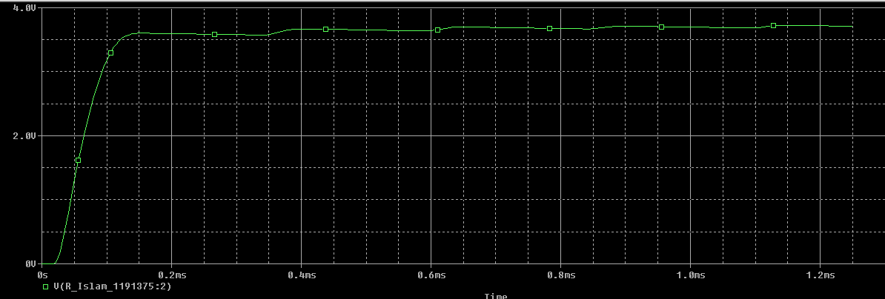
V_{lrPP}= 3.653 -3.443=0.0210V
VDC=8.6038-0.5x0.0210=8.3218V
V_{lrms}=v_{lrpp}/2sqrt3=0.0210/2x1.732=8.87x10⁻³
r%=vlrms/Vdc=0.23%
the ripple is small, so the simulation of the graph was close to DC

III. other applications:
- clipping: VDC=0
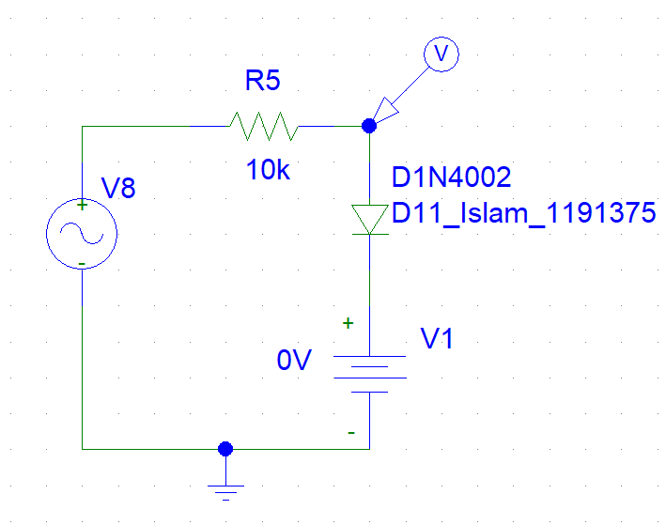
V_{DC}= 0V
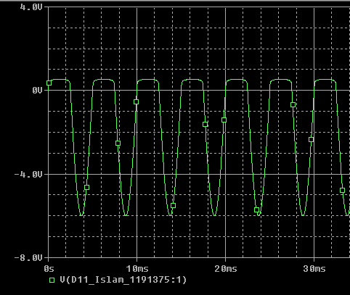
V_{DC}= 1.5V

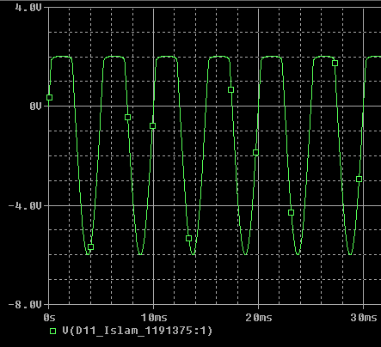
V_{DC}= 3.5V

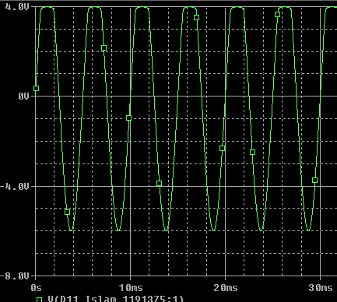

- Clamping:
V_{DC}= 0V
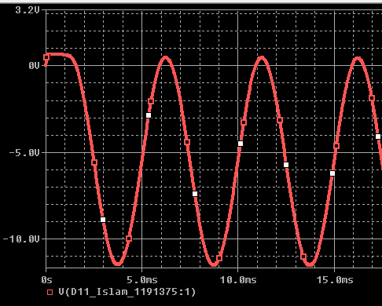
V_{DC}= 1.5V
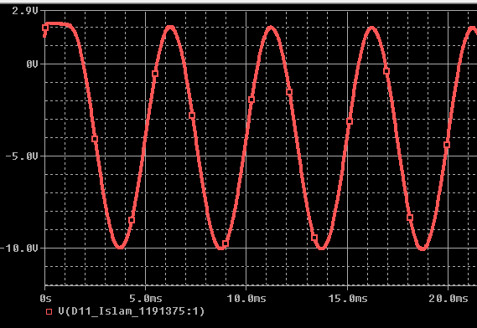
V_{DC}= 3.5V
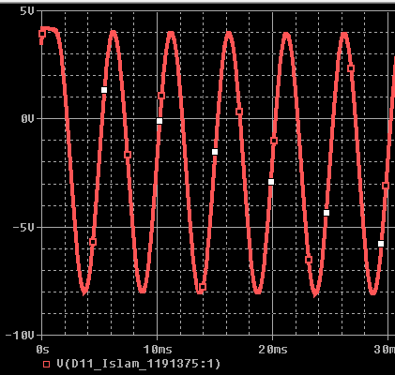

- VOLTAGE MULTIPLIER CIRCUITS
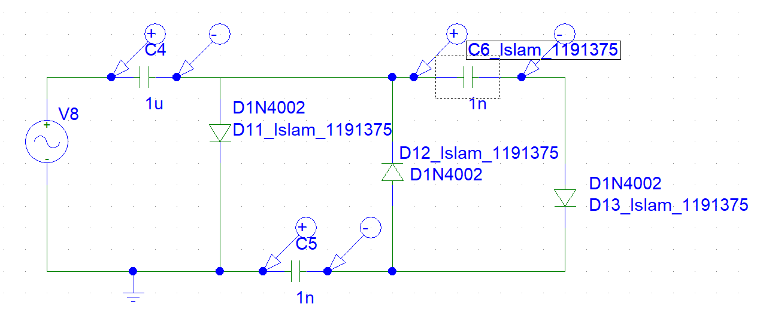
green is the voltage across C4, blue is the voltage across C5, red is the voltage across C6
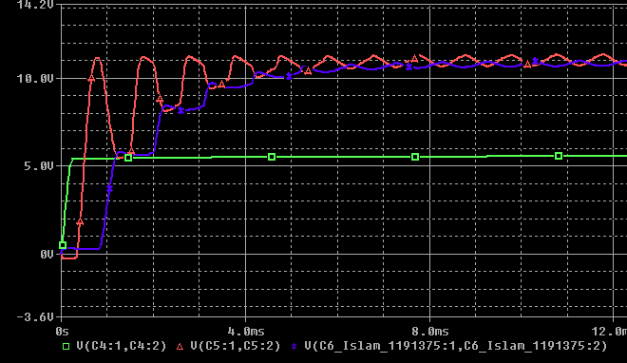
C1+C3
