
Department Of electrical and computer Engineering
ENEE2103 CIRCUITS AND ELECTRONICS LABORATORY
Experiment No.7 Prelab
Instructor: Dr. Alhareth Zyoud
Made By: Islam Jihad
ID: 1191375
TA: MR. Ismail Abualia
Date: 3/10/2021

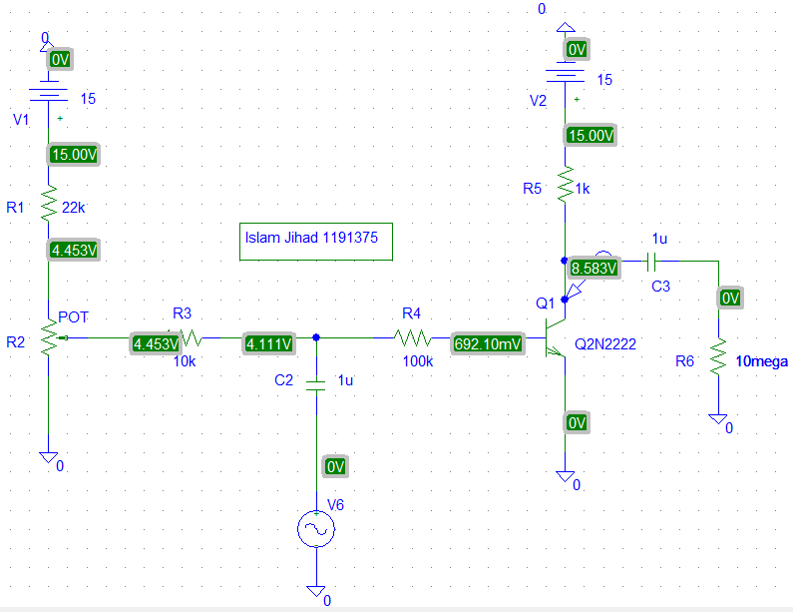
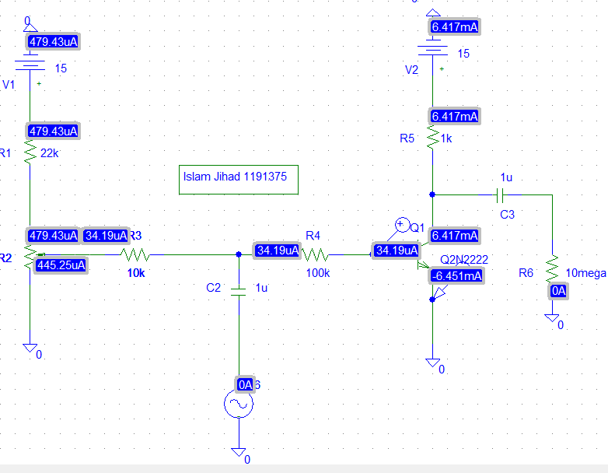
Vce=8.5828V
Vbe=0.7V

Vin=1:
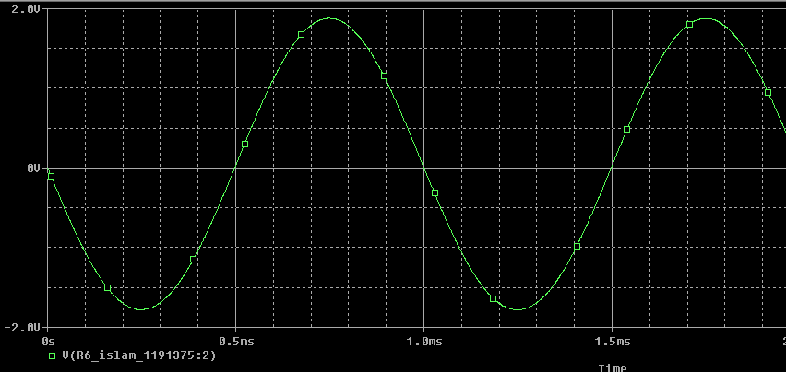
Changed the amplitude for Vin to 1V
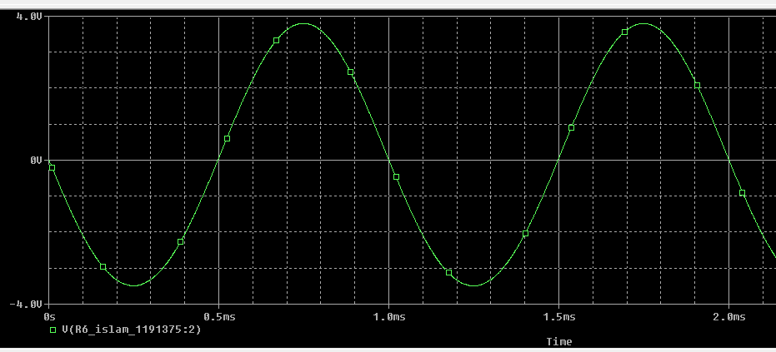

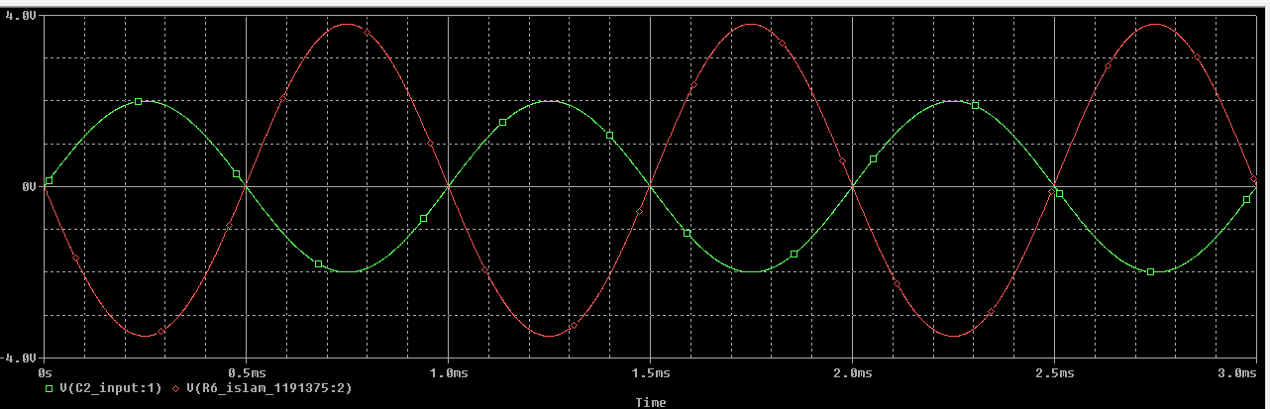
Av = Vo (t) / Vi (t)
Av=4/2=2v

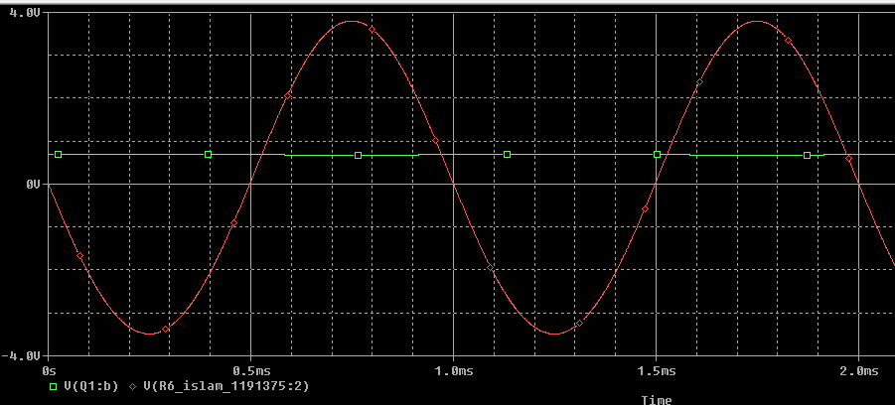
Av₁ = Vo (t) / V_{B} (t)
Av1= 4/0.7=5.71V
7.
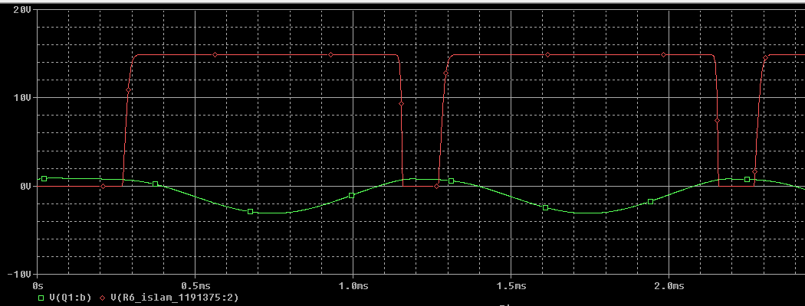

- COMMON COLLECTER TRANSISTOR AMPLIFIER.

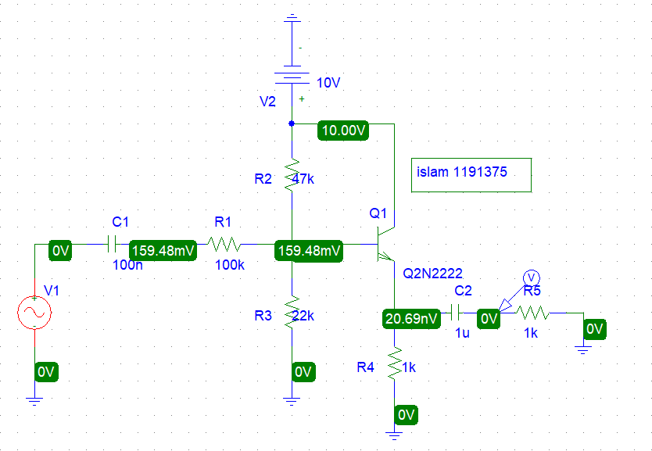
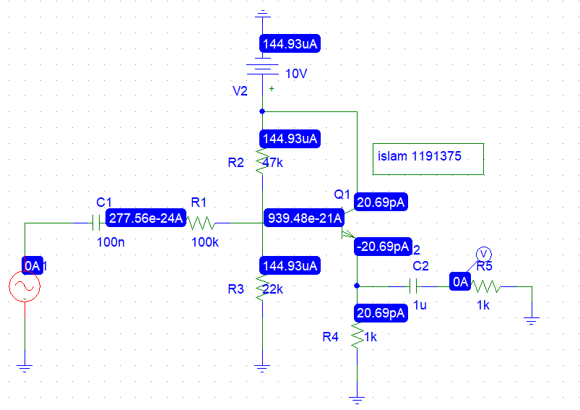
The output=2 when the Vsin amp=5.2
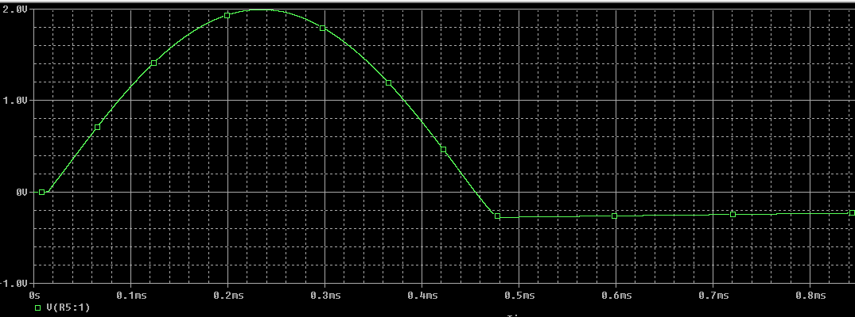

The needed input ac value:
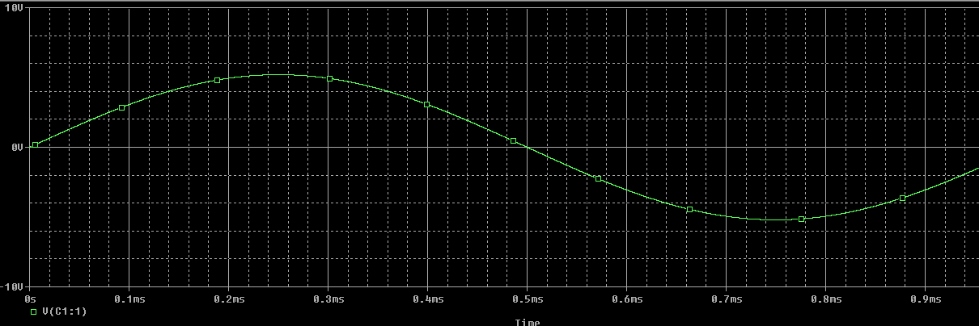

Quantity | Measured values
V_{in}
V_{out}
i_{in}
i_{out}
 | Calculated values
A_{V}=V_{out}/V_{in}
A_{i}=i_{out}/i_{in}
Z_{in}=V_{in}/i_{in}
Z_{out}
