Department Of electrical and computer Engineering

ENEE2103 CIRCUITS AND ELECTRONICS LABORATORY

Experiment No.9 report

Instructor: Dr. Alhareth Zyoud

Made By: Islam Jihad

ID: 1191375

TA: MR. Ismail Abualia

Date: 31/Oct/2021

**abstract**

In this experiment we will learn about multistage amplifier, what it do ,from what it consists of ,how to calculate the overall gain and sees the frequency response.

**TABLE OF CONTENTS**

1. Theory……………………………………………………………………4
2. Procedure & Calculations………………………………………………..5
3. first stage amplifier………………………………………………………………..6
4. second stage amplifier…………………………………………………………….8
5. first and second stage together…………………………………………………...10
6. Frequency response………………………………………………………………12
7. Questions………………………………………………………………..13
8. Conclusion………………………………………………………………15
9. References………………………………………………………………16

**Theory**

A multistage amplifier is an electronic amplifier consisting of two or more single-stage amplifiers connected. In this context, a single stage is an amplifier containing only a single transistor (sometimes a pair of transistors). The most common reason for using multiple stages is to increase the gain of the amplifier in applications where the input signal is very small or weak.

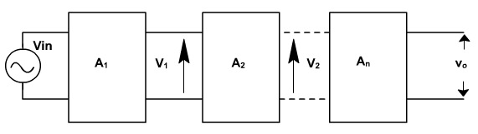

In Multistage amplifiers, the output of first stage is coupled to the input of next stage using a coupling device, These coupling devices can usually be a capacitor or a transformer. This process of joining two amplifier stages using a coupling device can be called as Cascading.

The overall gain is the product of voltage gain of individual stages.

Av = Av1 * Av2 * Av3 * Av4*….. *Avn.

The frequency response of an amplifier refers to the frequency range in which the amplifier will operate with negligible effects from capacitors and device internal capacitance. This range of frequencies can be called the mid-range.

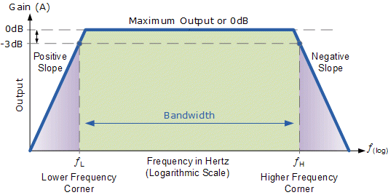

The mid-range frequency range of an amplifier is called the bandwidth of the amplifier, The bandwidth is defined by the lower and upper cutoff frequencies, Cutoff – any frequency at which the gain has dropped by 3 dB or 0.707A(mid).

**Procedure and Discussion**

The first stage:

We connected the circuit as shown

The input was 50mV

Vout is the blue.

Vin is the yellow

Av must be 35 but we got 22.5 in lab

|  |  |  |
| --- | --- | --- |
|  | The values I got from the  lab | The values I  got from the simulation |
| VB | 2.27 V | 2.986 V |
| VE | 1.57 V | 2.321 V |
| VCE | 7.77 V | 6.595 V |
| Vin(Amp) | 50mV | 10mV |
| Vout(P-P) | 1.08 V | 0.722 V |
| Av = Vout  / Vin | 22.5 | 36.12375 |

They are almost the same if we looked at the output if the input was equal.

The second stage:

The output is double the input

|  |  |  |
| --- | --- | --- |
|  | The values I got from the  lab | The values I  got from the simulation |
| VB | 2.23 V | 2.206 V |
| VE | 1.6 V | 1.531 V |
| VCE | 5.12 V | 4.416 V |
| Vin(Amp) | 1.08 V | 250mV |
| Vout(P-P) | 2.16 V | 1.042 V |
| Av = Vout  / Vin | 2 | 2.101 |

The first and second stages together:

As seen we got the double twice from the input in the 2stage amplifier 0.5V *2*2=2V

• What is the voltage gain of the two-stage amplifier?

Av= 43.2V

• What would happen if the coupling capacitor used did not have

negligible impedance at 1 kHz?

Capacitor provide open circuit, and to extract the output signal ,if it not has the negligible impedance ,then outputs will be useless , because of the DC voltage flow to the next stage and change its Q point.

**Frequency response:**

**Questions:**

• Does the output amplitude vary with frequency?

Yes.

• What happens to the output amplitude at low frequency?

It goes low

• What causes this effect at low frequencies?

The three capacitors.

a combination of three high-pass filter networks that allow signals having frequencies greater than the cutoff frequency of the dominant network to pass through while attenuating all others.

• What would you expect happen to the gain of the circuit at high

frequencies?

The gain decreases.

• Between which frequency limits does the amplifier have a constant gain?

300Hz – 100kHz

• At which frequencies is the gain 0.707 times the maximum gain?

0.707 * A(max) = 0.707 * 44 = 33.88

F $≅$ 75///1500K Hz

• What is the difference between these two frequencies? Mark these two points on your graph.

**Conclusion**

In this experiment we learned how multistage works and how to multiple it and make a bigger voltage from a small voltage input and how to calculate the gain and proved that the overall gain equal the multiply of each amplifier gain and calculate the lower & higher cutoff frequencies.

**References**

Dr. Nasser Ismail Slides and the manual PDF file