

**Faculty Of Information Technology**

**Electrical and Computer Engineering Department**

**CIRCUITS AND ELECTRONICS LABORATORY (ENEE2103)**

**Prelab Experiment#2**

**“Circuit Laws & Theorems”**

**Instructor: Dr.** **Wael Hashlamoun**

**Teacher: Eng. Mostafa Helal**

**Student Name: Mays Sbaih**

**Student Number:1160006**

**Section 3**

**Due to:17-2-2019**

# Part A: KVL & KCL

Bias simulation:

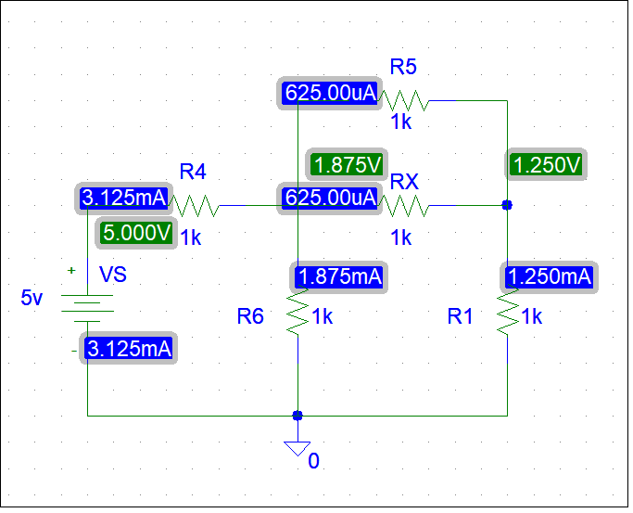

Fig A

# Part B: Voltage & Current Division

# Current Division

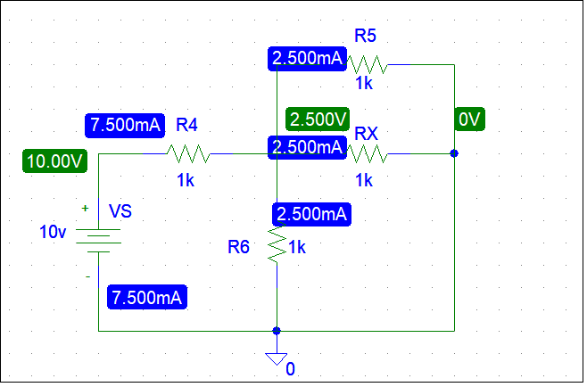

Fig B

# Part C: Superposition

* Vs1 = 5v, Vs2 = 10v >> VR6 = 4v & IR6 = 4mA

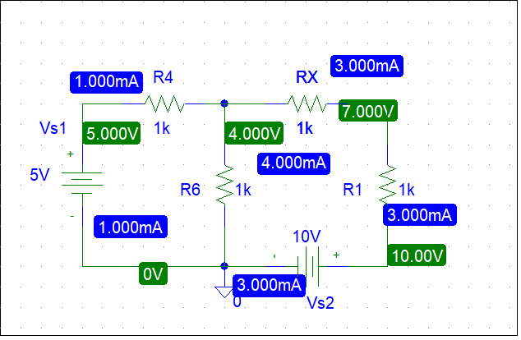

Fig C.1

* Vs1 = 0v, Vs2 = 10v >> VR6 = 2v & IR6 = 2mA

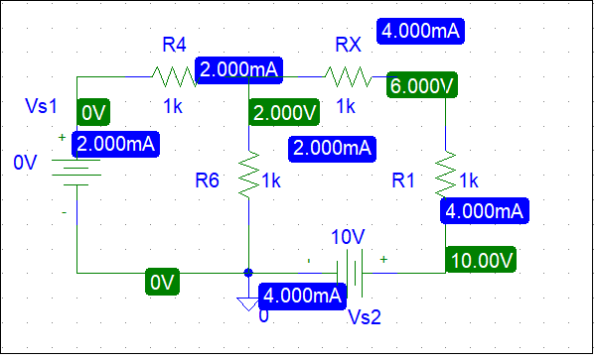

Fig C.2

* 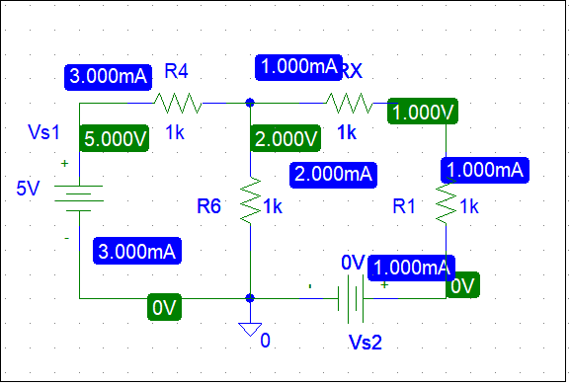Vs1 = 5v, Vs2 = 0v >> VR6 = 2v & IR6 = 2mA

Fig C.3

# Part D: Thevinin and Norton equivalent circuits.

# Current on R1 =3mA, and the voltage across R1= 7v – 10v = -3v.

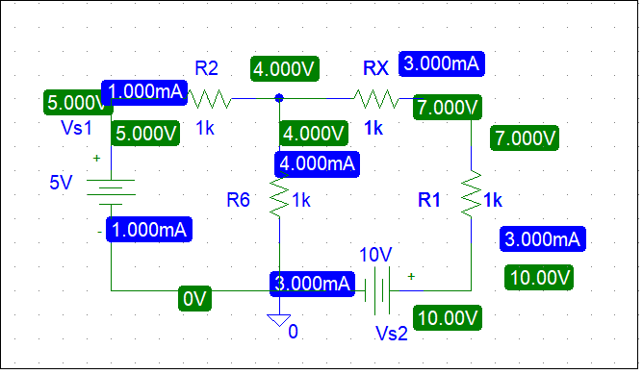

Fig D.1

* Open Circuit:

To measure Roc, I set the resistance on high value, Roc = 2.5 - 10 = -7.5v.

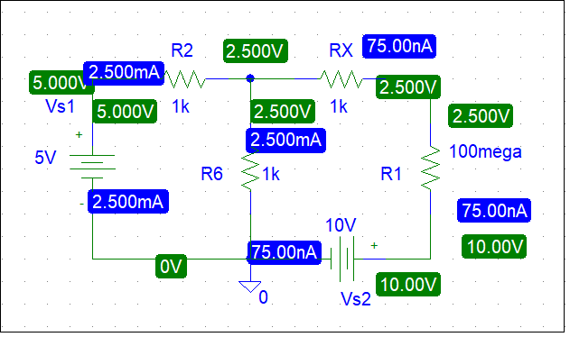

Fig D.2

* Short circuit:

Isc = -5mA.

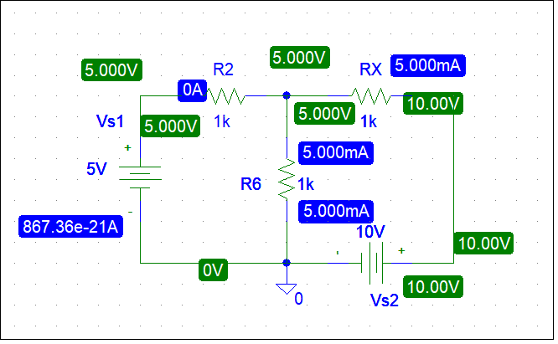

Fig D.3

* without terminals:

Rth = (R2//R6) + Rx = 1.5k.

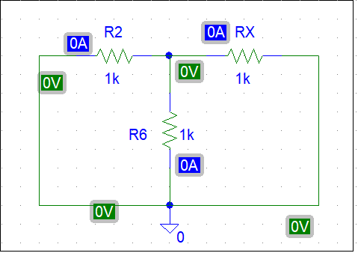

Fig D.4

* Equivalent Thevenin Circuit:

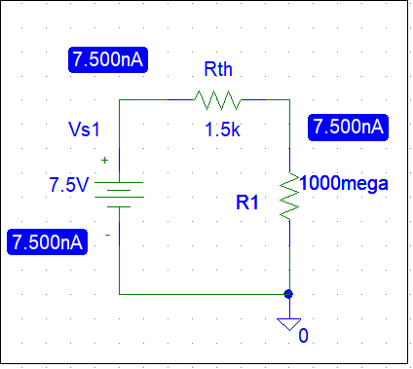

Fig D.5

* After connect R1:

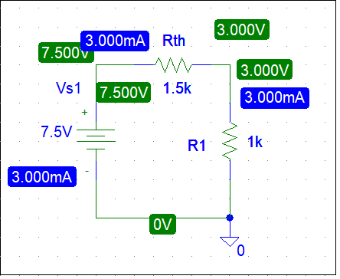

Fig D.6

The voltage across R1 =3 volt and this value is equal to the value we measured o step 2.

* After this comparison we conclude that the relationship between the two circuits is equivalent circuits but with different design.