**Prelab Instructions For Experiment#3 ENEE2103**

**First and Second Order Circuit**

**Pre-lab:**

1. Simulate the circuits in the procedure section and determine the required values)

# RC Circuit:

# Connect the circuit of Fig (3.1 in Pspice

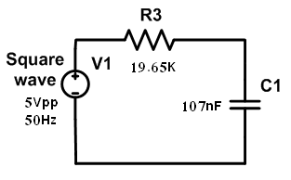

Fig (3.1)

1. Use Vpulse to replace the square wave with the following setting:

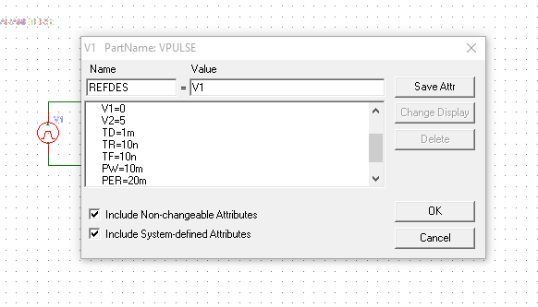

PER=period=1/f=1/50=20m

PW= pulse width=0.5T=10m

1. Run transient analysis, make sure to adjust Final Time( at least one period of the signal) and Step ceiling to 1% of the period or less

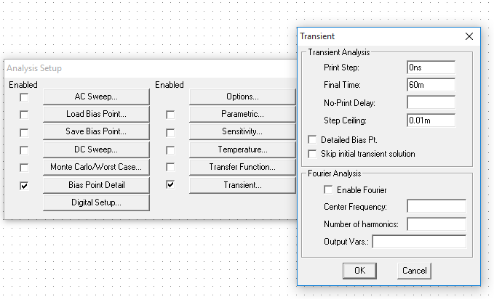

1. Plot the voltage across the capacitor and measure value of time constant on the plot using cursors

# RL Circuit:

# Connect the circuit of Fig (3.2) in Pspice.

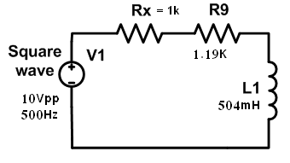

# Set the signal generator to generate a periodic square waveform from 0 to10V and f=500Hz

# Run transient analysis and display voltage and current responses of the inductor.

# Measure the time constant of the circuit and the steady state values of the voltage and current responses.

1. Change the period of the periodic square wave to T=2τL and repeat steps above.

# RLC Circuit:

1. **Response type:**

# Connect the circuit of Fig (3.3) in Pspice

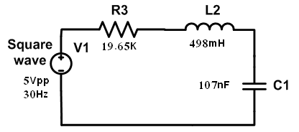

Fig (3.3)

1. Display the voltage across the capacitor.
2. From the plot, determine the type of the response. (under, over or critically damped)
3. Calculate R3 to give critically damped response ( Note that Rcritical will result in two equal roots S1=S2=-)
4. Run parametric + transient analysis with varying R3 with 3 values corresponding to critical damping, underdamped and overdamped responses
5. **Response parameters:**
6. Set the value of R3 to get an under damped response
7. Make sure to use the cursor to measure the decay-envelope time constant (), the damping coefficient () and the damped frequency (d)
8. Double the value of C1 and Measure the parameters defined in step2 noting the effect
9. Reset the capacitance to its initial value
10. Reduce value of L2 to half its value and note the effect on previous parameters

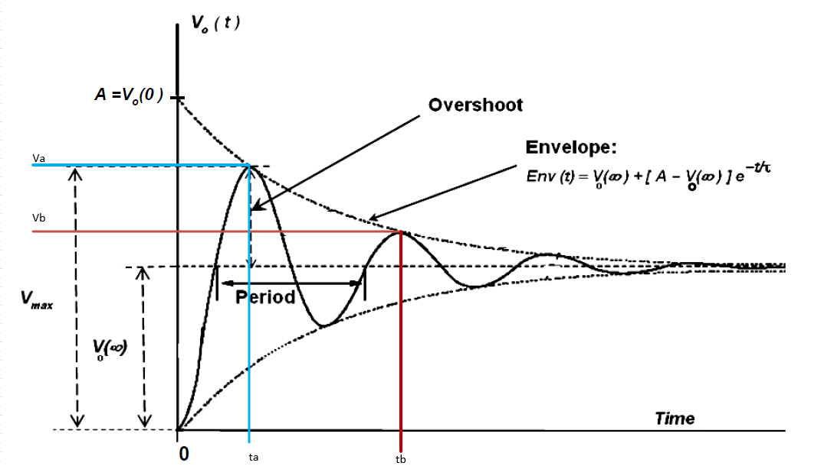

$$ω_{o}=\frac{1}{\sqrt{LC}}=20025$$

Decay time constant $τ=\frac{t_{b}-t_{a}}{ln\left(\frac{V_{a}-V_{o(∞)}}{V_{b}-V_{o(∞)}}\right)}$

Damping Coefficient $α=\frac{1}{τ}$

Damped radian frequency $ω_{d}=\frac{2π}{t_{b}-t_{a}}$

**Additional Info**

**For series RLC**

$$ω_{o}=\frac{1}{\sqrt{LC}}$$

$α<ω_{o}$ $→$ We have under damped case:

$$α>ω_{o} → over-damped case$$

$α=ω_{o} → Critically-damped case$

$α=\frac{R}{2L }$