

**Faculty of Information Technology**

**Electrical and Computer Engineering Department**

**CIRCUITS AND ELECTRONICS LABORATORY (ENEE2103)**

**Prelab Experiment#3**

**“First and Second Order Circuit”**

**Instructor: Dr.** **Wael Hashlamoun**

**Teacher: Eng. Mostafa Helal**

**Student Name: Mays Sbaih**

**Student Number:1160006**

**Section 3**

**Due to:25-2-2019**

# Part A. RC Circuit:

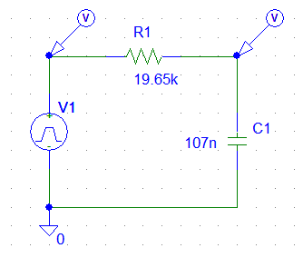

Steady state voltage value on the capacitor = 5 volt. To calculate time constant, we use the assumption that it is at charging when V(t) = 0.63*V max = 0.63*5 = 3.15v

* Time constant from Simulation =~ 3.0965 ms.
* Time Constant time from calculation (τ) = RC = (19.65k) (107nF) = 2.103 ms.

***Part B. RL Circuit:***

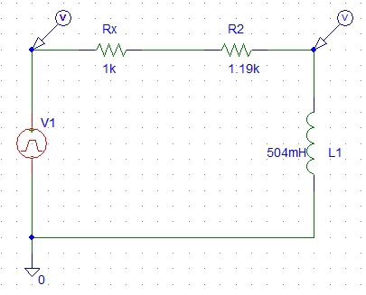

* When frequency = 500Hz.

Voltage response

To calculate time constant, we use the assumption that it is at discharging when V(t) = 0.37 V max = 0.37*10 = 3.7 volt

* Time constant from Simulation =~ 230.0 us.
* Time Constant from calculation = L/R = (504mH) / (2.19k) = 230.137 us.

Current response



* When T= 2*Time constant.
* Period T = 2*230.137 =~ 460 us.
* Frequency = 1/T = 2.17 mHz.

Current response



Voltage Response



# RLC Circuit:

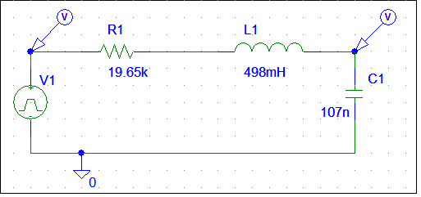



* Type of response is overdamping.

To find R that causes critical damping numerically:

Neper frequency (a) = R/2L, Wo = 1/sqrt (LC).

Critical damping when a2 = wo2 🡪 R = 2 sqrt(L/C) = 4314.7216 Ohm

* Critical Damping:
* Underdamping (R=500 Ohm)