

**Faculty of Information Technology**

**Electrical and Computer Engineering Department**

**CIRCUITS AND ELECTRONICS LABORATORY (ENEE2103)**

**Prelab Experiment#4**

**“Sinusoidal Steady State Circuit Analysis”**

**Instructor: Dr.** **Wael Hashlamoun**

**Teacher: Eng. Mostafa Helal**

**Student Name: Mays Sbaih**

**Student Number:1160006**

**Section 3**

**Due to:4-3-2019**

1. ***Impedance***:

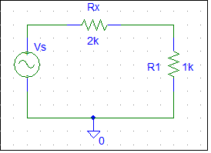

* ***Frequency = 1000Hz***.
* Total impedance = Vs/I = 3KΩ.



* Phase shift between V and I = 0. (since resisters do not result in phase shift).
* ***Frequency = 500Hz.***



* Total impedance = Vs/I = 3KΩ.



* Phase shift between V and I = 0.
* ***Frequency = 1500Hz.***



* Total impedance = Vs/I = 3KΩ.
* Phase shift between V and I = 0.
* **The impedance remains the same when frequency changes**

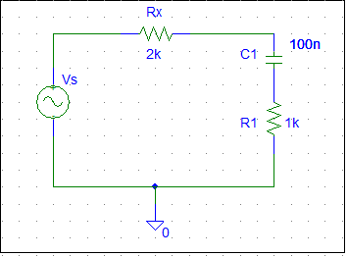

* ***Frequency = 1000Hz.***
* Phase shift theoretically = tan-1) ) = 27.9467 degree; since: R=3K, w = 2π $f$ = 2000π.
* Phase shift practically = ∆t*ω = (750.394 – 668.392) u *360* 1000 = 29.521 degree
* Zc = - $\frac{j}{ωc}$ = −1.592j kΩ.
* Total impedance = 3- 1.592j kΩ



* ***Frequency = 500Hz.***
* Phase shift theoretically = tan-1) ) = 46.696 degree; since: R=3K, w = 2π $f$ = 1000π.
* Phase shift practically = ∆t*ω = (2.5004 – 2.2404) m *360* 500 = 46.8 degree
* Zc = - $\frac{j}{ωc}$ = −3.1831j kΩ.
* Total impedance = 3- 3.1831j kΩ.



* ***Frequency = 1500Hz.***
* Phase shift theoretically = tan-1) ) = 19.478 degree; since: R=3K, w = 2π $f$ = 3000π.
* Phase shift practically = ∆t*ω = (1.4999 – 1.4639) m *360* 1500 = 19.44degree
* Zc = - $\frac{j}{ωc}$ = −1.061j kΩ.
* Total impedance = 3- 1.061j kΩ.



* ***Impedance is affected by frequency***

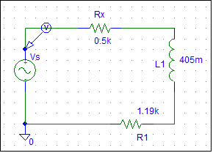

* ***Frequency = 1000Hz.***
* Phase shift theoretically = tan-1)- ) = -56.411 degree; since: R=1.69K, w = 2π $f$ = 2000π.
* Phase shift practically = ∆t*ω = (2.2503– 2.4063) m *360* 1000 = -56.16degree
* ZL = jwL= 2.545j kΩ.
* Total impedance = 1.69+2.545j kΩ.
* ***Frequency = 500Hz.***
* Phase shift theoretically = tan-1)- ) = -36.975 degree; since: R=1.69K, w = 2π $f$ = 1000π.
* Phase shift practically = ∆t*ω = (2.7051– 2.5001) m *360* 500 = 36.9 degree
* ZL = jwL= 1.272j kΩ.
* Total impedance = 1.69+1.272j kΩ.
* ***Frequency = 500Hz.***
* Phase shift theoretically = tan-1)- ) = -66.12 degree; since: R=1.69K, w = 2π $f$ = 3000π.
* Phase shift practically = ∆t*ω = (954.821– 833.819) u *360* 1500 = 65.34 degree
* ZL = jwL= 3.817j kΩ.
* Total impedance = 1.69+3.817j kΩ.



* ***impedance is changed when frequency is changed***

1. ***Capacitive and inductive behavior***:

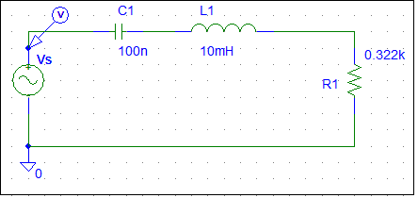

* ***Frequency = 400Hz.***



* Phase shift = ∆t*ω = (3.7821– 3.1250) m *360* 400 = 94.6224 degree
* Resonant frequency (fo) = = 5.33 KHz.
* ***Frequency = fo = 5.33KHz***
* Phase shift = ∆t*ω = (236.809– 234.809) u *360* 5.33k = 3.8376 degree.

The phase shift is very small we can ignore it.

* ***Frequency = 2fo = 10.66KHz***



* Phase shift = ∆t*ω = (273.574 – 210.572) u *360* 10.66k = 241.776 degree.
* ***After doubling the value of the capacitor (at Frequency = fo = 5.33KHz)***

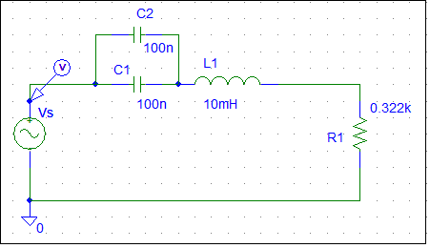



* Phase shift = ∆t*ω = (438.008 – 422.008) u *360* 5.33k = 30.7008 degree.
* ***After doubling the value of the Inductor (at Frequency = fo = 5.33KHz)***

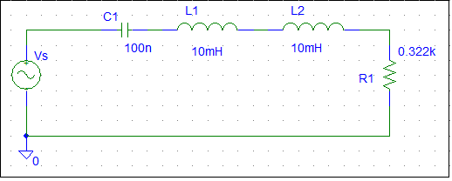



* Phase shift = ∆t*ω = (823.012 – 797.011) u *360* 5.33k = 49.891 degree.

1. ***Sinusoidal steady state power:***

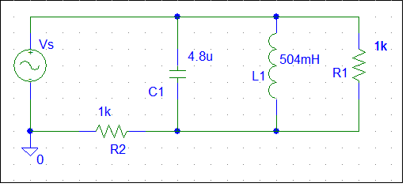

* Frequency = 2KHz.

V(R1):



I(R1):



Vs:



Is:



* Phase shift between Vs and Is = 0.



Vc:



Ic:



* Phase shift between Vs and Is = ∆t*ω = (3.7469 – 3.6229) m *360* 2k = 89.28.



VL:

IL:



* Phase shift between VL and IL = ∆t*ω = (1.3969 – 1.2439) m *360* 2k = 110.16.



V(R2):



I(R2) =Is:



* Phase shift between V(R2) and I (Rs2 = 0

