

**Faculty of Information Technology**

**Electrical and Computer Engineering Department**

**CIRCUITS AND ELECTRONICS LABORATORY (ENEE2103)**

**Prelab Experiment#5**

**“Filters”**

**Instructor: Dr.** **Wael Hashlamoun**

**Teacher: Eng. Mostafa Helal**

**Student Name: Mays Sbaih**

**Student Number:1160006**

**Section 3**

**Due to:11-3-2019**

# Passive filters:

1. 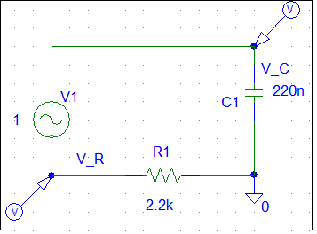**First order circuits:**

* Magnitude of VR and Vc in decibels:
* From the above plot, 3db cut-off frequency =~ 328.782 Hz.

Theoretically, 3db cut-off frequency = 1/ (2πRC) = 1/ (2π*2.2k * 220n) = 328.833 Hz.

* Phase of VR and VC in decibels:

1. 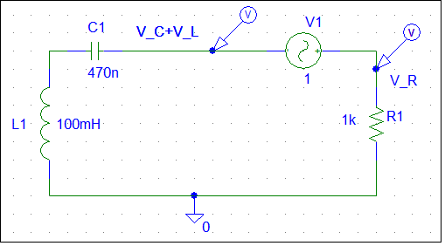**Second Order Filters:**

* Magnitude of V_R and (V_C + V_L) in decibels.



* Phase of VR and (Vc + VL).
* Plot of (VR/VI).

From plot above:

* Filter type is band-pass filter.
* fc1 = 287.171 Hz
* fc2= 1876.7 Hz
* fo = 726.752 Hz.
* Plot of ((VC +VL)/ Vi).

From plot above:

* Filter type is band-reject filter.
* fc1 = 286.629 Hz
* fc2= 1880.3 Hz
* fo = 726.752 Hz.
* Both plots of (VR / Vi) and ((VC + VL)/ Vi).
* Theoretically:

$f_{0}=\frac{1}{2Π\sqrt{LC}}$ = $\frac{1}{2Π\sqrt{100 mH x 470 nF}}$ = 734.13 Hz.

$f_{c1}=\frac{\begin{aligned}-\frac{R}{2L} +\sqrt{{\left(\frac{R}{2L}\right)}^{2}+\frac{1}{LC} }\end{aligned}}{2Π}$ = 286.907 Hz.

$f_{c2}=\frac{\begin{aligned}\frac{R}{2L} +\sqrt{{\left(\frac{R}{2L}\right)}^{2}+\frac{1}{LC} }\end{aligned}}{2Π}$ = 1878.456Hz.

# Passive filters:

* Magnitude of Vo in decibels.
* Phase of Vo.
* Magnitude-frequency Plot.



* From plot above:
* Filter type is low-pass filter.
* 3db cut-off (fc)= 328.292 Hz.

o Theoretically:

fc = 1/2πRC= 328.833Hz.