

**Faculty of Information Technology**

**Electrical and Computer Engineering Department**

**CIRCUITS AND ELECTRONICS LABORATORY (ENEE2103)**

**Prelab Experiment#6**

**“Diode Characteristic and Applications”**

**Instructor: Dr.** **Wael Hashlamoun**

**Teacher: Eng. Mostafa Helal**

**Student Name: Mays Sbaih**

**Student Number:1160006**

**Section 3**

**Due to:18-3-2019**

# Diode Characteristics:

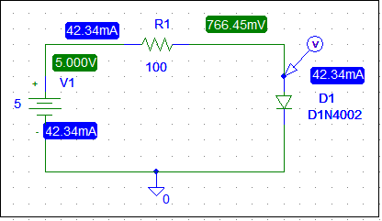

* VD



* VR1



* ID



* When diode is reversed:
* VD , VR1, V1



* ID



* When diode is reversed its voltage will always equal the input voltage since it is open.

1. ***RECTIFICATION.***
2. ***HALF - WAVE RECTIFICATION.***

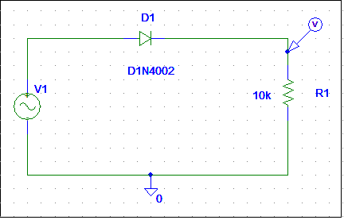

* Vout



* T period = 1/200 = 5ms.
* V pk =4.4685 volt.
* VDC = V pk /π = 1.4224 volt.
* We can obtain a negative voltage by reversing the diode as shown below:
* When adding a capacitor of 2.2µF to the circuit:

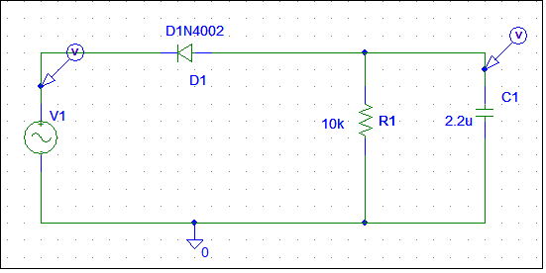

* Vout
* V p-p= 4.4272 – 3.6307 = 0.7965 volt.

o Mean value = Vm – ½ V p-p = 4.4272 – 0.39825 = 4.03 volt.

* When replacing the 2.2 µF capacitor by a much larger value of 47µF:



* V p-p= 4.3234 – 4.2810 = 0.0424 volt.

o Mean value = Vm – ½ V p-p = 4.3234 – 0.0212= 4.3022 volt.

* With lower value of capacitor, ripple is less and mean value is greater.

1. ***FULL-WAVE RECTIFICATION***

***Diode bridge circuit as a full wave rectifier***

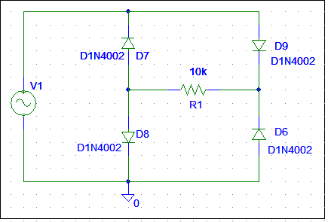



* T period= 2.3753 – 2.1253 = 0.25ms
* Vpk =3.9499volt.
* VDC = 2Vpk /π = 2.5146 volt.
* When adding capacitor = 2.2 uF.

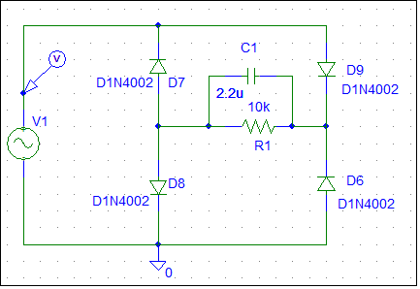



* Peak-to-peak voltage (Vp-p) = 3.743 – 3.7419 =~ 0.0011 volt.
* Mean value = V m – ½ V p-p = 3.743 – 0.0011 = 3.7441 volt.

1. **Other applications**
2. ***Clipping***

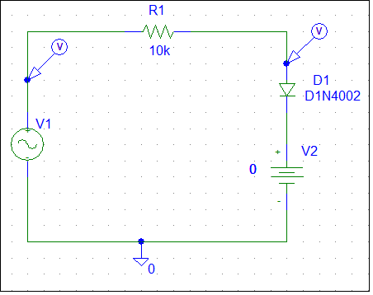

* When dc value equal 0V.



* When dc value equal 2V.



* When dc value equal 5V.



1. ***Clamping:***

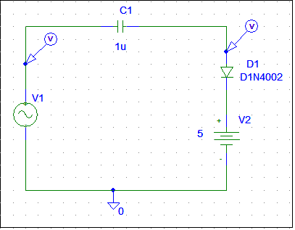

* When dc value equal 0V.



* When dc value equal 2V.



* When dc value equal 5V.



1. ***VOLTAGE MULTIPLIER CIRCUITS:***

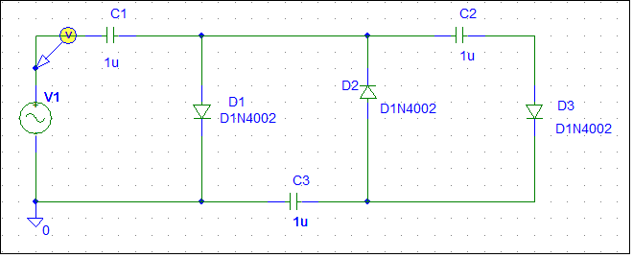

* Voltage across each capacitor.



* Voltage across C2+C3.