

**Faculty of Information Technology**

**Electrical and Computer Engineering Department**

**CIRCUITS AND ELECTRONICS LABORATORY (ENEE2103)**

**Prelab Experiment#7**

**“BJT Transistor as An Amplifier, CE, CC, CB Connection”**

**Instructor: Dr.** **Wael Hashlamoun**

**Teacher: Eng. Mostafa Helal**

**Student Name: Mays Sbaih**

**Student Number:1160006**

**Section 3**

**Due to:1-4-2019**

* ***Part I***

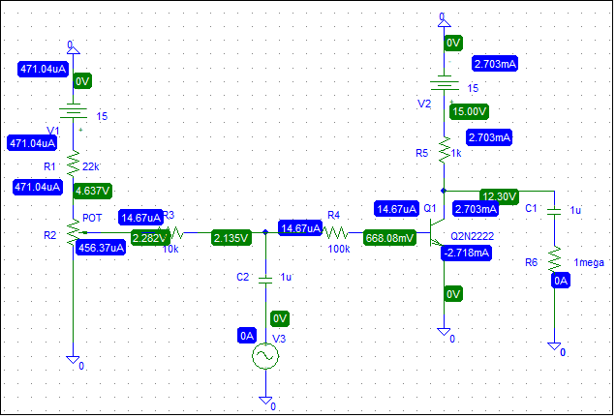

* **DC values:**

Vc = 12.30 volt.

VBE = 668.08mV

VCE = 12.30 volt

Ic = 2.703 mA

I B = 14.67 uA

* **For maximum Symmetrical Swing >> Q- point must be in the middle of AC load line:**

Rac = 1k // 1mega = ~ 1k

Rdc = 1 k

V CQ = V cc / (1+ R ac /R dc) = 15 / (1 +1) = 7.5 volt

I CQ = V cc / (R ac + R DC) = 15 / 2 = 7.5 mA

* **When amplitude of Vin = 1volt.**
* **To get an amplitude of 4 volt for Vo, we set amplitude of Vin= 2 volt (with Capacitor).**
* **when Removing capacitor:**

* **Av1 = Vo (t) / VB (t)**