

**Faculty of Information Technology**

**Electrical and Computer Engineering Department**

**CIRCUITS AND ELECTRONICS LABORATORY (ENEE2103)**

**Prelab Experiment#8**

**The Field-Effect Transistor**

**Instructor: Dr.** **Wael Hashlamoun**

**Teacher: Eng. Mostafa Helal**

**Student Name: Mays Sbaih**

**Student Number:1160006**

**Section 3**

**Due to:11-5-2019**

***I. CHARACTERESTICS OF AN N-CHANNEL JFET.***

* **Circuit:**

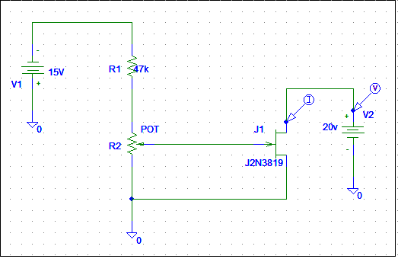

* **IDS as function of VDS:**
* Questions:
* **From your graph, above which values of VGS is ID almost unaffected by VDS when VGS=0?**

VGs = 0 approximately from figure above at VDS = 2v, when VDS = 2 IDS=3.7 mA.

* **For a given value of VDS, (say 10 V), do equal changes of VGS cause equal changes of ID?**

The change in VGS will not result equal changes of ID.

* **Can you measure IG or is it too small?**

We can note the value of IG too small.

* **From your graph, estimate the change in ID for 0.5 change in VGS when VDS =10 V, and VGS -1.0 V, then find the transconductance of the transistor(gm).**

Equation for gm is: gm = (2*𝐼𝐷𝑆𝑆/ |𝑉𝑃|) * (1- (𝑣𝑔𝑠 /𝑣𝑝)). Vp=2v, IDSS=3.7mA ->

gm=(2*3.7m/2) * (1-(1/2)) =1.85m >1.85m= ∆𝐼𝐷/ ∆𝑉𝐺𝑆. change in ID = 1.85m*0.5=0.925mA

***II. COMMON DRAIN AMPLIFIER.***

* **Circuit:**

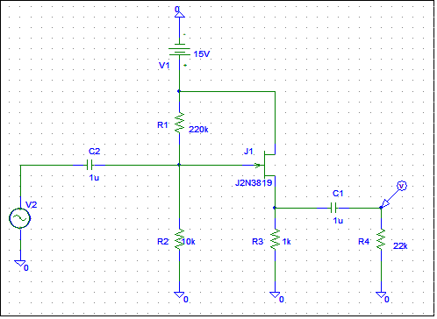

* **Perform bias point analysis and measure DC voltages of VG, and VS?**

**VG=652.17mV, VS=2.331V from figure below:**

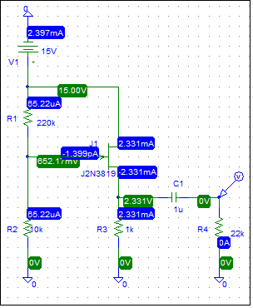

* **Simulation for transient analysis:**



* **Calculate the voltage gain and the phase shift between the input and output voltage?**

Phase shift=0. from graph.

Voltage gain = Vo/Vi= 150.779mm/200m=0.7538.

**Vin:**

ZI=VI/IIN = 200mv / 20.99uA = 9.528kohm

**Vout:**



ZOUT=VOUT/IOUT= (150.779mv/ 6.8338uA) = 22kohm.

***III. CONSTANT CURRENT SOURCE.***

* **Circuit:**

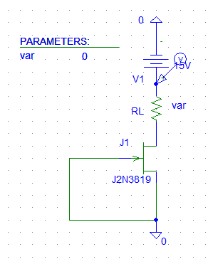

* 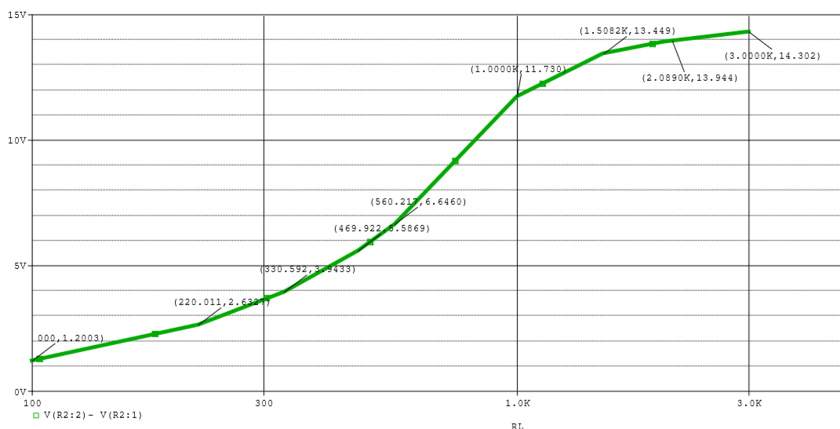**VL on RL:**
* **ID:**

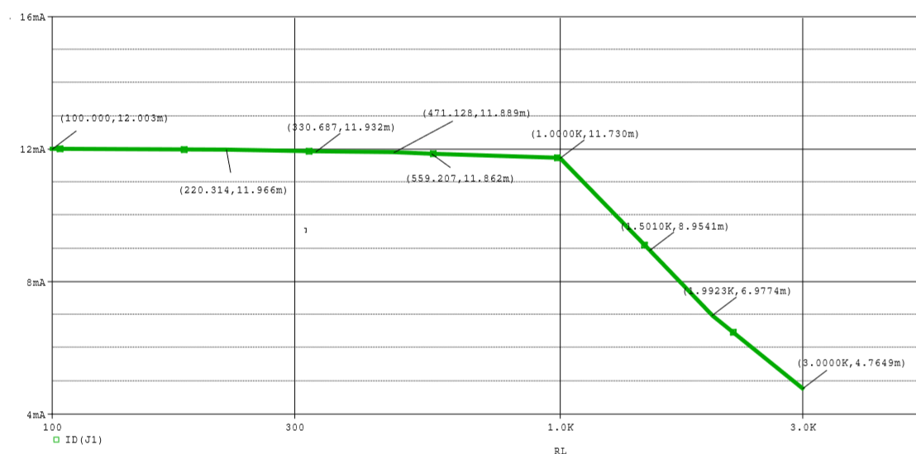

|  |  |  |
| --- | --- | --- |
| RL(Kohm) | VL(V) | ID (mA) |
| 0.1 | 1.2003 | 12.002 |
| 0.22 | 2.632 | 11.966 |
| 0.33 | 3.0433 | 11.932 |
| 0.47 | 5.5869 | 11.889 |
| 0.56 | 6.646 | 11.862 |
| 1 | 11.73 | 11.73 |
| 1.5 | 13.449 | 8.9541 |
| 2 | 13.944 | 6.9774 |
| 3 | 14.302 | 4.7649 |