

**Faculty of Engineering and Technology – Electrical and Computer Engineering Department**

**Circuit Analysis (ENEE2304)**

**Name: Majd Khasib**

**Id:1162331**

**Instructor Name: Mahran Quraan**

**Submission Date :2/1/2018**

**Abstract:**

**1)** The Aim of the experiment :

* Construct a simple power circuit connecting together Simulink blocks;
* Construct a circuit with passive circuit elements and build a simulator of a series RLC circuit and a simple power system;
* Understand the step response of RLC circuit;
* Be able to understand the influence of adding shunt capacitor to the load on the transmission line losses.

**2)** The method used: we used Matlab to simulate and plot The Variables(V,I,P,PF).

**-Theory:** Constructing complex circuits requires basic understanding of The RLC circuits since most complex circuits contain at least any of the three elements(R , L , C).when the three elements are constructed in series the study of the current behavior in the circuit depends on neper and resonant frequency ((R/(2*L)),(1/sqrt(L*C))).

Let x=R/(2*L) & y=1/sqrt(L*C),If x^2>y^2 we call the response overdamped . However if x^2<y^2 we refer the response as underdamped ,and finally if x^2=y^2 we call it critically damped.

To understand how electricity is delivered to houses and how could we reduce the loss in power due to the line we introduce the two major concepts (Active power & Reactive Power).

The Active power is the ordinary Power(P in watts ) which equals V * I*Power Factor .The power factor is the cos of the difference between the voltage angle and the current angle .on the other hand the Reactive power is (Q in VAR ) an imaginary power which is useful to reduce the power loss in the transmission line.

Some useful formulas :

Active power: P=V * I * PF

ReActive power: P=V * I * sin(cos^-1(PF))

Complex power:S=V*I*=P+jQ

Impedance : Z=V^/I^

Current in RLC series branch:

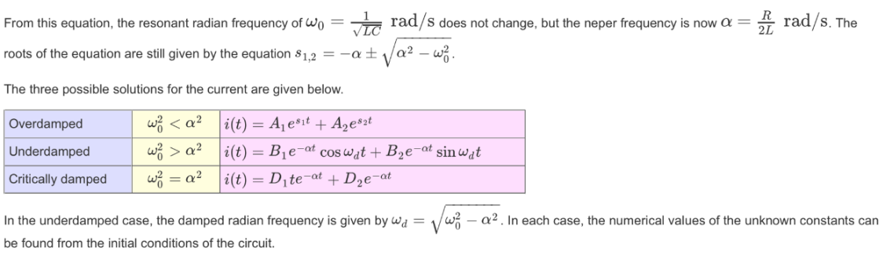

**Calculations:**

Simulation I:

Data: RLC circuit has a DC source voltage Vs = 220 V, inductance L = 2 mH and resistance, R = 160 Ω.

To make the response Critically damped:

B)

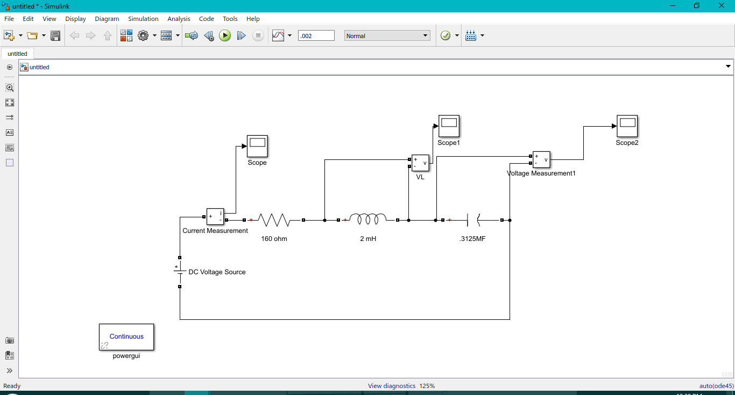

I(t)=

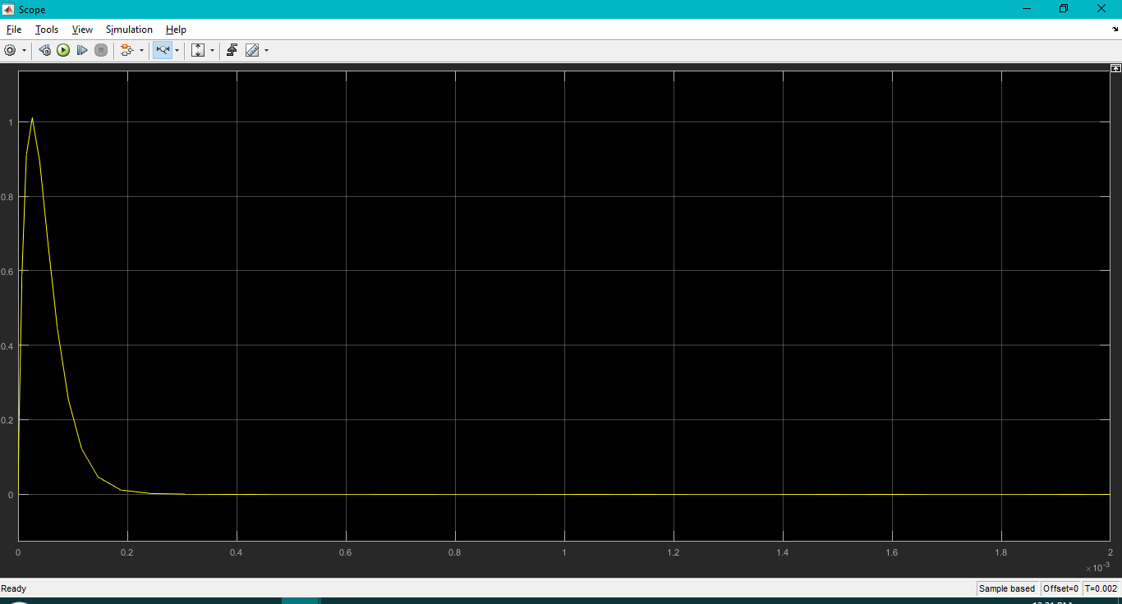

**VL(t)=L di(t)/dt**

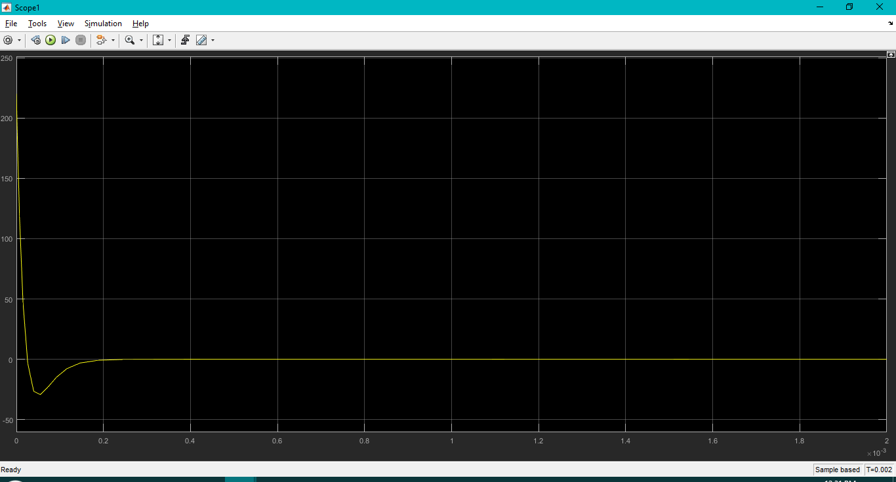

Vc(t)=Vs-IR-Vl(t)

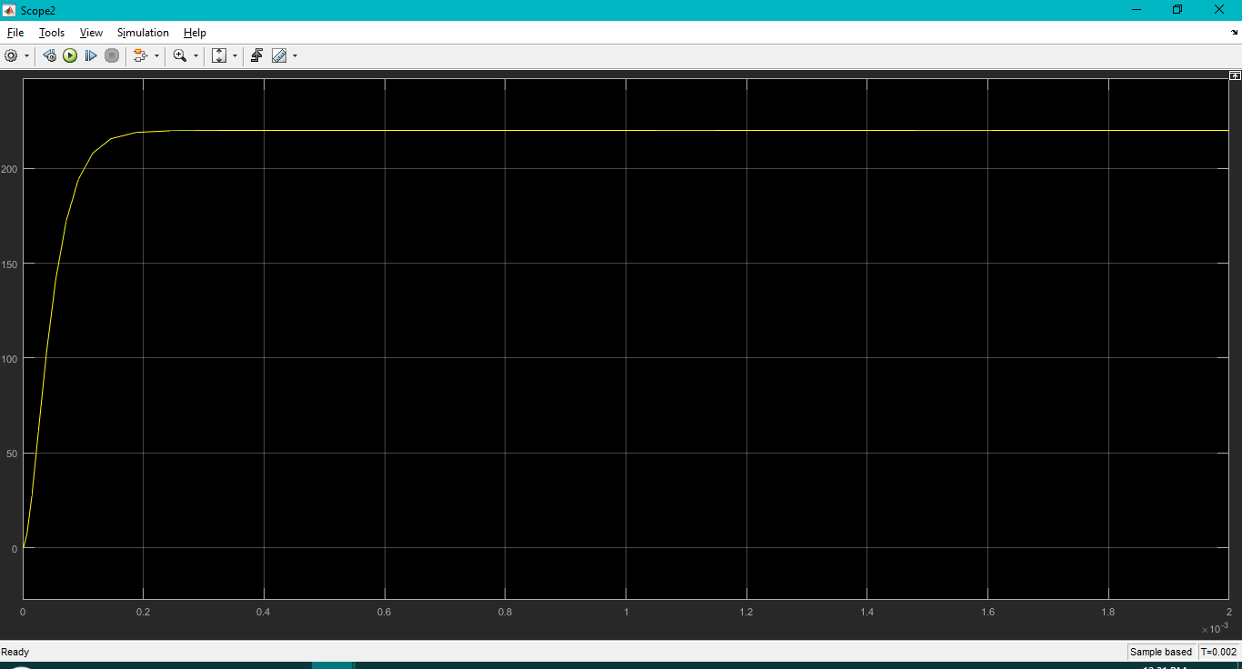

To make the response Overdamped:

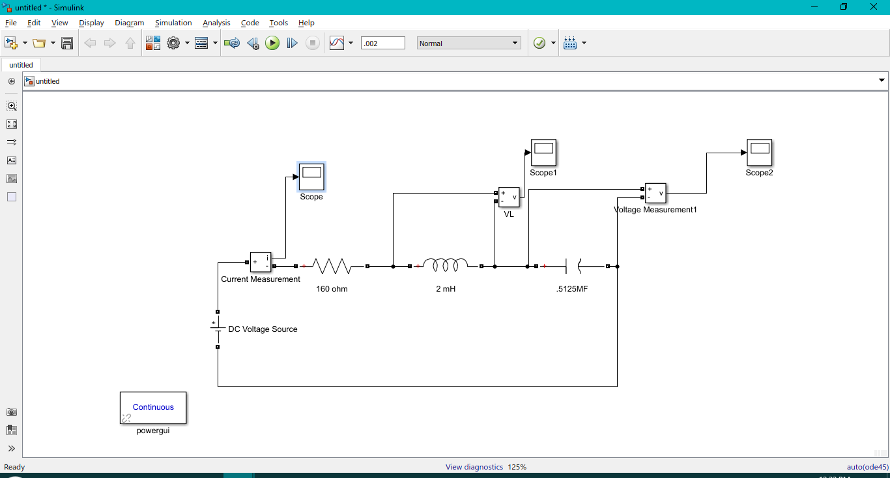

I(t)=

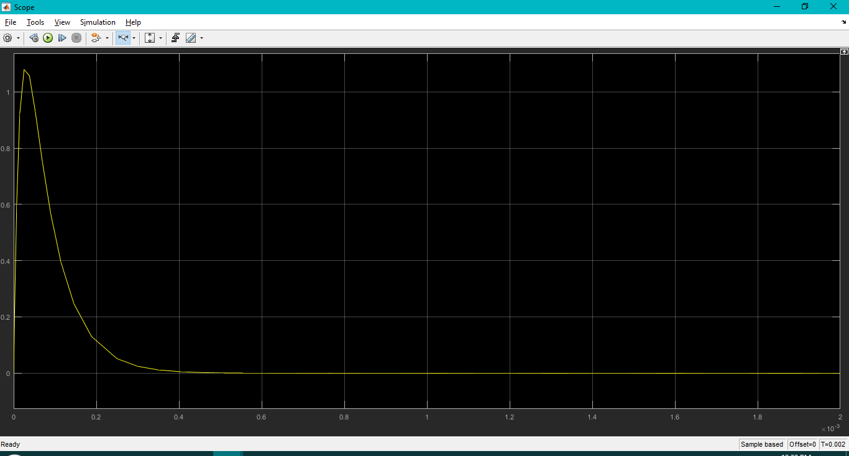

**VL(t)=L di(t)/dt**

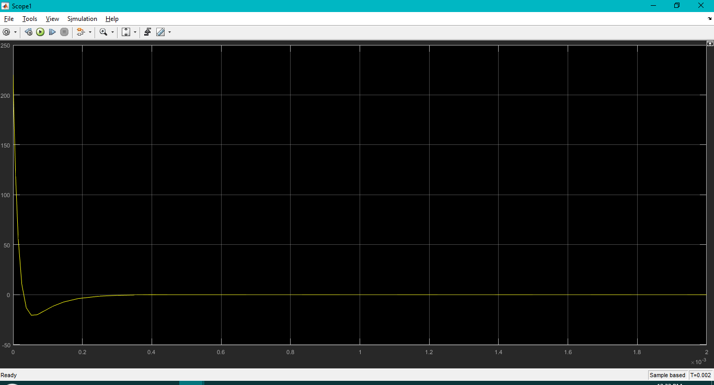

Vc(t)=Vs-IR-Vl(t)

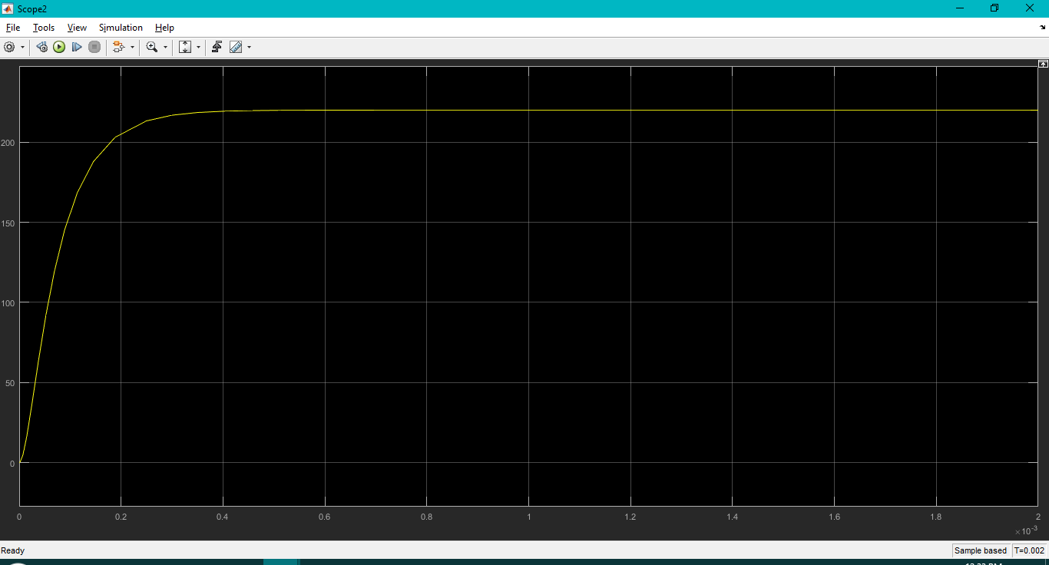

To make the response Underdamped:

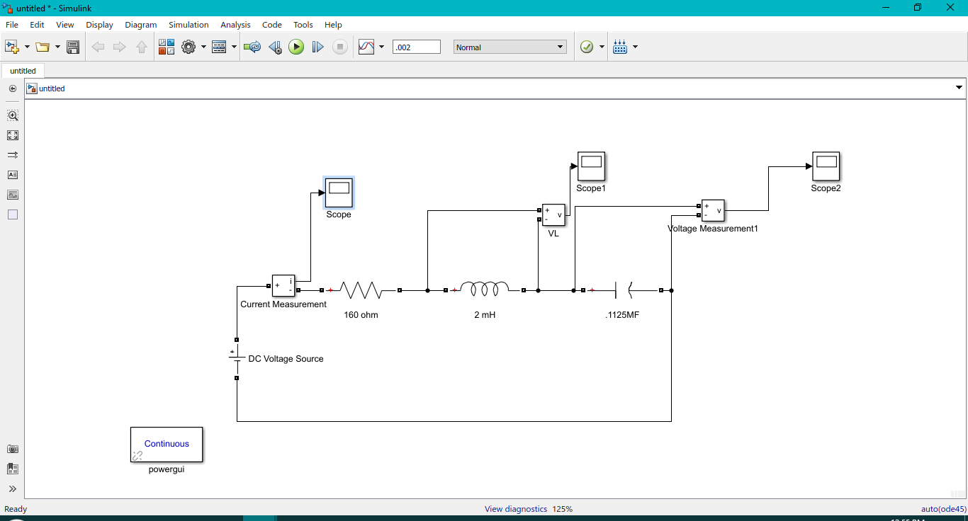

I(t)=

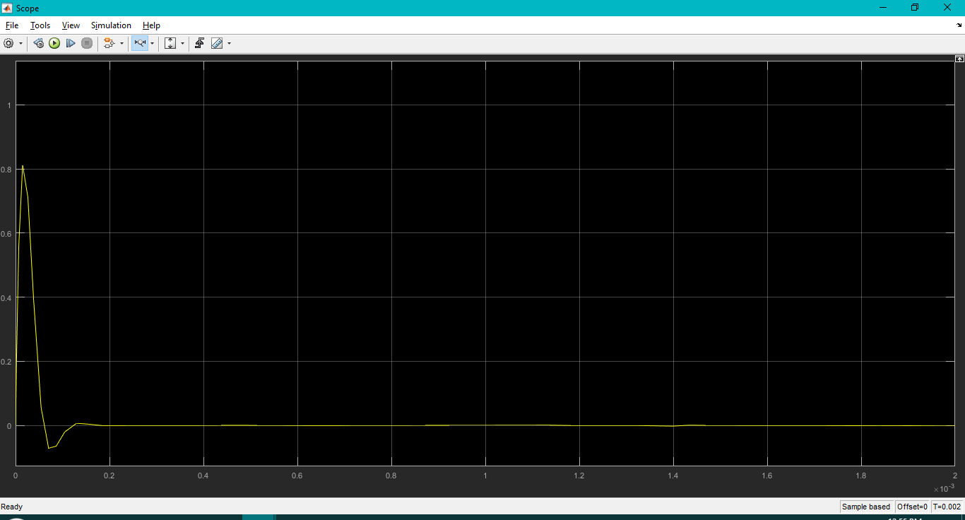

**VL(t)=L di(t)/dt**

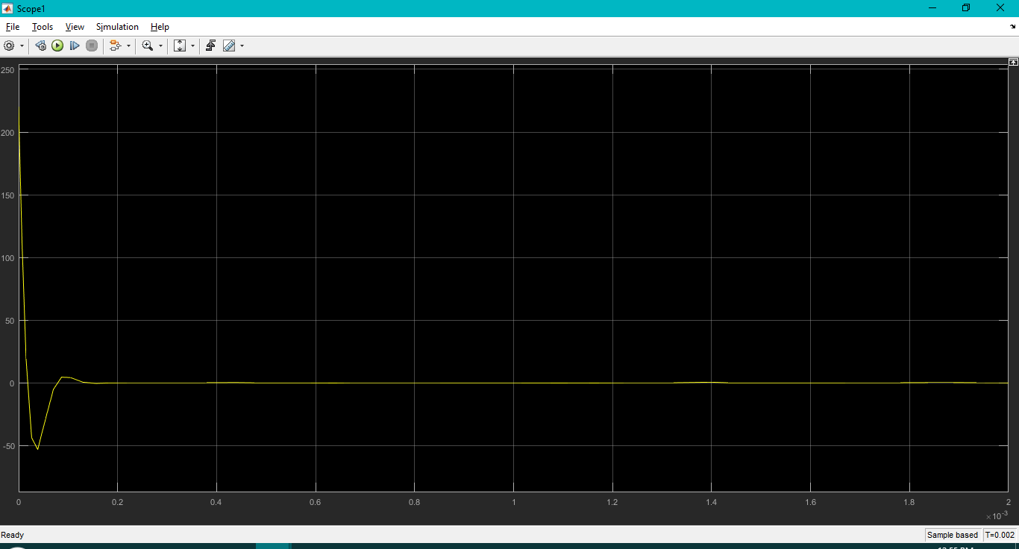

Vc(t)=Vs-IR-Vl(t)

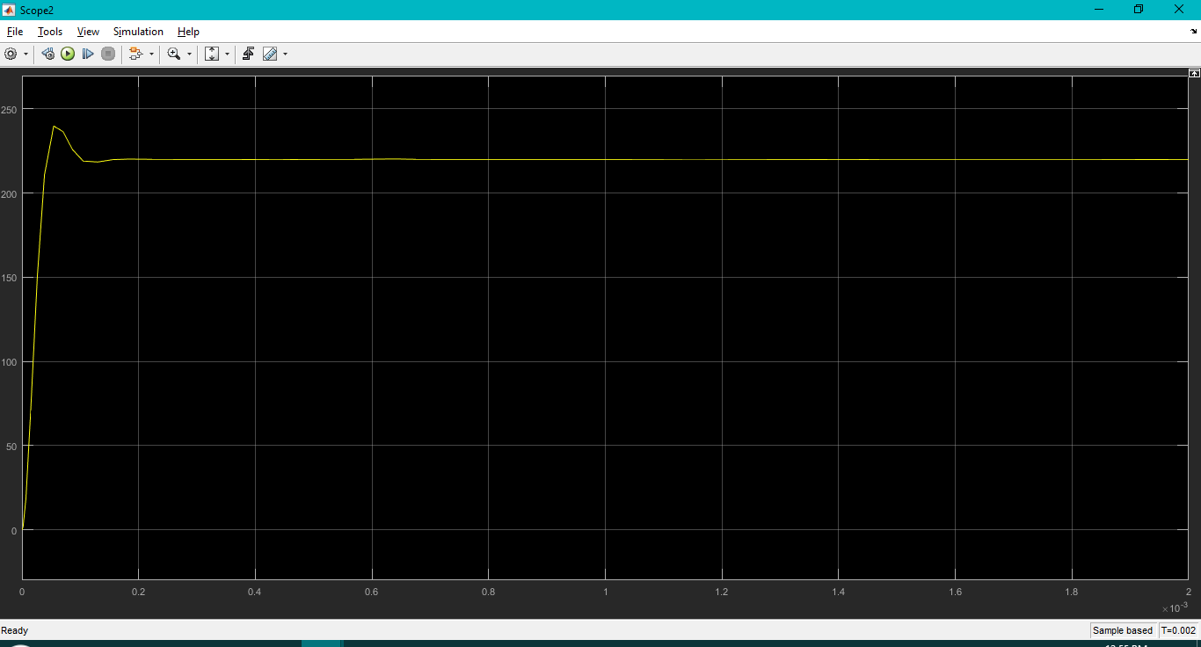

Simulation II:

**Data:** **The source electric frequency is 50 Hz,**

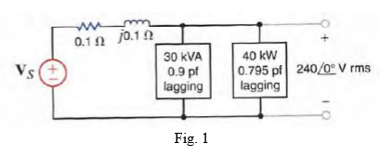

**To find Vs:**

**We first find the current from each source and then vs=vline+240<0**

**B)**

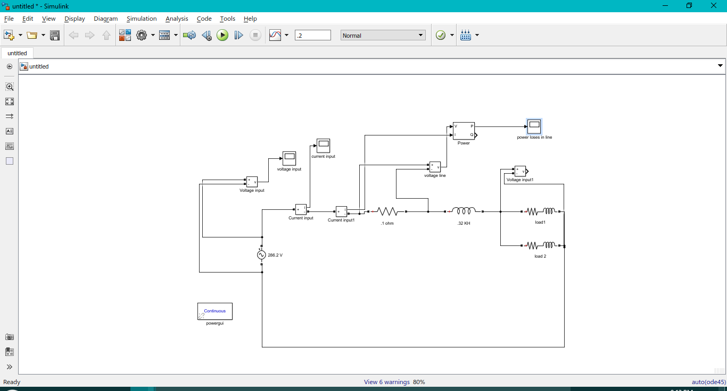

**C) input voltage:**

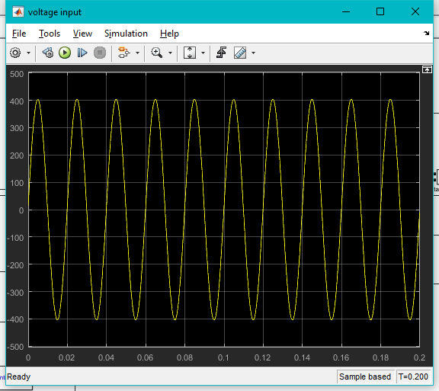

**Input Current:**

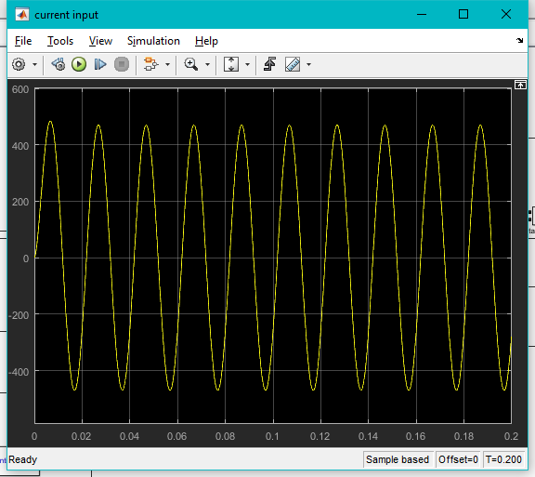

**input power factor:**

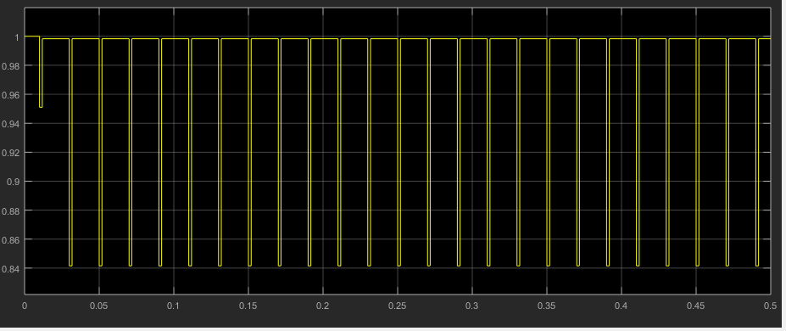

**line power losses:**

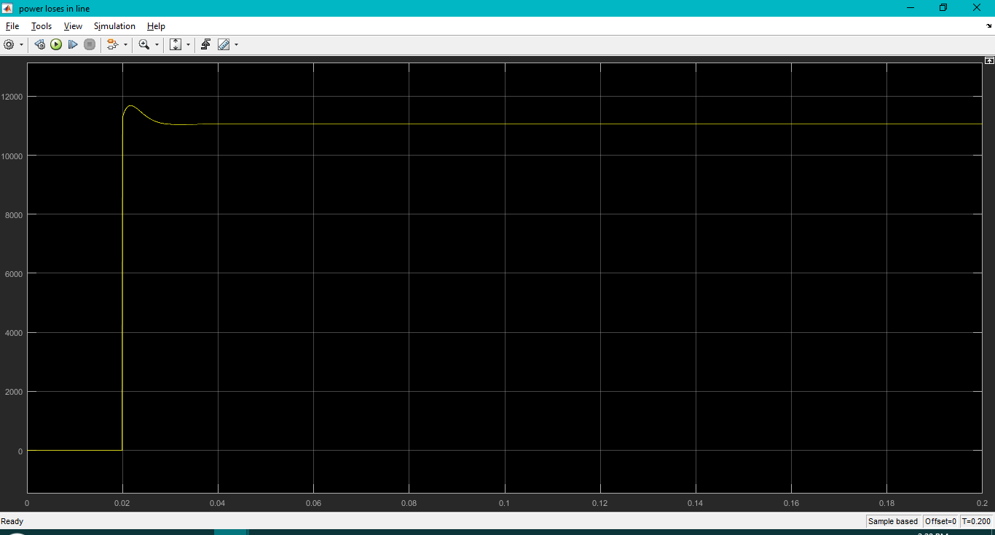

**D)**

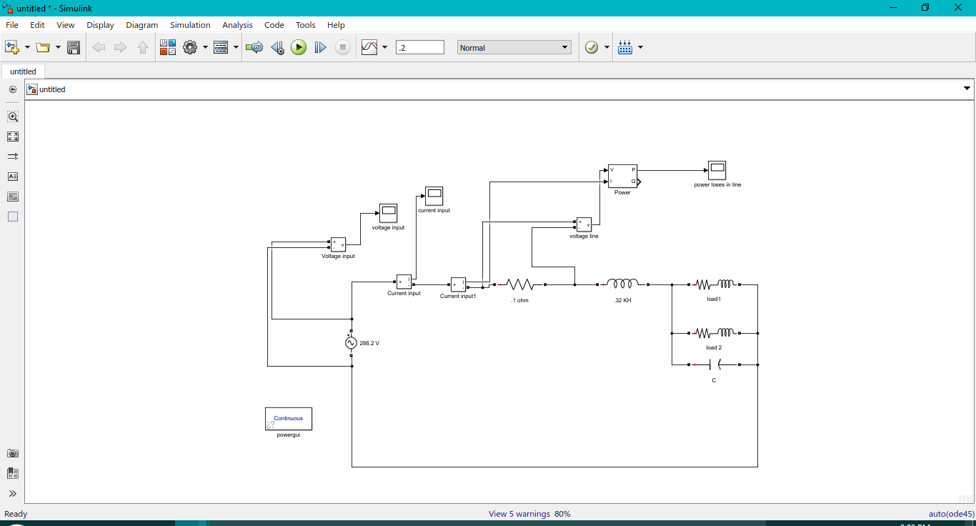

**The value of the capacitor is:**

**input voltage:**

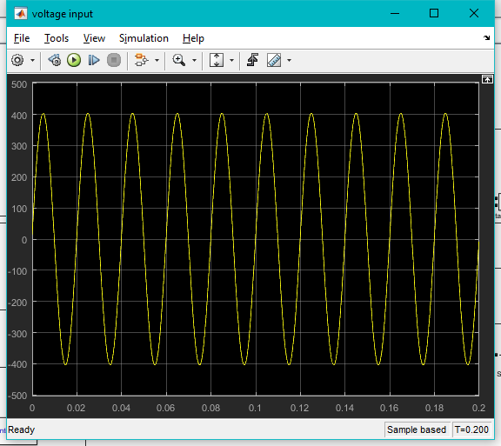

**Input Current:**

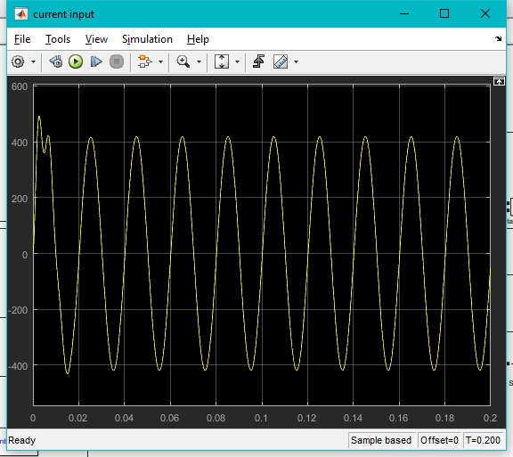

**line power losses:**

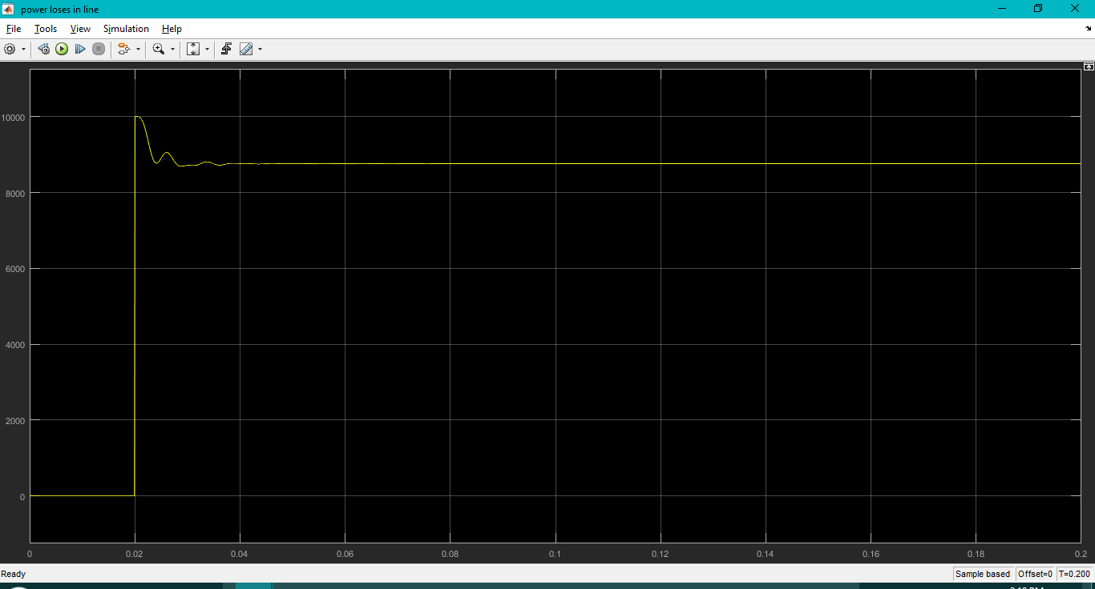

**the input power factor:**

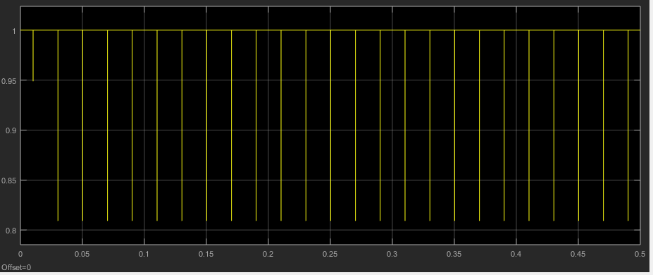

**Results:**