1. **Phase voltages**

Positive sequence

$$V_{an}=V_{p} ∠0°$$

$$V_{bn}=V_{p} ∠-120°$$

$$V_{cn}=V_{p} ∠120°$$

Negative sequence

$$V_{an}=V_{p} ∠0°$$

$$V_{bn}=V_{p} ∠120°$$

$$V_{cn}=V_{p} ∠-120°$$

1. **Y-load:**

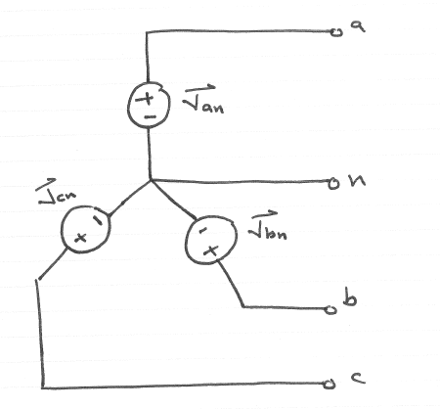

**Line voltages:**

Positive sequence

$$V_{ab}=\sqrt{3}V_{an} ∠30°=\sqrt{3}V_{p} ∠30°$$

$$V_{bc}=\sqrt{3}V_{bn} ∠30°=\sqrt{3}V_{p} ∠-90°$$

$$V_{ca}=\sqrt{3}V_{cn} ∠30°=\sqrt{3}V_{p} ∠150°$$

Negative sequence

$$V_{ab}=\sqrt{3}V_{an} ∠-30°=\sqrt{3}V_{p}∠-30°$$

$$V_{bc}=\sqrt{3}V_{bn} ∠-30°=\sqrt{3}V_{p} ∠90°$$

$$V_{ca}=\sqrt{3}V_{cn} ∠-30°=\sqrt{3}V_{p} ∠-150°$$

1. **Load impedance:**
$$Z_{Y}=\frac{Z_{∆}}{3}$$

2. **Balanced Y-Y system:**

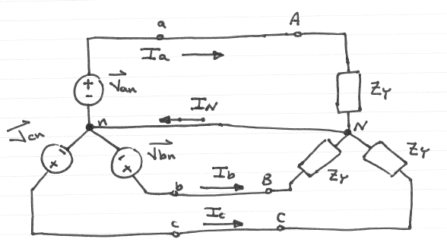

**Line currents:**

$$I_{a}=\frac{V_{an}}{Z_{y}}$$

$$I_{b}=\frac{V_{bn}}{Z_{y}}$$

$$I_{c}=\frac{V_{cn}}{Z_{y}}$$

1. **Balanced Y- $∆$ system:**

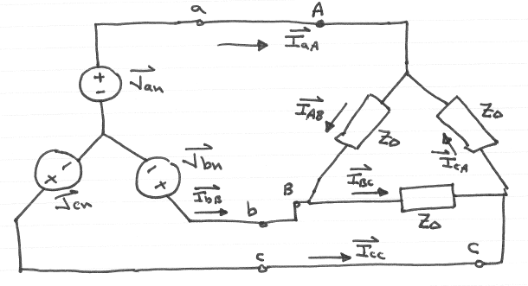

**Line currents:**

Turn the $∆$ impedance load into a y one and then solve the following:

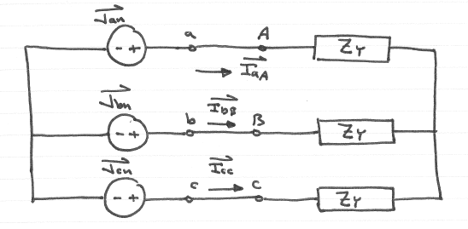

$$I_{aA}=\frac{V_{an}}{Z_{y}}=\frac{3V_{an}}{Z_{∆}}$$

$$I_{bB}=\frac{V_{bn}}{Z_{y}}=\frac{3V_{bn}}{Z_{∆}}$$

$$I_{cC}=\frac{V_{cn}}{Z_{y}}=\frac{3V_{cn}}{Z_{∆}}$$

**Phase currents of the load:**

$$I_{AB}=\left[\frac{1}{\sqrt{3}}∠30°\right] I_{aA}$$

$$I_{BC}=\left[\frac{1}{\sqrt{3}}∠30°\right] I_{bB}$$

$$I_{CA}=\left[\frac{1}{\sqrt{3}}∠30°\right] I_{cC}$$

1. **Power in a balanced system**

$$P\left(t\right)=3V_{p}I_{P} (PF)$$

**Y-load:**

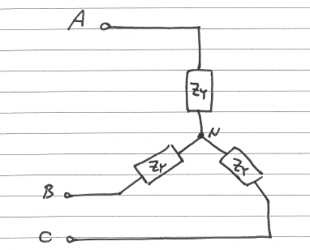

1. **Average Power:**
$$P_{T}=3V_{p}I_{P} \left(PF\right)=\sqrt{3}V_{L}I_{L} (PF)$$

2. **Reactive power:**
$$Q_{T}=3V_{p}I_{P}sin⁡(θ)=\sqrt{3}V_{L}I_{L} sin⁡(θ)$$

3. **Complex power:**

$$S_{T}=\sqrt{3}V_{L}I_{L} ∠θ$$

**Δ-load:**

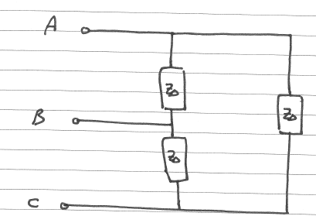

1. **Average Power:**
$$P_{T}=3V_{p}I_{P} \left(PF\right)=\sqrt{3}V_{L}I_{L} (PF)$$

2. **Reactive power:**
$$Q_{T}=3V_{p}I_{P}sin⁡(θ)=\sqrt{3}V_{L}I_{L} sin⁡(θ)$$

3. **Complex power:**
$$S_{T}=\sqrt{3}V_{L}I_{L} ∠θ$$

4. **Power loss**

$$P_{loss}=\frac{{P^{2}}_{load}}{{V^{2}}_{L}{PF}^{2}}R$$