

ISLAM JOMA

1191375

ENEE2312

Assignment

A=3 B=7 C=5

Q1:

It contains the first part 

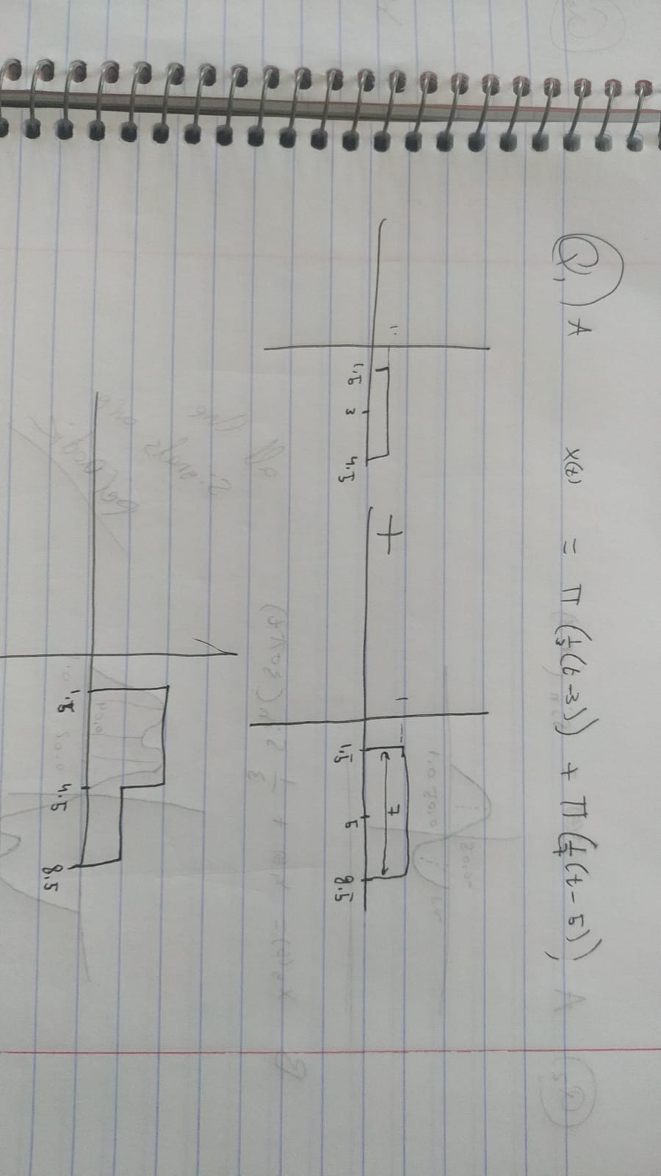

And the answer is the same as the MATLAB graph shows here

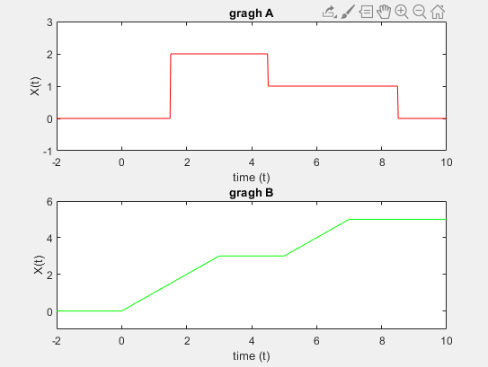

In the second graph it contains the second part of the question which is:



And by hand solve I got the same answer

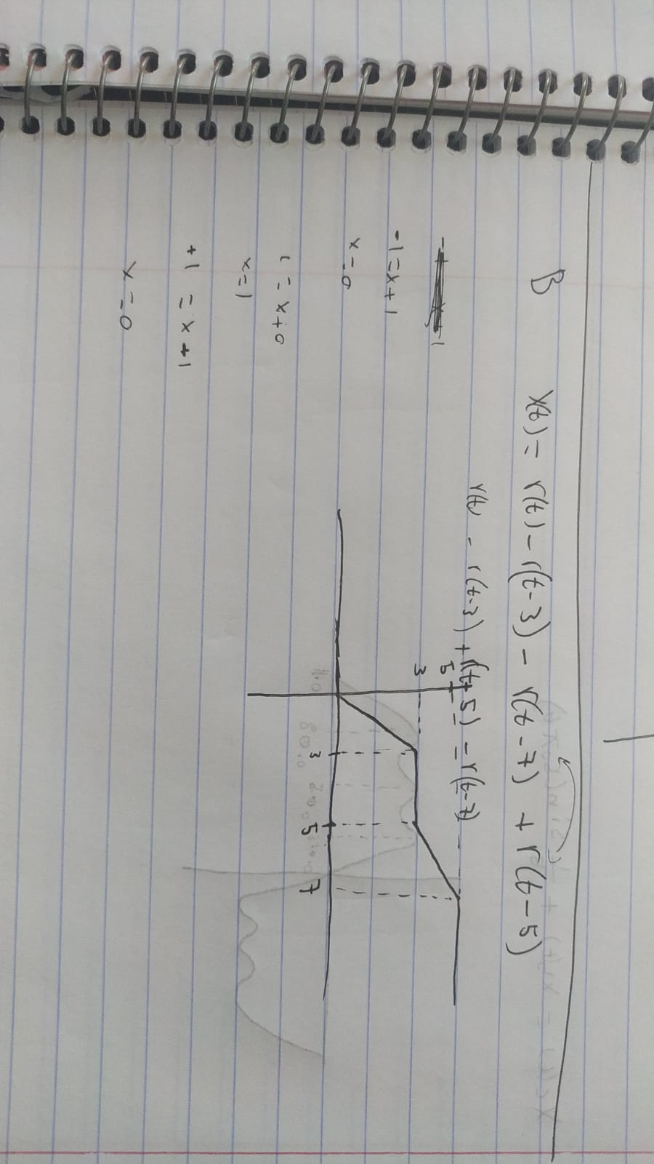

Here is the code for this question:

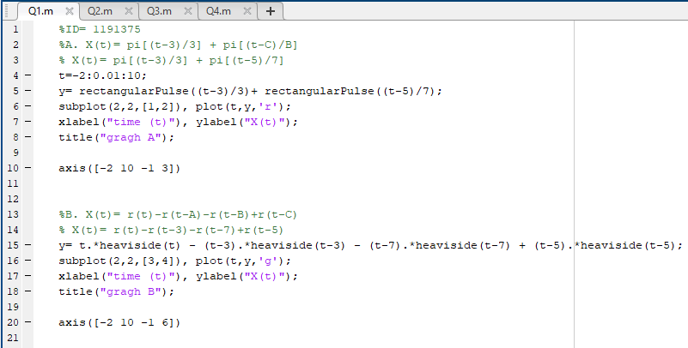

%ID= 1191375

%A. X(t)= pi[(t-3)/3] + pi[(t-C)/B]

% X(t)= pi[(t-3)/3] + pi[(t-5)/7]

t=-2:0.01:10;

y= rectangularPulse((t-3)/3)+ rectangularPulse((t-5)/7);

subplot(2,2,[1,2]), plot(t,y,'r');

xlabel("time (t)"), ylabel("X(t)");

title("gragh A");

axis([-2 10 -1 3])

%B. X(t)= r(t)-r(t-A)-r(t-B)+r(t-C)

% X(t)= r(t)-r(t-3)-r(t-7)+r(t-5)

y= t.\*heaviside(t) - (t-3).\*heaviside(t-3) - (t-7).\*heaviside(t-7) + (t-5).\*heaviside(t-5);

subplot(2,2,[3,4]), plot(t,y,'g');

xlabel("time (t)"), ylabel("X(t)");

title("gragh B");

axis([-2 10 -1 6])

Q2:



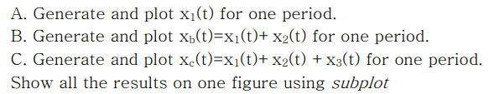

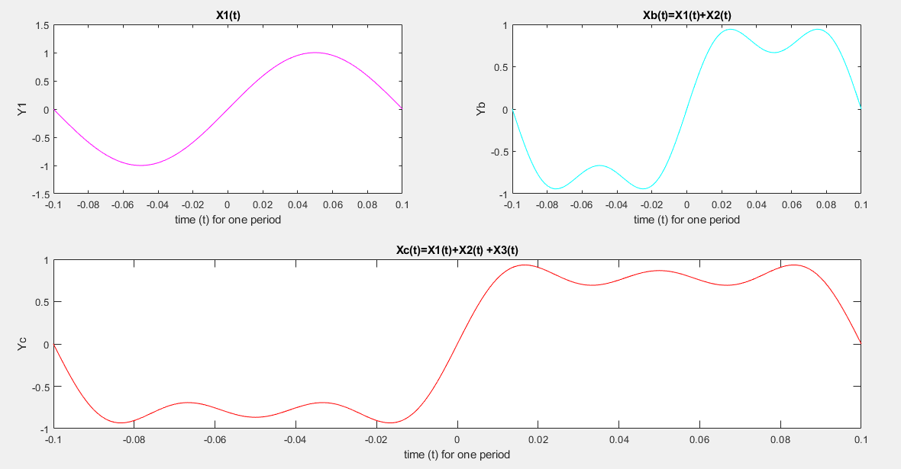

And by hand:

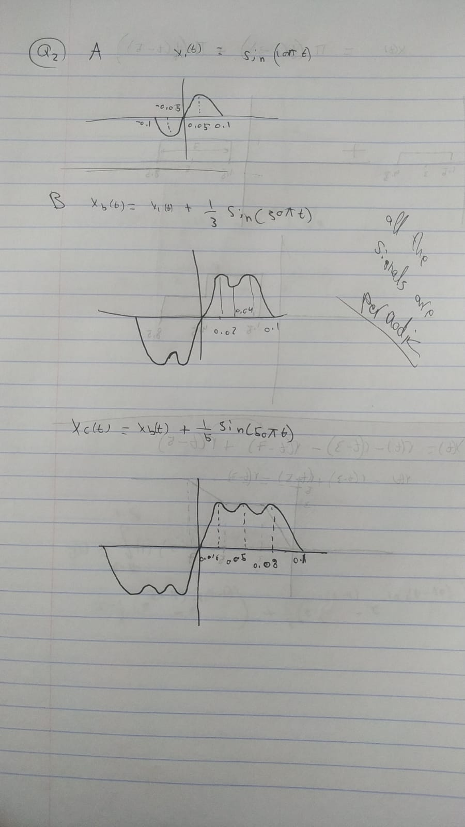

Here is the code for this question:

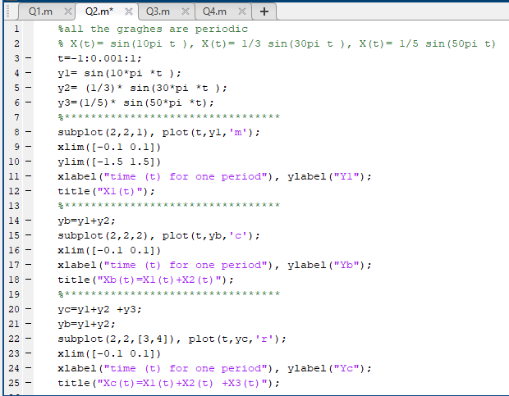

%all the graghes are periodic

% X(t)= sin(10pi t ), X(t)= 1/3 sin(30pi t ), X(t)= 1/5 sin(50pi t)

t=-1:0.001:1;

y1= sin(10\*pi \*t );

y2= (1/3)\* sin(30\*pi \*t );

y3=(1/5)\* sin(50\*pi \*t);

%\*\*\*\*\*\*\*\*\*\*\*\*\*\*\*\*\*\*\*\*\*\*\*\*\*\*\*\*\*\*\*\*\*

subplot(2,2,1), plot(t,y1,'m');

xlim([-0.1 0.1])

ylim([-1.5 1.5])

xlabel("time (t) for one period"), ylabel("Y1");

title("X1(t)");

%\*\*\*\*\*\*\*\*\*\*\*\*\*\*\*\*\*\*\*\*\*\*\*\*\*\*\*\*\*\*\*\*\*

yb=y1+y2;

subplot(2,2,2), plot(t,yb,'c');

xlim([-0.1 0.1])

xlabel("time (t) for one period"), ylabel("Yb");

title("Xb(t)=X1(t)+X2(t)");

%\*\*\*\*\*\*\*\*\*\*\*\*\*\*\*\*\*\*\*\*\*\*\*\*\*\*\*\*\*\*\*\*\*

yc=y1+y2 +y3;

yb=y1+y2;

subplot(2,2,[3,4]), plot(t,yc,'r');

xlim([-0.1 0.1])

xlabel("time (t) for one period"), ylabel("Yc");

title("Xc(t)=X1(t)+X2(t) +X3(t)");

Q3:

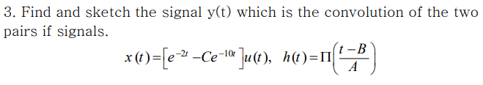

By solve by my hand I got this results:

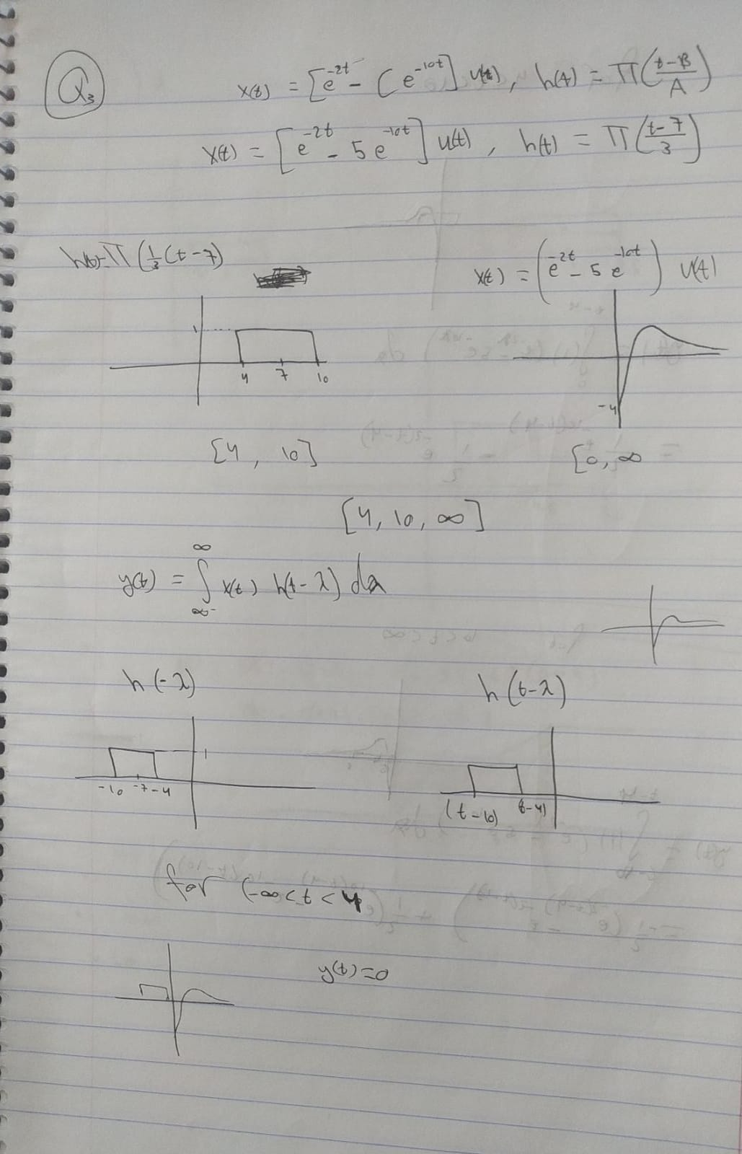

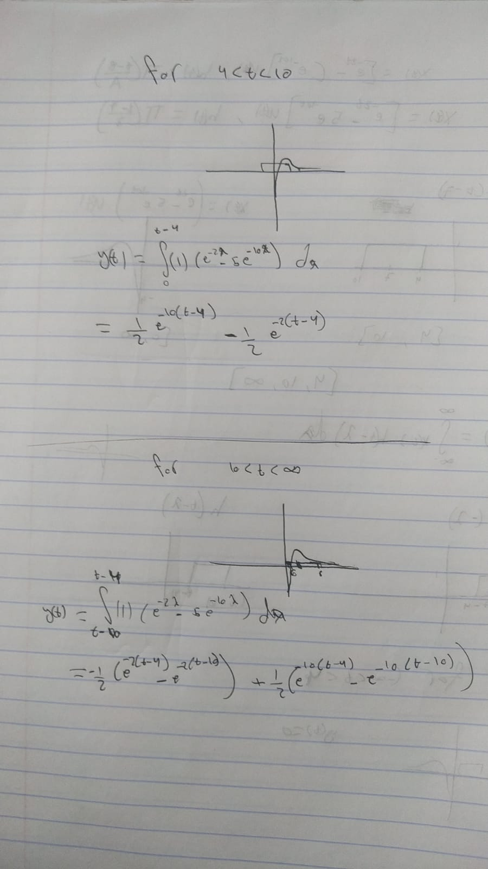

And by using MATLAB I got this graph:

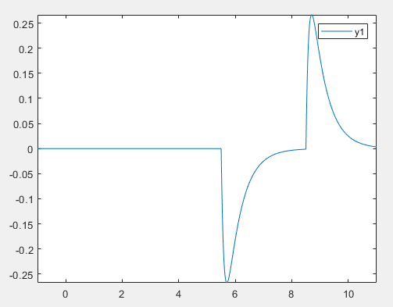

Which make a sense as having an exponential and integrated

Here is the code for this question:

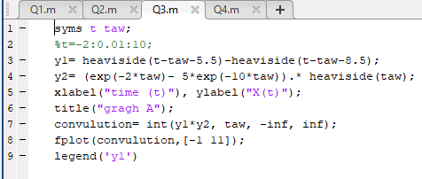

syms t taw;

%t=-2:0.01:10;

y1= heaviside(t-taw-5.5)-heaviside(t-taw-8.5);

y2= (exp(-2\*taw)- 5\*exp(-10\*taw)).\* heaviside(taw);

xlabel("time (t)"), ylabel("X(t)");

title("gragh A");

convulution= int(y1\*y2, taw, -inf, inf);

fplot(convulution,[-1 11]);

legend('y1')

Q4:

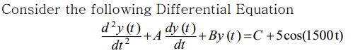



I couldn’t solve it by my hand as I got imaginary parts which is difficult to solve

But I got those results by MATLAB:

Answer:

cos((19^(1/2)\*x)/2)\*((5\*cos((19^(1/2)\*x)/2))/7 - (11249965\*cos(1500\*x - (19^(1/2)\*x)/2))/10124977500098 - (11249965\*cos(1500\*x + (19^(1/2)\*x)/2))/10124977500098 + (11250\*sin(1500\*x - (19^(1/2)\*x)/2))/5062488750049 + (11250\*sin(1500\*x + (19^(1/2)\*x)/2))/5062488750049 - (15\*19^(1/2)\*sin((19^(1/2)\*x)/2))/133 - (16874981250\*19^(1/2)\*cos(1500\*x - (19^(1/2)\*x)/2))/96187286250931 + (16874981250\*19^(1/2)\*cos(1500\*x + (19^(1/2)\*x)/2))/96187286250931 + (33750105\*19^(1/2)\*sin(1500\*x - (19^(1/2)\*x)/2))/192374572501862 - (33750105\*19^(1/2)\*sin(1500\*x + (19^(1/2)\*x)/2))/192374572501862) - (25312365000490\*exp(-(3\*x)/2)\*cos((19^(1/2)\*x)/2))/35437421250343 + sin((19^(1/2)\*x)/2)\*((5\*sin((19^(1/2)\*x)/2))/7 + (11250\*cos(1500\*x - (19^(1/2)\*x)/2))/5062488750049 - (11250\*cos(1500\*x + (19^(1/2)\*x)/2))/5062488750049 + (11249965\*sin(1500\*x - (19^(1/2)\*x)/2))/10124977500098 - (11249965\*sin(1500\*x + (19^(1/2)\*x)/2))/10124977500098 + (15\*19^(1/2)\*cos((19^(1/2)\*x)/2))/133 + (33750105\*19^(1/2)\*cos(1500\*x - (19^(1/2)\*x)/2))/192374572501862 + (33750105\*19^(1/2)\*cos(1500\*x + (19^(1/2)\*x)/2))/192374572501862 + (16874981250\*19^(1/2)\*sin(1500\*x - (19^(1/2)\*x)/2))/96187286250931 + (16874981250\*19^(1/2)\*sin(1500\*x + (19^(1/2)\*x)/2))/96187286250931) - (75937567501470\*19^(1/2)\*exp(-(3\*x)/2)\*sin((19^(1/2)\*x)/2))/673311003756517

and when we simplify it, we get:

(22500\*sin(1500\*x))/5062488750049 - (11249965\*cos(1500\*x))/5062488750049 - (25312365000490\*exp(-(3\*x)/2)\*cos((19^(1/2)\*x)/2))/35437421250343 - (75937567501470\*19^(1/2)\*exp(-(3\*x)/2)\*sin((19^(1/2)\*x)/2))/673311003756517 + 5/7

In the other hand when we use 3 instead of zero

We got this answer:

cos((19^(1/2)\*x)/2)\*((5\*cos((19^(1/2)\*x)/2))/7 - (11249965\*cos(1500\*x - (19^(1/2)\*x)/2))/10124977500098 - (11249965\*cos(1500\*x + (19^(1/2)\*x)/2))/10124977500098 + (11250\*sin(1500\*x - (19^(1/2)\*x)/2))/5062488750049 + (11250\*sin(1500\*x + (19^(1/2)\*x)/2))/5062488750049 - (15\*19^(1/2)\*sin((19^(1/2)\*x)/2))/133 - (16874981250\*19^(1/2)\*cos(1500\*x - (19^(1/2)\*x)/2))/96187286250931 + (16874981250\*19^(1/2)\*cos(1500\*x + (19^(1/2)\*x)/2))/96187286250931 + (33750105\*19^(1/2)\*sin(1500\*x - (19^(1/2)\*x)/2))/192374572501862 - (33750105\*19^(1/2)\*sin(1500\*x + (19^(1/2)\*x)/2))/192374572501862) - (25312365000490\*exp(-(3\*x)/2)\*cos((19^(1/2)\*x)/2))/35437421250343 + sin((19^(1/2)\*x)/2)\*((5\*sin((19^(1/2)\*x)/2))/7 + (11250\*cos(1500\*x - (19^(1/2)\*x)/2))/5062488750049 - (11250\*cos(1500\*x + (19^(1/2)\*x)/2))/5062488750049 + (11249965\*sin(1500\*x - (19^(1/2)\*x)/2))/10124977500098 - (11249965\*sin(1500\*x + (19^(1/2)\*x)/2))/10124977500098 + (15\*19^(1/2)\*cos((19^(1/2)\*x)/2))/133 + (33750105\*19^(1/2)\*cos(1500\*x - (19^(1/2)\*x)/2))/192374572501862 + (33750105\*19^(1/2)\*cos(1500\*x + (19^(1/2)\*x)/2))/192374572501862 + (16874981250\*19^(1/2)\*sin(1500\*x - (19^(1/2)\*x)/2))/96187286250931 + (16874981250\*19^(1/2)\*sin(1500\*x + (19^(1/2)\*x)/2))/96187286250931) + (136686960000588\*19^(1/2)\*exp(-(3\*x)/2)\*sin((19^(1/2)\*x)/2))/673311003756517

and when we simplify it, we get:

(22500\*sin(1500\*x))/5062488750049 - (11249965\*cos(1500\*x))/5062488750049 - (25312365000490\*exp(-(3\*x)/2)\*cos((19^(1/2)\*x)/2))/35437421250343 + (136686960000588\*19^(1/2)\*exp(-(3\*x)/2)\*sin((19^(1/2)\*x)/2))/673311003756517 + 5/7

You may see them the same answers but in fact there is a small deference made

Here is the code for this question:

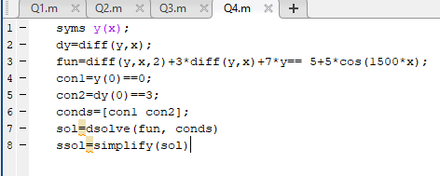

syms y(x);

dy=diff(y,x);

fun=diff(y,x,2)+3\*diff(y,x)+7\*y== 5+5\*cos(1500\*x);

con1=y(0)==0;

con2=dy(0)==3;

conds=[con1 con2];

sol=dsolve(fun, conds)

ssol=simplify(sol)