

***Faculty of Engineering & Technology***

***Electrical & Computer Engineering Department***

***ENEE 3304 – Electronics 2***

***Project 1***

**Prepared by:**

Baraa Ymani  student #:1180890

Sara Totah student #:1181779

Abdallah Fialah student #: 11 62193

**Instructor***: Dr* Mohammad Al Ju’Beh

Sec#: *2*

**Date: 12/25/202**

Table of Contents

Table of Figures: 2

*Introduction* 3

Description of the circuit function and operation: 3

*Weston Bridge:* 4

*Comparator* 4

*Instrumentation amplifier* 5

*A light-emitting diode (LED):* 6

Simulation and Discussion 6

Conclusion 16

References: 16

# Table of Figures:

Figure 1: Weston bridge circuit. 2

Figure 2: Comparator Circuit.[1] 2

Figure 3: Instrumentation OP-AMP Circuit. [2] 3

Figure 4: led 4

Figure 5: Weston Bridge when Rx = 100Ω. 6

Figure 6: The simulation to find the Variable Resistor of Weston bridge. 7

Figure 7: Second Stage " IC & OP-Amp & LEDS " 8

Figure 8: Weston Bridge when Rx = 120 Ω 10

Figure 9: Second Stage " IC & OP-Amp & LEDS " 11

Figure 10: Simulation for Weston Bridge when Rx = 138.5 kΩ 12

Figure 11: Second Stage " IC & OP-Amp & LEDS " 13

# *Introduction*

## Description of the circuit function and operation:

This circuit controls the temperature of the water as well as indicates it on an LED, it contains Weston bridge, instrumentation amplifier, comparator amplifier, LED’s, Relay, resistances, and Transistor. This circuit controls the temperature of water When the temperature of the water is 0 ° C, none of the LEDs glows. But when the temperature starts increasing to 97°C, LEDs from LED1 through LED8 starts glowing one after the other. When the temperature is around 30°C, only LED1 would glow ‘on’. For a temperature greater than 97°C, all display LEDs will glow ‘on’. We used a resistance-temperature detector (RTD) To be able to detect the temperature of the water, and It is connected to one of the arms of a Wheatstone bridge "sensors”.

At 0°C, it’s the ideal condition because the bridge has to be in a balanced condition and, for other temperatures, the bridge will be unbalanced. The unbalanced voltage of the bridge is converted into a suitable value in the range 0V to 6V (corresponding to temperatures 0°C to 100°C, respectively) by the instrumentation amplifier formed by op-amps IC1 through IC3 (uA741). The output of the instrumentation amplifier is coupled to voltage comparators for driving the display LEDs.

We used a type controller to control the temperature of the water ‘on’/’off’. The Lower threshold point is set at 80°C, and the upper threshold point is set at 97°C. An electric heater coil is used for heating the water. When the power supply is switched ‘on’, the heater starts heating the water. When the temperature reaches 80°C, the output of IC5 goes to become high. This turns ‘on’ relay driver transistor T1 to energize relayRL1. In this state, relay RL2 is in ‘off condition.

When the temperature of water crosses 97°C, the output of IC5(d) goes to become high. This makes transistor T2 on, which, in turn, energizes relay RL2. Relay RL2 in an energized state cuts off the power supply to the heater coil. Relay RL2, once energized, remains so due to the latching arrangement provided by its second pair of contacts. Simultaneously, the buzzer also sounds, due to the forward biasing of transistor T3. Since the supply to the heater is cut-off, the temperature of water starts decreasing. Gradually, the buzzer goes ‘off’, as the output of IC5(d) goes ‘low’. When the temperature goes below 80°C, the output of IC5(b) goes ‘low’ to turn ‘off’ transistor T1 and relay RL1. As a result, the power supply provided to relay RL2 is cut off, and relay RL2 de-energizes. This will again turn on the mains electric power supply to the heater coil. Once again, the temperature of water starts increasing and the cycle repeats to maintain water temperature within the limits of 80°C to 97°C. The lower and upper threshold points can be changed by connecting the base terminals of transistors T1 and T2 to different output terminals of voltage comparators (IC4 and IC5). Base terminals of transistors T1 and t2 are meant for lower and upper threshold points, respectively

*Weston Bridge:*

Is an electrical circuit used to measure unknown resistance values and as a means of calibrating measuring instruments, voltmeters, ammeters, etc., by the use of a long resistive slide wire It contains a temperature sensor that detects the water temperature. This bridge is used where small changes in resistance are to be measured like in sensor applications. This is used to convert a resistance change to a voltage change of a transducer.

Weston Bridge circuit topology:

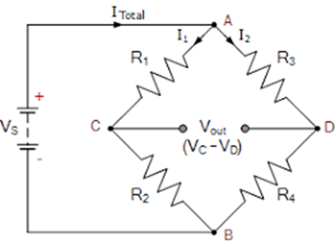

Figure : Weston bridge circuit.

The combination of this bridge and operational amplifier is widely used in the sensor industries as used in our project

*Comparator*

Generally, in electronics, the comparator is used to compare two voltages or currents which are given at the two inputs of the comparator. That means it takes two input voltages, then compares them and gives a differential output voltage. Figure 1 illustrates the circuit Op-Amp Comparator.

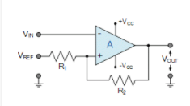

Figure : Comparator Circuit.[1]

There are very many uses for comparator circuits within electronic circuit design. It is often necessary to be able to detect a certain voltage and switch a circuit according to the voltage that has been detected.

One example could be for use in a temperature sensing circuit. This might produce a variable voltage dependent upon the temperature. It may be necessary to switch the heating on when the temperature falls below a given point and this can be achieved by using a comparator to sense when the voltage proportional to the temperature has fallen below a certain value.

# *Instrumentation amplifier*

An instrumentation amplifier is one kind of IC (integrated circuit), it is used for amplifying a signal. This amplifier comes under the family of the differential amplifier because it increases the disparity among two inputs.  The instrumentation amplifier IC is an essential component in the designing of the circuit due to its characteristics like high CMRR, the open-loop gain is high, low drift as well as low DC offset, etc. Figure 2 illustrates the circuit Op-Amp Comparator.

A simple temperature control system can be constructed using a thermistor as the transducer device, in the resistive bridge, as shown in the figure above.

The resistive bridge is kept balanced for some reference temperature. For any change in this reference temperature, the instrumentation amplifier will produce an output voltage, which drives the Relay which in turn turns ON/OFF the heating unit, thereby controlling the temperature.

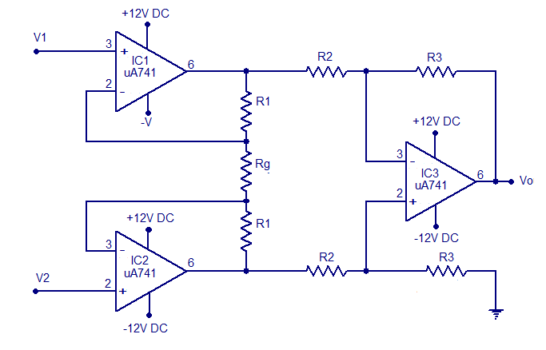

Figure 3: Instrumentation OP-AMP Circuit. [2]

# *A light-emitting diode (LED):*

is a semiconductor light source that emits light when current flows through it. The LED indicator is an indication of the high temperature of the water in the geyser, as the temperature becomes large the number of lamps that will burn out is large. at 30degree there is no led burn out at 97 almost all LEDs burn out

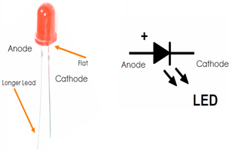

Figure : led

# **Simulation and Discussion**

**The following equations describe Instrumentation Amplifier: -**

$$V_{o}=\frac{R_{2}}{R_{1}}\left(1+\frac{2R_{3}}{R_{g}}\right)\left(V_{2}-V_{1}\right)$$

By using KCL we get:

$I= \frac{V}{R_{g}}=\frac{V_{a}-V_{b}}{R_{g}}$…………………………………………………………………………………… (1)

$I= \frac{V}{R_{g}}=\frac{V_{a}-V_{b}}{R_{g}+{2R}_{1} }$…………………………………………………………... (2)

When Eq (1) equality Eq (2) we get Eq (3):

$\frac{V_{1}-V_{2}}{R_{g}+{2R}_{1} }= \frac{V_{a}-V_{b}}{R_{g}}$…………………………..…………………………… (3)

To rearrange the equation, we get Eq (4): -

$$V_{1}-V_{2}=\frac{R_{g}+{2R}_{1}}{R_{g}} ( V_{1}-V_{2})$$

$V_{1}-V_{2}=1+\frac{{2R}_{1}}{R_{g}} \left( V_{1}-V_{2}\right)$…………………………………………………. (4)

Then the output voltage is:

$V_{o}=\left(\frac{R_{2}}{R_{1}}\right)\left(1+\frac{{2R}_{1}}{R_{g}} \right)\left( V_{1}-V_{2}\right)$………………………………………………(A)

If $R_{2}= R_{1}$:

$V_{o}=\left(1+\frac{{2R}_{1}}{R_{g}} \right)\left( V_{1}-V_{2}\right)$………………………………………… (B)

**The following equations describe Weston Bridge Eq:**

By using Voltage Divider at node C:

$V_{C}=\left(\frac{R_{X}}{R_{X}+R_{3}} \right)\left(V_{in} \right)$…………………………………………………………………………… (1)

By using Voltage Divider at node D:

$V_{D}=\left(\frac{R_{2}}{R_{2}+R_{1}} \right)\left(V_{in} \right)$…………………………………………………………………………… (2)

When subtraction Eq (1) From Eq (2) we get:

$$V_{C}-V_{D}=\left(\frac{R_{X}}{R_{X}+R_{3}} \right)\left(V_{in} \right)-\left(\frac{R_{2}}{R_{2}+R_{1}} \right)\left(V_{in} \right)$$

But $V_{D}= V_{c}= 0$, then we get Eq (3):

$0=\left(\frac{R_{X}}{R_{X}+R_{3}} \right)\left(V_{in} \right)-\left(\frac{R_{2}}{R_{2}+R_{1}} \right)\left(V_{in} \right)$…………………………………………………………………………… (3)

Then:

$$\left(\frac{R_{X}}{R_{X}+R_{3}} \right)=\left(\frac{R_{2}}{R_{2}+R_{1}} \right)$$

$$R_{2}{×R}_{X}+R_{1}×R_{X}= R_{2}{×R}_{X}+R_{3}×R_{2}$$

$$R_{1}×R_{X}=R_{3}×R_{2}$$

To rearrange the equation to find $R_{X}$, we get Eq (A):

…………………………………………………………………………………(A)

1) When Rx = 100 Ω

First Stage:



Figure 5: Weston Bridge when Rx = 100Ω.



Figure 6: The simulation to find the Variable Resistor of Weston bridge.

When performing the calculation to check the values in the simulations for Rx = 100 Ω in the first stage:

By using Voltage Divider at node C:

$V_{C}=\left(\frac{R_{X}}{R_{X}+R_{3}} \right)\left(V_{in} \right)$…………………………………………………………………………… (1)

By using Voltage Divider at node D:

$V_{D}=\left(\frac{R_{2}}{R_{2}+R_{1}} \right)\left(V_{in} \right)$…………………………………………………………………………… (2)

$$V_{C}=\frac{100}{100+100}*6=3volts$$

$$V_{D}=\frac{100}{100+100}*6=3volt$$

Second stage:



Figure 7: Second Stage " IC & OP-Amp & LEDS "

As the Figure above, When Rx = 100 Ω, there is no LEDs shine

When performing the calculation to check the values in the simulations for Rx = 100 Ω in the second stage:

………………………………………………(A)

VO =

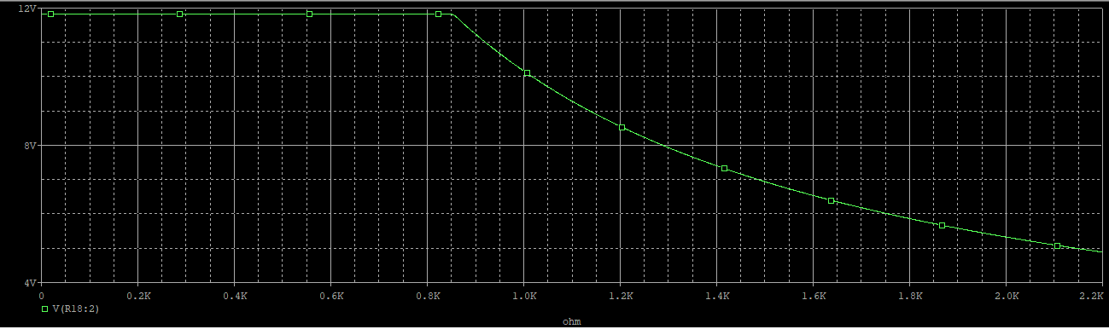

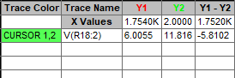

2) When Rx = 120 Ω

First Stage



Figure 8: Weston Bridge when Rx = 120 Ω

When performing the calculation to check the values in the simulations for Rx = 120 Ω in the First stage:

By using Voltage Divider at node C:

$V_{C}=\left(\frac{R_{X}}{R_{X}+R_{3}} \right)\left(V_{in} \right)$…………………………………………………………………………… (1)

By using Voltage Divider at node D:

$V_{D}=\left(\frac{R_{2}}{R_{2}+R_{1}} \right)\left(V_{in} \right)$…………………………………………………………………………… (2)

$$V_{C}=\frac{100}{120+100}*6=2.727volts$$

$$V_{D}=\frac{100}{100+100}*6=3volts$$

Second Stage:



Figure 9: Second Stage " IC & OP-Amp & LEDS "

As the Figure above, When Rx = 120 Ω, From LEDs 1 - 3 There is shine

When performing the calculation to check the values in the simulations for Rx = 120 Ω in the second stage:

………………………………………………(A)

VO =

3) When Rx = 138.5 Ω

First Stage:



Figure 10: Simulation for Weston Bridge when Rx = 138.5 kΩ

When performing the calculation to check the values in the simulations for Rx = 138.5 Ω in the second stage:

By using Voltage Divider at node C:

$V_{C}=\left(\frac{R_{X}}{R_{X}+R_{3}} \right)\left(V_{in} \right)$…………………………………………………………………………… (1)

By using Voltage Divider at node D:

$V_{D}=\left(\frac{R_{2}}{R_{2}+R_{1}} \right)\left(V_{in} \right)$…………………………………………………………………………… (2)

$$V_{C}=\frac{100}{138.5+100}*6=2.515 volts$$

$$V_{D}=\frac{100}{100+100}*6=3volts$$

Second Stage:



Figure : Second Stage " IC & OP-Amp & LEDS "

When performing the calculation to check the values in the simulations for Rx = 138.5 Ω in the second stage:

$V_{o}=\left(\frac{R_{2}}{R_{1}}\right)\left(1+\frac{{2R}_{1}}{R_{g}} \right)\left( V_{1}-V_{2}\right)$………………………………………………(A)

VO =

# Conclusion:

In conclusion, the water temperature controller was designed to measure the temperature of the water using LEDs, if the water temperature was 100oc all the LEDs will shine and that’s when the sensor resistor equals 138.5Ω, while if the water temperature was 0, then none of the LEDs will shine (when the sensor resistor equals 100Ω), the last sensor resistor was chosen to be 120 Ω, and only three LEDs shined. There were no major problems in implementing this project, the simulation results were acceptable since the simulation results were similar to the theoretical values calculated and shown before.

This project is a very interesting one, since that we apply some things we learned in the course, and we learned a lot of skills such as how to use ORCAD/ PSPICE to simulate any project or subproject.

# References:

1. <https://en.wikipedia.org/wiki/Wheatstone_bridge?fbclid=IwAR1lcZ8PubWgPWXlYT-N0QVZWeznm8isCtJ7NLCMMfjIp9C5GDLqAL1EFJA>
2. <https://www.electronoobs.com/eng_circuitos_tut30.php?fbclid=IwAR3p3hpqja7g9D9_DpeBZKpzBdMX3RxJdsR5vJywSZt7-L2_jklTgk5_tYo>
3. <https://en.wikipedia.org/wiki/Light-emitting_diode?fbclid=IwAR3kFUDrLrraPmCwPpXu6NcQayh_GyyhyiV7nQsNwrRciP2c8gzpKek1JXw>
4. <https://www.allaboutcircuits.com/technical-articles/practical-uses-of-instrumentation-amplifiers/?fbclid=IwAR3Ryqrl6ziEAgJ08EiODaoYeiTvVHhLNW8mKZlQk5WhBF0d0tr0sQ87SA4>