HW FET ac analysis
EE236
Solve the following Questions

From Floyd Chapter 8/7th edition

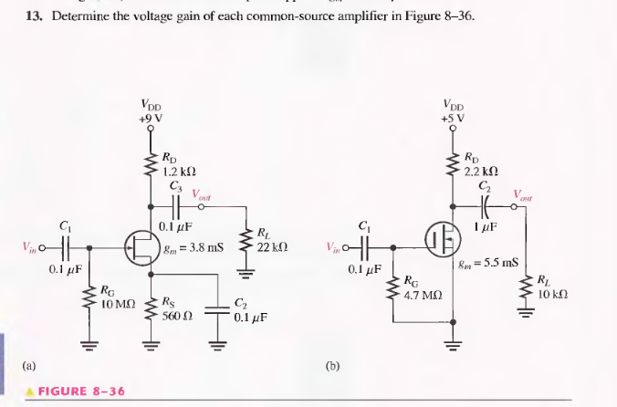

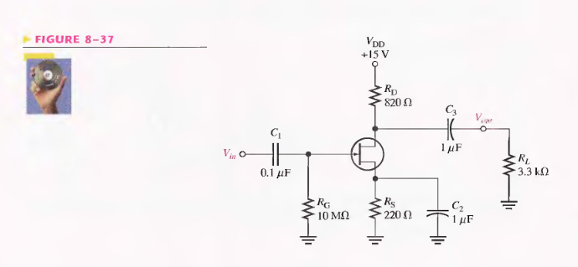

29. A common gate amplifier has a gm = 4000mS and Rd=1.5kΩ, what is the input resistance of the amplifier

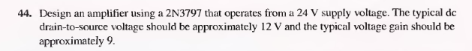

From Boylestad Book

1 (23). Determine Zi, Zo and Vo for the following network if Vi=20mV

2. (29) Determine Zi, Zo and Av for the following network (note Vgs(off)=Vp=-4.5V and rd=rds=40kΩ)
3.(33) Determine Zi, Zo and Av for the following network (note Vgs(off)=Vp=-4 V and rd=rds=33kΩ)

