

**ENEE2360**

**Instructor**: Dr. Nasser Ismail

**Prepared by:** Islam Jihad

**ID**: 1191375

**Section:** 1

**Date:** 16 \ 8 \ 2020

**contents**

the question ………………………………………………………………………………………………………………………………………… 3

abstract …………………………………………………………………………………………………………………………………………………. 4

half wave rectifier………………………………………………………………………………………………………………………………….. 5

design calculations ……………………………………………………………………………………………………………………. 5

simulation ………………………………………………………………………………………………………………………………… 6

comparison……………………………………………………………………………………………………………………………….. 7

full wave rectifier…………………………………………………………………………………………………………………………………… 8

design calculations …………………………………………………………………………………………………………………… 8

simulation…………………………………………………………………………………………………………………………………. 9

comparison……………………………………………………………………………………………………………………………… 10

center tapped full wave rectifier …………………………………………………………………………………………………………. 11

design calculations………………………………………………………………………………………………………..………… 11

simulation……………………………………………………………………………………………………………………………….. 12

comparison……………………………………………………………………………………………………………………………… 13

conclusion……………………………………………………………………………………………………………………………………………. 14

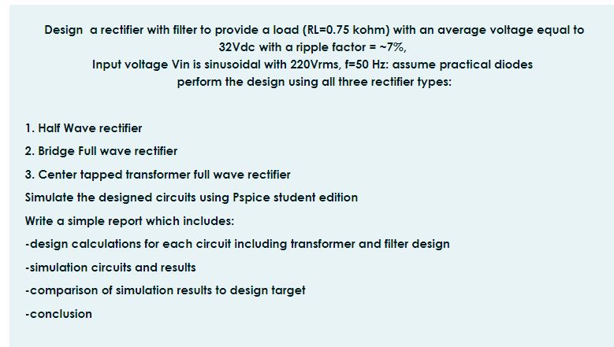

Abstract

The aim of this assignment is to study and apply on PSpice the half, full and center tapped rectifiers applications circuits that used to convert from ac to dc.

1. **Half Wave rectifier**

**Design and calculations**

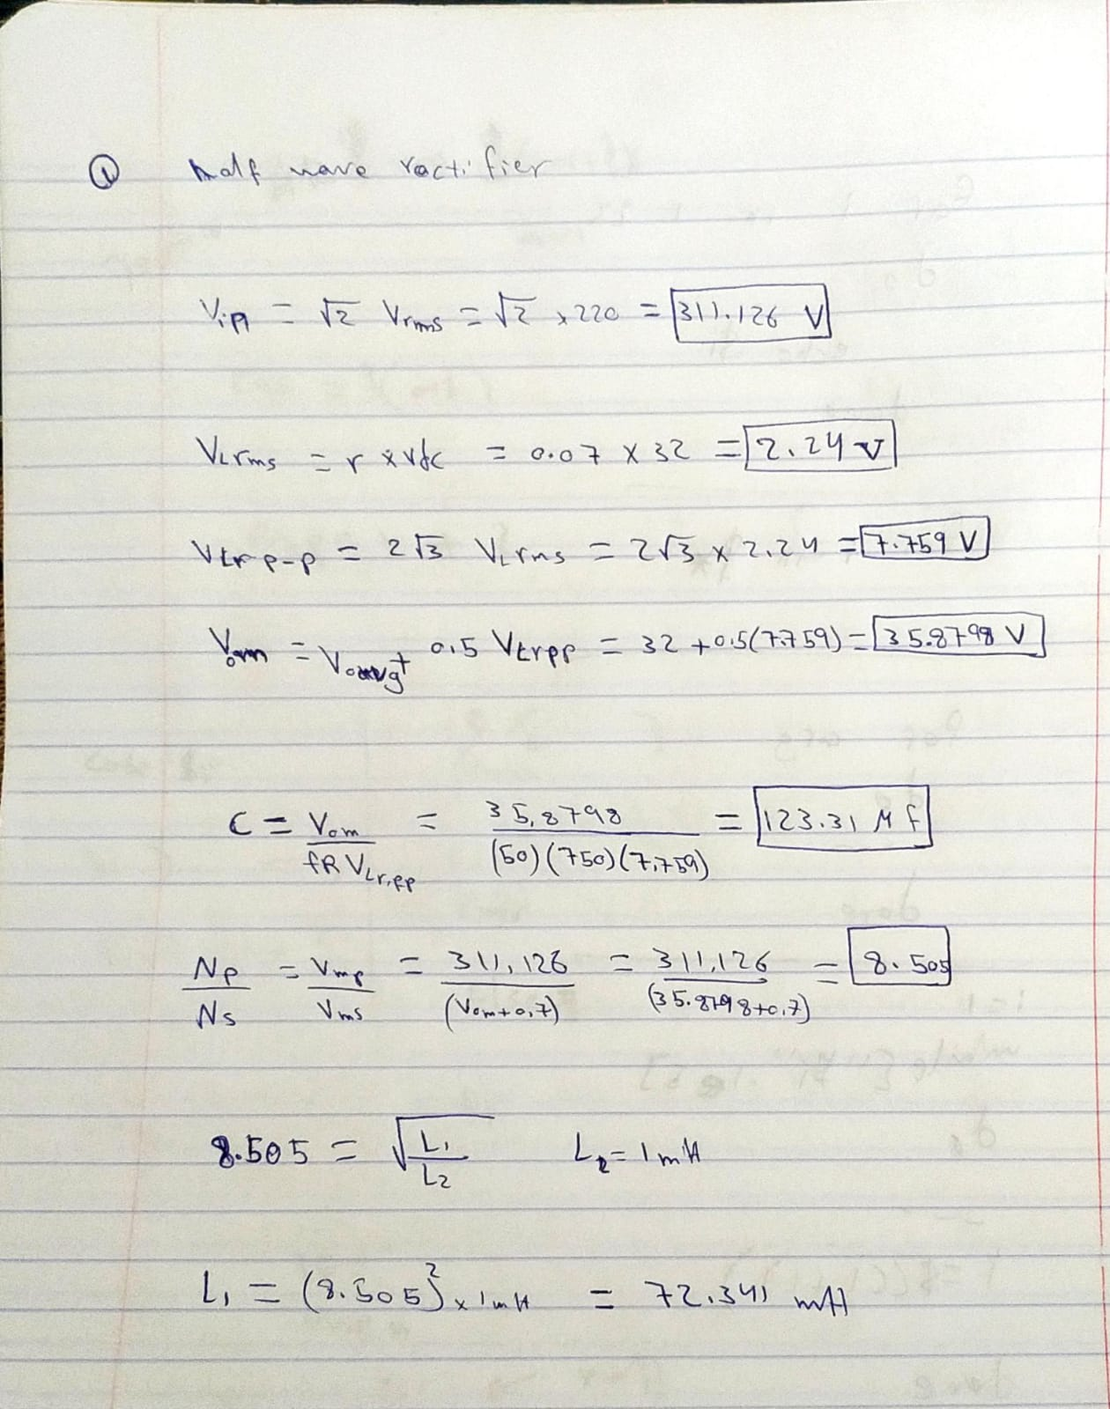

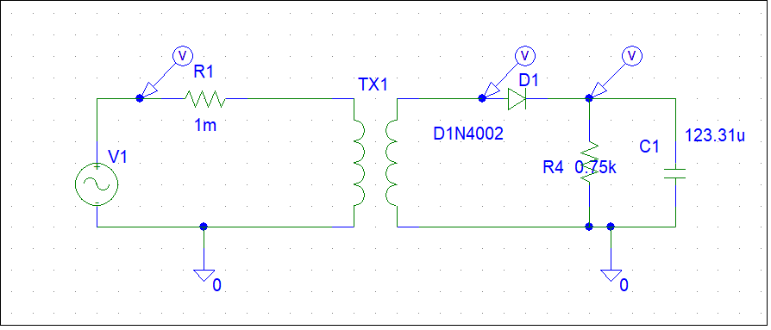

**Simulation results**





**Comparison**

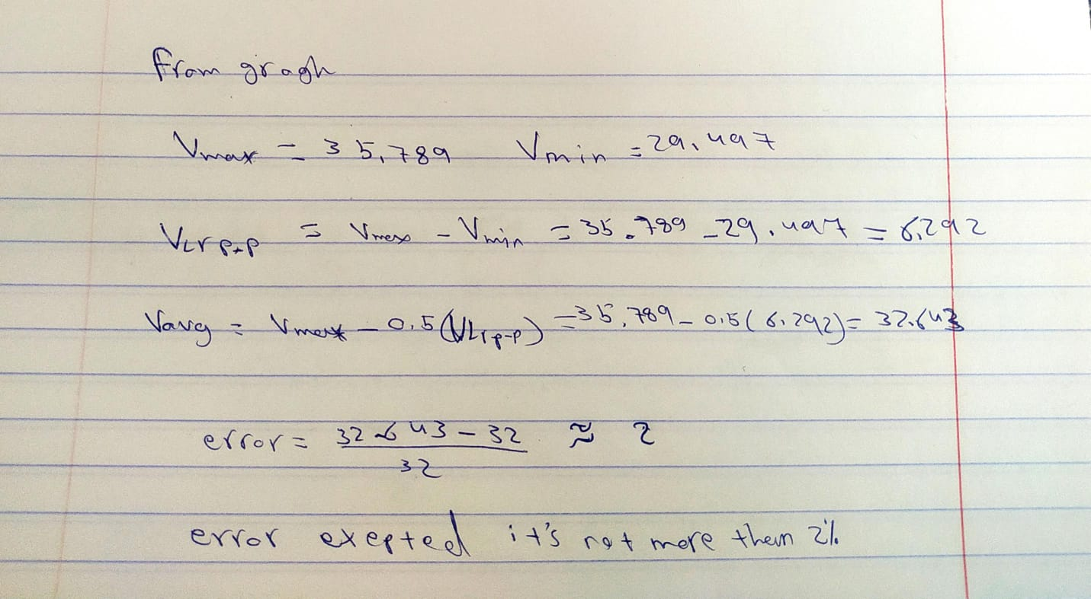

The values were realistic to the calculations on paper

1. **Bridge Full wave rectifier**

**Design and calculations**

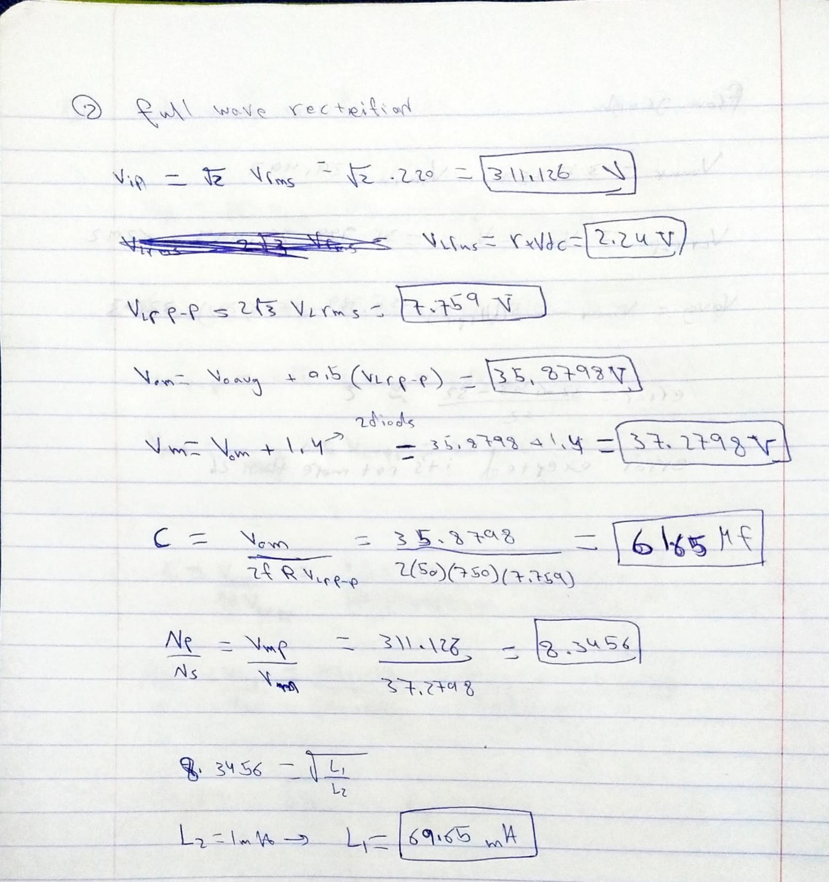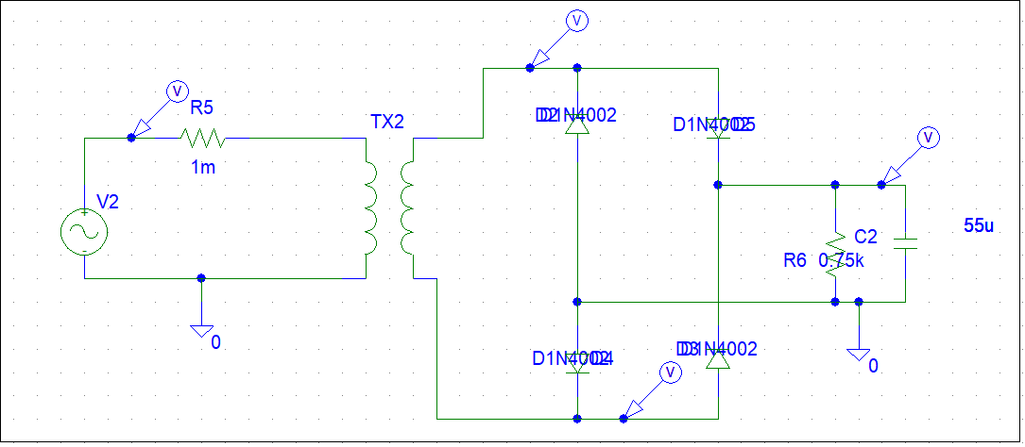

**Simulation results**





**Comparison**

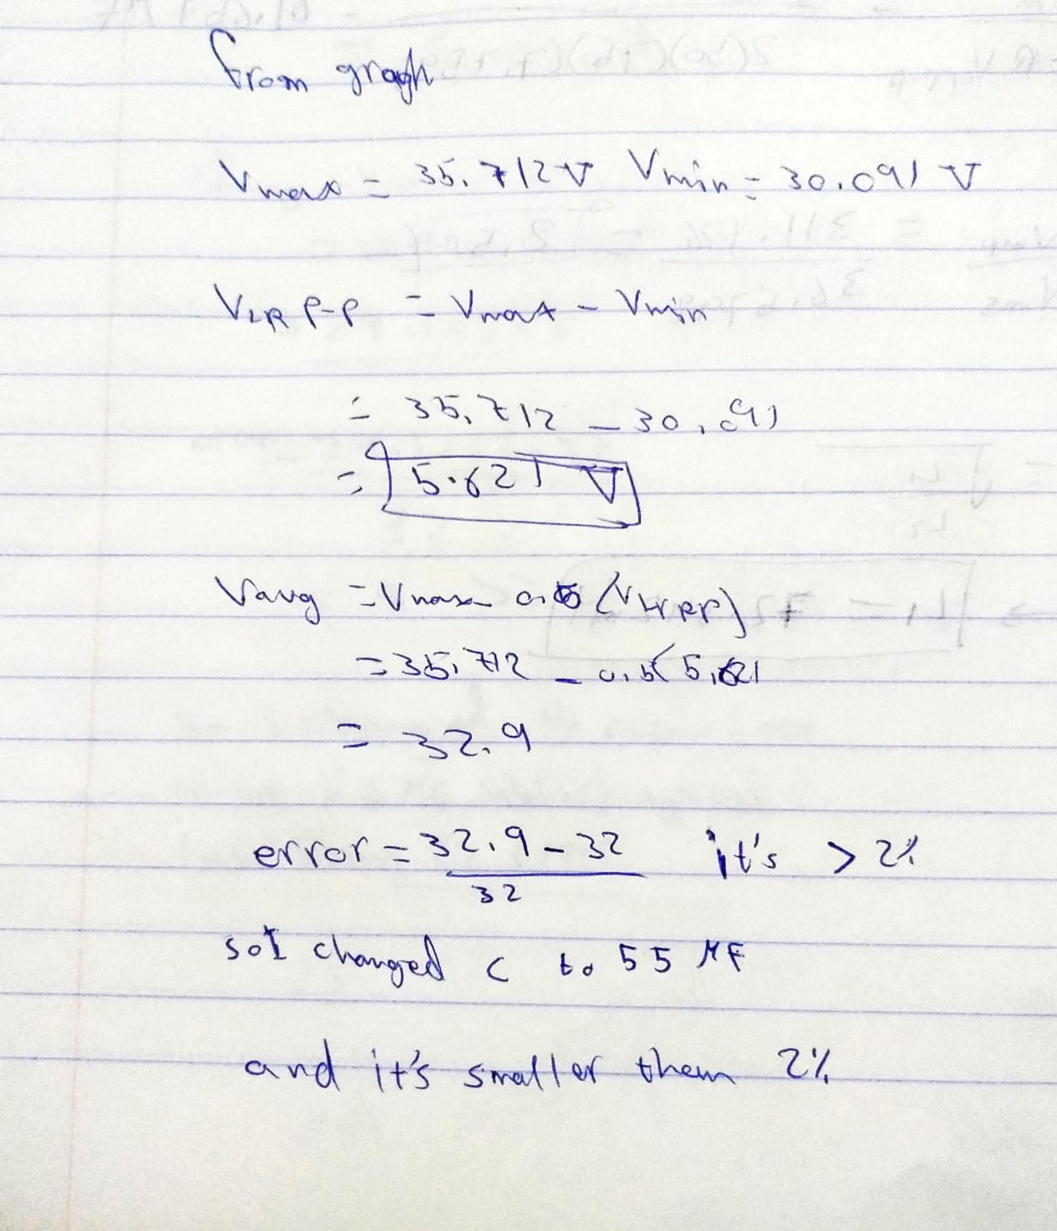

The values were a bit far (more than 2% error) so I changed the capacitor value to 55 MF to fit it and got realistic values to results on paper

1. **Center tapped transformer full wave rectifier**

**Design and calculations**

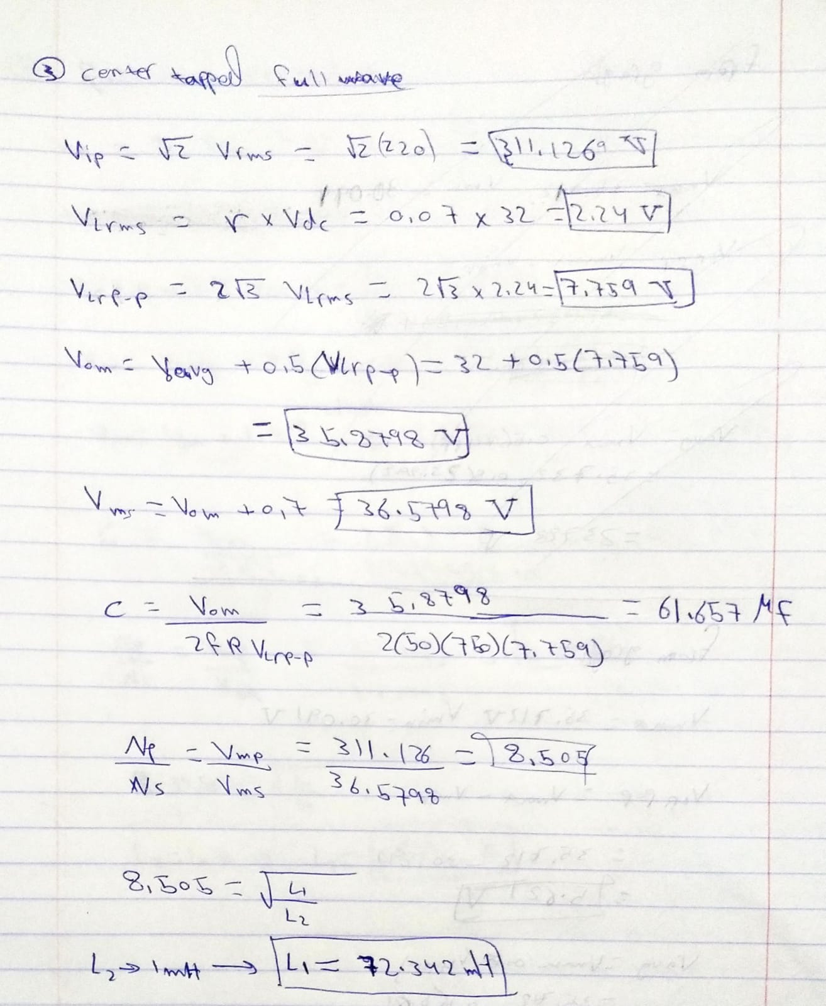

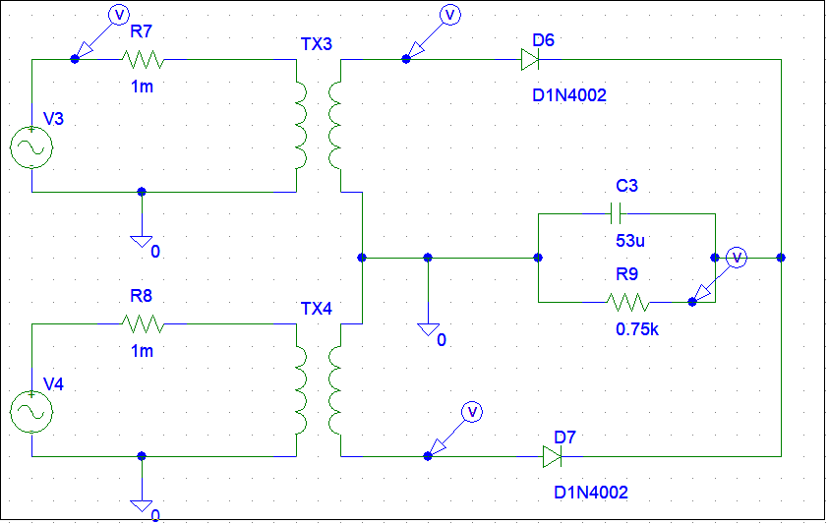

**Simulation results**





**Comparison**

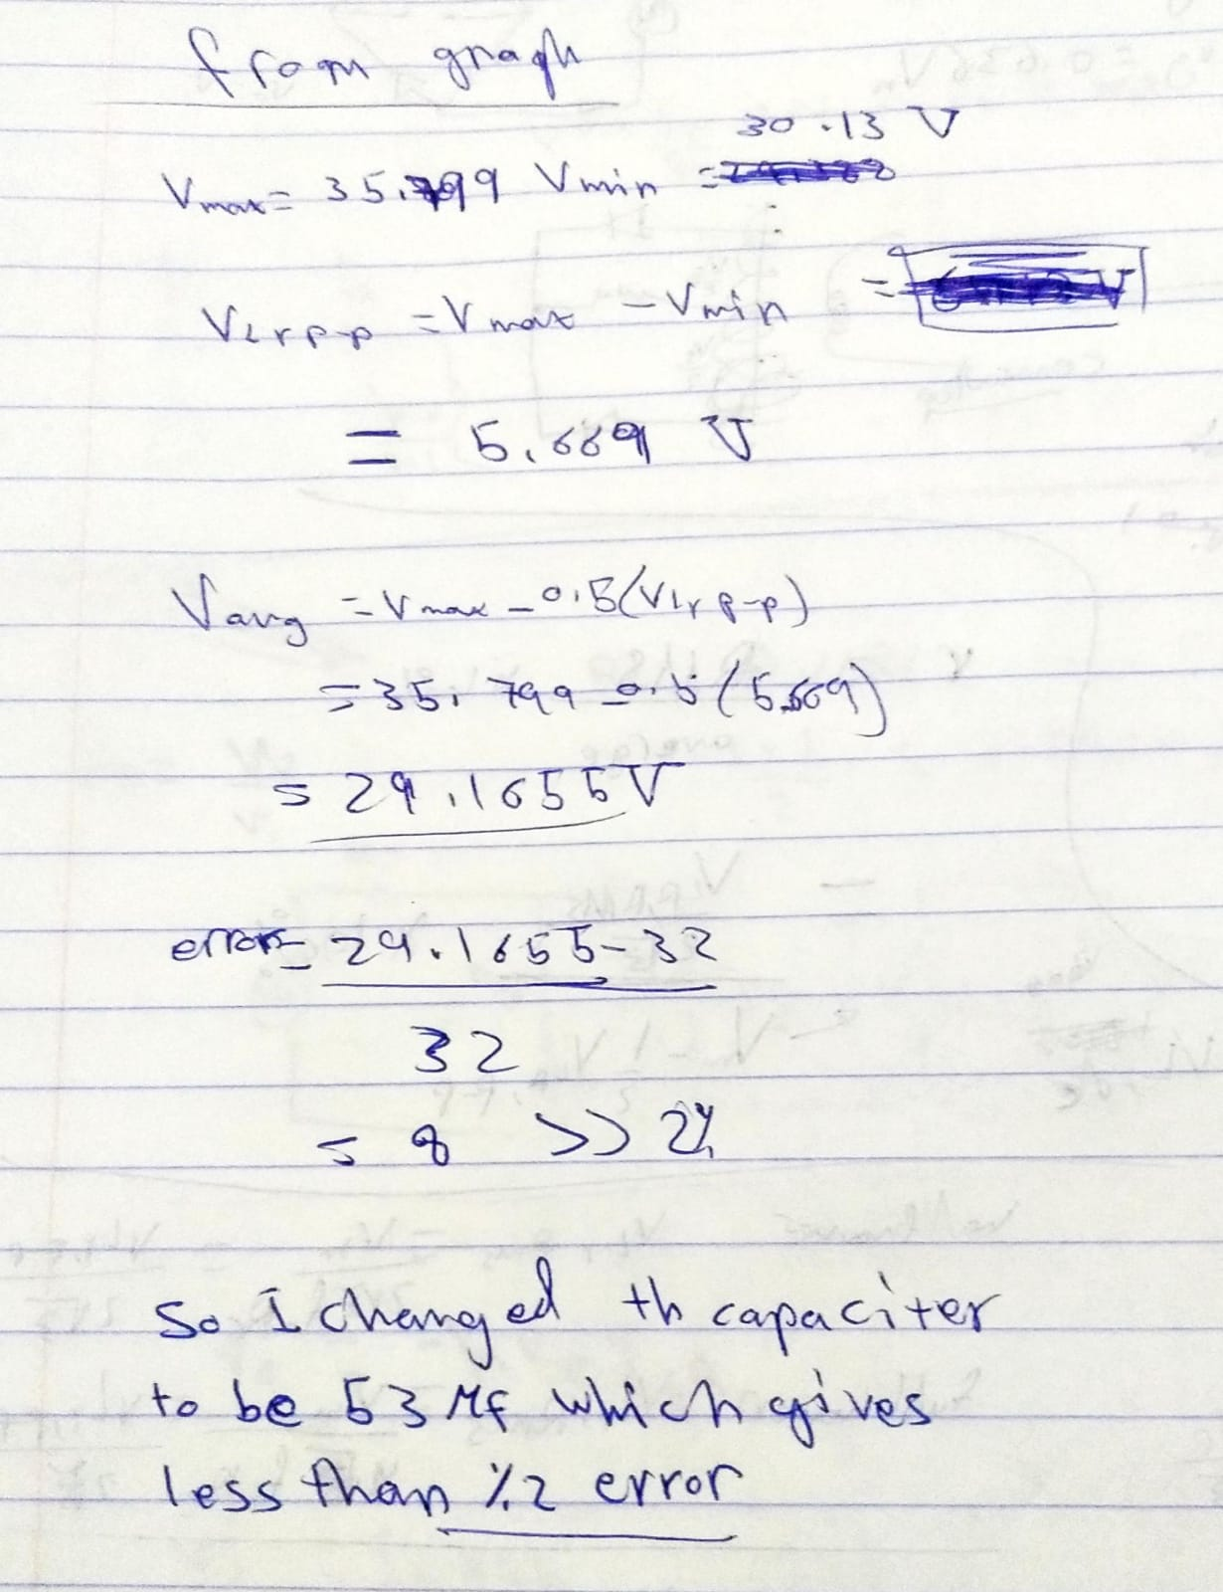

I got the same problem in the previous circuit and fix it by changing the capacitor value to 53MF to get realistic data to ones on paper

**Conclusion**

All the 3 circuits show us how the rectifier works by changing the values form AC to a DC static value. in this assignment we make 3 circuits, half wave, full wave and center tapped full wav rectifier I made some calculations on paper and designed them on PSpice and compared the results.