

# **Faculty of Engineering & Technology**

# **Electrical & Computer Engineering Department**

**ENEE236**

**Assignment 1**

**Prepared by : Tareq Shannak**

**ID Number : 1181404**

**Instructor : Dr. Nasser Ismail**

**Section Number : 1**

**Date : 4/8/2020**

# Objectives

* Design Half-Wave Rectifier on PSpice
* Design Bridge Full-Wave Rectifier
* Design CT Transformer Full-Wave Rectifier

## Half-Wave Rectifier

### Calculations

### 

### Circuit without Filtering

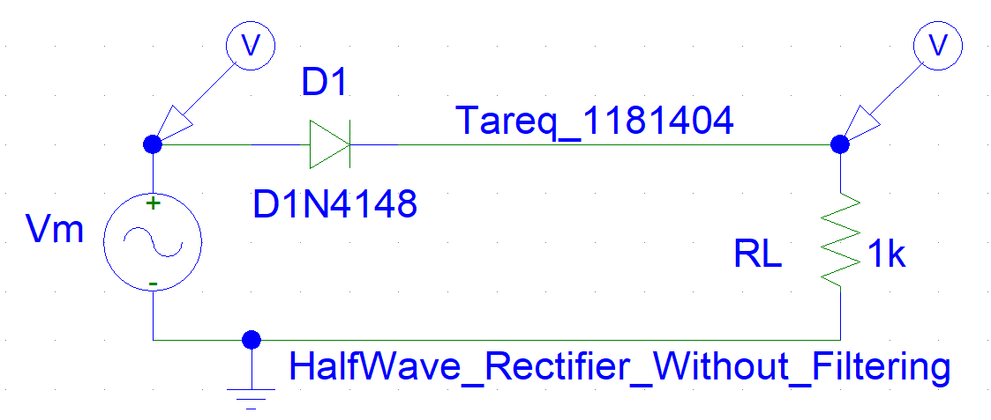

### Simulation

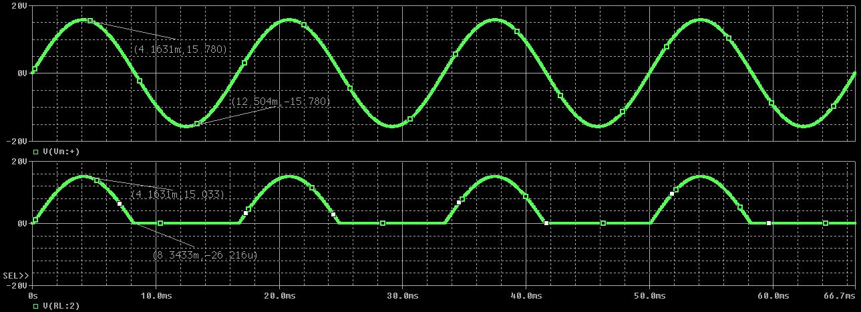

### Circuit with Filtering

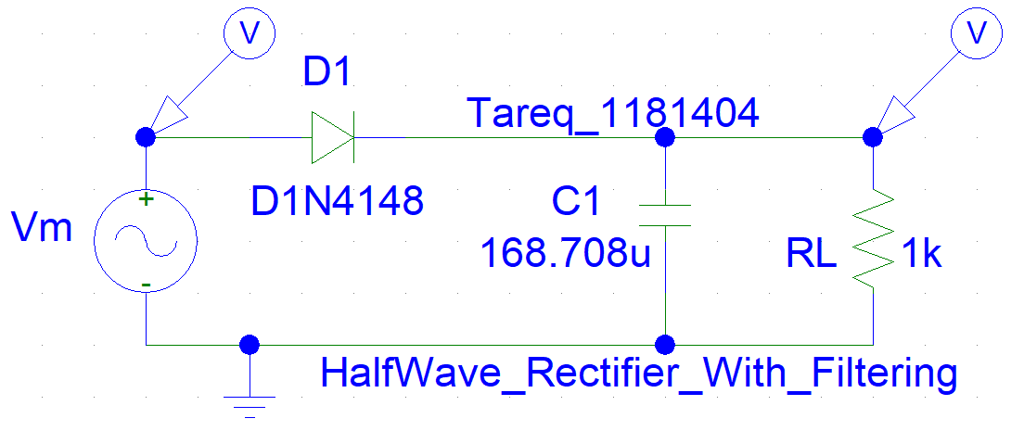

### Simulation

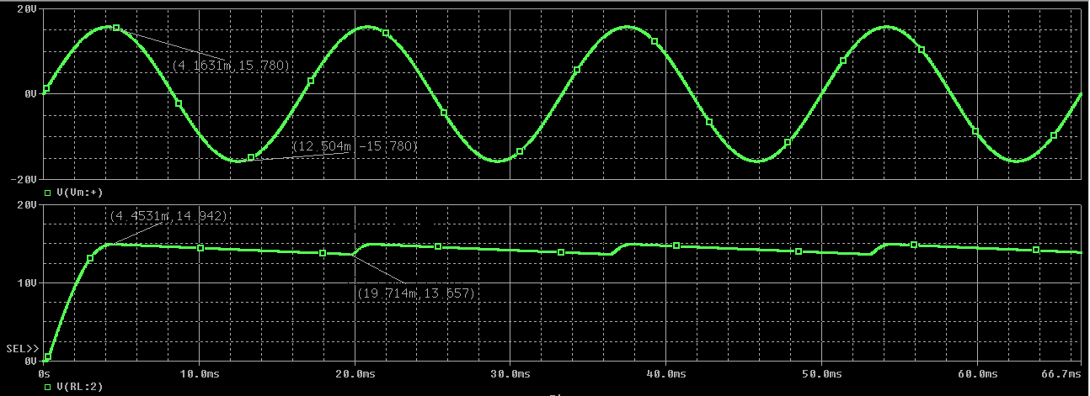

## Bridge Full-Wave Rectifier

### Calculations

### 

### Circuit without Filtering

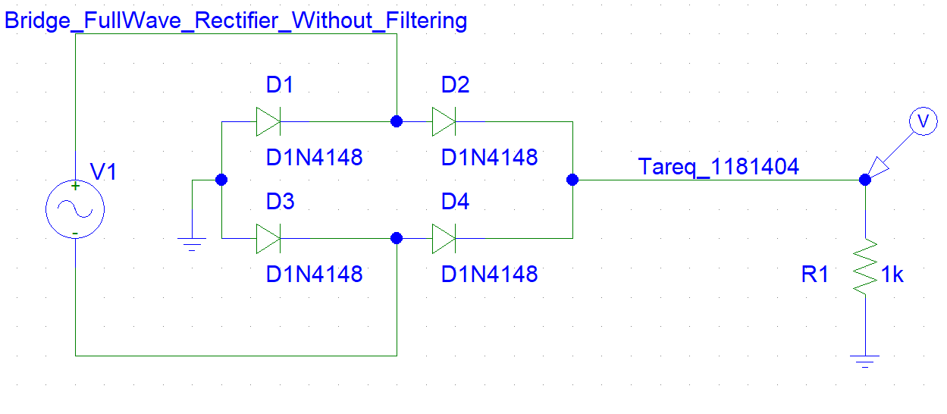

### Simulation

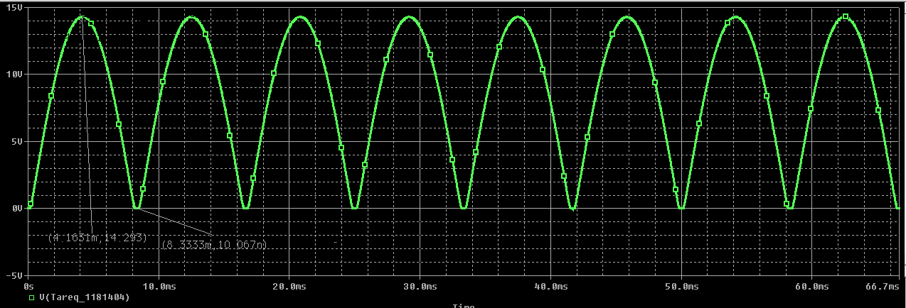

### Circuit with Filtering

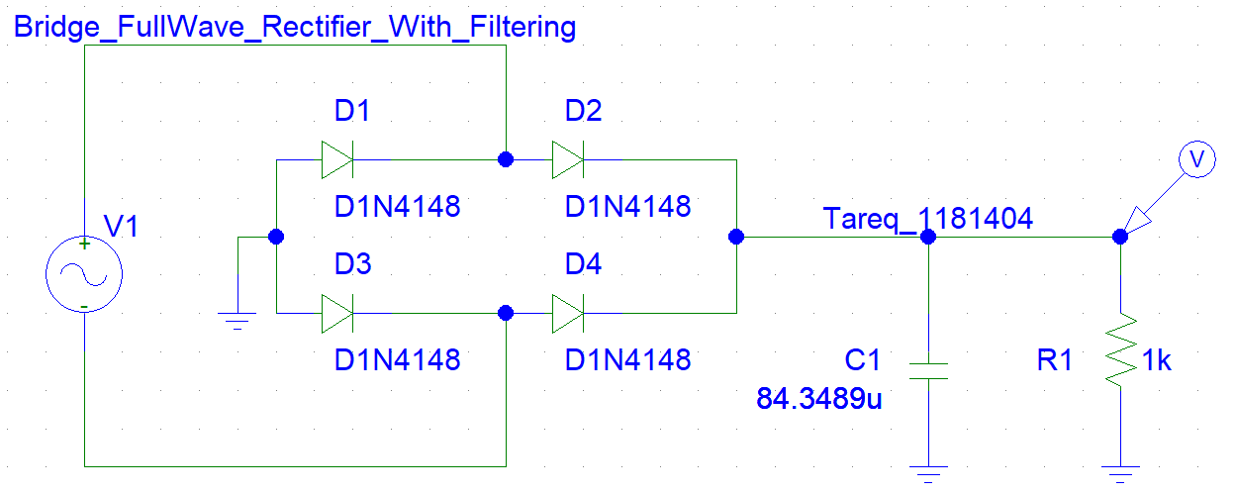

### Simulation

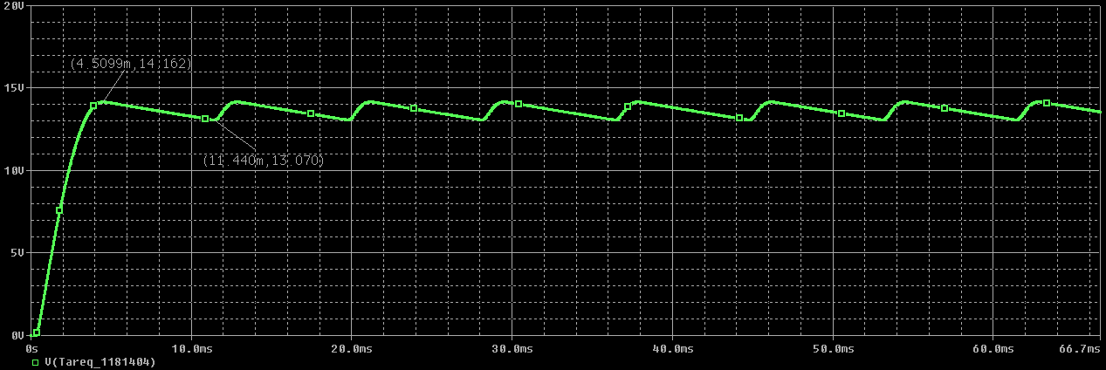

## CT Transformer Full-Wave Rectifier

### Calculations

### 

### Circuit without Filtering

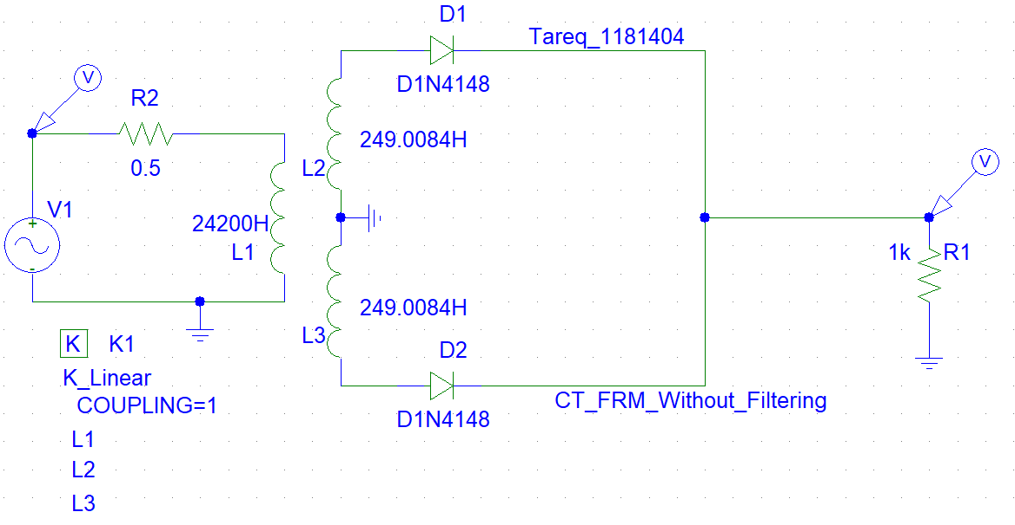

### Simulation

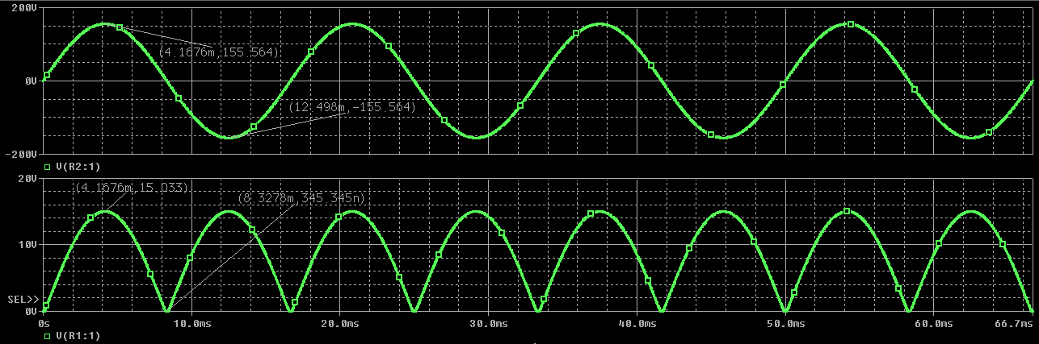

### Circuit with Filtering

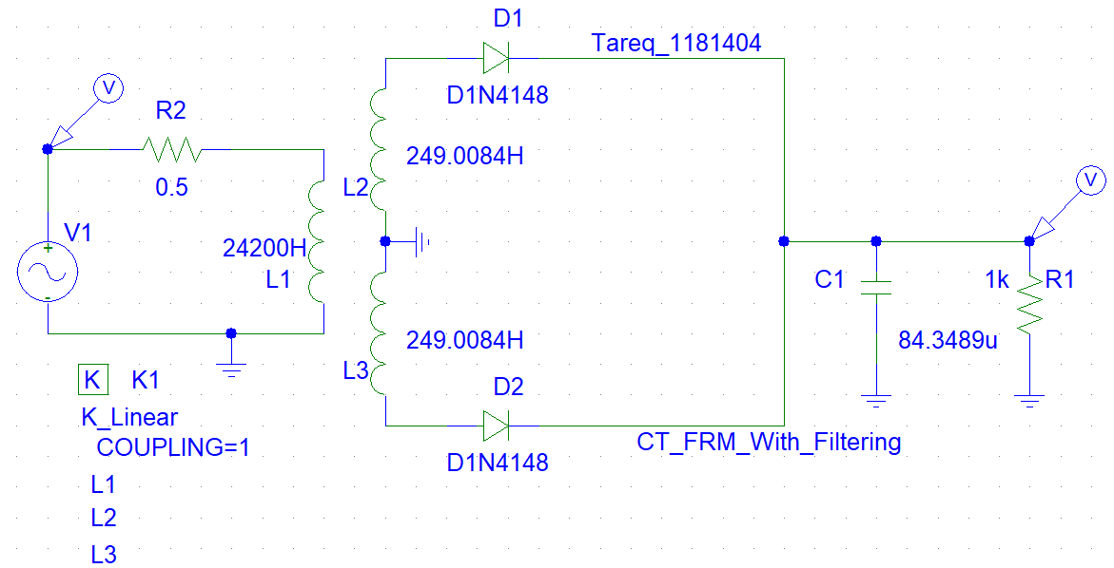

### Simulation

