

# **Faculty of Engineering & Technology**

# **Electrical & Computer Engineering Department**

**ENEE236**

**Assignment 2**

**Prepared by : Tareq Shannak**

**Id Number : 1181404**

**Instructor : Dr. Nasser Ismael**

**Section : 1**

**Date : 21/8/2020**

# Objectives

* Design an CE Amplifier using npn BJT transistor
* Testing the voltage gain with different inputs

# Calculations

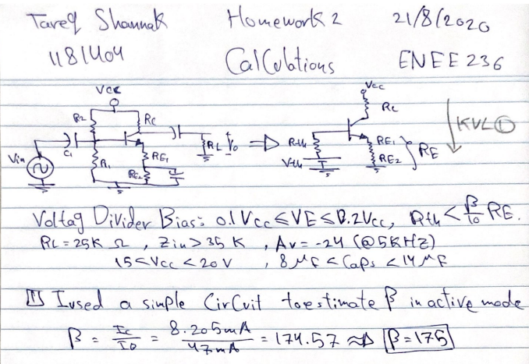

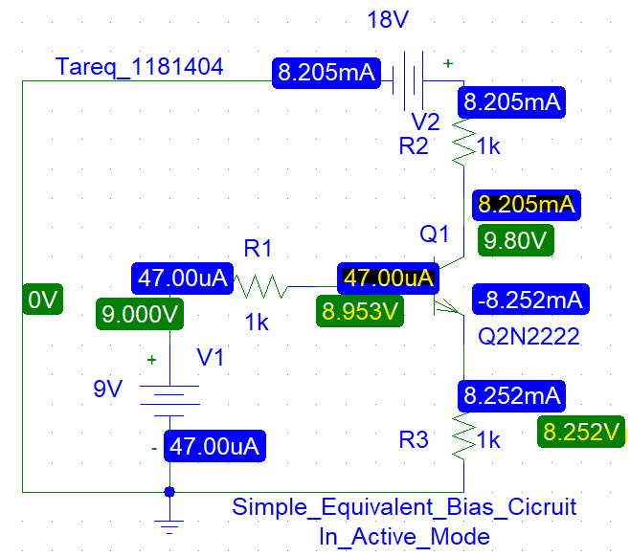

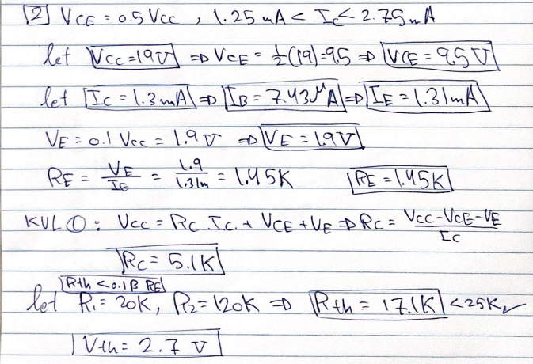

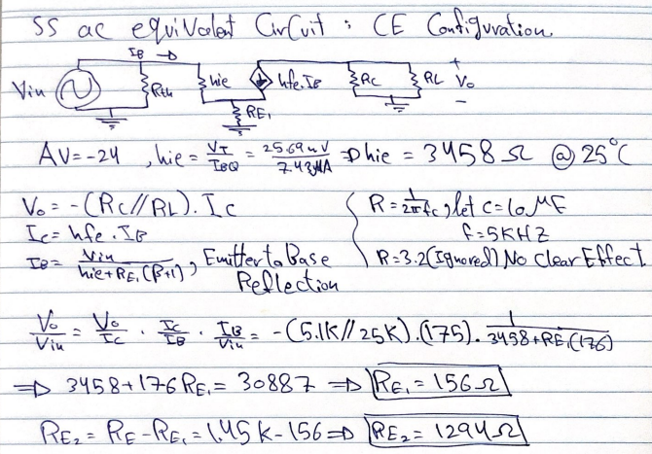

# Result

I supposed C=10uF.

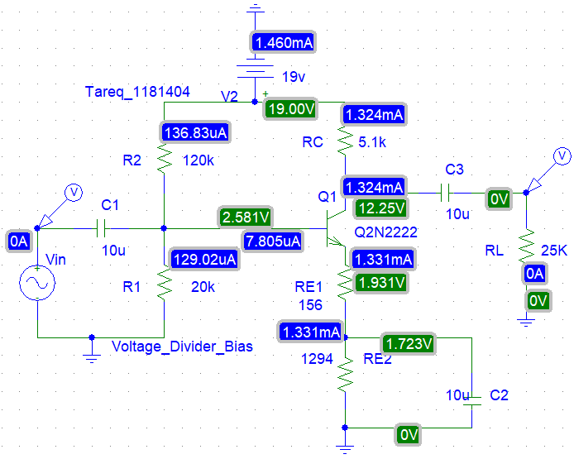

|  |  |  |  |
| --- | --- | --- | --- |
|  | Ib | Ic | Ie |
| Theoretical | 7.43uA | 1.3mA | 1.31mA |
| Practical | 7.805uA | 1.324mA | 1.331mA |

Vce = 12.25-1.931=10.319 (near 9.5v)

### Testing the voltage gain with amplitude=15mV, and different frequencies: 1 KHz, 5KHz, 10KHz Using PARAM.

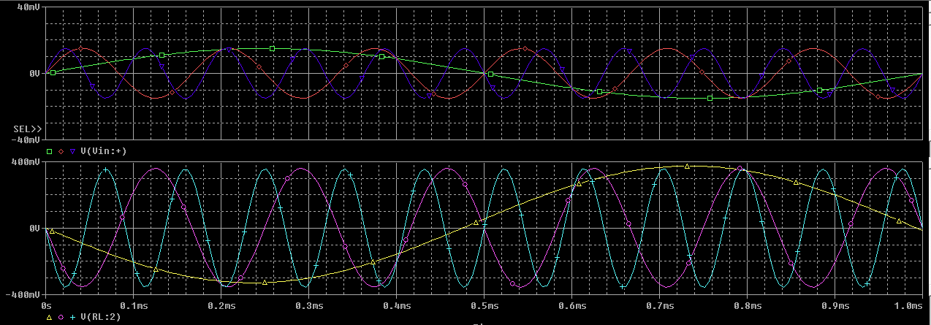

To check the voltage gain, here are the max points.

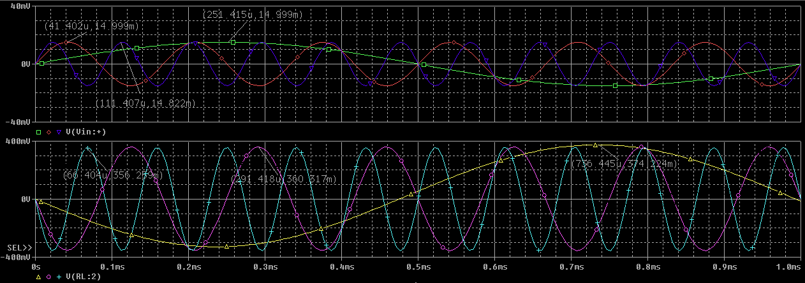

|  |  |  |  |
| --- | --- | --- | --- |
|  | F=1KHZ | F=5KHZ | F=10KHZ |
| Vin | 14.999m | 14.999m | 14.822m |
| Vout | -374.224m | -360.317m | -356.269m |
| Av | -24.94993 | -24.02273485 | -24.0365 |

The results are too close of the theoretical value (-24).

### Testing the voltage gain with amplitude=1V, Using ac sweep (1Hz-1MHz).

In any frequency of the three frequencies, we will have the same output. The second plot is with DB Scale.

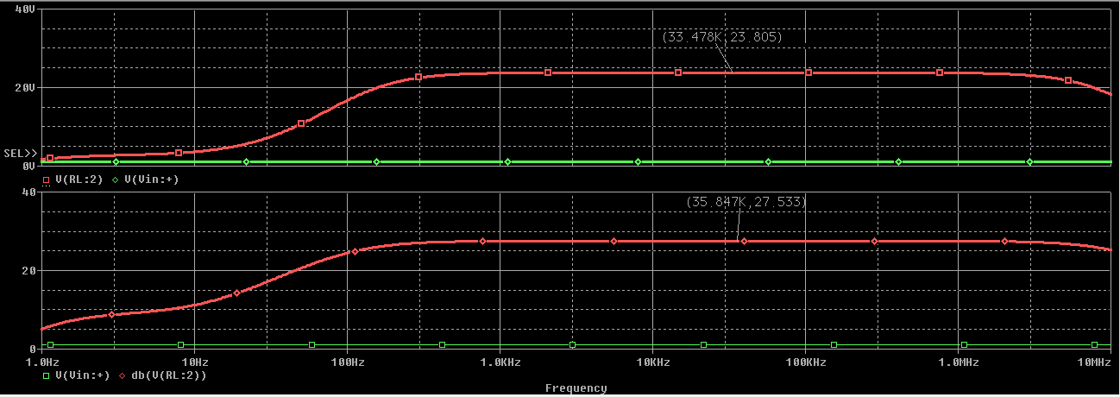

From first plot, |AV|=23.805 (approximately 24)

From the second one, 20*log(|Av|)=27.533 **=>** log(|Av|)=1.37665 **=>** |Av|=23.804 (=24).

**NOTE**: I had tried too much to make this condition (Zin>35K), but this will force me to change the values that I chose to accredited values and it will broke the value of AV.