



**Electric and Computer Systems Engineering Department**

**ELECTRICAL MACHINES “ENEE2408”**

# 

# Assignment On Induction Motors

*Prepared For: Dr.Mohammad Abu-Khaizaran*

*Prepared By: Ali Sider 1111829  
  
  
 Section 2*

a) Show the torque plot versus speed and also the torque versus s at rated voltage,**Also show the converted output power versus slip.***Torque Vs Speed plot*  
close all;clear all ;clc;

Vt= 460 ;fe= 60 ;p=4;

R1=0.15 ;R2=0.154 ;

X1=0.852 ; X2=1.066 ; Xm=20 ;

Vph=Vt/sqrt(3);

Nsync=(120*fe)/p;

Wsync=2*3.14*Nsync/60;

Vth =(Xm/(sqrt(R1^2+(X1+Xm)^2)))*Vph;

Zth =((j*Xm)*(R1+(j*X1)))/(R1+j*(Xm+X1));

Rth = real(Zth);

Xth = imag(Zth);

s=-1.0001:0.0001:2.0001;

Nm=(1-s)*Nsync;

Wm=(1 - s)*Wsync;

for i = 1:length(s)

Tind(i) = (3*Vth^2*R2 / s(i)) / (Wsync*((Rth + R2/s(i))^2 + (Xth + X2)^2) );

end

plot(Nm,Tind);

xlabel('Nm(Rev/min)');ylabel('Tind(N.m)');title ('Induced Torque versus Speed (Ali Sider)');

grid on;

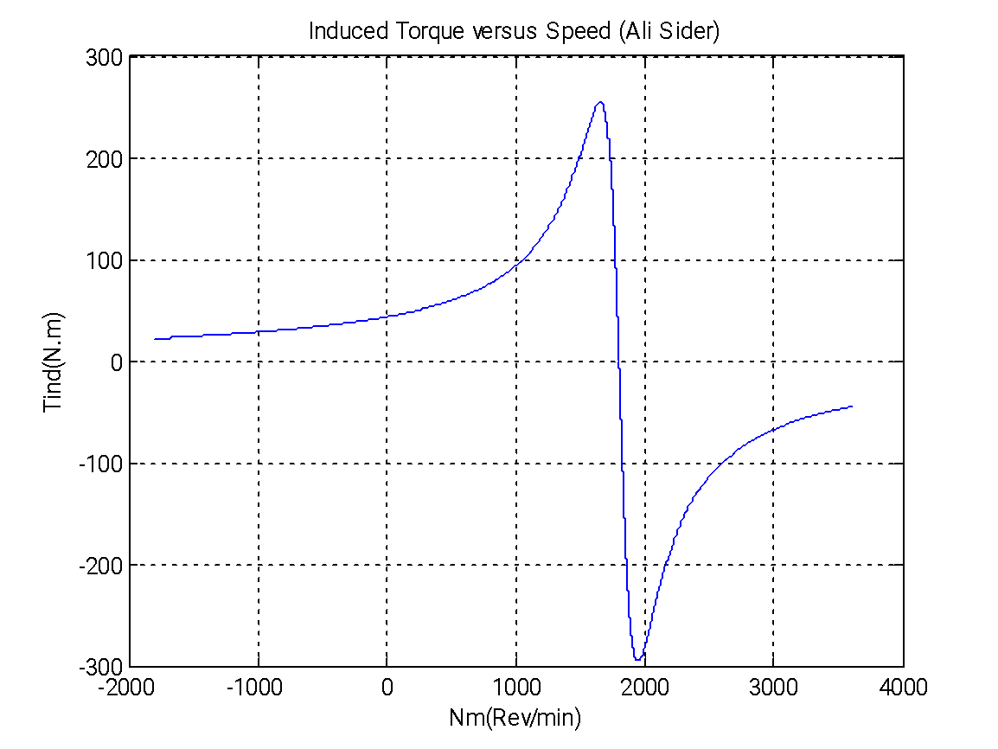  
  
  
  
  
  
 *Torque Vs S at rated voltage plot*close all;clear all ;clc;

Vt= 460 ;fe= 60 ;p=4;

R1=0.15 ;R2=0.154 ;

X1=0.852 ; X2=1.066 ; Xm=20 ;

Vph=Vt/sqrt(3);

Nsync=(120*fe)/p;

Wsync=2*3.14*Nsync/60;

Vth =(Xm/(sqrt(R1^2+(X1+Xm)^2)))*Vph;

Zth =((j*Xm)*(R1+(j*X1)))/(R1+j*(Xm+X1));

Rth = real(Zth);

Xth = imag(Zth);

s=-1.0001:0.0001:2.0001;

Nm=(1-s)*Nsync;

Wm=(1 - s)*Wsync;

for i = 1:length(s)

Tind(i) = (3*Vth^2*R2 / s(i)) / (Wsync*((Rth + R2/s(i))^2 + (Xth + X2)^2) );

end

plot(s,Tind,'r');

xlabel('s');ylabel('Tind(N.m)');title ('Induced Torque versus s (Ali Sider)');

grid on;

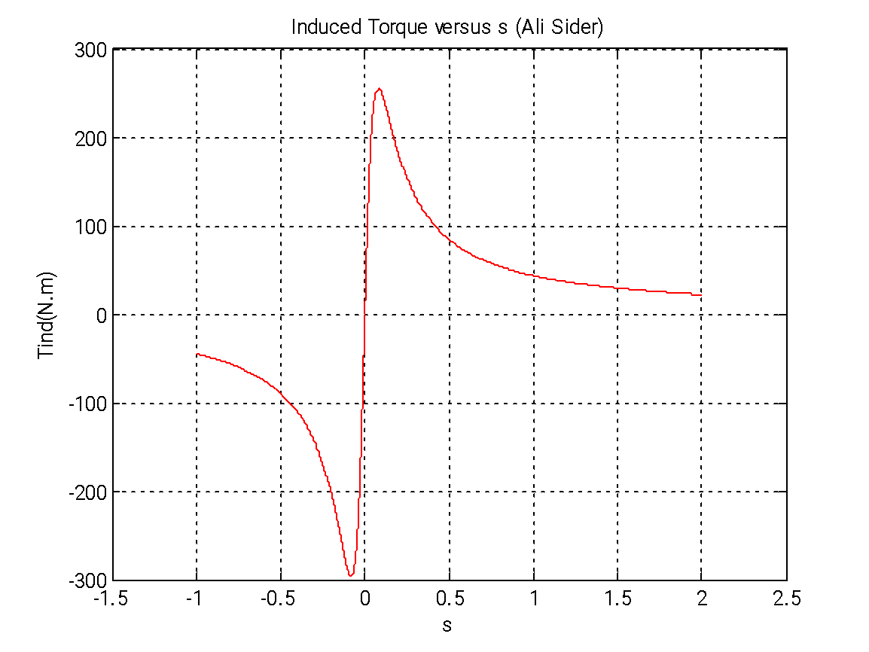  
  
  
  
  
  
  
  
  
  
*Converted output power Vs S plot*  
close all;clear all ;clc;

Vt= 460 ;fe= 60 ;p=4;

R1=0.15 ;R2=0.154 ;

X1=0.852 ; X2=1.066 ; Xm=20 ;

Vph=Vt/sqrt(3);

Nsync=(120*fe)/p;

Wsync=2*3.14*Nsync/60;

Vth =(Xm/(sqrt(R1^2+(X1+Xm)^2)))*Vph;

Zth =((j*Xm)*(R1+(j*X1)))/(R1+j*(Xm+X1));

Rth = real(Zth);

Xth = imag(Zth);

s=-1.0001:0.0001:2.0001;

Nm=(1-s)*Nsync;

Wm=(1 - s)*Wsync;

for i = 1:length(s)

Tind(i) = (3*Vth^2*R2 / s(i)) / (Wsync*((Rth + R2/s(i))^2 + (Xth + X2)^2) );

Pconv(i) = Tind(i) * Wm(i);

end

plot(s,Pconv,'--k');

xlabel('s');ylabel('Pconv(Kw)');title ('Converted power versus s (Ali Sider)');

grid on;

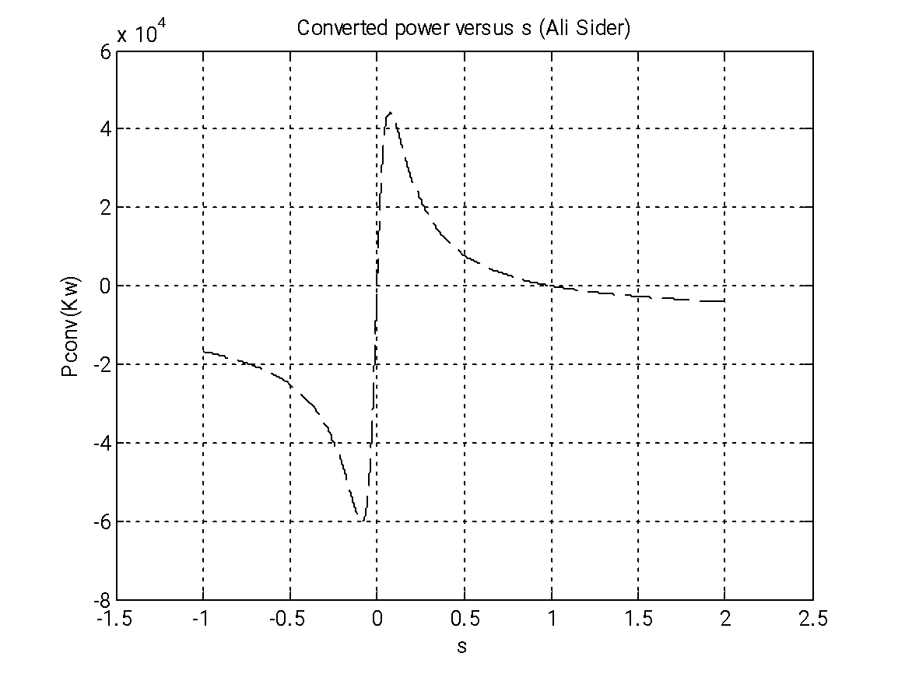  
  
  
  
  
  
  
  
  
  
b) repeat a)  for VLL reduced to 75% of VLL rated, 50%, 25% then to 10% of rated voltage  
  
*Torque Vs Speed plot*  
close all;clear all ;clc;

Vt= 460 ;fe= 60 ;p=4;R1=0.15 ;R2=0.154 ;X1=0.852 ; X2=1.066 ; Xm=20 ;

Vph=Vt/sqrt(3);Nsync=(120*fe)/p;Wsync=2*3.14*Nsync/60;

Vth =(Xm/(sqrt(R1^2+(X1+Xm)^2)))*Vph;

Zth =((j*Xm)*(R1+(j*X1)))/(R1+j*(Xm+X1));

Rth = real(Zth);Xth = imag(Zth);

s=-1.0001:0.0001:2.0001;

Nm=(1-s)*Nsync; Wm=(1 - s)*Wsync;

for i = 1:length(s)

Tind(i) = (3*Vth^2*R2 / s(i)) / (Wsync*((Rth + R2/s(i))^2 + (Xth + X2)^2) );

end

V75=0.75*Vth;V50=0.50*Vth;V25=0.25*Vth;V10=0.10*Vth;

for i=1:length(s)

Tind1(i)= (3 * V75^2 * R2 / s(i)) / (Wsync * ((Rth + R2/s(i))^2 + (Xth + X2)^2) );

Pconv1(i) = Tind1(i) * Wm(i);

end

for i=1:length(s)

Tind2(i)= (3 * V50^2 * R2 / s(i)) / (Wsync * ((Rth + R2/s(i))^2 + (Xth + X2)^2) );

pconv2(i) = Tind2(i) * Wm(i);

end

for i=1:length(s);

Tind3(i)= (3 * V25^2 * R2 / s(i)) / (Wsync * ((Rth + R2/s(i))^2 + (Xth + X2)^2) );

Pconv3(i) = Tind3(i) * Wm(i);

end

for i=1:length(s)

Tind4(i)= (3 * V10^2 * R2 / s(i)) / (Wsync * ((Rth + R2/s(i))^2 + (Xth + X2)^2) );

Pconv4(i) = Tind4(i) * Wm(i);

end

plot(Nm,Tind1,'color','c');hold on

plot(Nm,Tind2,'color','r');plot(Nm,Tind3,'color','k');plot(Nm,Tind4,'color','g');

xlabel('Nm(Rev/min)');ylabel('Tind(N.m)');title('Induction motor torque - speed characteristic (Ali Sider)');legend('75%','50%','25%','10%');

hold off;grid on;

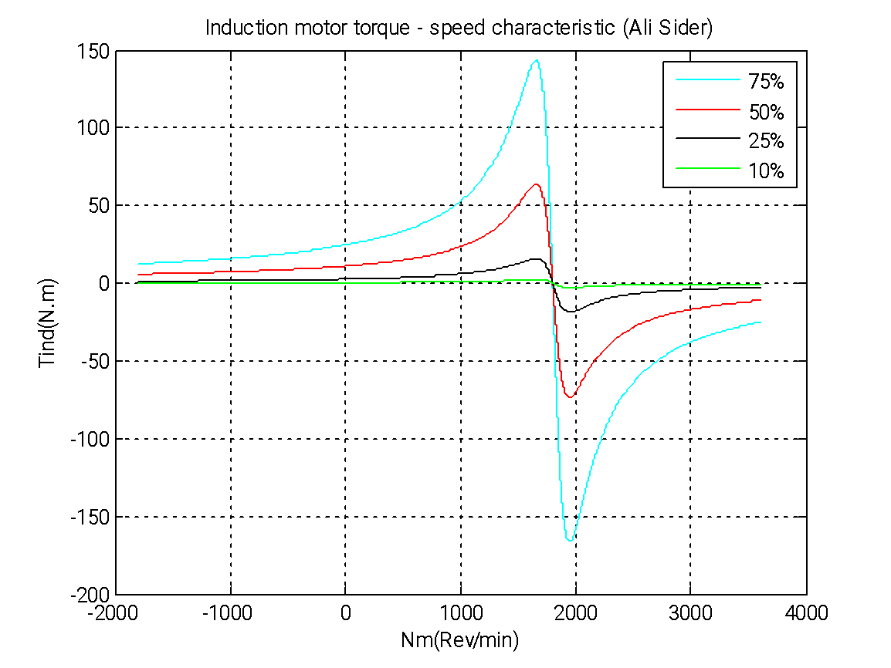  
*Torque Vs S at rated voltage plot*close all;clear all ;clc;

Vt= 460 ;fe= 60 ;p=4;R1=0.15 ;R2=0.154 ;X1=0.852 ; X2=1.066 ; Xm=20 ;

Vph=Vt/sqrt(3);Nsync=(120*fe)/p;Wsync=2*3.14*Nsync/60;

Vth =(Xm/(sqrt(R1^2+(X1+Xm)^2)))*Vph;

Zth =((j*Xm)*(R1+(j*X1)))/(R1+j*(Xm+X1));

Rth = real(Zth);Xth = imag(Zth);

s=-1.0001:0.0001:2.0001;

Nm=(1-s)*Nsync; Wm=(1 - s)*Wsync;

for i = 1:length(s)

Tind(i) = (3*Vth^2*R2 / s(i)) / (Wsync*((Rth + R2/s(i))^2 + (Xth + X2)^2) );

end

V75=0.75*Vth;V50=0.50*Vth;V25=0.25*Vth;V10=0.10*Vth;

for i=1:length(s)

Tind1(i)= (3 * V75^2 * R2 / s(i)) / (Wsync * ((Rth + R2/s(i))^2 + (Xth + X2)^2) );

Pconv1(i) = Tind1(i) * Wm(i);

end

for i=1:length(s)

Tind2(i)= (3 * V50^2 * R2 / s(i)) / (Wsync * ((Rth + R2/s(i))^2 + (Xth + X2)^2) );

pconv2(i) = Tind2(i) * Wm(i);

end

for i=1:length(s);

Tind3(i)= (3 * V25^2 * R2 / s(i)) / (Wsync * ((Rth + R2/s(i))^2 + (Xth + X2)^2) );

Pconv3(i) = Tind3(i) * Wm(i);

end

for i=1:length(s)

Tind4(i)= (3 * V10^2 * R2 / s(i)) / (Wsync * ((Rth + R2/s(i))^2 + (Xth + X2)^2) );

Pconv4(i) = Tind4(i) * Wm(i);

end

plot(s,Tind1,'color','c');hold on

plot(s,Tind2,'color','r');plot(s,Tind3,'color','k');plot(s,Tind4,'color','g');

xlabel('s');ylabel('Tind(N.m)');title('Induction motor torque- slip characteristic (Ali Sider)');

legend('75%','50%','25%','10%');hold off;grid on;

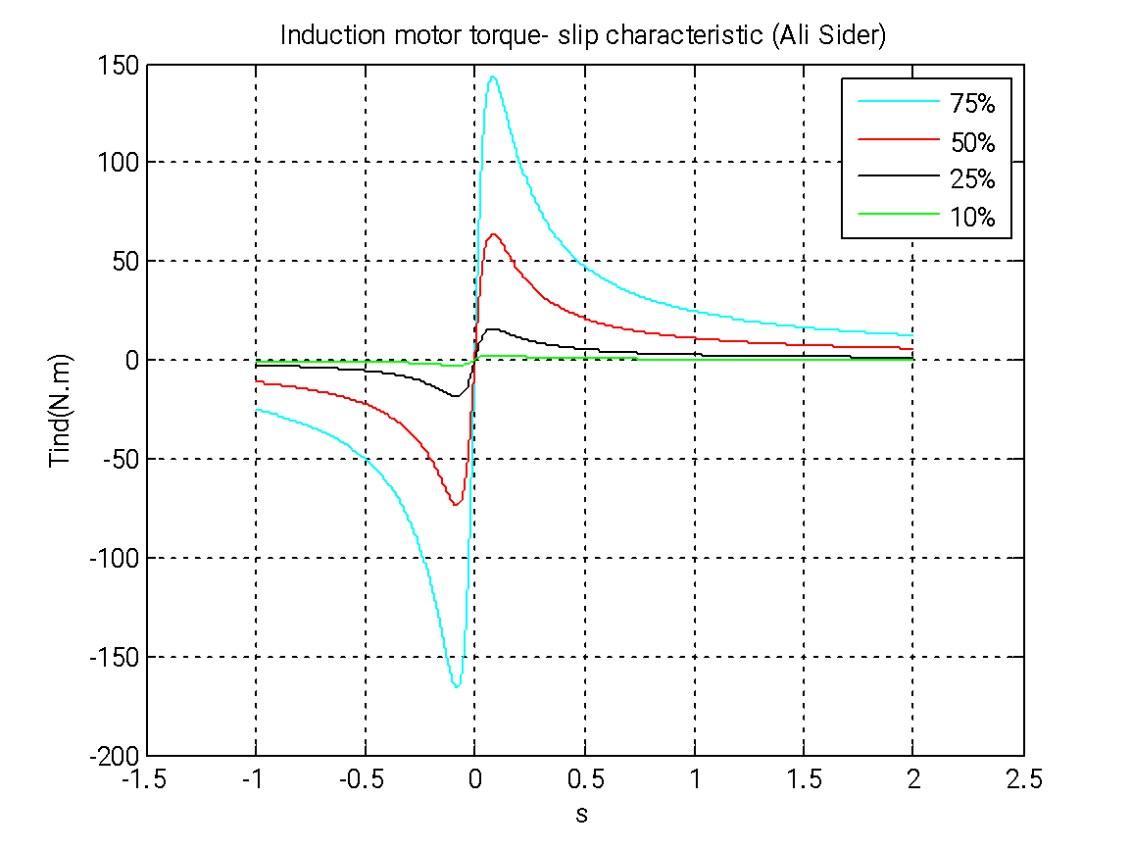  
  
  
*Converted output power Vs S plot*close all;clear all ;clc;

Vt= 460 ;fe= 60 ;p=4;R1=0.15 ;R2=0.154 ;X1=0.852 ; X2=1.066 ; Xm=20 ;

Vph=Vt/sqrt(3);Nsync=(120*fe)/p;Wsync=2*3.14*Nsync/60;

Vth =(Xm/(sqrt(R1^2+(X1+Xm)^2)))*Vph;

Zth =((j*Xm)*(R1+(j*X1)))/(R1+j*(Xm+X1));

Rth = real(Zth);Xth = imag(Zth);

s=-1.0001:0.0001:2.0001;

Nm=(1-s)*Nsync; Wm=(1 - s)*Wsync;

for i = 1:length(s)

Tind(i) = (3*Vth^2*R2 / s(i)) / (Wsync*((Rth + R2/s(i))^2 + (Xth + X2)^2) );

end

V75=0.75*Vth;V50=0.50*Vth;V25=0.25*Vth;V10=0.10*Vth;

for i=1:length(s)

Tind1(i)= (3 * V75^2 * R2 / s(i)) / (Wsync * ((Rth + R2/s(i))^2 + (Xth + X2)^2) );

Pconv1(i) = Tind1(i) * Wm(i);

end

for i=1:length(s)

Tind2(i)= (3 * V50^2 * R2 / s(i)) / (Wsync * ((Rth + R2/s(i))^2 + (Xth + X2)^2) );

Pconv2(i) = Tind2(i) * Wm(i);

end

for i=1:length(s);

Tind3(i)= (3 * V25^2 * R2 / s(i)) / (Wsync * ((Rth + R2/s(i))^2 + (Xth + X2)^2) );

Pconv3(i) = Tind3(i) * Wm(i);

end

for i=1:length(s)

Tind4(i)= (3 * V10^2 * R2 / s(i)) / (Wsync * ((Rth + R2/s(i))^2 + (Xth + X2)^2) );

Pconv4(i) = Tind4(i) * Wm(i);

end

plot(s,Pconv1,'color','c');hold on

plot(s,Pconv2,'color','r');plot(s,Pconv3,'color','k');plot(s,Pconv4,'color','g');

xlabel('s');ylabel('Pconv(Kw)');title('Power Converted versus slip characteristic (Ali Sider)');

legend('75%','50%','25%','10%');hold off;grid on;

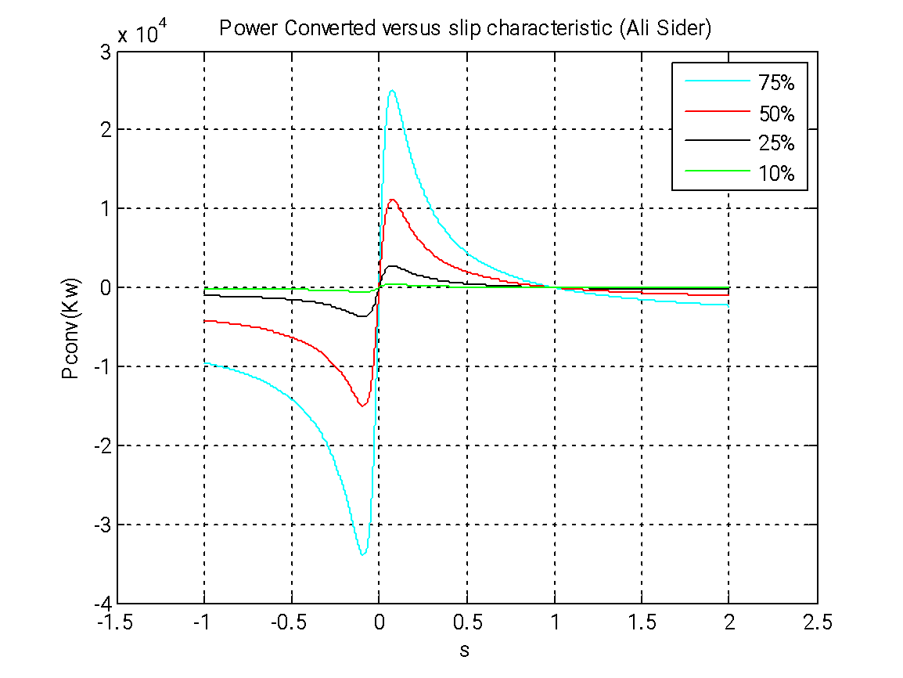  
c) repeat a) for R2 increased to have every time one of the following values: 0.1,  0.2, 0.6, 1.2, 2.8, 4.5, 8  and 15 OHMs (show plots on the same figure)  
*Torque Vs Speed plot*close all;clear all ;clc;

Vt= 460 ;fe= 60 ;p=4;R1=0.15 ;R2=0.154 ;X1=0.852 ; X2=1.066 ; Xm=20 ;

Vph=Vt/sqrt(3);Nsync=(120*fe)/p;Wsync=2*3.14*Nsync/60;

Vth =(Xm/(sqrt(R1^2+(X1+Xm)^2)))*Vph;

Zth =((j*Xm)*(R1+(j*X1)))/(R1+j*(Xm+X1));

Rth = real(Zth);Xth = imag(Zth);

s=-1.0001:0.0001:2.0001;

Nm=(1-s)*Nsync; Wm=(1 - s)*Wsync;

R21=0.1;R22=0.2;R23=0.6;R24=1.2;R25=2.8;R26=4.5;R27=8.0;R28=15.0;

for i = 1:length(s)

Tind1(i) = (3 * Vth^2 * R21 / s(i)) / (Wsync * ((Rth + R21/s(i))^2 + (Xth + X2)^2) );

Pconv1(i) = Tind1(i) * Wm(i);

end

for i = 1:length(s)

Tind2(i) = (3 * Vth^2 * R22 / s(i)) / (Wsync * ((Rth + R22/s(i))^2 + (Xth + X2)^2) );

Pconv2(i) = Tind2(i) * Wm(i);

end

for i = 1:length(s)

Tind3(i) = (3 * Vth^2 * R23 / s(i)) / (Wsync * ((Rth + R23/s(i))^2 + (Xth + X2)^2) );

Pconv3(i) = Tind3(i) * Wm(i);

end

for i = 1:length(s)

Tind4(i) = (3 * Vth^2 * R24 / s(i)) / (Wsync * ((Rth + R24/s(i))^2 + (Xth + X2)^2) );

Pconv4(i) = Tind4(i) * Wm(i);

end

for i = 1:length(s)

Tind5(i) = (3 * Vth^2 * R25 / s(i)) / (Wsync * ((Rth + R25/s(i))^2 + (Xth + X2)^2) );

Pconv5(i) = Tind5(i) * Wm(i);

end

for i = 1:length(s)

Tind6(i) = (3 * Vth^2 * R26 / s(i)) / (Wsync * ((Rth + R26/s(i))^2 + (Xth + X2)^2) );

Pconv6(i) = Tind6(i) * Wm(i);

end

for i = 1:length(s)

Tind7(i) = (3 * Vth^2 * R27 / s(i)) / (Wsync * ((Rth + R27/s(i))^2 + (Xth + X2)^2) );

Pconv7(i) = Tind7(i) * Wm(i);

end

for i = 1:length(s)

Tind8(i) = (3 * Vth^2 * R28 / s(i)) / (Wsync * ((Rth + R28/s(i))^2 + (Xth + X2)^2) );

Pconv8(i) = Tind8(i) * Wm(i);

end

plot(Nm,Tind1,'r');hold on;

plot(Nm,Tind2,'m');plot(Nm,Tind3,'k');plot(Nm,Tind4,'g');plot(Nm,Tind5,'y');plot(Nm,Tind6,'b');plot(Nm,Tind7,'c');plot(Nm,Tind8,'--b');

xlabel('Nm');ylabel('Tind(N.m)');title('Induction motor torque- speed characteristic (Ali Sider)');

legend('R2=0.1','R2=0.2','R2=0.6','R2=1.2', 'R2=2.8', 'R2=4.5', 'R2=8.0', 'R2=15.0');grid on;hold off;  
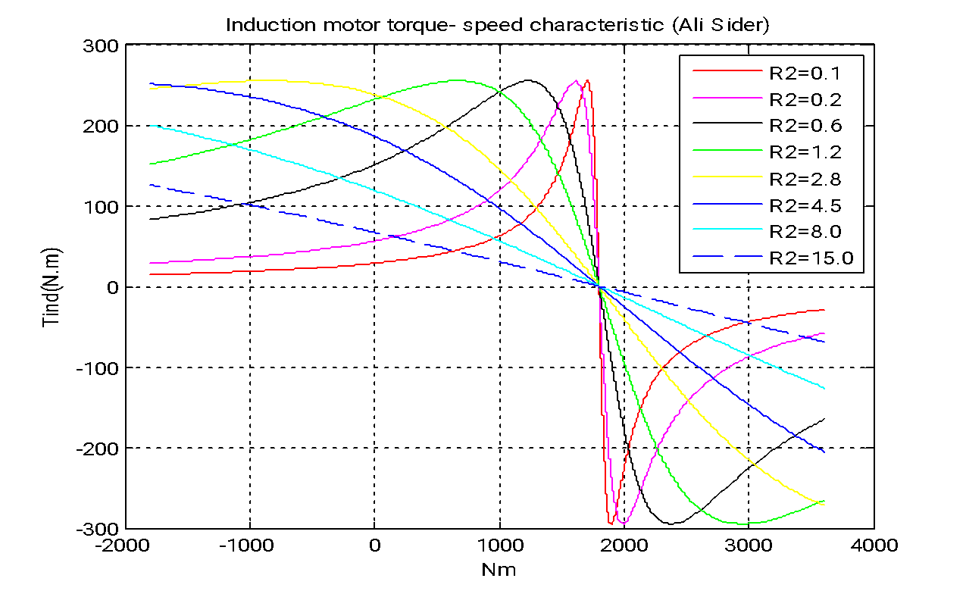

*Torque Vs S at rated voltage plot*close all;clear all ;clc;

Vt= 460 ;fe= 60 ;p=4;R1=0.15 ;R2=0.154 ;X1=0.852 ; X2=1.066 ; Xm=20 ;

Vph=Vt/sqrt(3);Nsync=(120*fe)/p;Wsync=2*3.14*Nsync/60;

Vth =(Xm/(sqrt(R1^2+(X1+Xm)^2)))*Vph;

Zth =((j*Xm)*(R1+(j*X1)))/(R1+j*(Xm+X1));

Rth = real(Zth);Xth = imag(Zth);

s=-1.0001:0.0001:2.0001;

Nm=(1-s)*Nsync; Wm=(1 - s)*Wsync;

R21=0.1;R22=0.2;R23=0.6;R24=1.2;R25=2.8;R26=4.5;R27=8.0;R28=15.0;

for i = 1:length(s)

Tind1(i) = (3 * Vth^2 * R21 / s(i)) / (Wsync * ((Rth + R21/s(i))^2 + (Xth + X2)^2) );

Pconv1(i) = Tind1(i) * Wm(i);

end

for i = 1:length(s)

Tind2(i) = (3 * Vth^2 * R22 / s(i)) / (Wsync * ((Rth + R22/s(i))^2 + (Xth + X2)^2) );

Pconv2(i) = Tind2(i) * Wm(i);

end

for i = 1:length(s)

Tind3(i) = (3 * Vth^2 * R23 / s(i)) / (Wsync * ((Rth + R23/s(i))^2 + (Xth + X2)^2) );

Pconv3(i) = Tind3(i) * Wm(i);

end

for i = 1:length(s)

Tind4(i) = (3 * Vth^2 * R24 / s(i)) / (Wsync * ((Rth + R24/s(i))^2 + (Xth + X2)^2) );

Pconv4(i) = Tind4(i) * Wm(i);

end

for i = 1:length(s)

Tind5(i) = (3 * Vth^2 * R25 / s(i)) / (Wsync * ((Rth + R25/s(i))^2 + (Xth + X2)^2) );

Pconv5(i) = Tind5(i) * Wm(i);

end

for i = 1:length(s)

Tind6(i) = (3 * Vth^2 * R26 / s(i)) / (Wsync * ((Rth + R26/s(i))^2 + (Xth + X2)^2) );

Pconv6(i) = Tind6(i) * Wm(i);

end

for i = 1:length(s)

Tind7(i) = (3 * Vth^2 * R27 / s(i)) / (Wsync * ((Rth + R27/s(i))^2 + (Xth + X2)^2) );

Pconv7(i) = Tind7(i) * Wm(i);

end

for i = 1:length(s)

Tind8(i) = (3 * Vth^2 * R28 / s(i)) / (Wsync * ((Rth + R28/s(i))^2 + (Xth + X2)^2) );

Pconv8(i) = Tind8(i) * Wm(i);

end

plot(s,Tind1,'r');hold on;

plot(s,Tind2,'m');plot(s,Tind3,'k');plot(s,Tind4,'g');plot(s,Tind5,'y');plot(s,Tind6,'b');plot(s,Tind7,'c');plot(s,Tind8,'--b');

xlabel('s');ylabel('Tind(N.m)');title('Induction motor torque Vs s characteristic (Ali Sider)');

legend('R2=0.1','R2=0.2','R2=0.6','R2=1.2', 'R2=2.8', 'R2=4.5', 'R2=8.0', 'R2=15.0');grid on;hold off;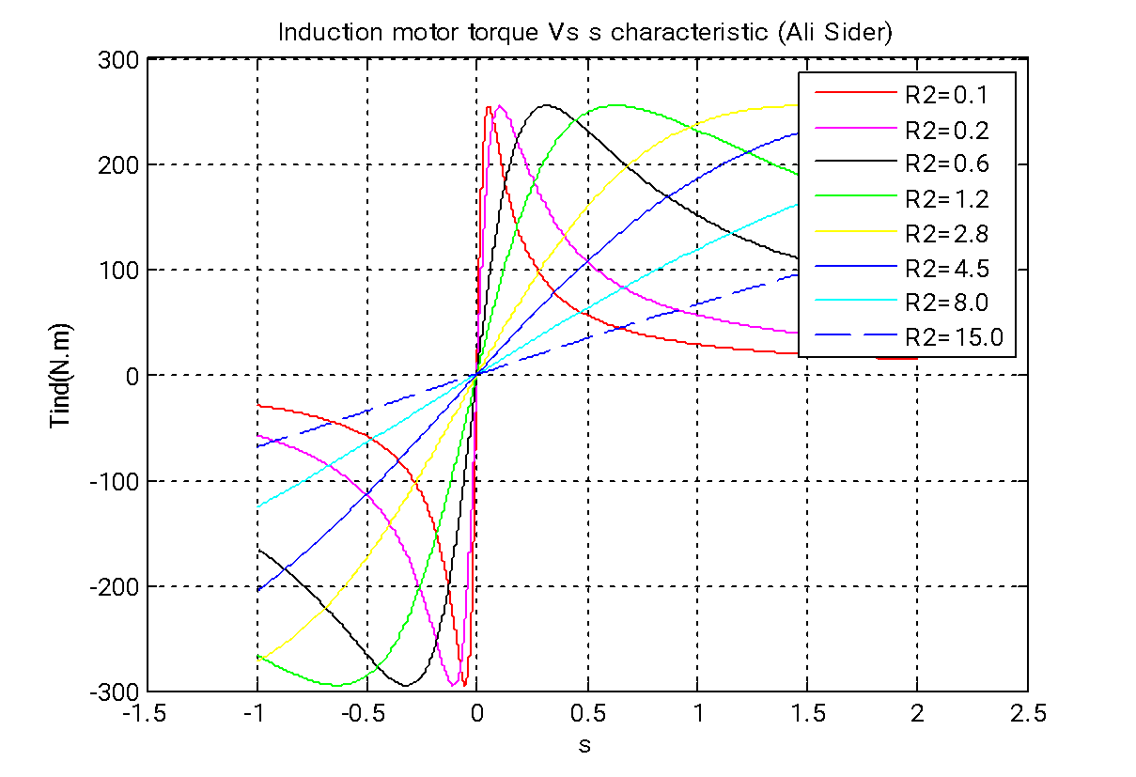  
  
  
*Converted output power Vs S plot*close all;clear all ;clc;

Vt= 460 ;fe= 60 ;p=4;R1=0.15 ;R2=0.154 ;X1=0.852 ; X2=1.066 ; Xm=20 ;

Vph=Vt/sqrt(3);Nsync=(120*fe)/p;Wsync=2*3.14*Nsync/60;

Vth =(Xm/(sqrt(R1^2+(X1+Xm)^2)))*Vph;

Zth =((j*Xm)*(R1+(j*X1)))/(R1+j*(Xm+X1));

Rth = real(Zth);Xth = imag(Zth);

s=-1.0001:0.0001:2.0001;

Nm=(1-s)*Nsync; Wm=(1 - s)*Wsync;

R21=0.1;R22=0.2;R23=0.6;R24=1.2;R25=2.8;R26=4.5;R27=8.0;R28=15.0;

for i = 1:length(s)

Tind1(i) = (3 * Vth^2 * R21 / s(i)) / (Wsync * ((Rth + R21/s(i))^2 + (Xth + X2)^2) );

Pconv1(i) = Tind1(i) * Wm(i);

end

for i = 1:length(s)

Tind2(i) = (3 * Vth^2 * R22 / s(i)) / (Wsync * ((Rth + R22/s(i))^2 + (Xth + X2)^2) );

Pconv2(i) = Tind2(i) * Wm(i);

end

for i = 1:length(s)

Tind3(i) = (3 * Vth^2 * R23 / s(i)) / (Wsync * ((Rth + R23/s(i))^2 + (Xth + X2)^2) );

Pconv3(i) = Tind3(i) * Wm(i);

end

for i = 1:length(s)

Tind4(i) = (3 * Vth^2 * R24 / s(i)) / (Wsync * ((Rth + R24/s(i))^2 + (Xth + X2)^2) );

Pconv4(i) = Tind4(i) * Wm(i);

end

for i = 1:length(s)

Tind5(i) = (3 * Vth^2 * R25 / s(i)) / (Wsync * ((Rth + R25/s(i))^2 + (Xth + X2)^2) );

Pconv5(i) = Tind5(i) * Wm(i);

end

for i = 1:length(s)

Tind6(i) = (3 * Vth^2 * R26 / s(i)) / (Wsync * ((Rth + R26/s(i))^2 + (Xth + X2)^2) );

Pconv6(i) = Tind6(i) * Wm(i);

end

for i = 1:length(s)

Tind7(i) = (3 * Vth^2 * R27 / s(i)) / (Wsync * ((Rth + R27/s(i))^2 + (Xth + X2)^2) );

Pconv7(i) = Tind7(i) * Wm(i);

end

for i = 1:length(s)

Tind8(i) = (3 * Vth^2 * R28 / s(i)) / (Wsync * ((Rth + R28/s(i))^2 + (Xth + X2)^2) );

Pconv8(i) = Tind8(i) * Wm(i);

end

plot(s,Pconv1,'r');hold on;

plot(s,Pconv2,'m');plot(s,Pconv3,'k');plot(s,Pconv4,'g');plot(s,Pconv5,'y');plot(s,Pconv6,'b');plot(s,Pconv7,'c');plot(s,Pconv8,'--b');

xlabel('s');ylabel('Pconv(Kw)');title('Converted power Vs s characteristic (Ali Sider)');

legend('R2=0.1','R2=0.2','R2=0.6','R2=1.2', 'R2=2.8', 'R2=4.5', 'R2=8.0', 'R2=15.0');grid on;hold off;

