

Faculty of Engineering and Technology

Electrical and Computer Engineering Department

Electronics LAB (ENEE3102)

Pre-LAB of Experiment #10

Zener Diodes and Voltage Regulators

**________________________________________________________**

Prepared by:

Name: Sara Totah Number: 1181779

Instructor:

Mohammad Jehad Al Ju'Beh

Date:

06/11/2020

Section: #1

# Pre-Lab

## ZENER DIODE

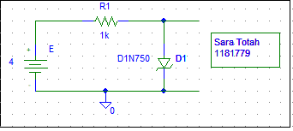

Figure (1)

|  |  |  |  |
| --- | --- | --- | --- |
| E(v) | VR­­ | VZ | I |
| 0.1 | 0.01mV | 99.99mV | 10.17nA |
| 0.2 | 0.07mV | 199.93mV | 73.36nA |
| 0.3 | 0.46mV | 299.54mV | 459.62nA |
| 0.4 | 2.68mV | 397.32mV | 2.676 µA |
| 0.5 | 13.05mV | 486.95mV | 13.05 µA |
| 0.6 | 43.87mV | 556.13mV | 43.87 µA |
| 0.7 | 98.78mV | 601.22mV | 98.78 µA |
| 0.8 | 170.35mV | 629.65mV | 170.35 µA |
| 0.9 | 251.48mV | 648.52mV | 251.48 µA |
| 1 | 0.338V | 661.92mV | 338.08 µA |
| 2 | 1.286V | 713.19mV | 1.287mA |
| 3 | 2.268V | 731.57mV | 2.268mA |
| 4 | 3.257V | 742.69mV | 3.257Ma |

Table (1)

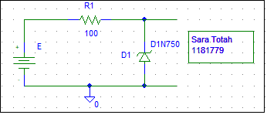

Figure (2)

|  |  |  |
| --- | --- | --- |
| E(V) | VZ | I |
| 0.1 | 100mV | 6.234nA |
| 0.5 | 500mV | 40.67nA |
| 1 | 1V | 141.89nA |
| 2 | 2V | 1.839µA |
| 3 | 2.998V | 24.13 µA |
| 4 | 3.970V | 297.19µA |
| 5 | 4.607V | 3.928mA |
| 6 | 4.678V | 13.22mA |
| 7 | 4.707V | 22.93mA |
| 8 | 4.727V | 32.74mA |
| 9 | 4.741V | 42.59mA |
| 10 | 4.753V | 52.47mA |
| 11 | 4.763V | 62.37mA |
| 12 | 4.773V | 72.27mA |
| 13 | 4.781V | 82.19mA |
| 14 | 4.789V | 92.12mA |
| 15 | 4.796V | 102.04mA |

Table (2)

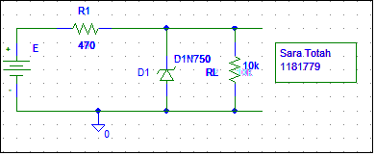

Figure (3)

|  |  |  |  |  |  |
| --- | --- | --- | --- | --- | --- |
| E | 10 | 11 | 12 | 13 | 14 |
| VL | 4.459V | 4.495V | 4.519V | 4.536V | 4.549V |

Table (3)

* With E set to 10V measure the load voltage VL:

|  |  |  |  |  |
| --- | --- | --- | --- | --- |
| RL | 8.2kΩ | 6.8 kΩ | 4.7 kΩ | 2.2 kΩ |
| VL | 4.457V | 4.455V | 4.449V | 4.421V |

Table (4)

## THE VOLTAGE REGULATED POWER SUPPLY

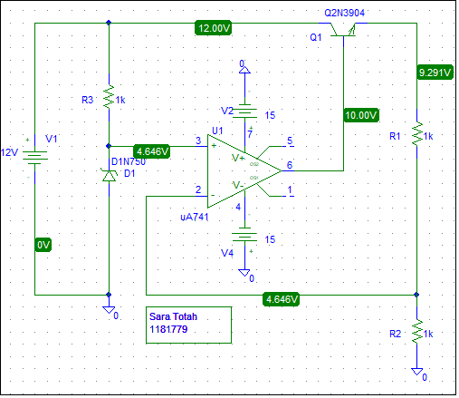

Figure (4)

VO = 9.291V

* Attach a 1k load resistor to the output and measure VO and IO:

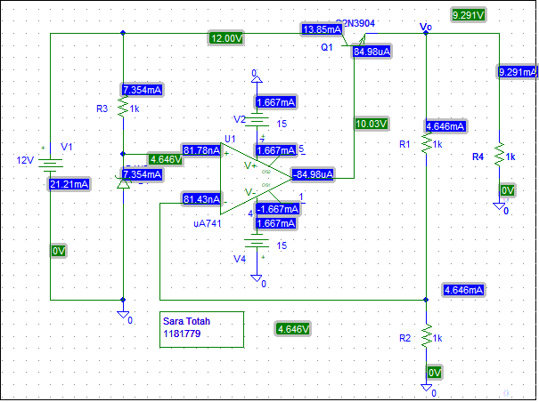

Figure (5)

VO = 9.291V

IO = 9.291mA

|  |  |  |  |  |  |  |
| --- | --- | --- | --- | --- | --- | --- |
| RL | open | 1kΩ | 680Ω | 470 Ω | 220 Ω | 100 Ω |
| VO | 9.291V | 9.291V | 9.291V | 9.291V | 9.291V | 9.291V |
| IO | 0 | 9.291mA | 13.66mA | 19.77mA | 42.23mA | 92.91mA |

Table (5)

* Set RL back to 1k. Change the value of R2 to 470 ohm . What is the new output voltage?

VO = 12V

IO = 12Ma

* Change R2 to 2.2k. What is the output voltage now?

VO =6.757V

IO = 6.757mA

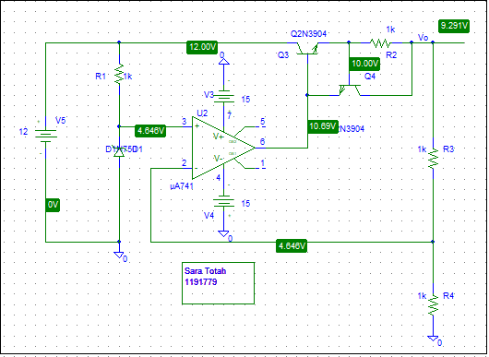

Figure (6)

VO = 9.291V

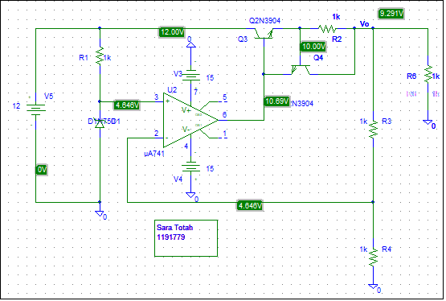

Figure (7)

|  |  |  |  |  |  |  |  |
| --- | --- | --- | --- | --- | --- | --- | --- |
| RL | open | 1kΩ | 680Ω | 470Ω | 220Ω | 100Ω | 50Ω |
| VO | 9.291V | 9.291V | 9.291V | 9.291V | 9.291V | 9.200V | 4.718V |
| IO | 0 | 9.291mA | 13.66mA | 19.77mA | 42.23mA | 92.00mA | 94.36mA |

Table (6)

Note: OrCad was used for the last two parts

## THREE TERMINAL FIXED VOLTAGE REGULATOR 7805



Figure (8)

|  |  |  |
| --- | --- | --- |
| RL | VL | IL |
| 25 | 4.995V | 199.8mA |
| 50 | 4.996V | 99.9mA |
| 100 | 4.996V | 49.96mA |
| 200 | 4.997V | 24.9mA |
| 400 | 4.997V | 12.5mA |
| 600 | 4.997V | 8.32mA |
| 800 | 4.997V | 6.25mA |
| 1000 | 4.997V | 4.98mA |

Table (7)

Load Regulation = $\frac{∆VL}{∆IL}=$-0.01001

Set RL=100 ohm, adjust the input voltage Vi, Measure VL and IL for each input voltage in the table:

|  |  |  |
| --- | --- | --- |
| Vi(V) | VL | IL |
| 8 | 4.996V | 49.96 mA |
| 9 | 4.996V | 49.96 mA |
| 10 | 4.996V | 49.96 mA |
| 11 | 4.997V | 49.97 mA |
| 12 | 4.997V | 49.97 mA |
| 13 | 4.997V | 49.97 mA |
| 14 | 4.997V | 49.97 mA |
| 15 | 4.997V | 49.98 mA |

Table (8)

Line regulation = $\frac{∆VL}{∆Vi} ≈0$

## THE LM317 ADJUSTABLE VOLTAGE REGULATOR



Figure (9)

Table 3

|  |  |  |
| --- | --- | --- |
| R3(Ω) | VL(V) | IL(mA) |
| 0 | 2.507 | 2.507 |
| 100 | 2.507 | 2.507 |
| 200 | 3.762 | 3.762 |
| 300 | 5.017 | 5.017 |
| 500 | 7.527 | 7.527 |
| 700 | 8.500 | 8.500 |

Table (9)

* With RL =1k , R1=100 ohm , R2=220 , adjust Vi as listed in table 10.5.

|  |  |  |
| --- | --- | --- |
| Vi(V) | VL(V) | IL(mA) |
| 10 | 4.007 | 4.007 |
| 12 | 4.007 | 4.007 |
| 14 | 4.007 | 4.007 |
| 15 | 4.007 | 4.007 |
| 16 | 4.007 | 4.007 |
| 17 | 4.007 | 4.007 |

Table (10)

Line regulation = $\frac{∆VL}{∆Vi} ≈0$

* With Vi=10V, R1=100 ohm, R2=220, adjust RL as shown in table

|  |  |  |
| --- | --- | --- |
| RL(Ω) | VL(V) | IL(mA) |
| 100 | 4.013 | 40.13 |
| 200 | 4.013 | 20.07 |
| 400 | 4.013 | 10.03 |
| 500 | 4.013 | 8.027 |
| 600 | 4.013 | 6.689 |
| 700 | 4.013 | 5.733 |
| 1000 | 4.013 | 4.013 |

Table (11)