Birzeit University logo

Electronics lab

ــــــــــــــــــــــــــــــــــــــــــــــــــــــــــــــــــــــــــــــــــــــــــــــــــــــــــــــــــــــــــــــــــــــــــــــــــــــــــــــــــــــــــــــــــــــ

### *Oscillators*

Dana Abu Hussein 1131657

Prelab exp #10

***I. THE WEIN BRIDGE OSCILLATOR.***

* C1 = c2 = 0.1u:

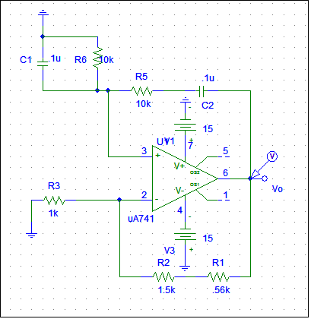

With R = 560, Vo is:



Frequency curve:



So it's at F = 144.231Hz

Amplitude = 136.795mV

* When C1 = c2 = .33u

Vo curve:



F curve:



F = 44.091Hz

Amplitude = 6.0408mV

* With R1 = R2 = 1K

Vo curve is:



F curve:



F = 436.3Hz

Amplitude = 85.5mV

# *II. THE RC PHASE SHIFT OSCILLATOR.*

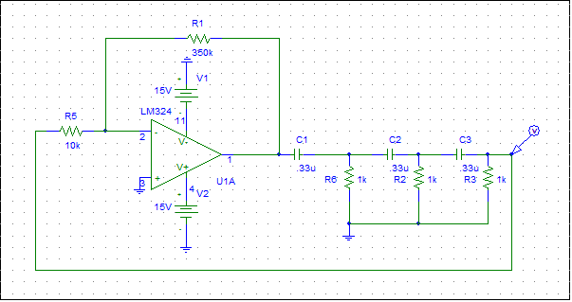

* C1 = c2 = c3 = 0.33u

R1 = R2 = R3 = 1K

Vo curve:



F curve:



F = 186.7Hz

Amplitude = 18.97

* When c1 = c2 = c3 = 0.47u

Vo curve:



F curve:



F= 135 Hz

Amplitude = 147.8mV

* When R1 = R2 = R3 = 470

Vo curve:



F curve:



F = 275.055Hz

Amplitude = 209.6mV

# *III. THE COLPITTS OSCILLATOR.*

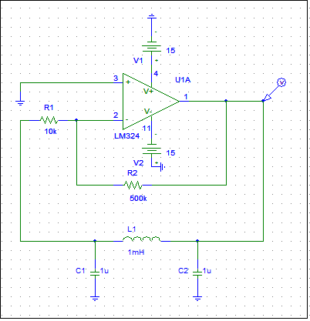

* R= 500k, 1mH, Vo curve:



F curve:



F = 6.8kHz

Amplitude = 1.58

* At R =40k:



F curve:



F = 6.8k

* At 10mH , R=100k:

Vo curve:



F curve:



F = 2.2k

# *IV. THE RC ASTABLE OSCILLATOR.*

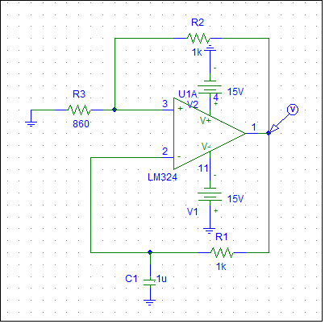

* At C = 1u

V o curve:



F curve:



F = 480.09Hz

Amplitude = 18.266

* At C = 0.1u



F curve:



F = 3.428KHz

Amplitude = 9.023

# *V. THE 555 TIMER CHIP AS AN ASTABLE MULTIVIBRATOR.*

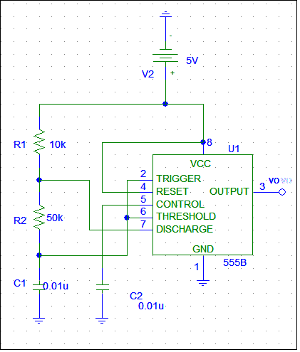

* At R =10k

Vo curve:



Vc curve :



Duty cycle = (1.617m- 1.4676m)/( 1.617m- 1.3844m)=0.643

F curve :



F = 4.5KHz

* At R =20k

Vo curve:



F curve:



F = 2.8KHz

Vc curve :



Duty cycle = (1.4717m- 1.2488m)/( 1.4717m- 1.0922m)=0.58

* At R = 30K

Vo curve:



F curve:



F = 2.04

Vc curve***:***



Duty cycle = (1.4926m- 1.2001m)/( 1.4926m- 970.947u)=0.56

* At R = 40K

Vo curve:



F curve:



F = 1.47KHz

Vc curve:



Duty cycle = (1.892m- 1.5218m)/( 1.892m- 1.2278m)=0.55

* At R = 50k

Vo curve:



F curve:



F = 1.25

Vc curve:



Duty cycle = (2.2887m- 1.8505m)/( 2.2887m- 1.4818m)=0.543