

Faculty of Engineering and Technology

Electrical and Computer Engineering Department

ENEE3102

Electronics Lab

Experiment # 10

Pre lab

*Student’s name : Juomah Bader*

*Student’s number : 1162462*

*Instructor : Dr.Mohammad AL-Jubeh*

*I. ZENER DIODE :*

**A.**

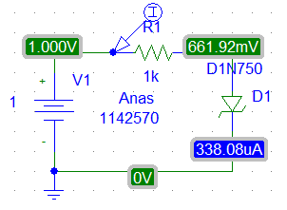

Juomah 1162462

1. VR (V) :



1. VZ (V) :



1. I (mA) :



**B.**

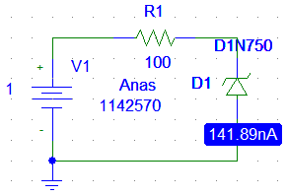

Juomah 1162462

1. VR (V) :



1. VZ (V) :



1. I (mA) :



**C.** 1.

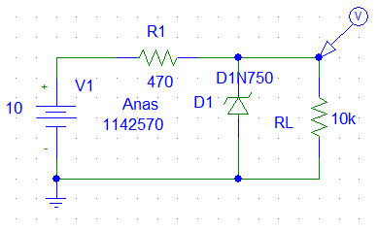

Juomah 1162462



2.

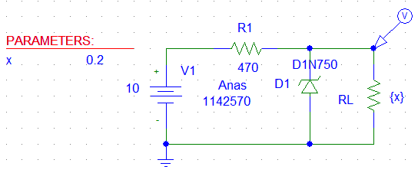

Juomah 1162462



*II. THE VOLTAGE REGULATED POWER SUPPLY :*

1. 1. When RL is open :

Io = 0

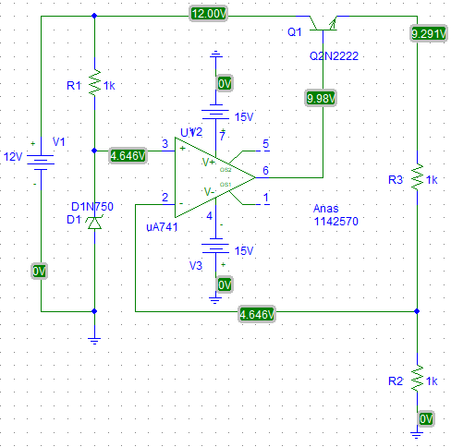

Juomah 1162462

2. with RL :

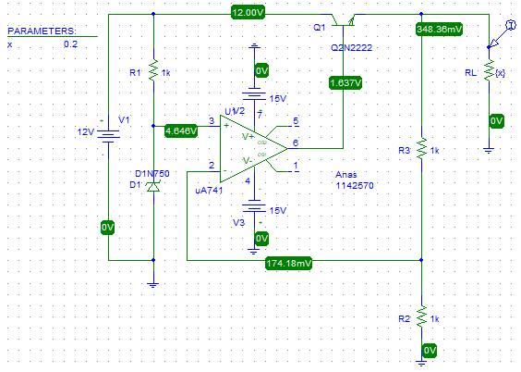

Juomah 1162462

Vo :



Io :



1. 1. When RL is open :

Io = 0 And : Vo = 9.291 V

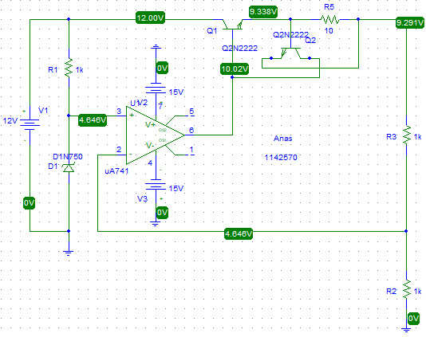

Juomah 1162462

2. with RL :

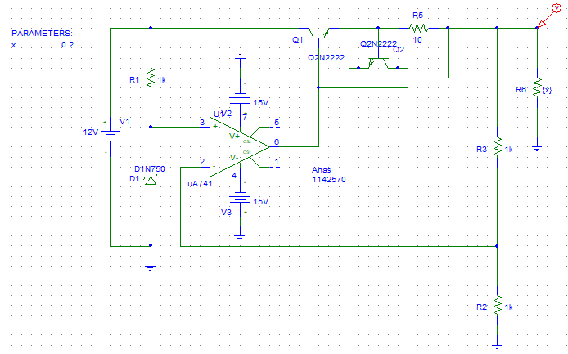

Juomah 1162462

Vo :



Io :

