

Faculty of Engineering and Technology

Electrical and Computer Engineering Department

**ENEE 3102 – Electronics Lab**

Pre-lab for Experiment No.10

**Zener Diodes and Voltage Regulators**

Prepared By:

Name: Suhaeb Qadan Number: 1160297

Instructor: Dr. Mohammad Al Jubeh

TA: Eng. Almo`tassem Billah

Date: 20/11/2019

Sec#: 1

**Part 1: Zener Diode**

The circuit shown below connected using PSPICE Simulation

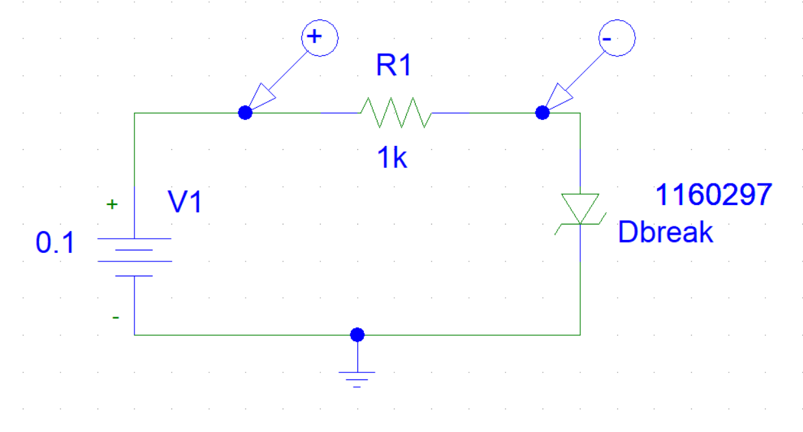

Figure

VR, VZand I were measured at difference values of V1

The simulation output of VR:



Figure

The simulation output of VZ:



Figure

The simulation output of the current:



Figure

The circuit shown below connected using PSPICE Simulation

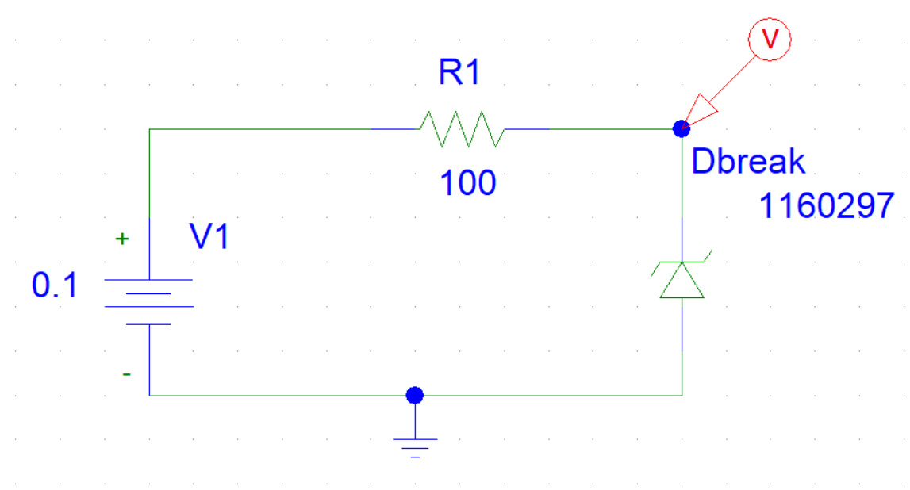

Figure

the voltage across the Zener diode and the current through the Zener diode were measured at difference values of V1:

The simulation output of VZ:



Figure

The simulation output of the current:



Figure

The circuit shown below connected using PSPICE Simulation

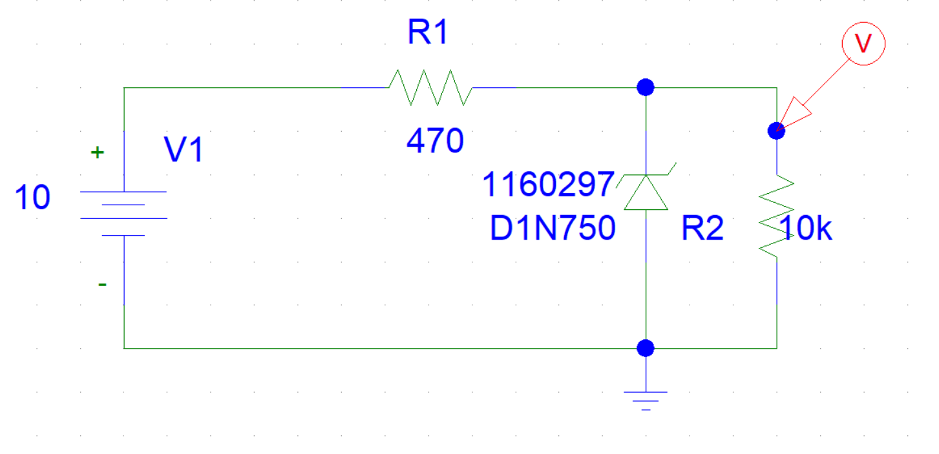

Figure

The load voltage VL at difference values of V1 shown in figure below 

Figure

The load voltage VL at difference values of RL shown in figure below 

Figure

**Part 2: THE VOLTAGE REGULATED POWER SUPPLY**

The circuit shown below connected using PSPICE Simulation

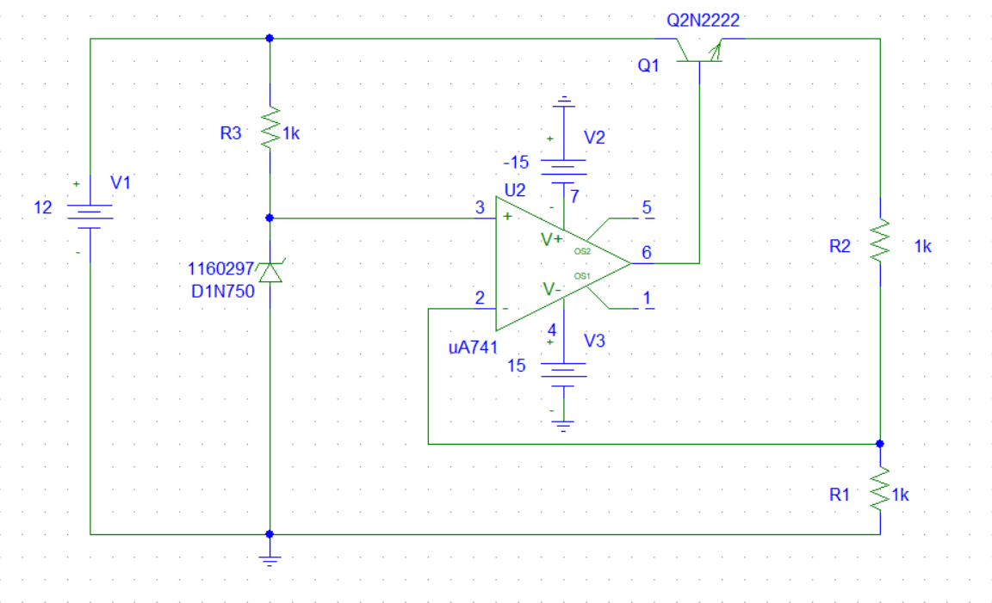

Figure

The DC voltages

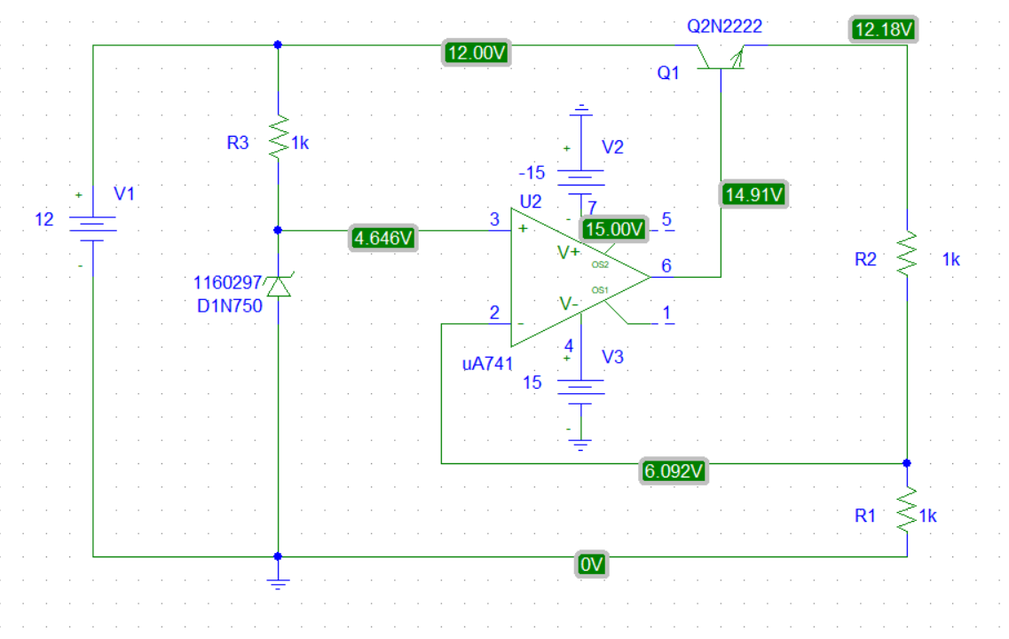

Figure

V0 = 12.18 V

After attaching a 1k load resistor to the output. Io and Vo were measured.

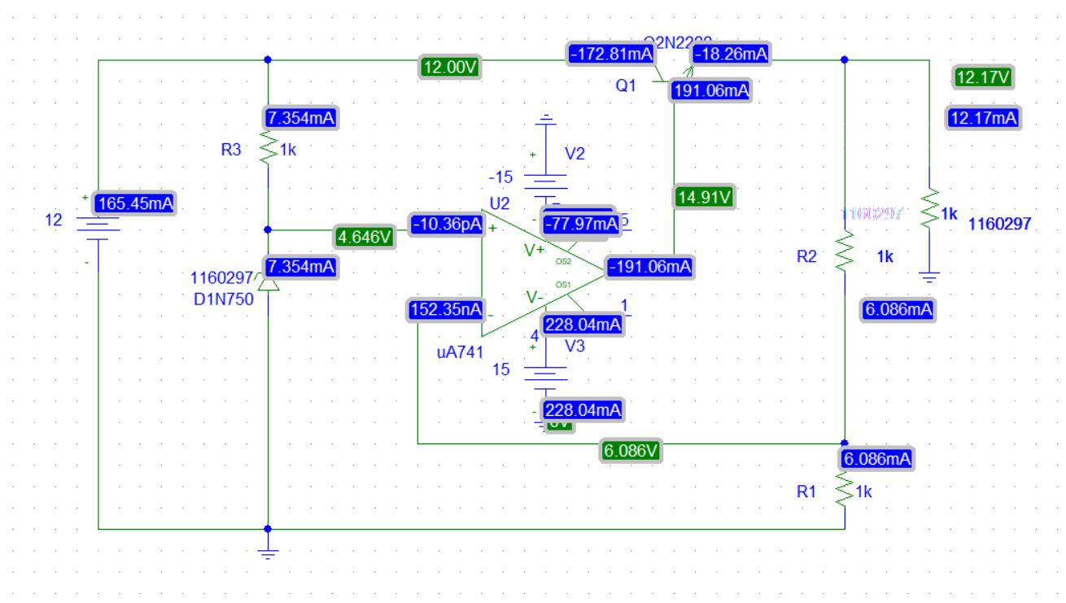

Figure

VO = 12.17

IO = 12.17 mA

For RL = (680, 470, 220, 100), The circuit connected below was used to find V0 and I0:

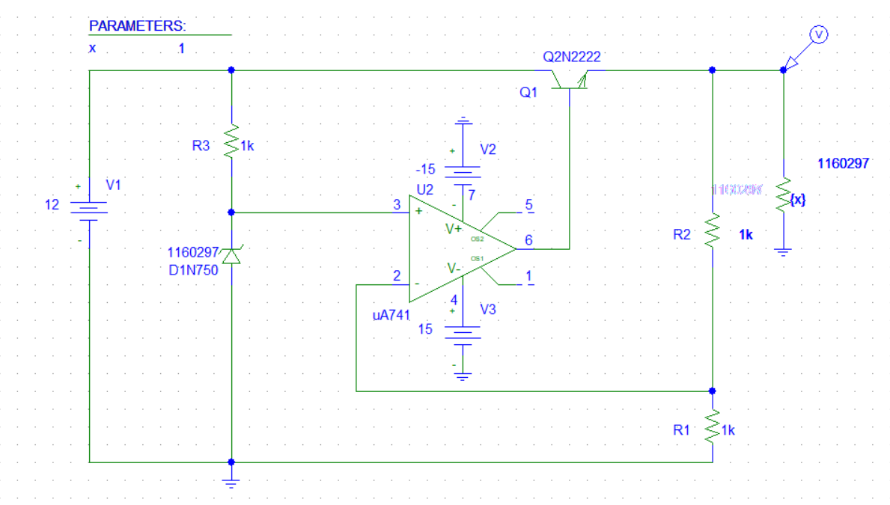

Figure

The output voltage VO at difference values of RL shown in figure below 

Figure

The output current IO at difference values of RL shown in figure below 

RL back to 1K. The value of R2 was set to 470 ohms. The new output voltage:

V0 = 12.17 V

R2 was changed to 2.2k. The output voltage:

V0 = 6.57 V

The circuit shown below connected using PSPICE Simulation

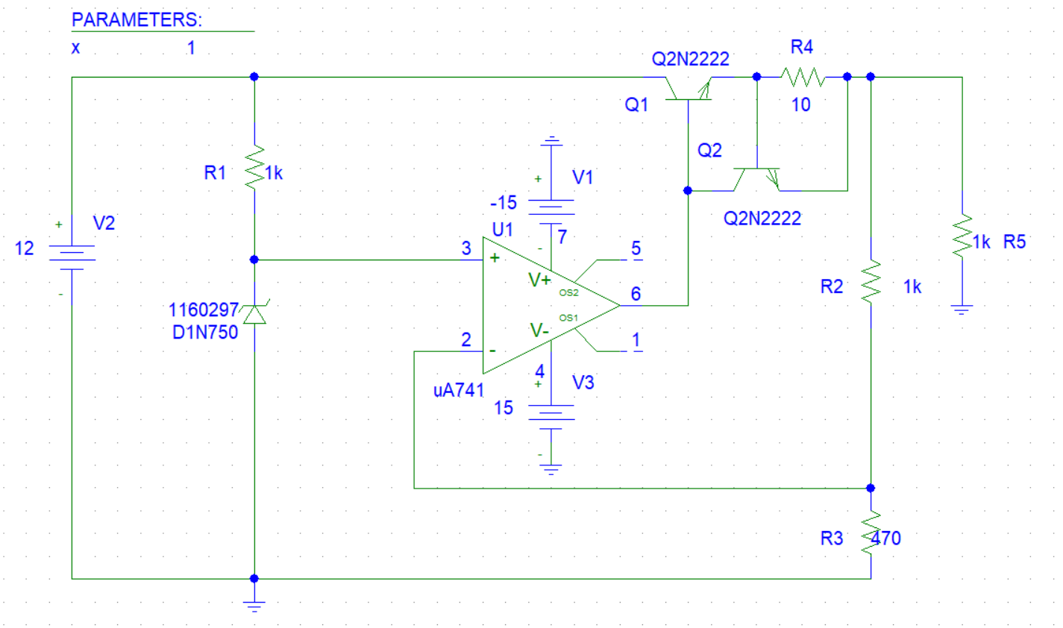

Figure

The DC voltages

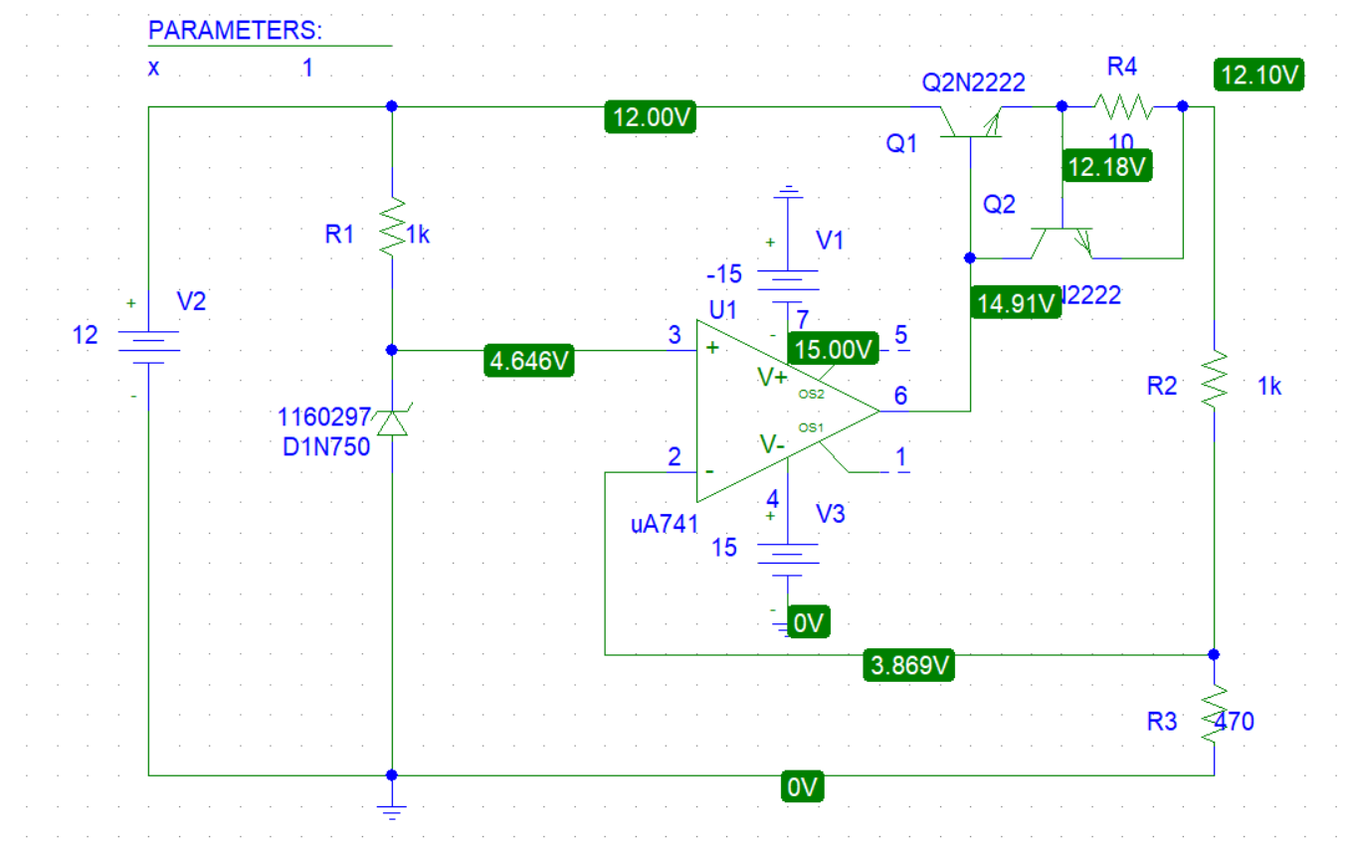

Figure

The output voltage Vo = 12.10 V

After attaching a 1k load resistor to the output. Io and Vo were measured.

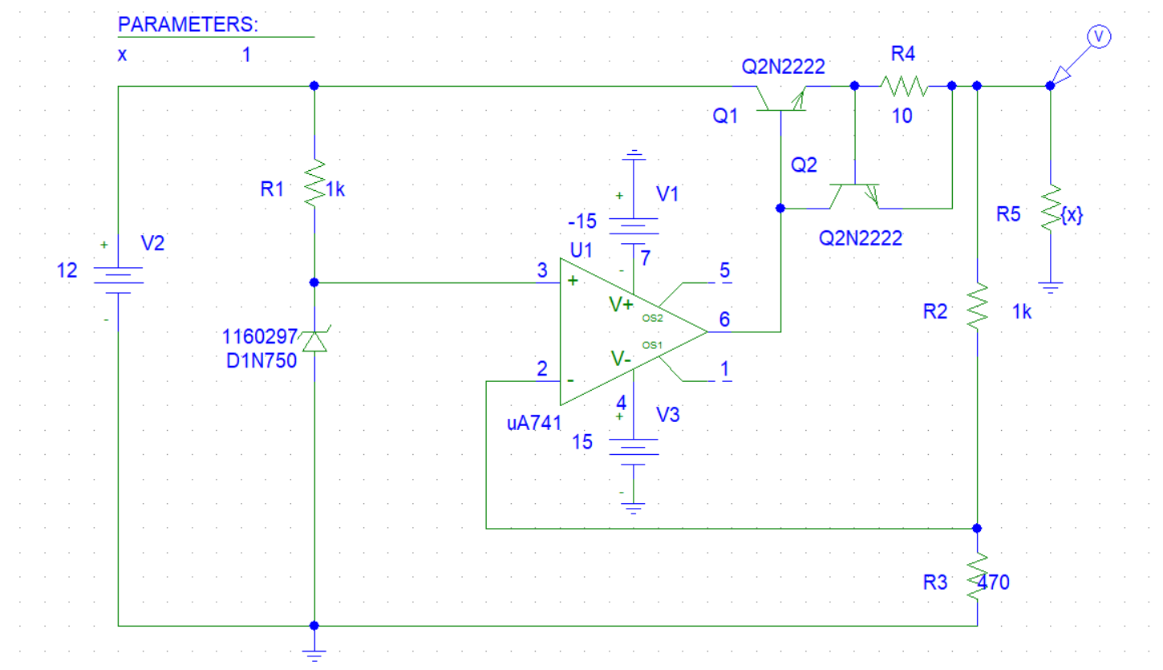

Figure

The output voltage V0 = 12

The output current Io = 12 mv

For difference values of RL, The output voltage and output current were measured.

The simulation output for V0: 

Figure

The simulation output for IO:



Figure

**Part 3: THREE TERMINAL FIXED VOLTAGE REGULATOR 7805**

The circuit shown below was built using ORCAD PSPICE simulation:

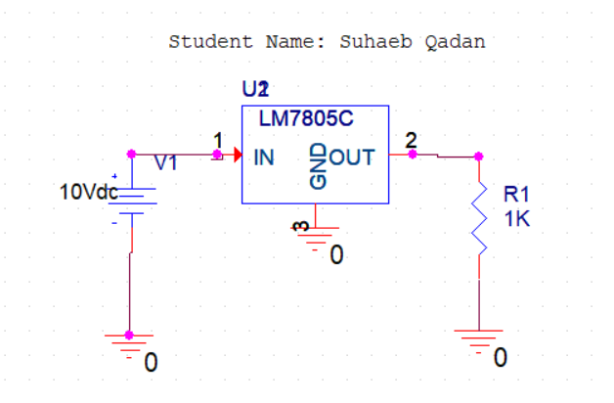

Figure

With Vi=10V, IL and VL were measured for the load resistances listed in the table below:

Table

|  |  |  |
| --- | --- | --- |
| **RL(Ω)** | **VL(V)** | **IL(mA)** |
| **25** | 4.995 | 199.8 |
| **50** | 4.996 | 99.92 |
| **100** | 4.996 | 49.96 |
| **200** | 4.997 | 24.98 |
| **400** | 4.997 | 12.49 |
| **600** | 4.997 | 8.328 |
| **800** | 4.997 | 6.246 |
| **1000** | 4.997 | 4.997 |

The Load regulation = ΔVL /Δ IL

Load regulation = 0.001/-99.88 = -0.00001001

RL was set to 100 ohms, the input voltage Vi adjusted in table. VL and IL were measured for each input voltage in the table below:

Table

|  |  |  |
| --- | --- | --- |
| **Vi(V)** | **VL(V)** | **IL(mA)** |
| **8** | 4.996 | 49.96 |
| **9** | 4.996 | 49.96 |
| **10** | 4.996 | 49.96 |
| **11** | 4.997 | 49.97 |
| **12** | 4.997 | 49.97 |
| **13** | 4.997 | 49.97 |
| **14** | 4.997 | 49.97 |
| **15** | 4.997 | 49.97 |

The Line regulation = ΔVL/ΔVi = 0

**Part 4: THE LM317 ADJUSTABLE VOLTAGE REGULATOR**

The circuit shown below was built using ORCAD PSPICE simulation:

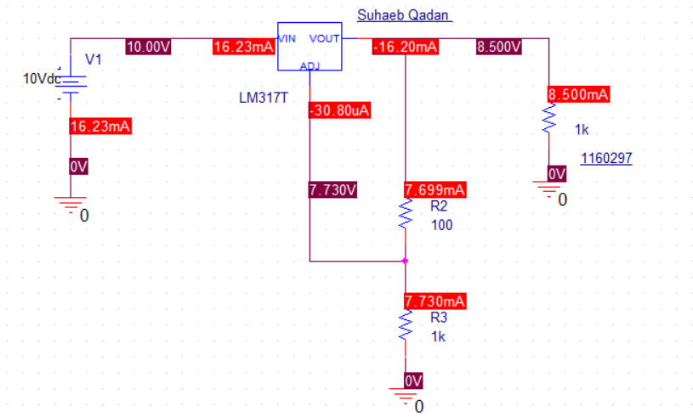

Figure

For this circuit, the Value of R3 was changed, and measurements was taken for VL, IL.

Table

|  |  |  |
| --- | --- | --- |
| **R3(Ω)** | **VL(V)** | **IL(mA)** |
| **0** | 2.507 | 2.507 |
| **100** | 2.507 | 2.507 |
| **200** | 3.762 | 3.762 |
| **300** | 5.017 | 5.017 |
| **500** | 7.527 | 7.527 |
| **700** | 8.500 | 8.500 |

with setting RL = 1kΩ, R1 = 100Ω, R3 = 220Ω, VL and IL were measured by changing Vin as follows:

Table

|  |  |  |
| --- | --- | --- |
| **Vi(V)** | **VL(V)** | **IL(mA)** |
| **10** | 4.006 | 4.006 |
| **12** | 4.006 | 4.006 |
| **14** | 4.006 | 4.006 |
| **15** | 4.006 | 4.006 |
| **16** | 4.006 | 4.006 |
| **17** | 4.006 | 4.006 |

The Line regulation = 0

Now with setting Vi =10V, R1 = 100Ω, R2 = 220Ω, VL, IL were measured by changing RL as follows:

Table

|  |  |  |
| --- | --- | --- |
| **RL(Ω)** | **VL(V)** | **IL(mA)** |
| **100** | 4.013 | 40.13 |
| **200** | 4.013 | 20.07 |
| **400** | 4.013 | 10.03 |
| **500** | 4.013 | 8.027 |
| **600** | 4.013 | 6.689 |
| **700** | 4.013 | 5.733 |
| **1000** | 4.013 | 4.013 |