

Faculty of Engineering and Technology

Electrical Engineering Department

ــــــــــــــــــــــــــــــــــــــــــــــــــــــــــــــــــــــــــــــــــــــــــــــــــــــــــــــــــــــــــــــــــــــــــــــ

ELECTRONIC LAB

Pre Lab

Experiment#11

Oscillators

**Student’s Name: Jana Al-Zeer**

**Student’s No : 1161228**

**Instructors :Dr.** Mohammad Ju’beh

Eng.Qassam Barghouthi

**Section : 2**

***THE WEIN BRIDGE OSCILLATOR.***

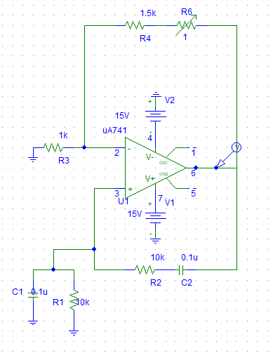



when C1=C2=0.33u the output is:



With R1 = R2 = 1K and C1=C2=0.33u



II. THE RC PHASE SHIFT OSCILLATOR

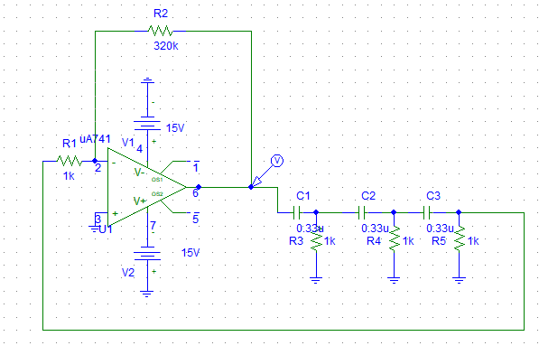



When c1 = c2 = c3 = 0.47u





The curve of frequency:



# III. THE COLPITTS OSCILLATOR

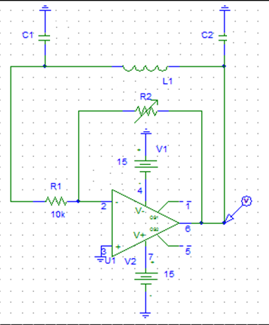





At L=10 m

The output voltage will be :



# IV. THE RC ASTABLE OSCILLATOR.

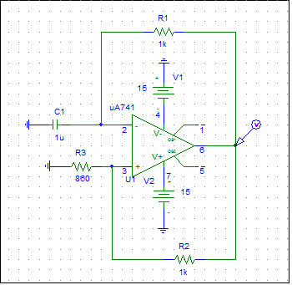

At C = 1u





At C = 0.1u





# V. THE 555 TIMER CHIP AS AN ASTABLE MULTIVIBRATOR.

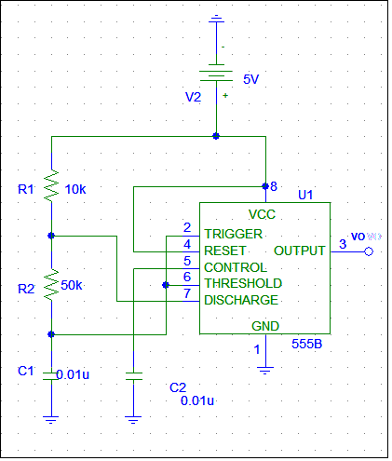

At R =10k



Vc curve :



Duty cycle = (1.617m- 1.4676m)/( 1.617m- 1.3844m)=0.643



F = 4.5KHz

At R =20k





F = 2.8KHz

Vc curve :



Duty cycle = (1.4717m- 1.2488m)/( 1.4717m- 1.0922m)=0.58

At R = 30K





F = 2.04

Vc curve***:***



Duty cycle = (1.4926m- 1.2001m)/( 1.4926m- 970.947u)=0.56

At R = 40K





F = 1.47KHz

Vc curve:



Duty cycle = (1.892m- 1.5218m)/( 1.892m- 1.2278m)=0.55

At R = 50k





F = 1.25



Duty cycle = (2.2887m- 1.8505m)/( 2.2887m- 1.4818m)=0.543