

Faculty of Engineering and Technology

Electrical and Computer Engineering Department

ENEE3102

Electronics Lab

Experiment # 2

Pre lab

*Student’s name : Anas Joudeh*

*Student’s number : 1142570*

*Instructor : Dr.Mohammad AL-Jubeh*

*DATE : 28/6/2018*

1. *DIODE CHARACTERISTICS :*

By pSpice :

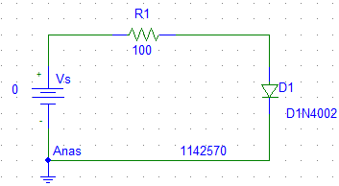

|  |  |  |  |
| --- | --- | --- | --- |
| Vs (Volt) | VR(Volt) | VD(Volt) | ID(mA) |
| 0 | 0 | 0 | 0 |
| 0.1 | 0 | 0.1 | 0 |
| 0.2 | 0 | 0.2 | 0 |
| 0.3 | 0.00048 | 0.2995 | $$5*{10}^{-3}$$ |
| 0.4 | 0.00323 | 0.3967 | $$32.27*{10}^{-3}$$ |
| 0.5 | 0.0173 | 0.4827 | $$172.6*{10}^{-3}$$ |
| 0.6 | 0.0565 | 0.5435 | $$5.65*{10}^{-3}$$ |
| 0.7 | 0.118 | 0.582 | 1.18 |
| 0.8 | 0.193 | 0.607 | 1.93 |
| 0.9 | 0.275 | 0.625 | 2.75 |
| 1.0 | 0.360 | 0.64 | 3.6 |
| 1.5 | 0.820 | 0.68 | 8.2 |
| 2.0 | 1.295 | 0.705 | 12.95 |
| 2.5 | 1.770 | 0.73 | 17.70 |
| 3.0 | 2.266 | 0.734 | 22.66 |

* When the diode revers then diode means diode is open circuit

$V_{s}=V_{D}$ or ID = 0 or close to zero

1. *RECTIFICATION :*

*A . HALF - WAVE RECTIFICATION :*

By pSpice :

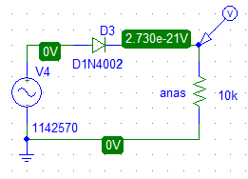

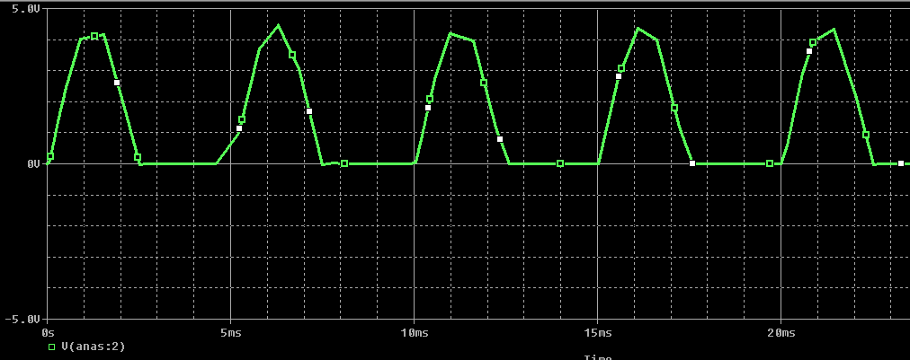

* from graph:
* T= 5ms.
* Vpk=4.41 volt
* Vdc= 2.730 * 10-21 Volt
* The output of resistance (anas) when revers the diode:

By pSpice :



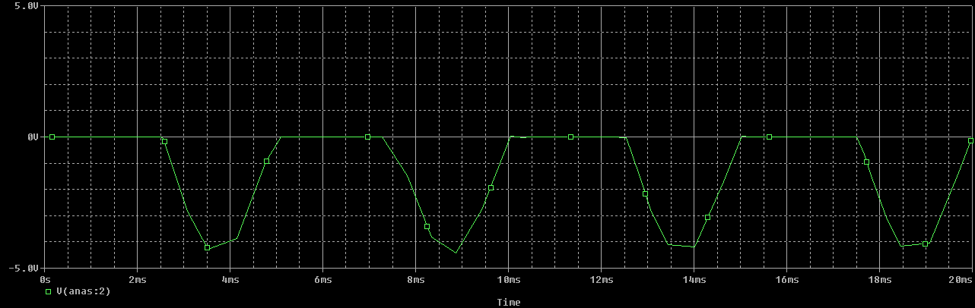

* The same circuit with capacitor:

By pSpice :

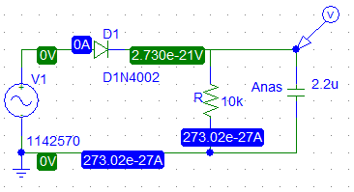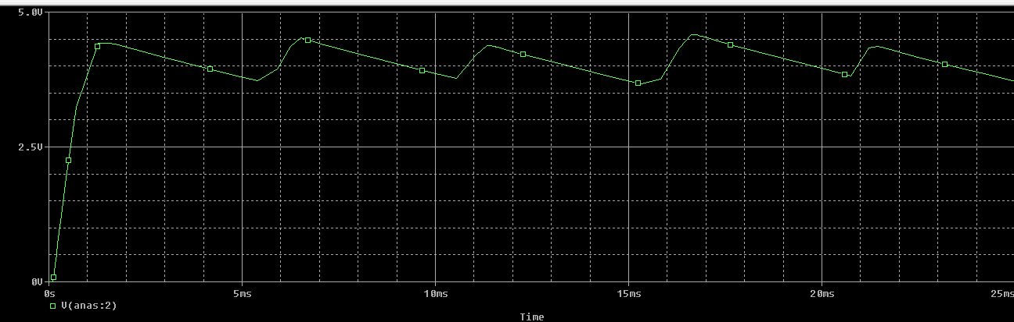

* Vpp,r=0.7957 Volt.
* Vdc= $2.730*{10}^{-21}$ Volt .
* The output after added capacitor (47uF):

By pSpice :

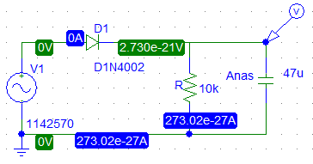

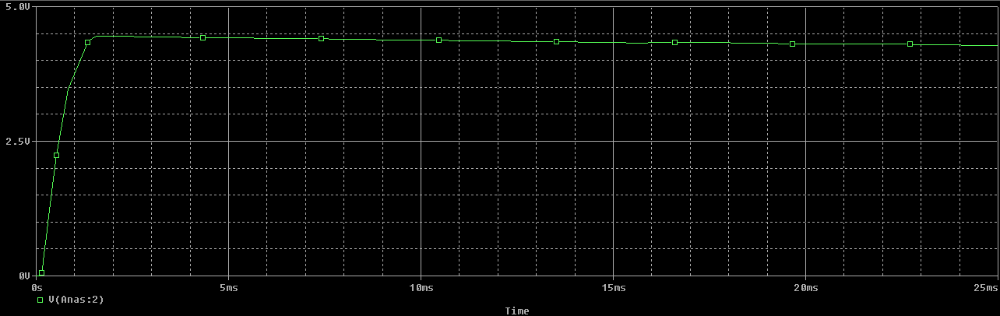

* Vpp,r=0.05 Volt.
* Vdc= $2.730*{10}^{-21}$ Volt .

B. *FULL-WAVE RECTIFICATION* ***:***

1. By pSpice :

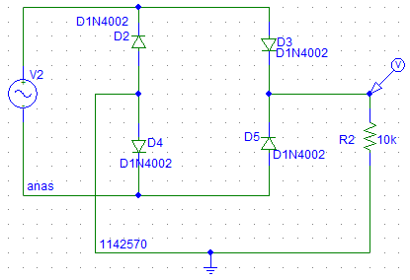

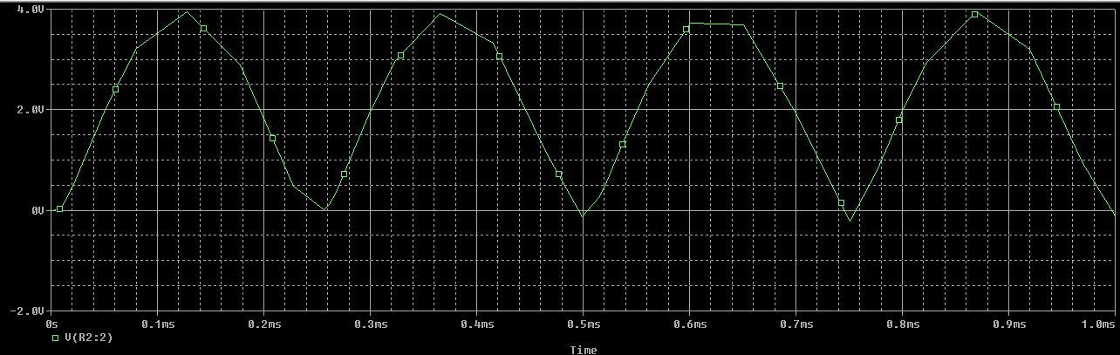

* Vp =4 Volt .

2. By pSpice :

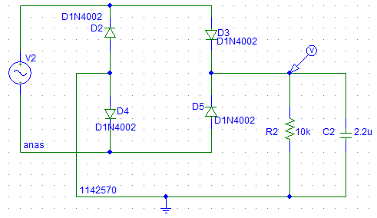

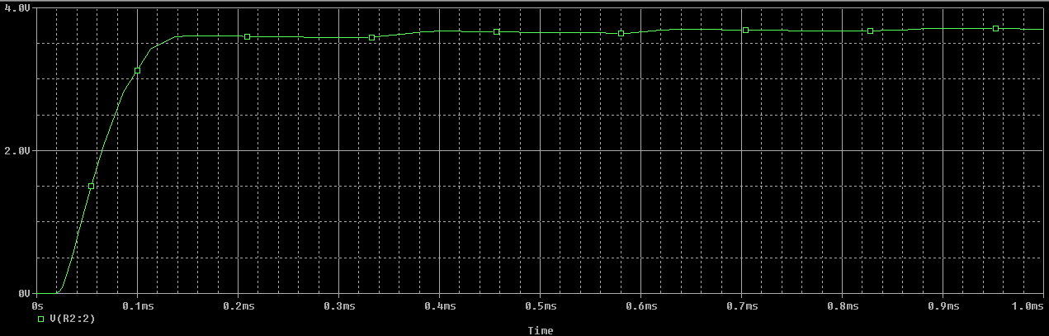

*3. other applications:*

*A. clipping:*

By pSpice :

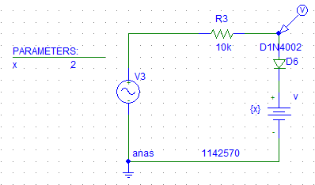

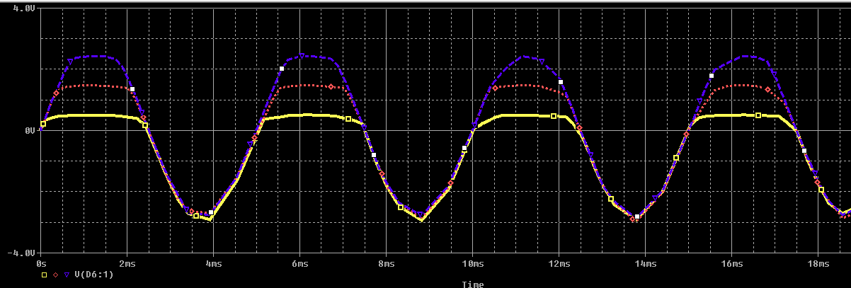

*B. Clamping:*

By pSpice :

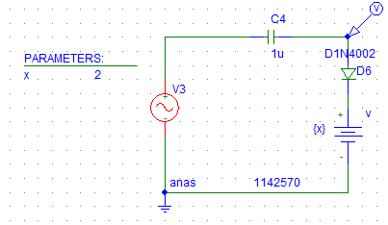

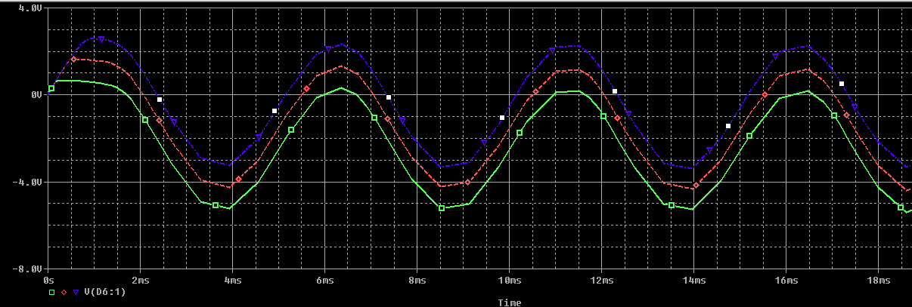

*C. VOLTAGE MULTIPLIER CIRCUITS :*

By pSpice :

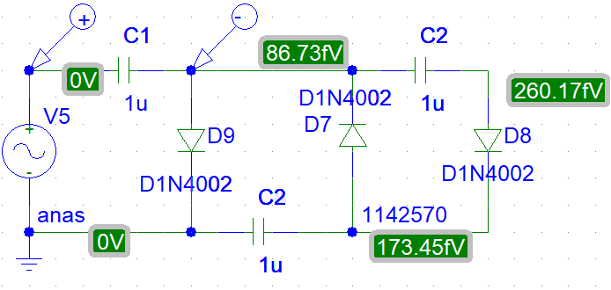

Vc1 = 2.4 V

Vc2 = 3.84 V

Vc3 = 2.96 V