

Faculty of Engineering and Technology

Electrical and Computer Engineering Department

**ENEE 3102 – Electronics Lab**

Pre-lab No. 2

**The transistor biasing and DC Parameters**

Prepared By:

Name: Suhaeb Qadan Number: 1160297

Instructor: Dr. Mohammad Al Jubeh

TA: Eng. Almo`tassem Bilhah

Date: 18/9/2019

Sec#: 1

**Table of Contents**

**Part 1: The Transistor Biasing** 2

**Part 2: The Transistor DC Parameters** 4

**2.1: Input Characteristic** 4

**2.2: Forward Current Transfer Characteristic** 5

**2.3: Reverse Voltage Characteristic** 6

**2.4: The output Characteristics** 6

**List of Figures**

Figure 1: Circuit for transistor biasing using the PnP transistor 2

Figure 2: Circuit for transistor biasing using the PnP transistor when the connections of the supply were reversed 3

Figure 3: Circuit for transistor biasing using the PnP transistor when the two variable DC sources were set to 15V 3

Figure 4: Circuit for transistor biasing using the nPn transistor when the two variable DC sources were reversed 4

Figure 5: Circuit to show the DC parameters for transistor using the nPn transistor, potentiometer, power supply. 4

Figure 6:The simulation output between VBE against IB at difference values of VCE, VBE is on the y-axis. 5

Figure 7: the plot of IC against IB with IB on the X-axis. 5

Figure 8: the plot of VBE against VCE with VBE on the Y-axis. 6

Figure 9: the plot of IC against VCE with VCE on the X-axis. 6

# **Part 1: The Transistor Biasing**

The circuit below was built using PSpice simulation using the PnP transistor, when the variable DC source up to 4V, the values of IE, IC and IB were measured as shown in Figure 1.

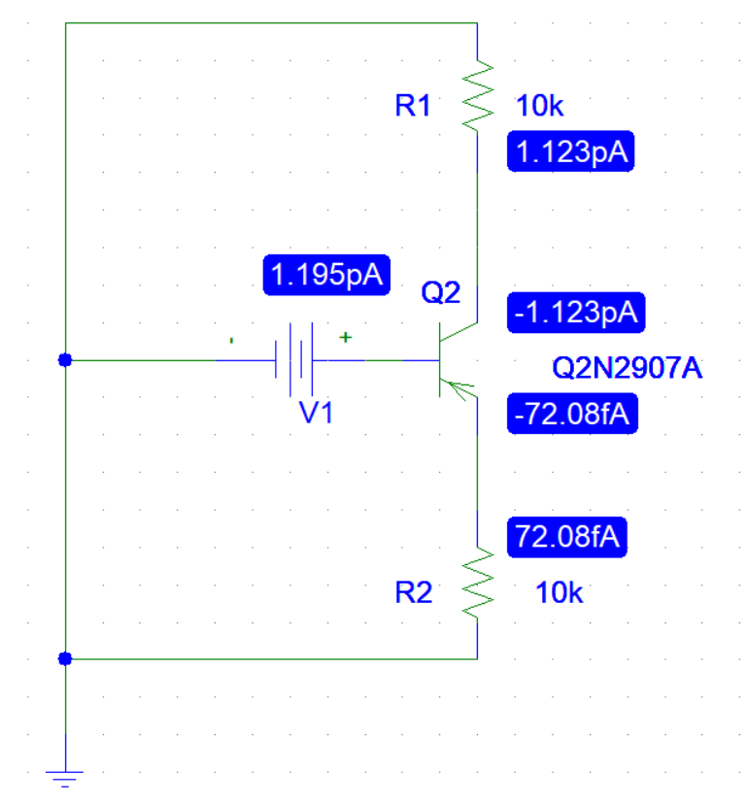

Figure : Circuit for transistor biasing using the PnP transistor

When the connections of the supply were reversed such that both junctions are forward biased.

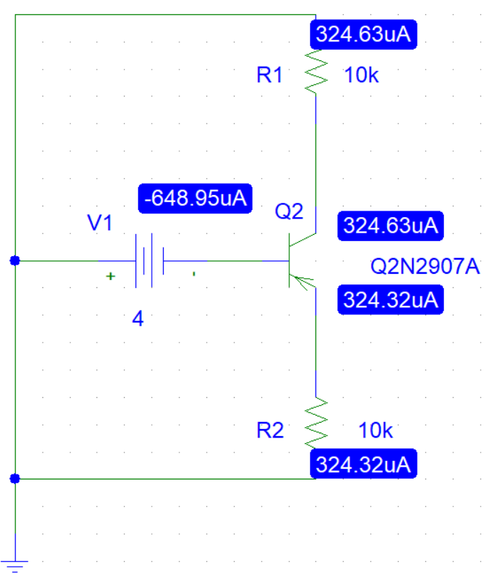

Figure : Circuit for transistor biasing using the PnP transistor when the connections of the supply were reversed

The circuit below was built using PSpice simulation using the PnP transistor, when the two variable DC sources were set to 15V, the values of IE, IC and IB were measured as shown in Figure 2.

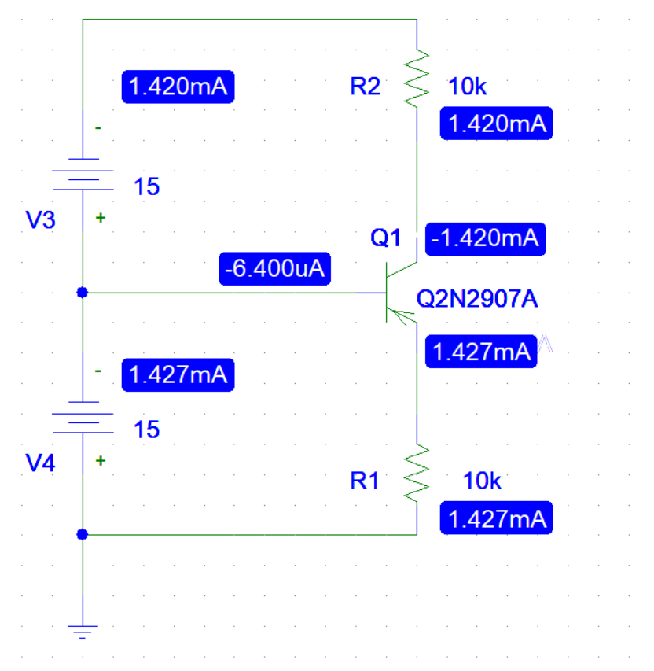

Figure : Circuit for transistor biasing using the PnP transistor when the two variable DC sources were set to 15V

When the connections of the two supplies were reversed using nPn transistor.

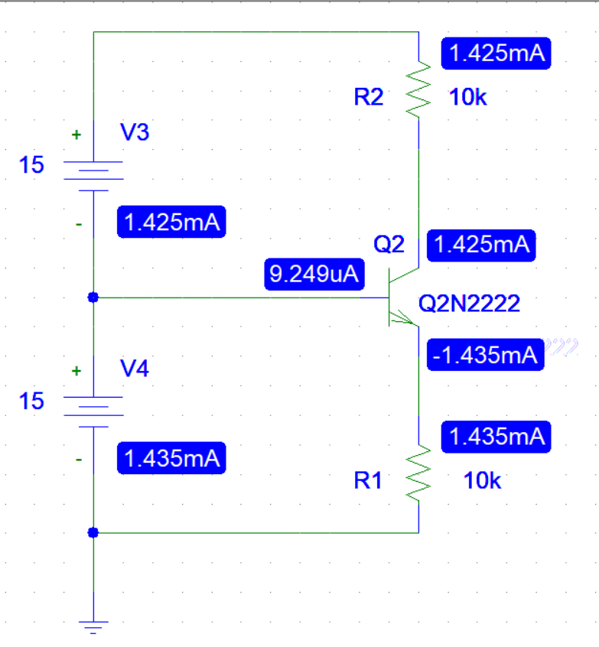

Figure : Circuit for transistor biasing using the nPn transistor when the two variable DC sources were reversed

# **Part 2: The Transistor DC Parameters**

## **2.1: Input Characteristic**

The circuit below was built using PSpice simulation using the nPn transistor, potentiometer, power supply. The value VBE was measured at different values of IB and VCE.

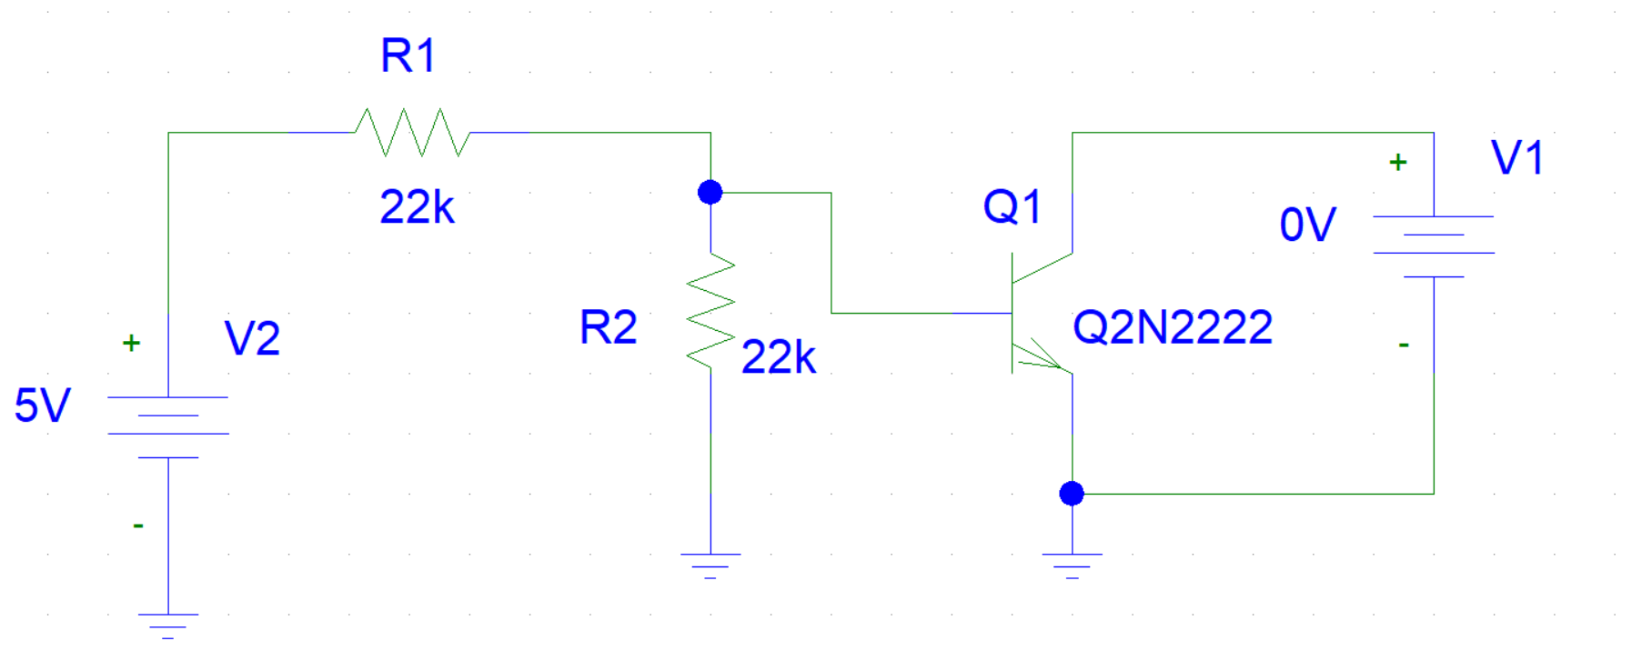

Figure : Circuit to show the DC parameters for transistor using the nPn transistor, potentiometer, power supply.

The graph below shows the relationship between VBE against IB at difference values of VCE, VBE is on the y-axis.



Figure :The simulation output between VBE against IB at difference values of VCE, VBE is on the y-axis.

## **2.2: Forward Current Transfer Characteristic**

For the same circuit of Figure 5, IC was measured with IB at difference values of VCE, the graph below shows the plot of IC against IB with IB on the X-axis.



Figure : the plot of IC against IB with IB on the X-axis.

## **2.3: Reverse Voltage Characteristic**

For the same circuit of Figure 5, VBE was measured with VCE at difference values of IB, the graph below shows the plot of VBE against VCE with VBE on the Y-axis.



Figure : the plot of VBE against VCE with VBE on the Y-axis.

## **2.4: The output Characteristics**

For the same circuit of Figure 5, IC was measured with VCE at difference values of IB, the graph below shows the plot of IC against VCE with VCE on the X-axis.

Figure : the plot of IC against VCE with VCE on the X-axis.