

Faculty of Engineering and Technology

Electrical and Computer Engineering Department

ENEE3102

Electronics Lab

Experiment # 3

Pre lab

*Student’s name : Anas Joudeh*

*Student’s number : 1142570*

*Instructor : Dr.Mohammad AL-Jubeh*

*DATE : 3/7/2018*

1. The Transistor Biasing:

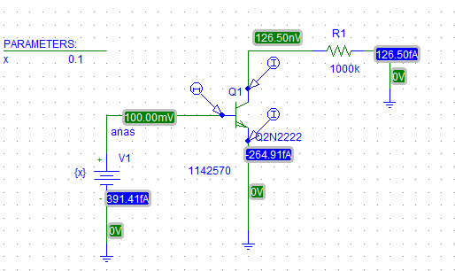

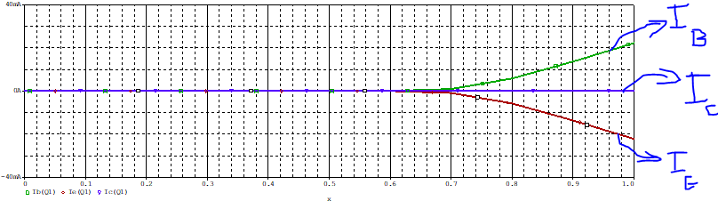

2. Reverse the supply connections :

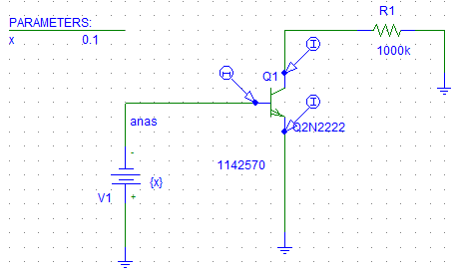

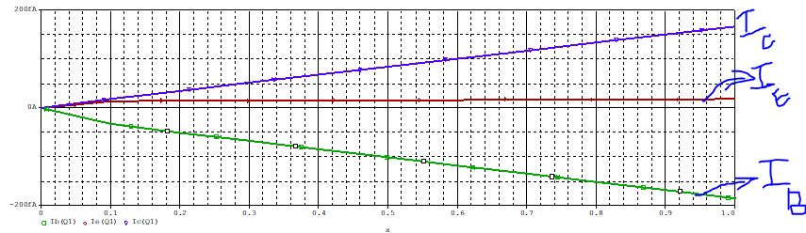

4.

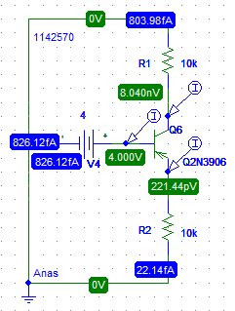

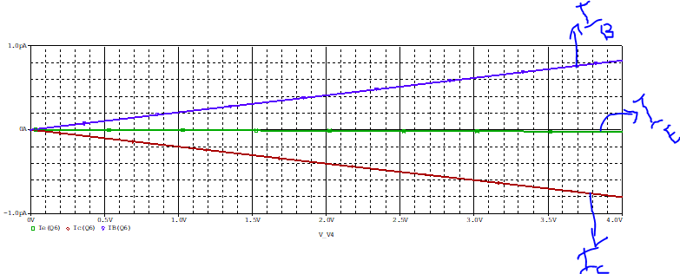

b.

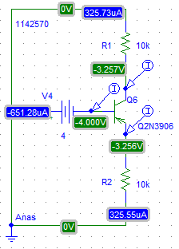

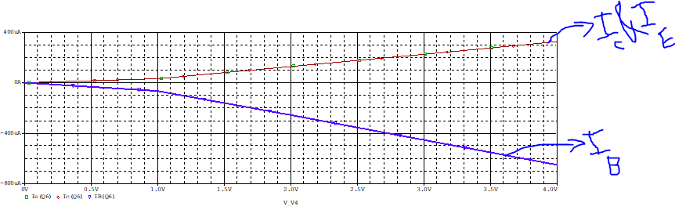

6.

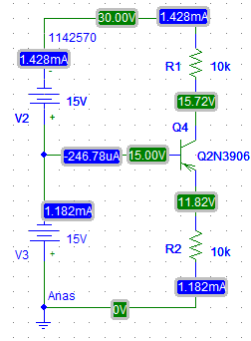

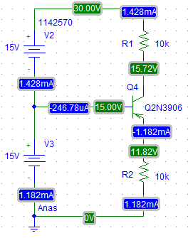

7. npn

a.

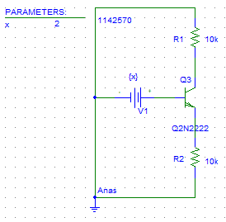







b.

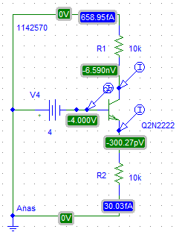

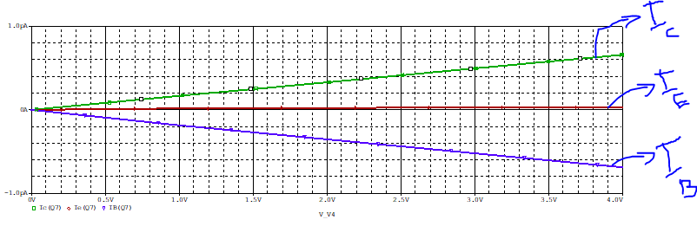

c.

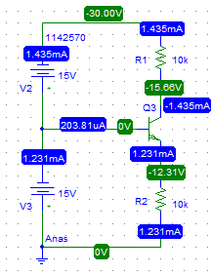

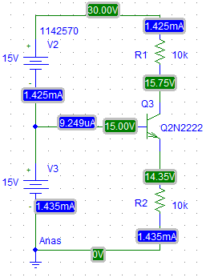

**II. The Transistor DC Parameters:**

**A : Input Characteristic :**

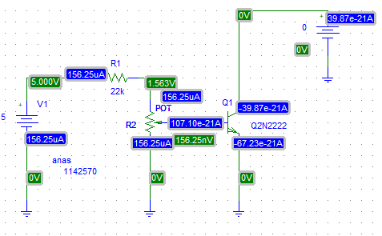

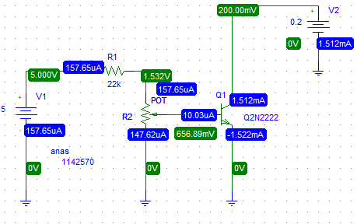

|  |  |  |
| --- | --- | --- |
| VCE | ICE[uA] | VBE[V] measure |
| 0 | 0 | 156.25nV |
| 5 | 516.26mV |
| 10 | 539.65mV |
| 15 | 549.2mV |
| 0.2 | 0 | 227.26nV |
| 5 | 654.65mV |
| 10 | 656.89mV |
| 15 | 668.37mV |
| 0.4 | 0 | 227.27nV |
| 5 | 654.65mV |
| 10 | 657.08mV |
| 15 | 668.61mV |