

Faculty of Engineering and Technology

Electrical Engineering Department

ــــــــــــــــــــــــــــــــــــــــــــــــــــــــــــــــــــــــــــــــــــــــــــــــــــــــــــــــــــــــــــــــــــــــــــــ

ELECTRONIC LAB

Pre Lab

Experiment#4

*The Field-Effect Transistor*

**Student’s Name: Dana Abu Hussien**

**Student’s No : 1131657**

**Instructors : Dr.**  **Nasser Ismai**

**Section : 2**

***I. CHARACTERESTICS OF AN N-CHANNEL JFET.***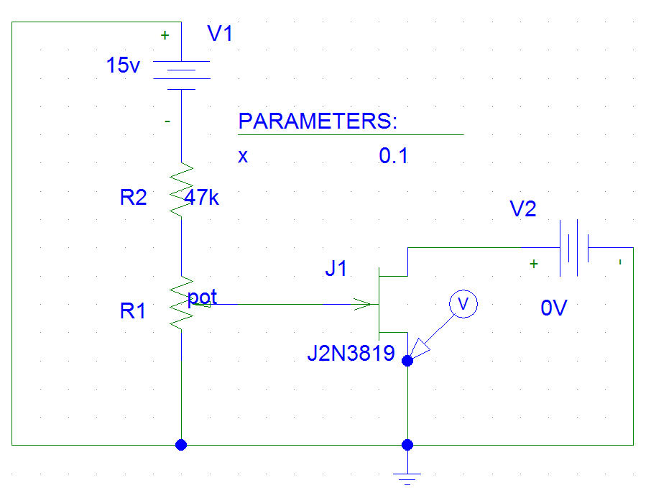

FIG(1)



FIG(2)



FIG(3)

Question

1) When the value of Vds between 5 and 10 volts then Ids is unaffected by Vds.

2) when Vds =10 volt then equal changes in Vgs doesn't cause an equal changes in Ids.

3) Ig can't be measured because it's too small.

***II. A JFET AMPLIFIER.***

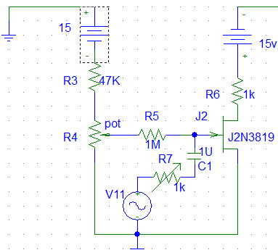

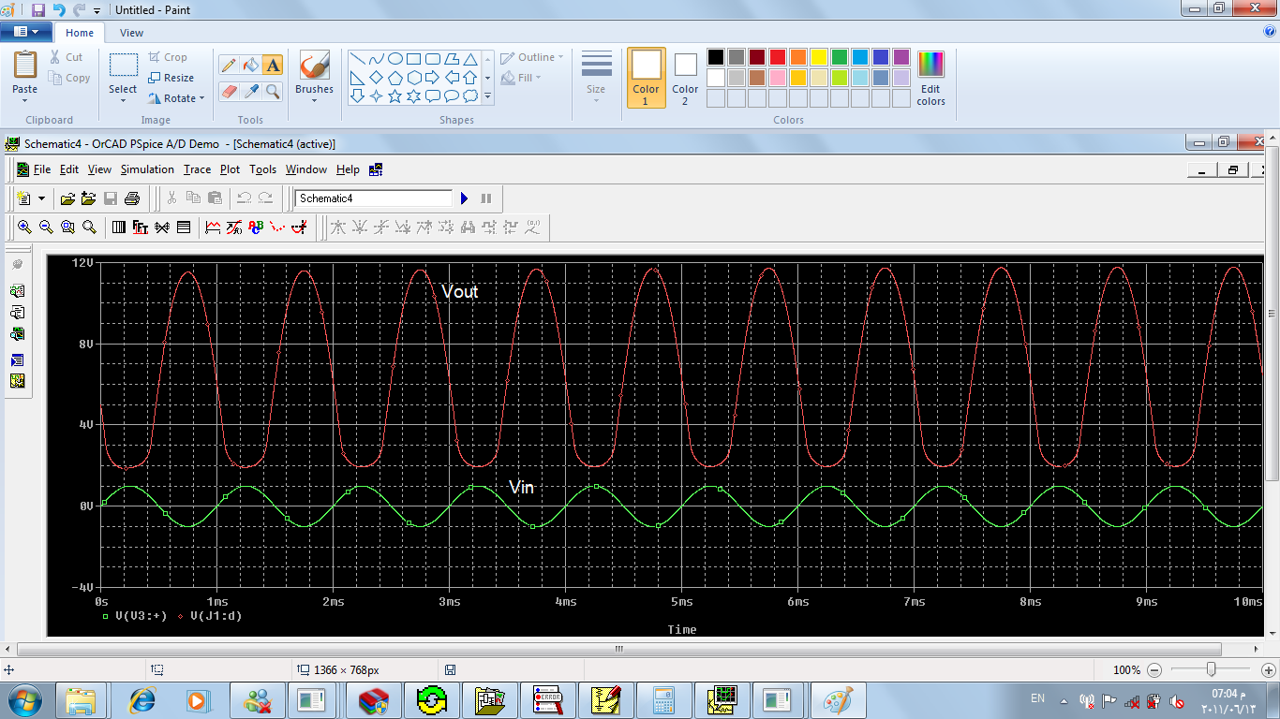***FIG (4)***

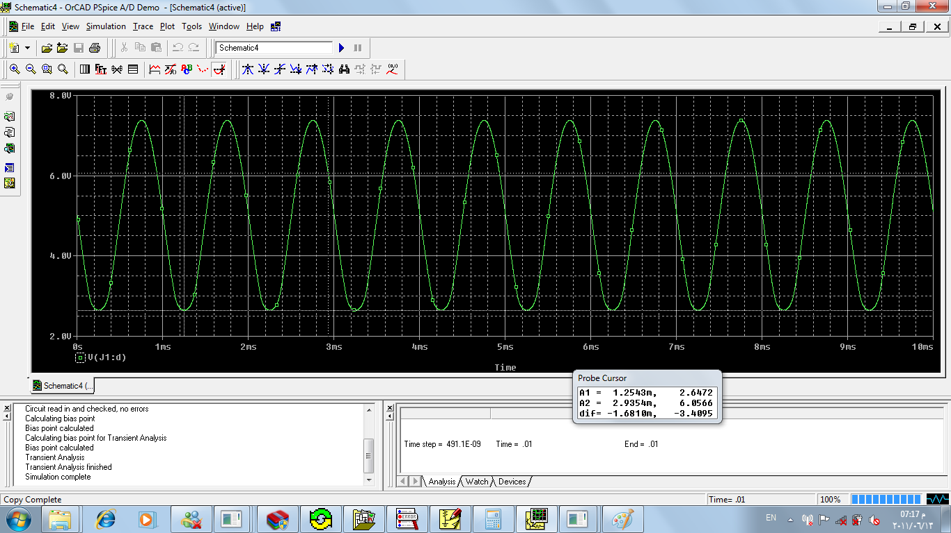***FIG(5)***

***FIG(6)***

When AC input is 2volt P-P then the output is 9.55volt P-P , and its output is shown in fig(5) , the voltage gain is Vout/Vin=9.55/2=4.775.

To make the output equals 4.775( half its original ) volt P-P, Rvar should be about 1.8MΩ. the output is shown in fig (6).

Question:

1. the input impedance is close to Rg.

***III. COMMON DRAIN AMPLIFIER.***

The input impedance and the output impedance will be:

Zin = 10k//22k=9.565 kΩ.

Zout = 22k//1k=956.52 Ω.

***III. CONSTANT CURRENT SOURCE.***

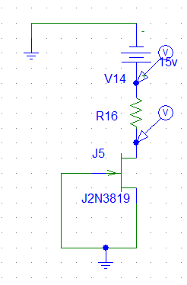

***FIG (9)***

|  |  |  |
| --- | --- | --- |
| RL(KΩ) | VL(V) | ID(mA) |
| 0.1 | 1.2 | 12 |
| 0.22 | 2.63 | 11.97 |
| 0.33 | 3.94 | 11.93 |
| 0.47 | 5.588 | 11.89 |
| 0.56 | 6.643 | 11.86 |
| 1 | 11.729 | 11.73 |
| 1.5 | 13.44 | 8.96 |
| 2 | 13.901 | 6.951 |
| 3 | 14.31 | 4.767 |