

ENEE3102

ELECTRONICS LAB

Mohammad Jehad Al Ju'Beh

Section 1

PreLab: Experiment #2

Student Name: Sara Totah

Student ID: 1181779

13/9/2020

Fall semester 2020/2021

**Experiment #4: BJT Transistor as An Amplifier, CE, CC, CB Connection:**

1. COMMON EMITTER TRANSISTOR AMPLIFIER:

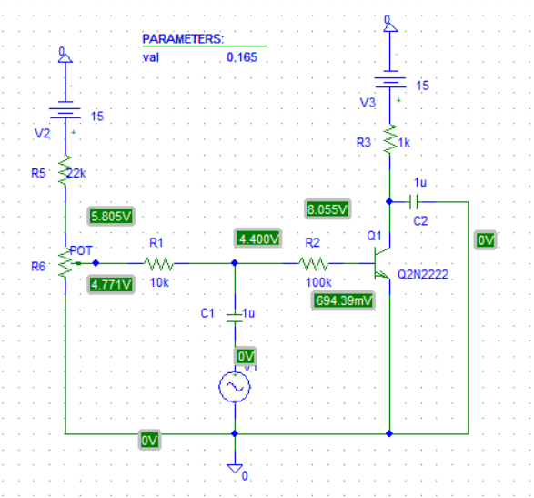

Note: I have changed the value of R6 from 10k as in the manual to 15k, to adjust the base bias potentiometer for a DC collector voltage (VC) of 8 volts.



Output voltage vs input voltage

Voltage gain of amplifier = Vo/Vi = 7.783 / 4.319 = 1.802

Voltage gain of the transistor = Vo/Vb = 7.783 / 1.377 = 5.652



Output current vs input current

Current gain = Io/Ii = 7.788u / 42.998u = 0.18

Zi = Vi/Ii = 7.783 / 42.998u = 181k

1. COMMON COLLECTER TRANSISTOR AMPLIFIER:

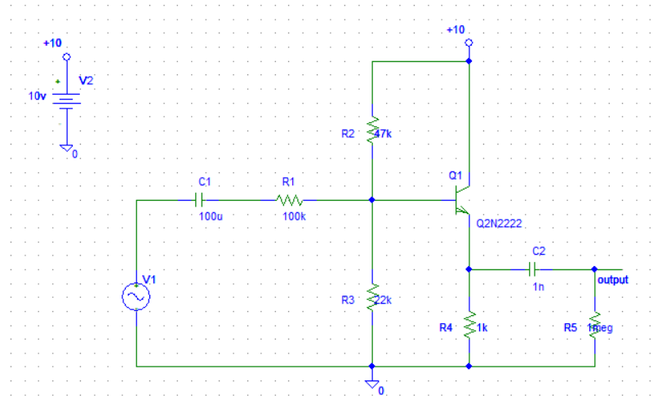

When the amplitude = 0 :

Vb = 2.988v

Ve = 2.323v

We increased the output amplitude of the sine wave generator to 8v so the output amplitude from the amplifier is about 2 volts peak-to-peak.



The Voltage gain = Vo/Vi = 1/8 = 0.125.

The Voltage across the 100k resistor:



Based on the previous measurement:

The input current =Vin / R = 64uA

The output current =Vo / R = 1mA

Current gain =Io / Iin =50.31

The input impedance =Vi /Iin = 125kΩ

The output impedance =Vo /Io = 1kΩ

***III. COMMON BASE TRANSISTOR AMPLIFIER.***

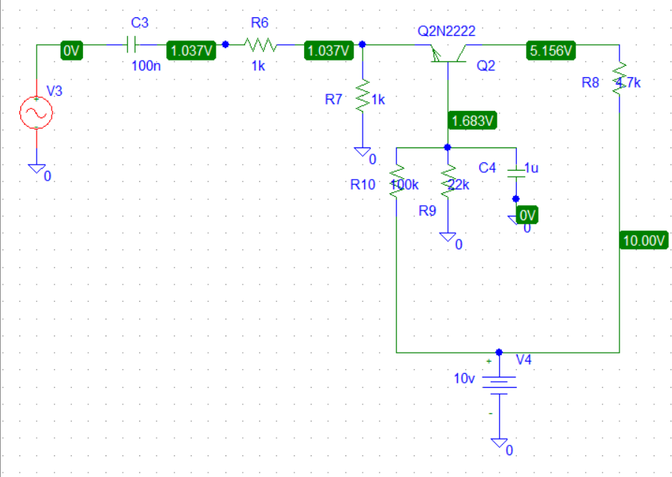

VBE= 0.651v

VCE=4.12v

VBC=-3.45v

IA= 1.03mA

IB=6.7uA

We increased the output amplitude of the sine wave generator to 2.3v so the output amplitude from Vc = +10 volts.



The voltage gain =Vo / Vin = 1/2.3 = 0.435

The ac voltage across the 10KΩ input resistor:



The input current =Vin / R

= 2.3/10k = 0.23mA

The output current =Vo / R

= 1/4.7k = 0.21mA

Current gain =Io / Iin =0.91

The input impedance =Vi /Iin

= 2.3/.23m = 10kΩ

The output impedance =Vo /Io = 4.8kΩ