

Faculty of Engineering and Technology

Electrical and Computer Engineering Department

ENEE3102

Electronics Lab

Experiment # 4

Pre lab

*Student’s name : Anas Joudeh*

*Student’s number : 1142570*

*Instructor : Dr.Mohammad AL-Jubeh*

*DATE : 5/7/2018*

1. *COMMON EMITTER TRANSISTOR AMPLIFIER* ***:***

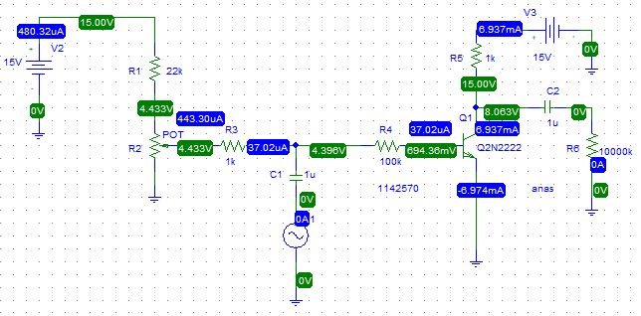

* Input signal with 4 V p-p and 1kHZ :



* The output voltage:



* the voltage of the base is :



* The emitter current is :



* The Collector current is :



* The base current is :



* The voltage gain :

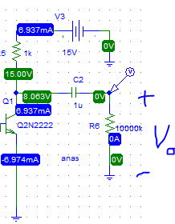



Gain = Vo / V in = 6.9/3.9 = 1.77 .

1. ***COMMON COLLECTER TRANSISTOR AMPLIFIER :***

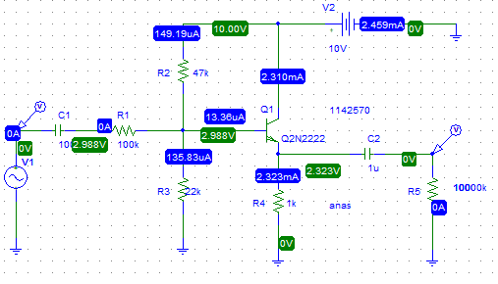

* The voltage gain :

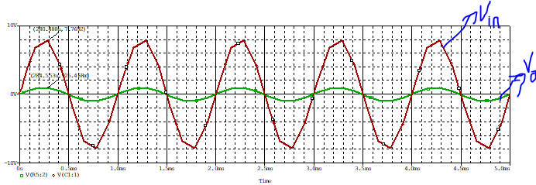

Gain = Vo / V in = 0.925/7.76 = 0.125 .

* The base current is :



* The emitter current is :



* The curent gain is :

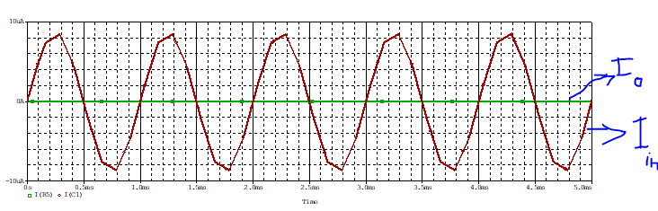

The current gain is about 0 .

* voltage across the 100KΩ input resistor :



1. ***COMMON BASE TRANSISTOR AMPLIFIER:***

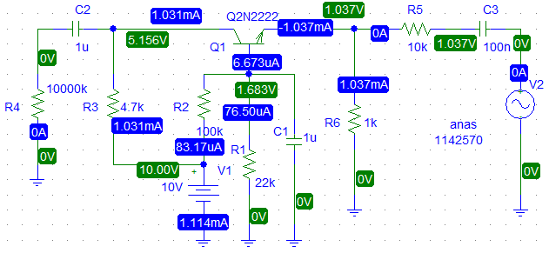

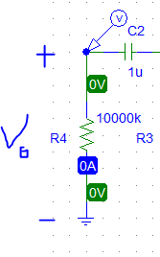

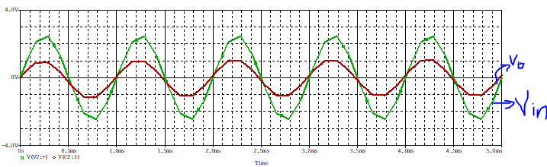

The input signal was set to 5 Vp-p

To output signal of about 2 Vp-p

* The voltage gain is=1/2.5=0.4
* voltage across the 10 kΩ input resistor :



* input current on 10 K is :



* The output current is :

