

Faculty of Engineering and Technology

Electrical and Computer Engineering Department

**ENEE 3102 – Electronics Lab**

Pre-lab No. 3

**BJT Transistor As An Amplifier, CE, CC, CB Connection**

Prepared By:

Name: Suhaeb Qadan Number: 1160297

Instructor: Dr. Mohammad Al Jubeh

TA: Eng. Almo`tassem Bilhah

Date: 18/9/2019

Sec#: 1

**Part 1: COMMON EMITTER TRANSISTOR AMPLIFIER.**

The circuit below was built using PSpice simulation as shown:

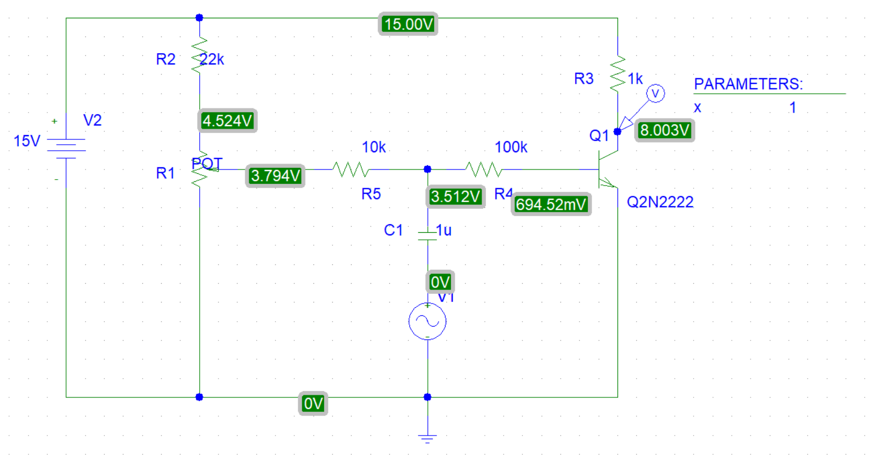

The DC collector voltage (VC) adjust to equal 8V by using parameters and the setting value of the potentiometer equal 0.153.

The DC currents:

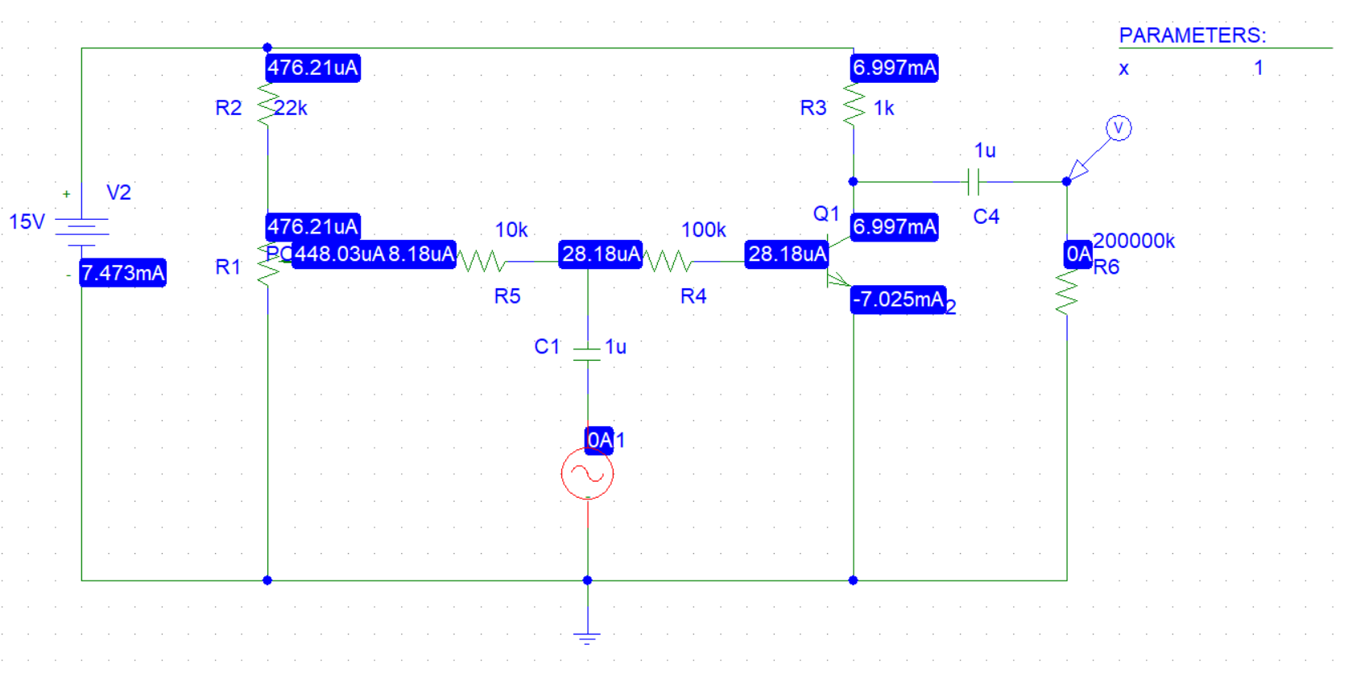

The DC voltages: 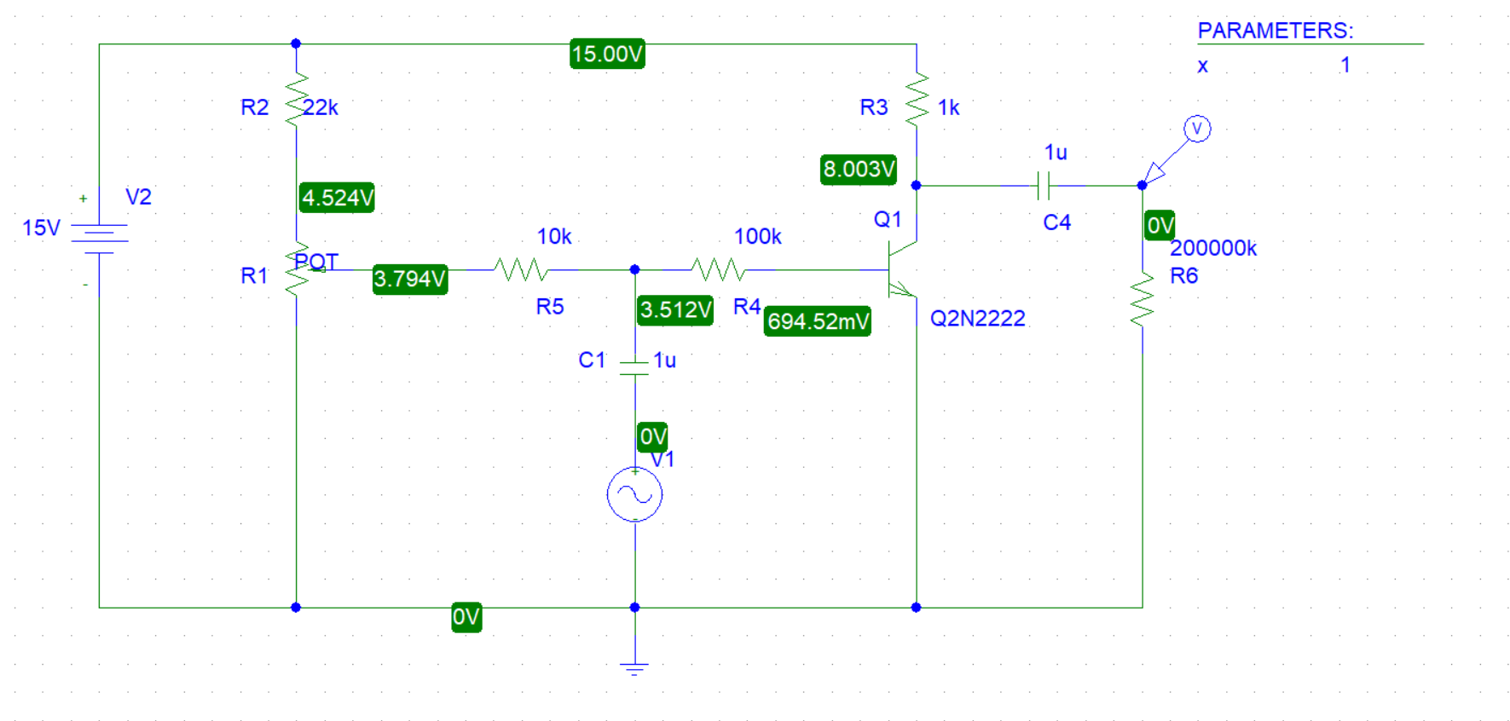

The following circuit was used to measure Vo 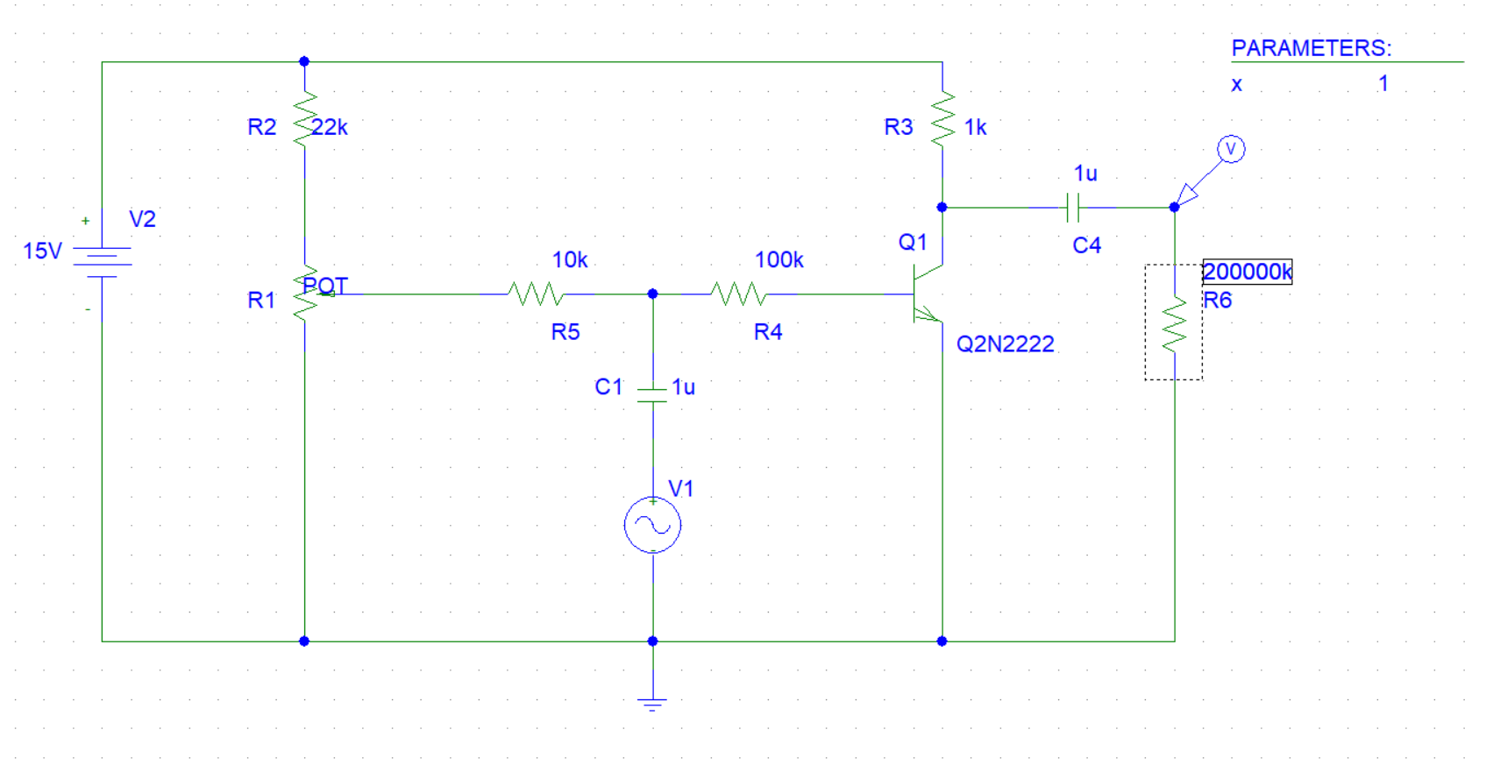

The peak value of VO = 7V.

The plot of Vo:

VBE = 0.7V

The plot of VBE:



the voltage gain of the transistor, Vo/VBE = 7/0.7 = 10

the voltage gain of the amplifier, Vo/Vi = 7/4 = 1.75

The AC currents for both the base and the collector of the transistor:

IB = 67.48 µA

IC = 15 mA

The plot of IB:



The plot of IC:



the current gain of the transistor IC /IB= 15 mA / 67.48 µA

IC /IB= 222.28

The plot of iO:



The plot of ii:



iO = 15 mA

ii = 277.158 µA

current gain of the amplifier, Io /Ii = 54.12

the input impedance of the amplifier, Zi = Vi /Ii = 14.4 kΩ

**Part 2: COMMON COLLECTER TRANSISTOR AMPLIFIER**

The circuit below was built using PSpice simulation as shown:

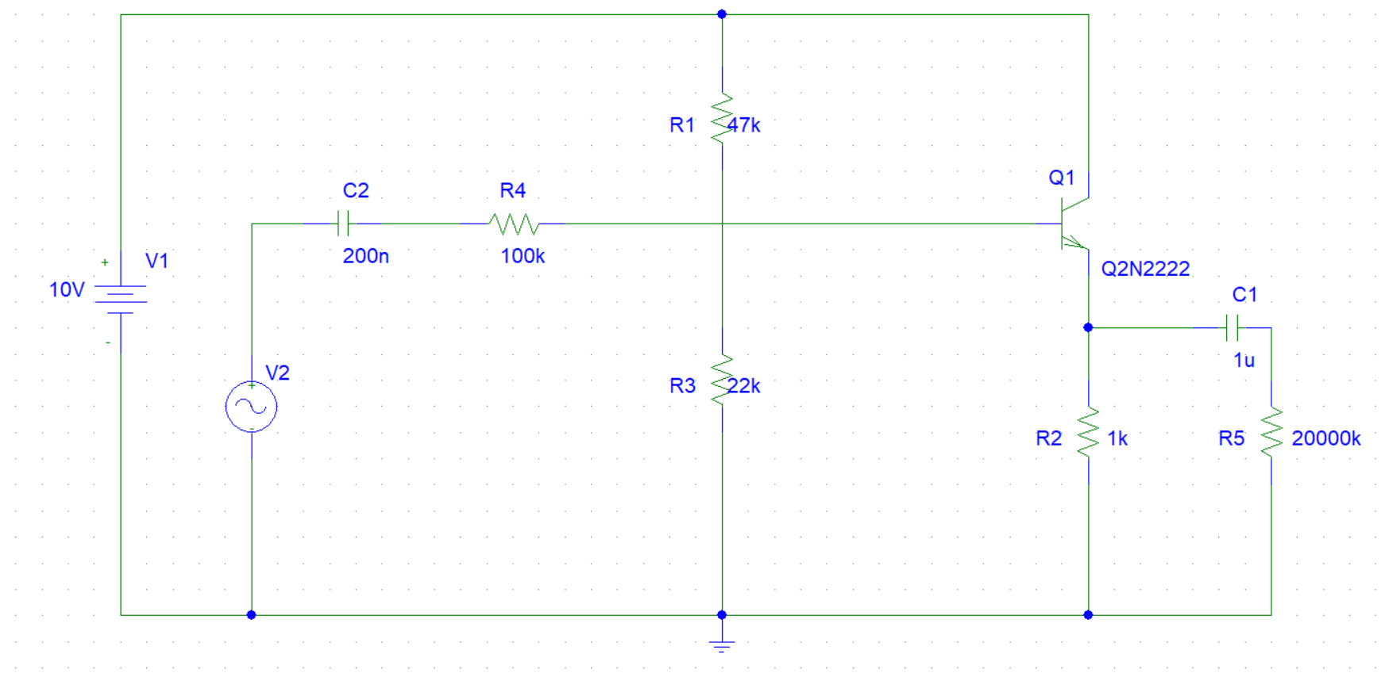

DC voltages:

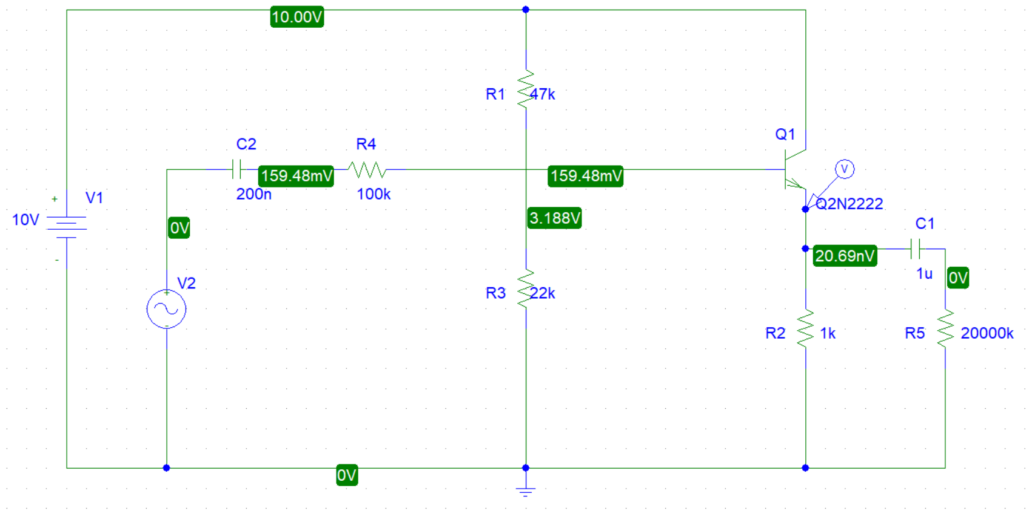

DC current:

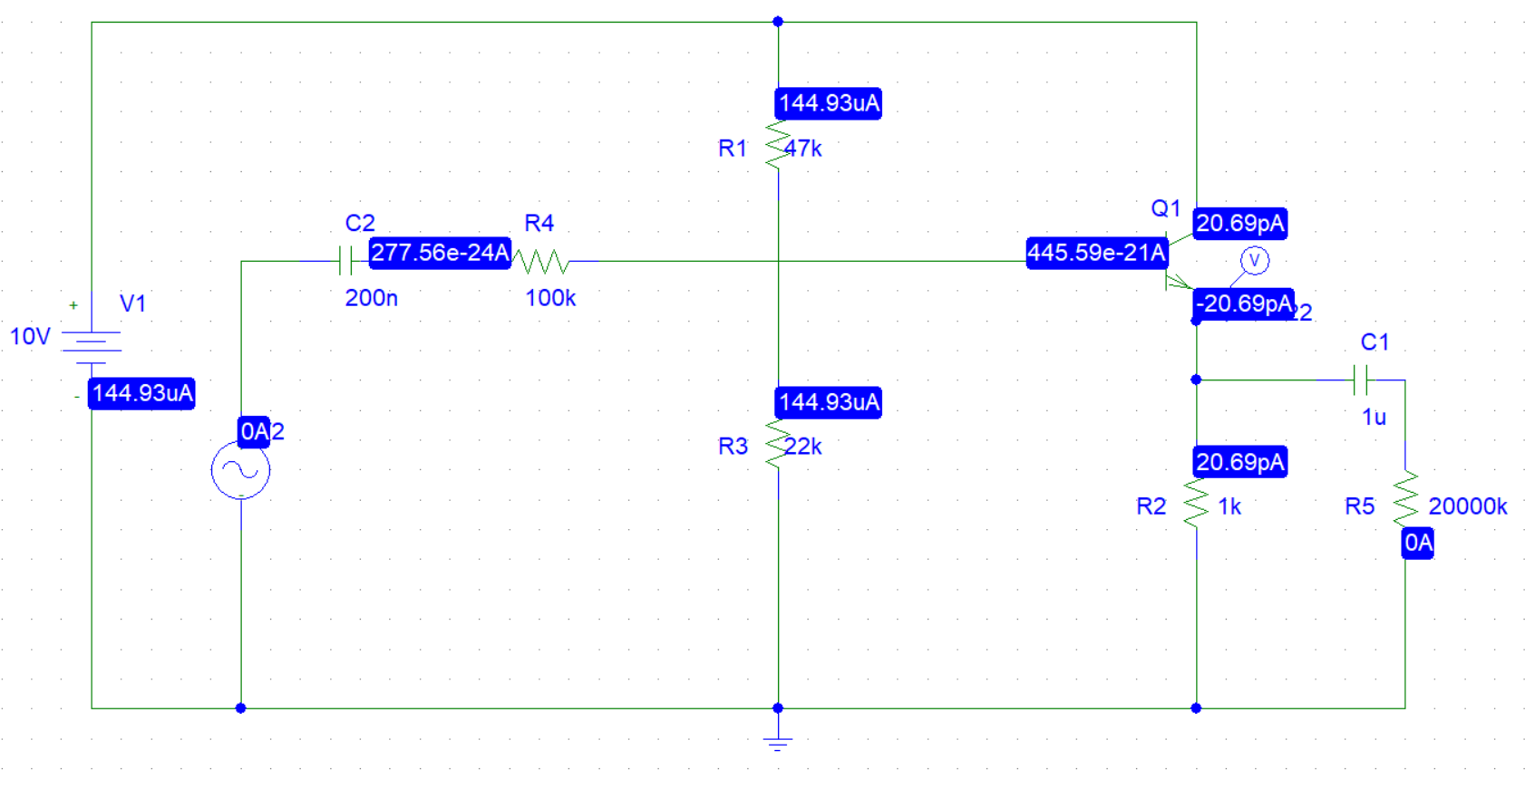

The quiescent bias voltages of the circuit, VE and VB

VE = 2.364V

The plot of VE:



VBE = 3.03 V

The plot of VB:



mplitude of the sine wave generator until an output amplitude from the amplifier is about 2volts peak-to-peak. The amplitude was set to 8.5V.



The plot of AC input voltage (8.5 V)



Voltage gain = 1 / 8.5 = 0.117

the AC voltage across the 100KΩ input resistor. VR = 5V

The plot of the AC voltage across the 100KΩ



The value of the input current using the measured value of voltage across the input resistor. (Ii = 147.2 µA)

The plot of the input current:



The AC output current =50 µA

The plot of the AC output current:



Current gain = 0.339

To find Zo, the input sine wave generator and replace it with a short circuit, then connect the generator to the output (emitter) via a capacitor, and measure its output voltage and current.

ZO = VO/IO = 20 kΩ

**Part 3: COMMON COLLECTER TRANSISTOR AMPLIFIER.**

The circuit below was built using PSpice simulation as shown:

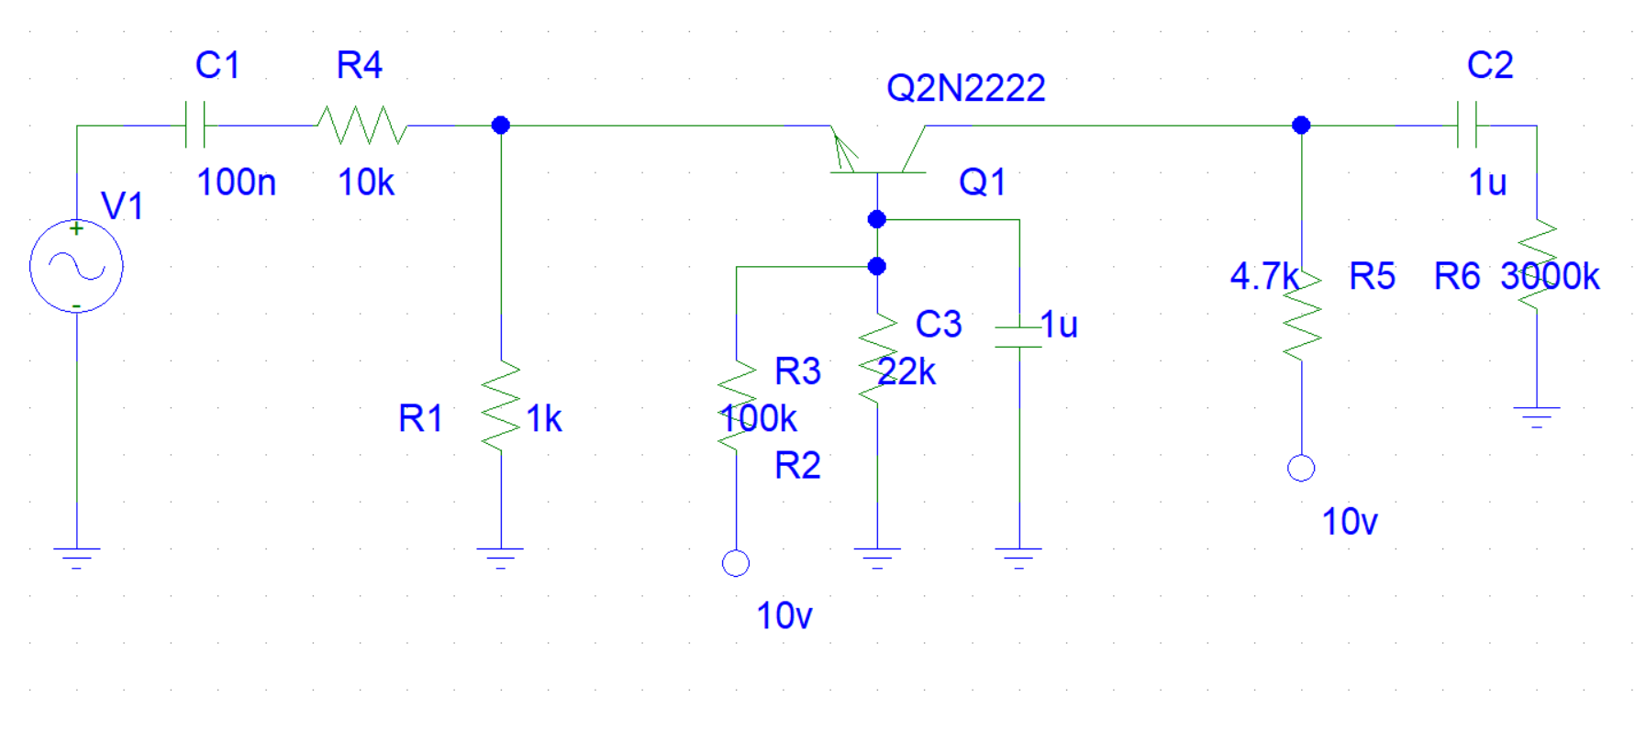

DC voltages

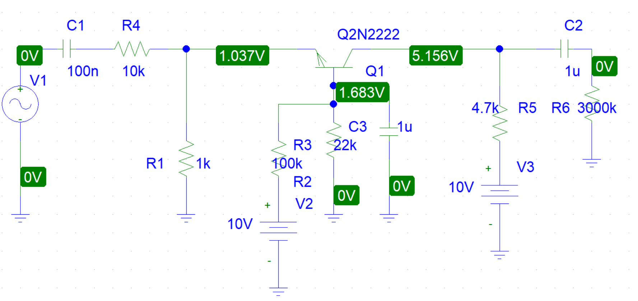

DC currents:

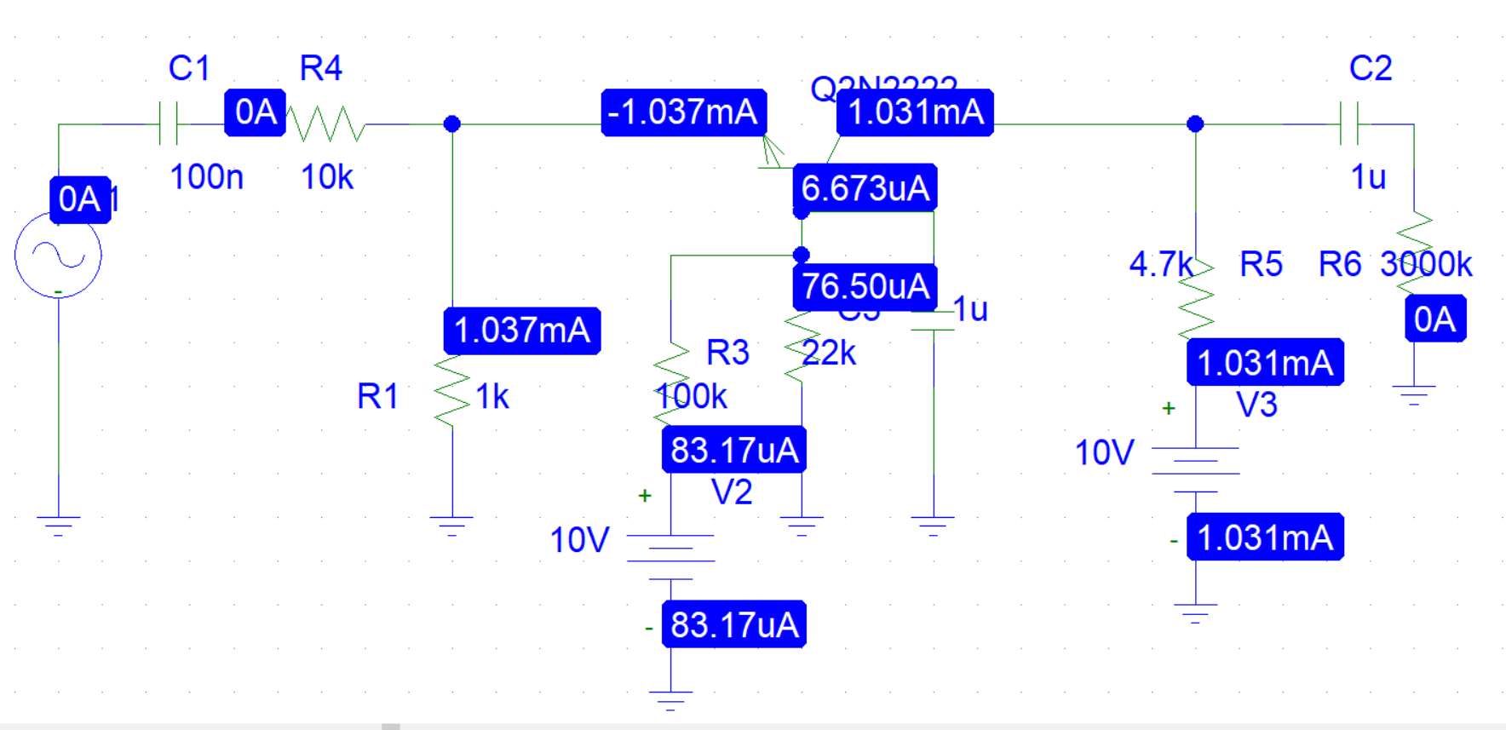

The quiescent bias voltages and currents IB, IC, VBE, VBC and VCE, using DVM.

IB = 6.673 µA

IC = 1.031 mA

VBE = 0.646 V

VCE = 4.119 V

VBC = 3.473 V

The output voltage is 2V peak to peak when the amplitude of **the generator is 2.2V.**

The plot of the output voltage:



the AC input voltage needed to achieve this output = 2.19V

The plot of the AC input voltage:



voltage gain (Av) = 0.9

the AC voltage across the 10 kΩ input resistor = 3.109 V

The plot of the AC voltage across the 10 kΩ input resistor:



The input current = 233 µA

The plot of the input current:



The AC output current = 354 µA

The plot of the AC output current:



The current gain = 1.52

The input impedance Zin = 9.39 kΩ

To find Zo, the input sine wave generator and replace it with a short circuit, then connect the generator to the output (emitter) via a capacitor, and measure its output voltage and current.

ZO = VO/IO = 2824.85Ω