

BERZIET UNIVERSITY

FACULTY OF ENGINEERING AND TECHNOLOGY

DEPARTMENT OF ELECTRICAL AND COMPUTER ENGINEERING

ENEE 3102

Electronics Laboratory

Experiment.4 Prelab

**BJT Transistor As An Amplifier, CE, CC, CB Connection**

Abdallateef Wahdan   
ID:1183005

Supervised by:

Dr. Mohammad Jehad Al JuBeh

Teacher assistance:

Bilal Ismail

2021/7/26

**I. COMMON EMITTER TRANSISTOR AMPLIFIER.**





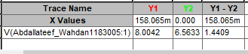

**When the SET in the potentiometer equal 0.158065 the Voltage on Vo equal 8V**

**II. COMMON COLLECTER TRANSISTOR AMPLIFIER.**





**III. COMMON BASE TRANSISTOR AMPLIFIER.**





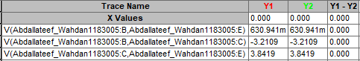



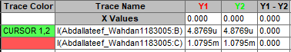

Voltage in R=10k ohm

