

**Faculty of Engineering and Technology**

**Electrical and Computer Engineering Department**

**Electronics LAB (ENEE3102)**

**Pre LAB of Experiment #5**

# The Field-Effect Transistor

Prepared by:

Name: Abdallah Fialah Number: 1162193

Instructor:

Mr: Mohammad Al-jubeh TA: Eng.Amjad Ziyad

Date:

4/10/2020

Section: #1

Q1)

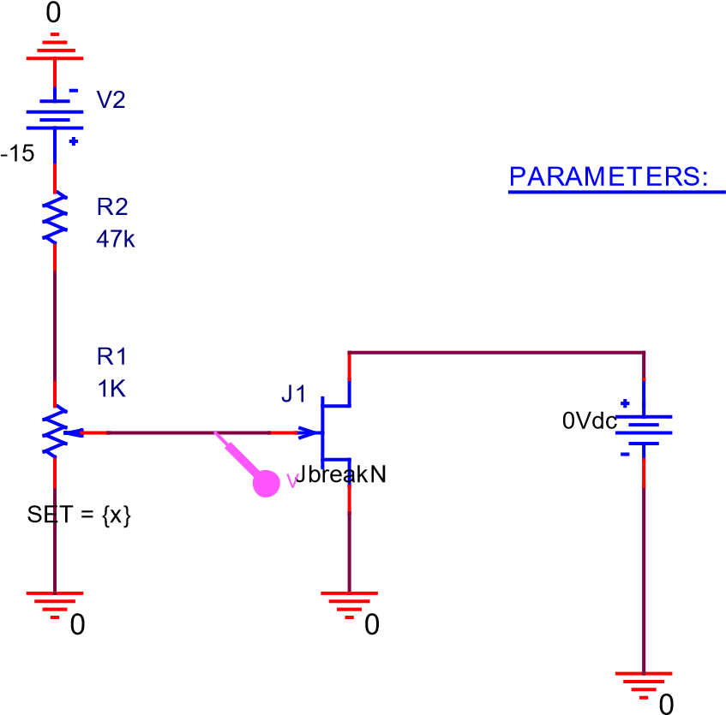V1

**Figure 1: The Circuit Diagram**

x

0

0.1

0.2

0.3

0.4

0.5

0.6

0.7

0.8

0.9

1.0

V(J1:g)

mV

-400

mV

-300

mV

-200

mV

-100

mV

0

(898.347m,-31.767m)

(564.463m,-136.106m)

(339.669m,-206.354m)

(131.405m,-271.436m)

(48.760m,-297.263m)

**Figure 2: The Plot of Vj VS Set**

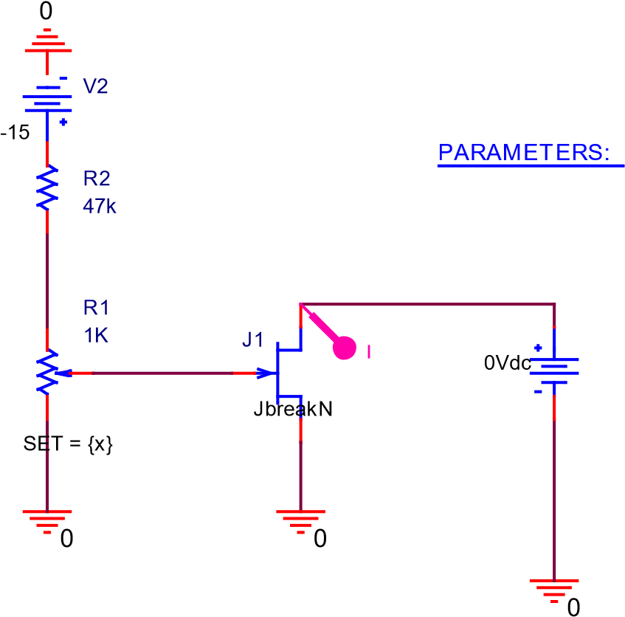V1

## Figure 3: The Circuit Diagram

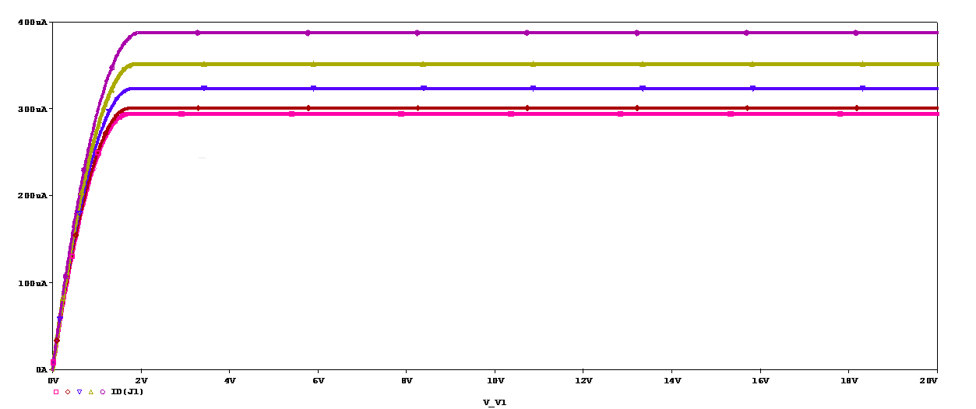

**Figure 4: The Characteristics curve of jFET**

## Q2)

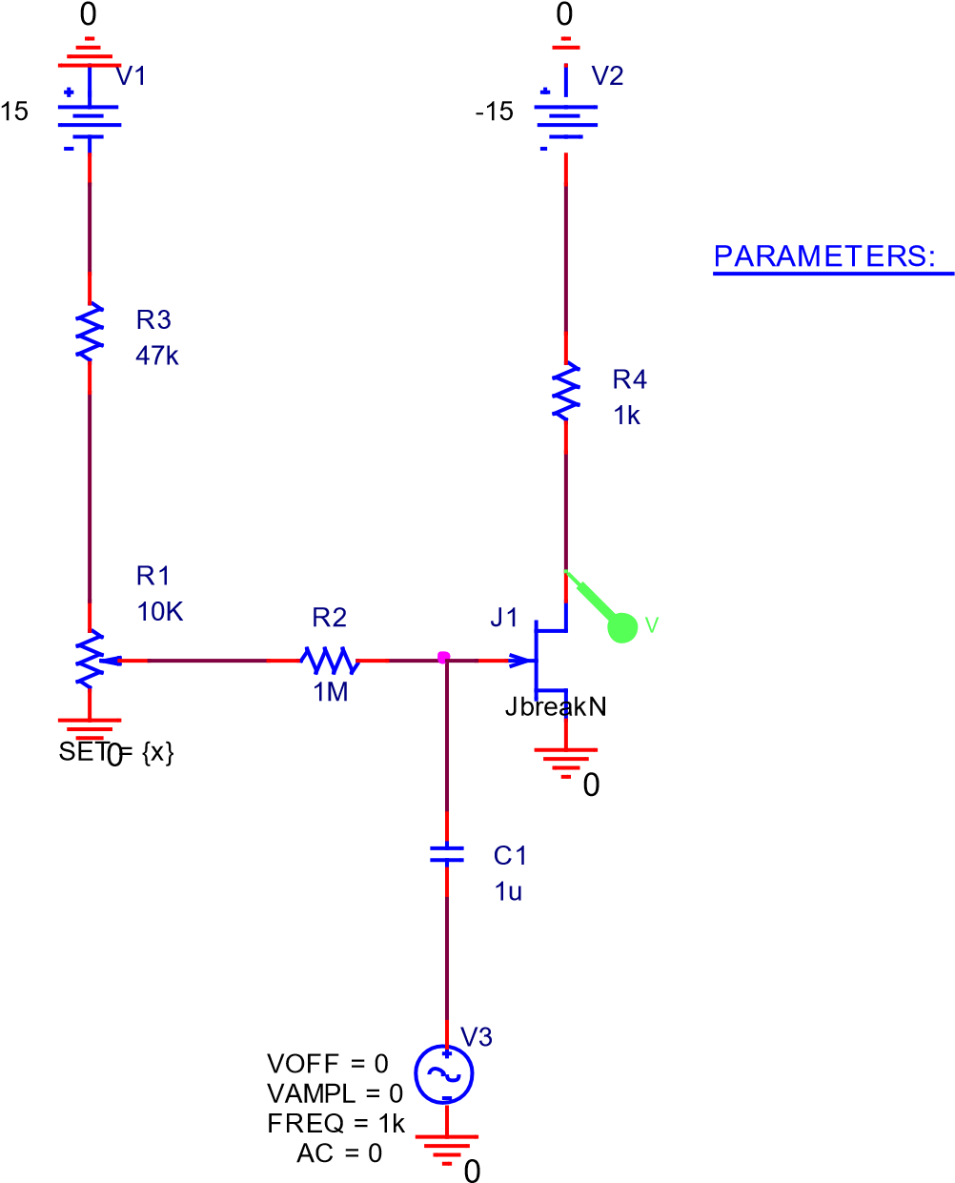

**Figure 5: The jFET as an Amplifier**

x

0

0.1

0.2

0.3

0.4

0.5

0.6

0.7

0.8

0.9

1.0

V(J1:d)

V

14.6

V

14.7

14.8

V

V

14.9

V

15.0

(784.426m,14.795)

(866.393m,14.728)

(654.918m,14.881)

(611.475m,14.904)

(567.213m,14.926)

(472.131m,14.963)

(417.213m,14.978)

(204.098m,15.000)

(62.295m,15.000)

**Figure 6: The Plot of Vj VS Set**

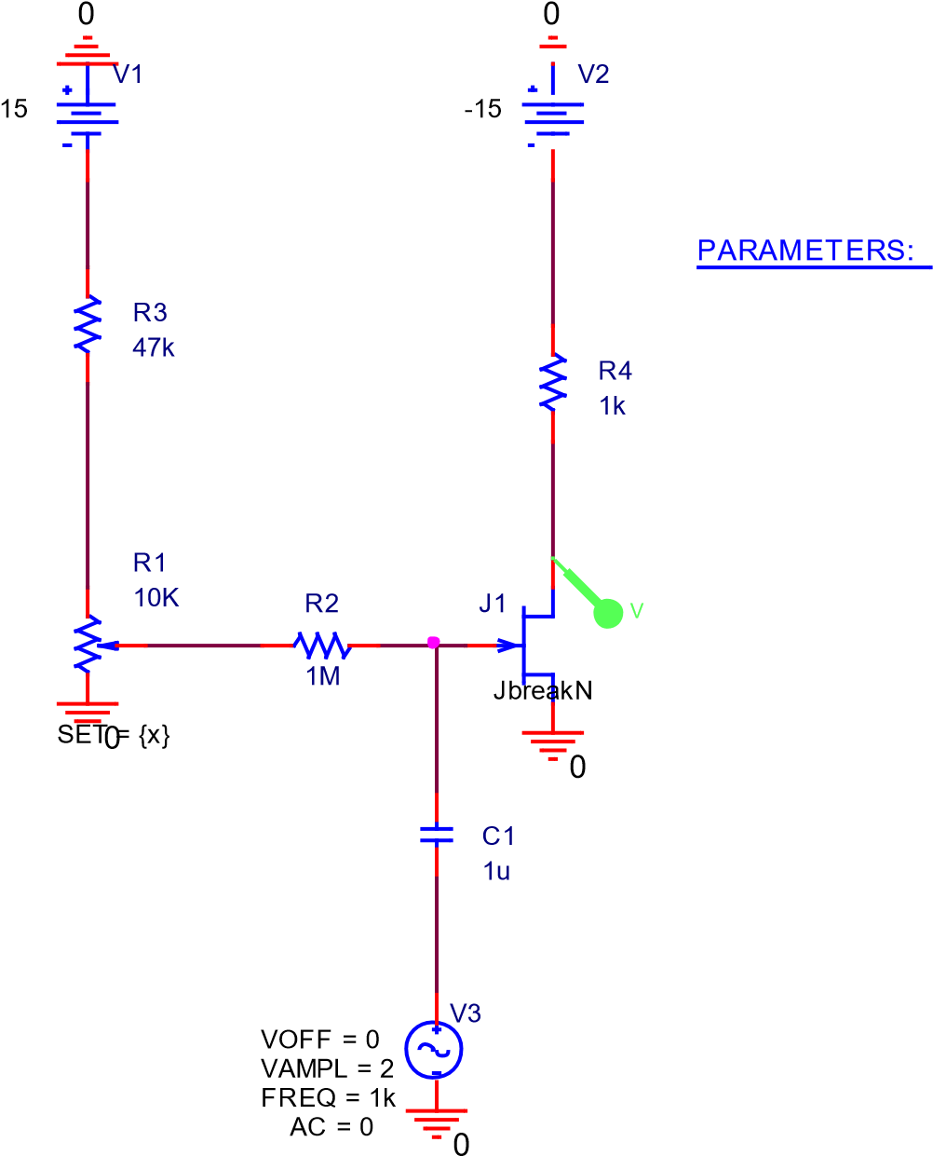

**Figure 7: when applying 2 VP_P**

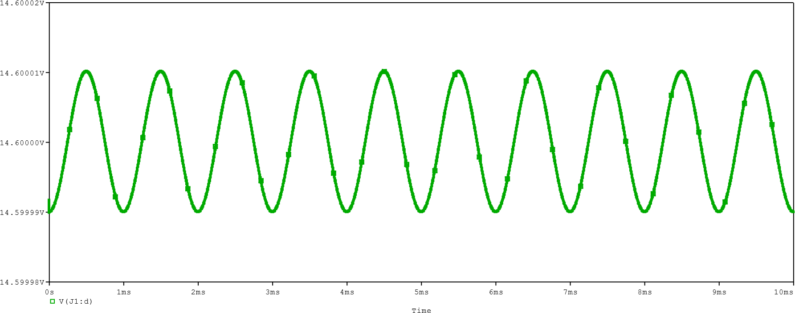

**Figure 8: The output when 2VP-P apply**

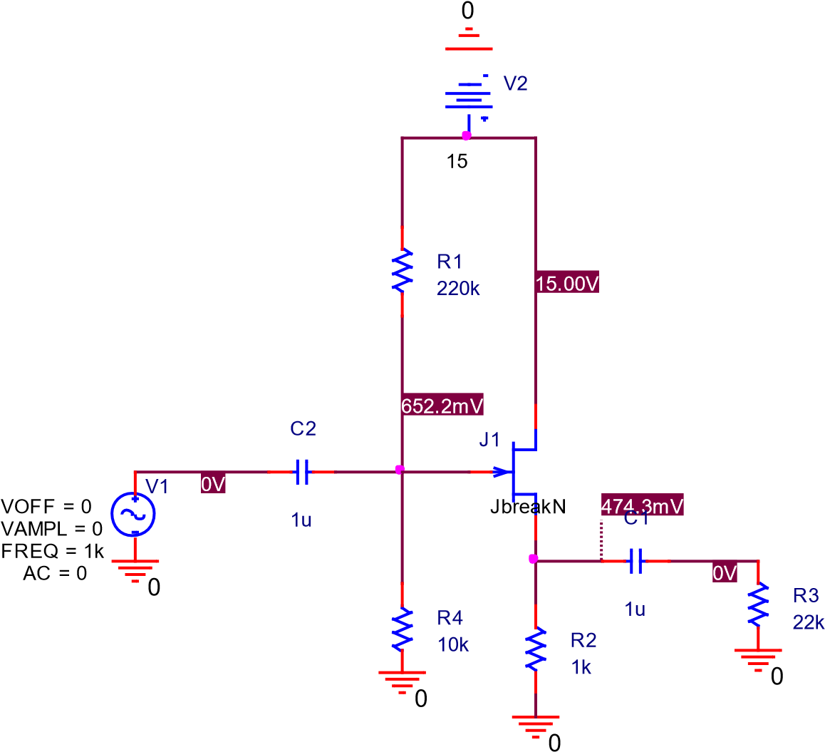

**Figure 9: Common Drain Amplifier**

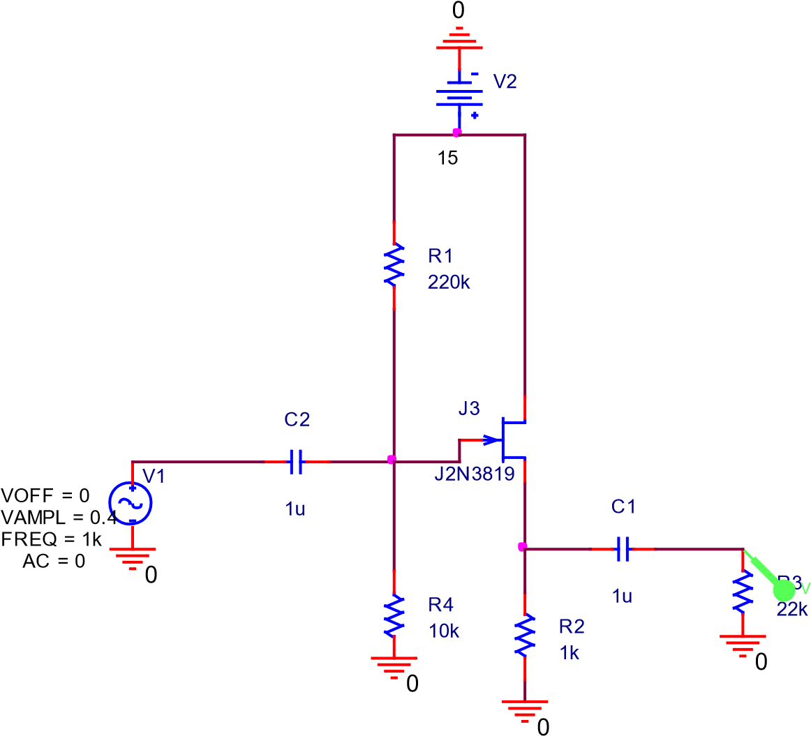

**Figure 10: Common Drain Amplifier input 0.4 V**

**Figure 11: The output of Common drain Amplifier**

Time

0

s

0.2

ms

ms

0.4

0.6

ms

0.8

ms

1.0

ms

1.2

ms

1.4

ms

ms

1.6

ms

1.8

ms

2.0

V(R3:2)

V

1.4

1.6

V

V

1.8

V

2.0

V

2.2

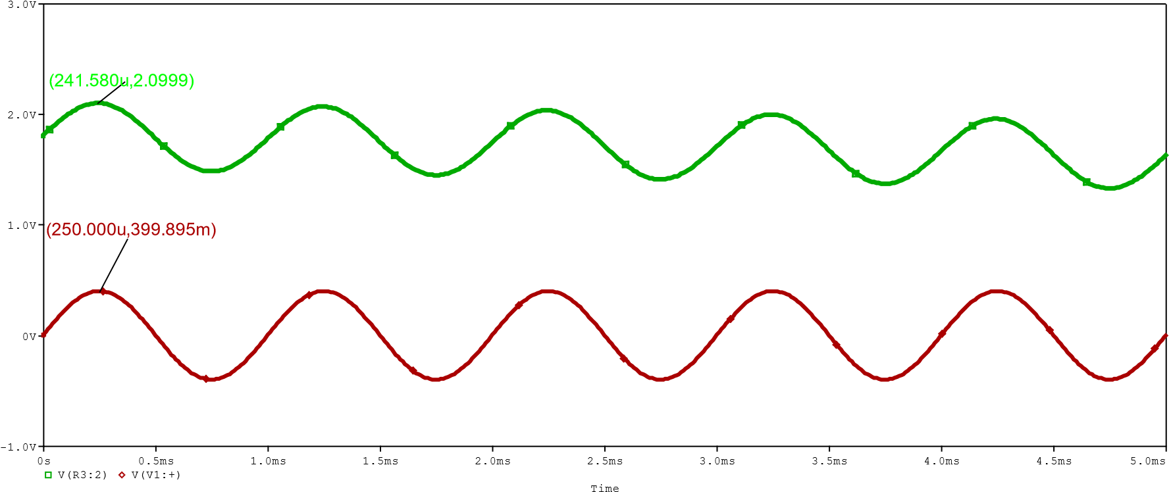

**Figure 11: the plot of input and output to calculate the phase shift**

Phase Shift = 2*3.14*∆t

➔ ∆t= 11us ➔ phase shift=

0

J1

J2N3819

R1

{

x

}

PARAMETERS:

I

V1

15

0

**Figure 12: The constant current source**

x

0

0.5

K

K

1.0

K

1.5

K

2.0

K

2.5

K

3.0

ID(J1)

mA

4

mA

8

mA

12

mA

16

(3.0000K,4.7673m)

(2.0000K,6.9455m)

(1.5000K,8.9589m)

(1.0000K,11.730m)

(560.976,11.861m)

(470.732,11.889m)

(329.268,11.932m)

(219.512,11.966m)

(100.000,12.003m)

**Figure 13: The plot of ID at the Difference value of resistor**

The value of current recorded in the table 1 below.

**Table 1: The current IL and The Voltage VL**

|  |  |  |
| --- | --- | --- |
| **RL(KΩ)** | **IL(mA)** | **VL(Calculated)** |
| 0.1 | 12.003 | 1.2 |
| .22 | 11.965 | 2.63 |
| .33 | 11.932 | 3.93 |
| .47 | 11.889 | 5.588 |
| .56 | 11.862 | 6.643 |
| 1 | 11.729 | 11.729 |
| 1.5 | 8.9662 | 13.49 |
| 2 | 6.9432 | 13.903 |
| 3 | 4.7677 | 14.302 |