

Faculty of Engineering

Electrical Engineering Department

Electronics lab (ENEE311)

Experiment IV

“*The Field-Effect Transistor*”

______________________________________________________

Prepared by:

Name: Samer Mukhaimar Number: 1110727

Instructor: Mr Mohammad Al Ju'Beh.

TA: Eng. Omar Shaheen.

Section: 2

Date: 3 / 4 / 2014

Problem 1

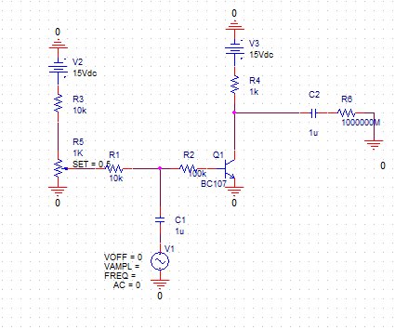

the simulation for Vsin = 2 V

*class B* Power amplifier

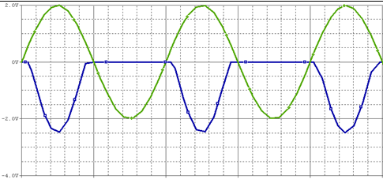

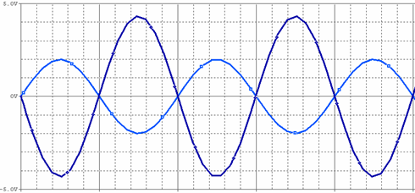If set were increased to 0.5

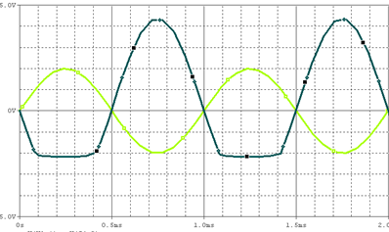Class AB Power Amplifier

increasing Vin

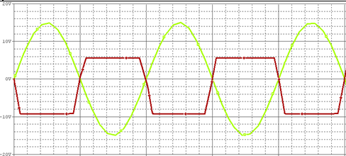

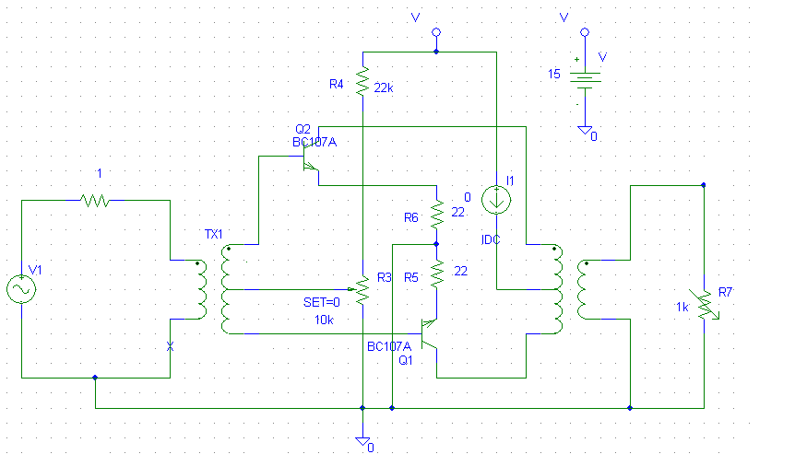PUSH-Pull Power Amplifier

Vo

