

Faculty of Engineering and Technology

Electrical and Computer Engineering Department

ENEE3102

Electronics Lab

Experiment # 5

Pre lab

*Student’s name : Anas Joudeh*

*Student’s number : 1142570*

*Instructor : Dr.Mohammad AL-Jubeh*

*DATE : 9/7/2018*

1. ***CHARACTERESTICS OF AN N-CHANNEL JFET :***

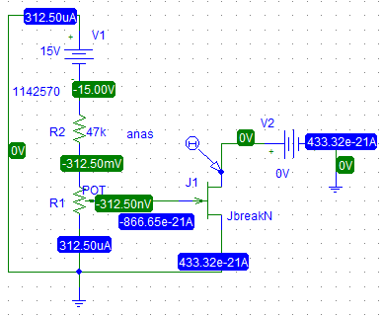

* When Vgs = 0 :



* When Vgs = -0.5 V :



* When Vgs = -1 V :



* When Vgs = -1.5 V :



* When Vgs = -2 V :



* When Vgs = -2.5 V :



2.

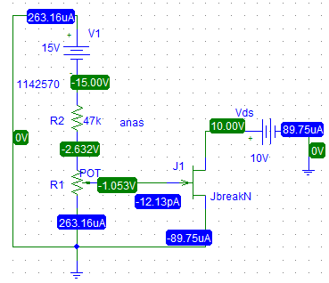

SO IG = -12.13 PA

1. ***A JFET AMPLIFIER :***

1.

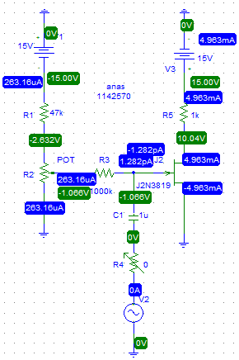



Voltage gain = 5 / 1 = 5.

1. ***COMMON DRAIN AMPLIFIER :***

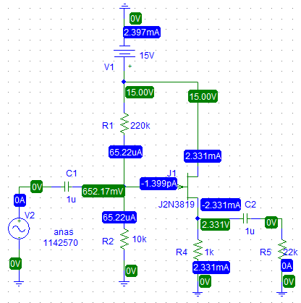



The gain voltage = 146.748/195.329 = 0.751

The phase shift = 0

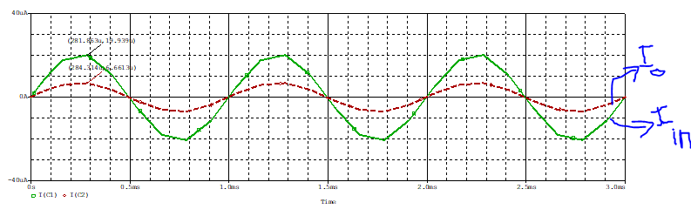

Zin = Vin / Iin = 195.329m/19.939u = 9.8k ohm.

Zo = Vo / Io = 146.748 / 6.661u = 22k ohm.

***III. CONSTANT CURRENT SOURCE.:***

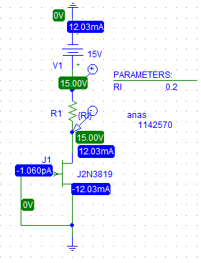

* RL Vs VL :



* RL Vs IL :



**THE END**