

Faculty of Engineering and Technology

Electrical Engineering Department

ــــــــــــــــــــــــــــــــــــــــــــــــــــــــــــــــــــــــــــــــــــــــــــــــــــــــــــــــــــــــــــــــــــــــــــــ

ELECTRONIC LAB

Pre Lab

Experiment#5

The Field-Effect Transistor

**Student’s Name: hani shweiki**

**Student’s No : 1160212**

**Instructors :** mohammad ju’beh

Eng.Amjaad

**Section : 2**

***I. CHARACTERESTICS OF AN N-CHANNEL JFET***

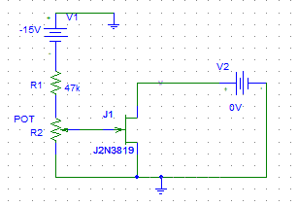

|  |  |  |  |  |  |  |  |
| --- | --- | --- | --- | --- | --- | --- | --- |
| ID(mA)for vds(v) | | | | | | | vDs  VGS |
| 15 | 10 | 5 | 2 | 1 | 0.5 | 0 |  |
| 12.034mA | 11.904mA | 11.774mA | A 10.266m | 6.5019mA | 3.251mA | 1.98e-18A | 0 |
| 8.372mA | 8.28mA | 8.2mA | 7.8mA | 5.2mA | 2.9mA | 406.9 0fA | -0.5 |
| 5.369mA | 5.31mA | 5.26mA | 5.22mA | 3.9mA | 2.3mA | 448fA | -1.0 |
| 3.01mA | 2.97mA | 2.94mA | 2.934mA | 2.6mA | 1.61mA | 483fA | -1.5 |
| 1.342mA | 1.329mA | 1.31mA | 1.3mA | 1.3mA | 977uA | 514fA | -2.0 |
| 339uA | 333uA | 329uA | 327.6uA | 326.5uA | 326uA | 542fA | -2.5 |

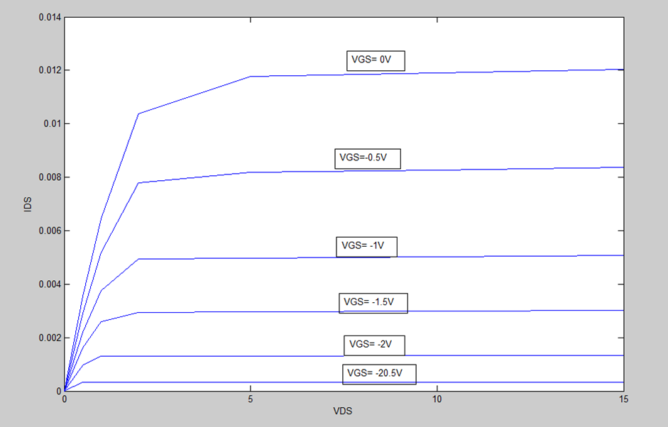

***II. A JFET AMPLIFIER.***

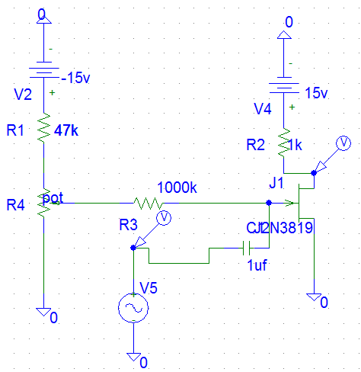



It is seen that (Vop-p=10volt and Vinp-p=2volt),so the voltage gain is 10/2=5 , The value of the resistor that makes the output voltage = 0.5 its original value equals 1 M Ω

the output voltage :



***III. COMMON DRAIN AMPLIFIER.***

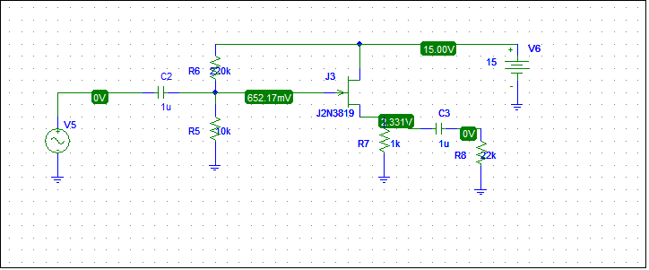

So VG=652.17m V and Vs=2.331 V

The plot of the input and output voltages is :



The voltage gain = 0.308/0.4=0.77

The phase shift = 0

The input current :



So Zin =Vin/Iin = 0.4/41.795u = 9.57k Ω

To find the output impedance,we must short replace the input voltage by a short circuit and put an input voltage to the output ,then measure the output current.

The output current :



Zout = Vout/Iout = 0.4/4.269m = 93.7 Ω

***IIII. CONSTANT CURRENT SOURCE.***

***Consider the circuit beside:***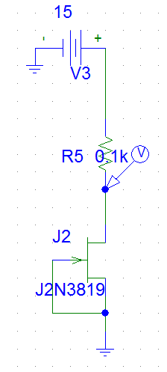

|  |  |  |
| --- | --- | --- |
| RL(KΩ) | VL(V) | ID(mA) |
| 0.1 | 1.2 | 12 |
| 0.22 | 2.63 | 11.97 |
| 0.33 | 3.94 | 11.93 |
| 0.47 | 5.588 | 11.89 |
| 0.56 | 6.643 | 11.86 |
| 1 | 11.729 | 11.73 |
| 1.5 | 13.44 | 8.96 |
| 2 | 13.901 | 6.951 |
| 3 | 14.31 | 4.767 |